HASHIR AHMED
22I-1988
DS

DW-PROJECT

Project Overview:
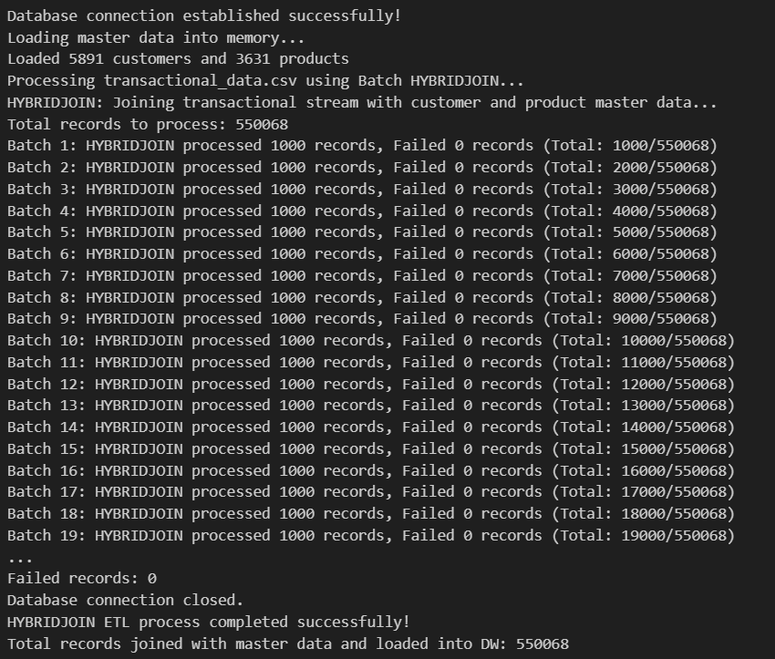
This project implements a near-real-time Data Warehouse (DW) prototype for Walmart, designed to analyze shopping behavior dynamically for enabling personalized offers and promotions. The system processes transactional data streams enriched with customer and product master data using the HYBRIDJOIN algorithm.

Key Objectives:
- Design and implement a star schema data warehouse
- Develop HYBRIDJOIN algorithm for stream-relation joins
- Enable near-real-time data processing capabilities
- Provide comprehensive OLAP analysis for business intelligence

Business Value:
- Real-time customer behavior analysis
- Dynamic promotion optimization
- Personalized marketing strategies
- Multi-dimensional sales analysis

Data Warehouse Schema Design:
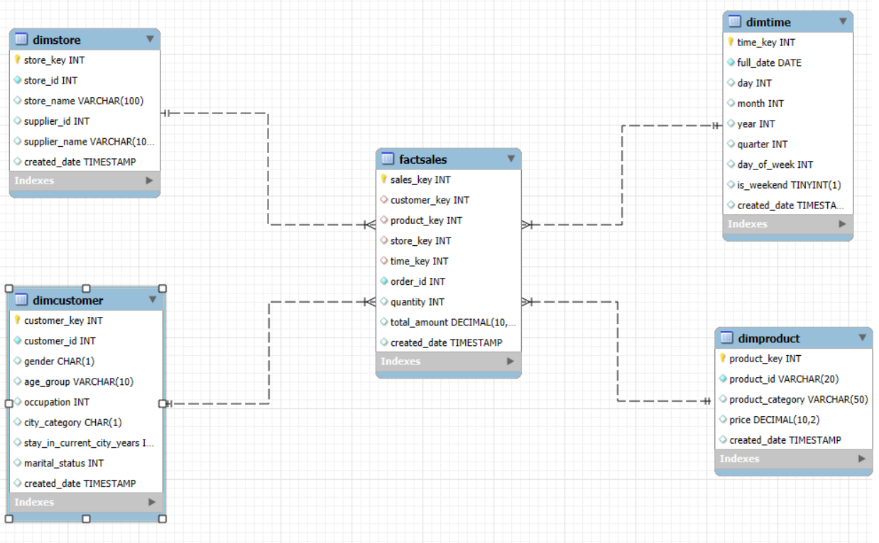
Star Schema Components:

Dimension Tables:
- DimCustomer: Customer demographic information
- DimProduct: Product catalog and pricing
- DimStore: Store and supplier details
- DimTime: Time intelligence for trend analysis

Fact Table:
- FactSales: Sales transactions with foreign keys to all dimensions

Schema Relationships:
FactSales connects to DimCustomer, DimProduct, DimStore, and DimTime using surrogate keys.

Key Design Decisions:
- Surrogate keys used for dimensions
- Proper indexing for performance
- Complete descriptive business attributes maintained
- Referential integrity enforced through foreign key constraints

HYBRIDJOIN Algorithm Implementation:
Algorithm Components:
- Stream Buffer: Manages incoming transactional data and prevents data loss
- Hash Table: 10,000 slots for efficient tuple lookup
- Disk Buffer: Loads partitioned master data (500 tuples each)
- Queue: Doubly-linked list for FIFO and efficient deletions

Implementation Approach:
A batch-based HYBRIDJOIN was implemented using Python and data structures such as hash tables and buffers to simulate real-time data enrichment.

ETL Process:
- Extract: Read transactional data from CSV
- Transform: Enrich using HYBRIDJOIN
- Load: Insert enriched records into the DW

Shortcomings of HYBRIDJOIN
1 Memory Intensive Operations
Master data loaded entirely into RAM can be problematic for large datasets and limited-memory systems.
2 Batch Processing Limitations
Batch processing introduces latency and may not support high-velocity streams.
3 Complexity in Error Handling
Complex data structures make debugging and thread safety difficult.

Lessons Learned
1 Data Warehouse Design Principles
- Star schema improves OLAP performance
- Indexing is essential
- Dimensions must include complete descriptive attributes

2 Stream Processing Challenges
- Real-time needs efficient resource handling
- Data enrichment increases complexity
- Batch processing can simulate streaming effectively

3 Algorithm Insights
- HYBRIDJOIN balances memory-disk usage
- Data structure selection greatly affects performance
- Testing at realistic scale is critical

4 Business Intelligence Value
OLAP queries generated insights for customer segmentation, seasonal trends, product performance, and store comparisons.

Implementation Challenges & Solutions
Challenge 1: Data Quality Issues
Solution: Added validation and error checking.

Challenge 2: Performance Optimization
Solution: Applied indexing and optimized joins.

Challenge 3: Algorithm Complexity
Solution: Simplified HYBRIDJOIN using batch mode.

Business Insights Generated
- Identify high-value customer demographics
- Analyze product performance trends
- Detect seasonal purchasing behavior
- Compare store performance
- Identify cross-selling opportunities

Queries:
1
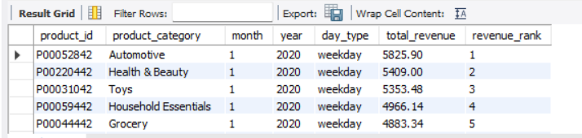
2
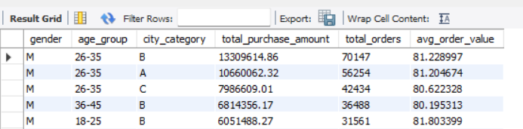
3
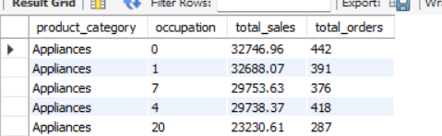

4
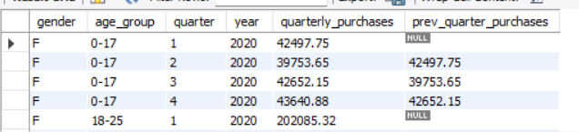
5
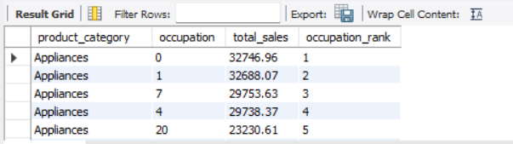
6
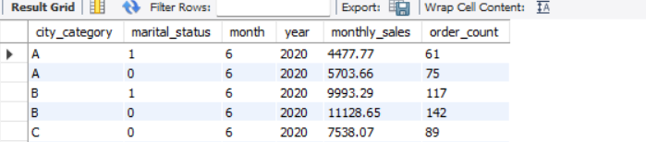
7
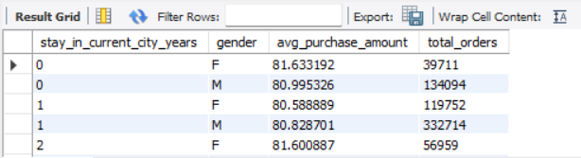

8

9
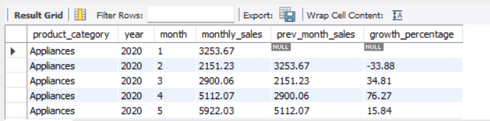
10
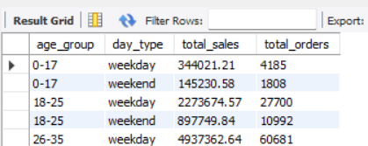
11
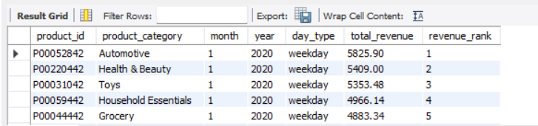

12
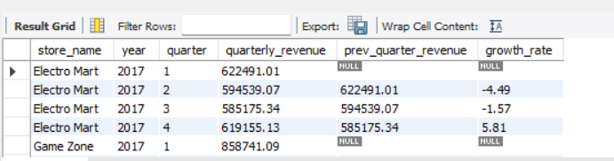
13
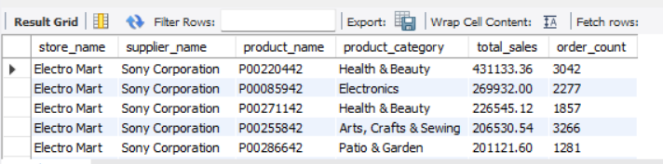
14
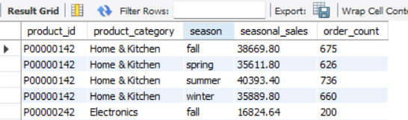
15
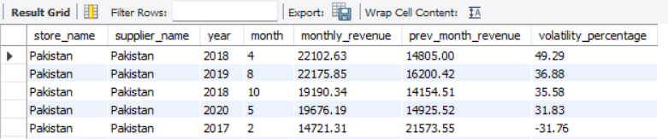

17
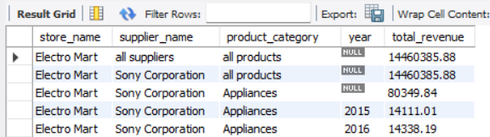
18
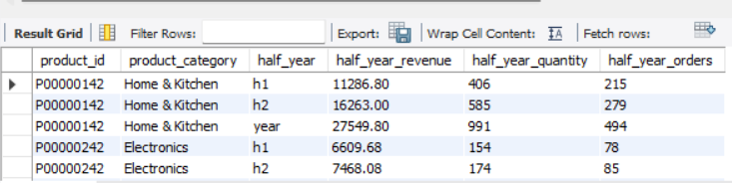
19
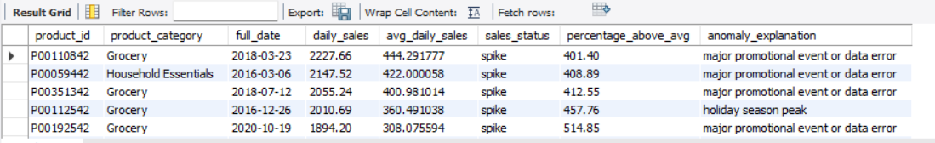

Conclusion
This project showcases a near-real-time data warehouse implementation using HYBRIDJOIN. It enriches transactional data streams, loads them into a star-schema DW, and enables multi-dimensional OLAP analysis. Walmart can use this system for personalized marketing, dynamic promotions, and enhanced business decision-making.

