Instructions

1. Download and install anaconda3 from given link(ignore step 1,3 if you already done )

- link : <https://www.filehorse.com/download-anaconda-64/download/>

Make sure that like given in the image below, check first three checkboxes

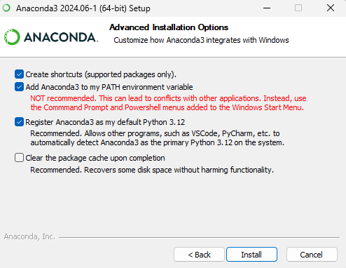

1. Extract “disaster.rar” file in a folder
2. Extract “qualityenv.rar” file to location C->users->user(it may be vary based on your system)->anaconda3->envs
3. Open anaconda prompt
4. Navigate to “disaster/mob/backend” folder
5. Command: python server.py
6. Install flutter for windows refer the video for installation and setup

Link:https://www.youtube.com/watch?v=1KidD72q87s

1. In vscode install extension dart and open terminal
2. Command : flutter run