First of all I derived equations through a MATLAB code. It is “symbolic_derivation.m”

*As you can see the output of code is a little different from standard format

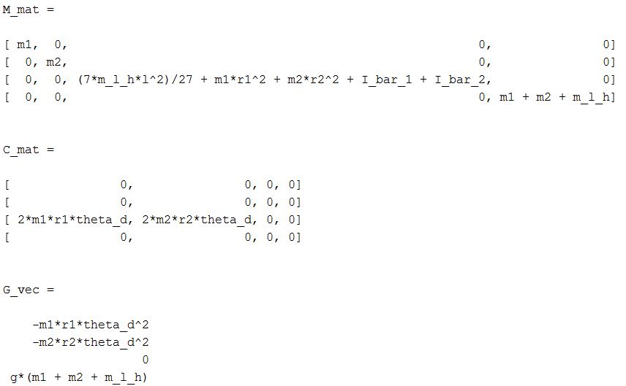

So I edited it manually to have them in standard format. Then the results are as below:

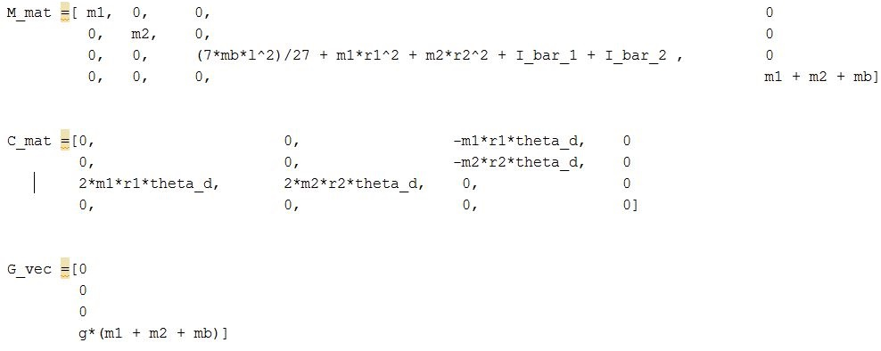

As you assume m1 and m2 as point masses you should set I_bar_1 and I_bar_2 equal to 0.

*theta_d is angular velocity of horizontal beam.

**Simulink:**

I implemented forward dynamics simulation of model in “initial_simulation_forward.slx”

I set all inputs equal to zero. You can edit them if wish.

All constant parameters are defined as constants in SIMULINK file you can also edit them if you wish.

I implemented inverse dynamics simulation of model in “initial_simulation_inverse.slx”

I made a simulation of constant angular velocity of horizontal beam and all other variables are set to constant values (r1, r2, z).

You can also define a desired motion. Anything you wish.