EC2 Flask + Express Full Deployment Guide

Launch EC2 Instance
Screenshot for: Launch EC2 Instance
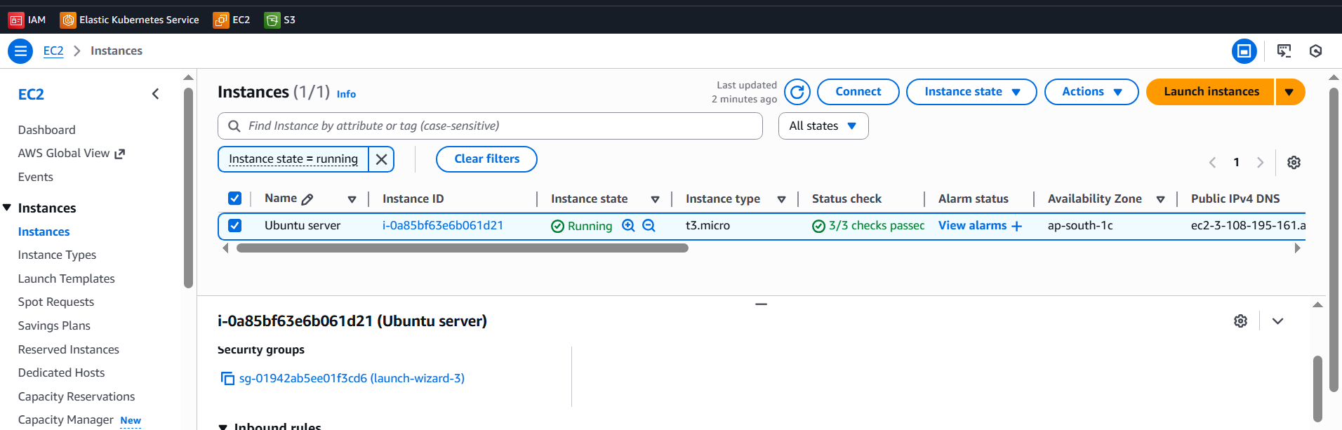

EC2 Instance Running
Screenshot for: EC2 Instance Running
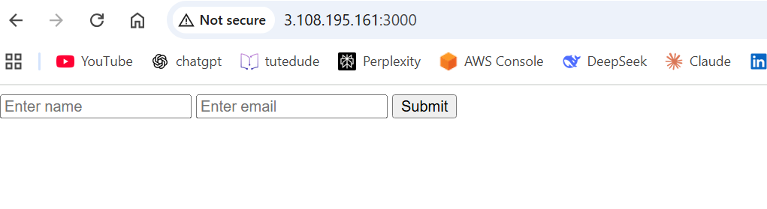

Backend Setup Installing Flask
Screenshot for: Backend Setup Installing Flask
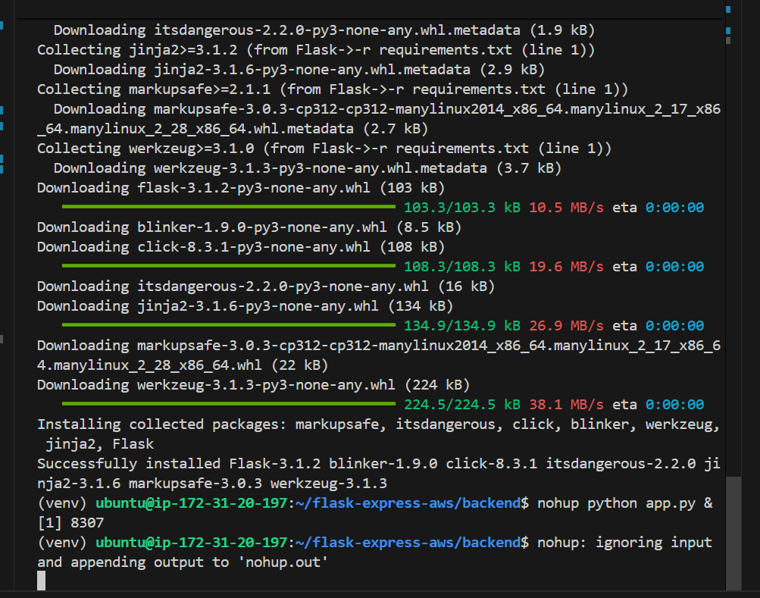

Frontend + Backend EC2 Instances
Screenshot for: Frontend + Backend EC2 Instances
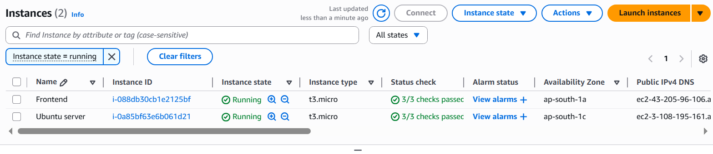

Frontend Security Group Settings
Screenshot for: Frontend Security Group Settings
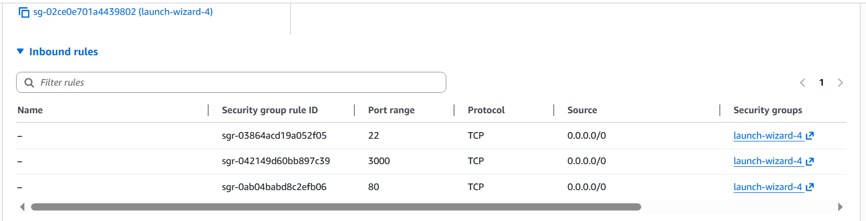

Backend Security Group Settings
Screenshot for: Backend Security Group Settings
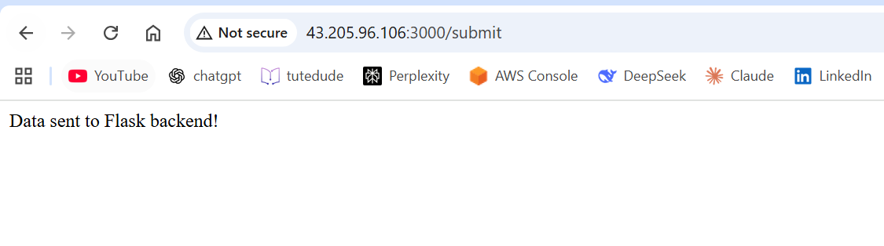

Final Output — Data Sent Successfully
Screenshot for: Final Output — Data Sent Successfully
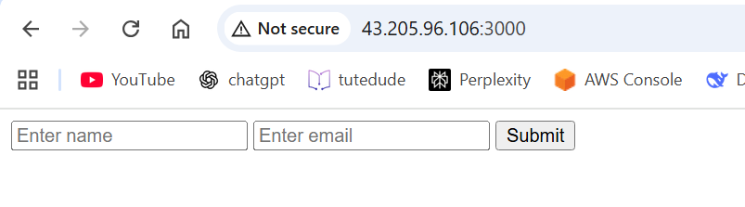

Backend Flask Logs
Screenshot for: Backend Flask Logs
