EC2 Flask + Express Full Deployment Guide

Student: Mosharib Ahmad Hashmi
GitHub Repository:
🔗 https://github.com/Hashmi64/flask-express-aws

Launch EC2 Instance

1.EC2 Instance Running
Screenshot for: EC2 Instance Running
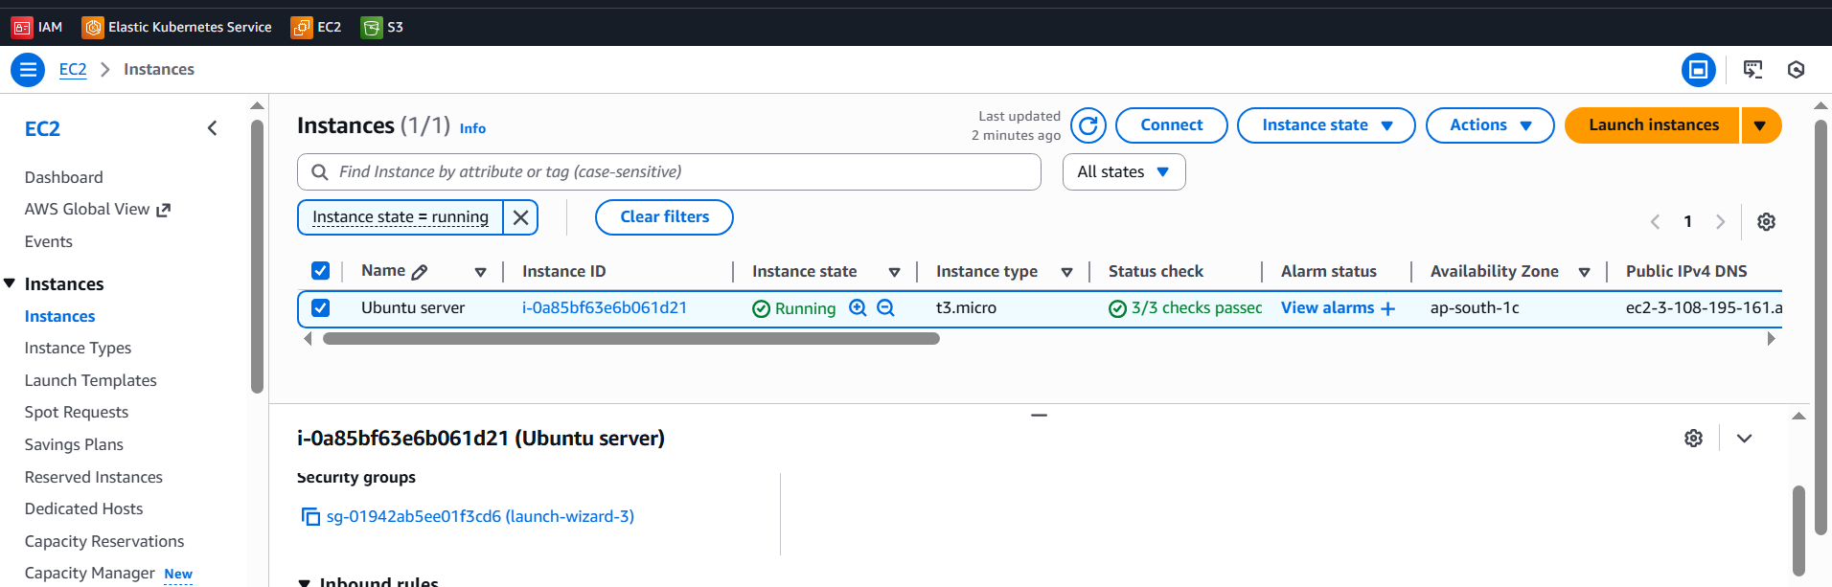
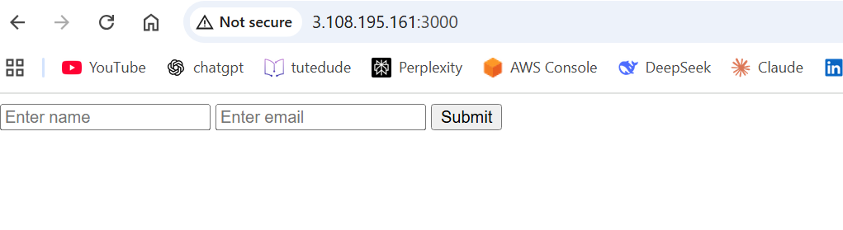

2.Frontend + Backend EC2 Instances
Screenshot for: Frontend + Backend EC2 Instances
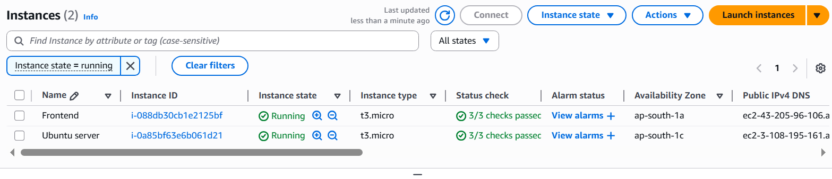

Backend Setup Installing Flask
Screenshot for: Backend Setup Installing Flask
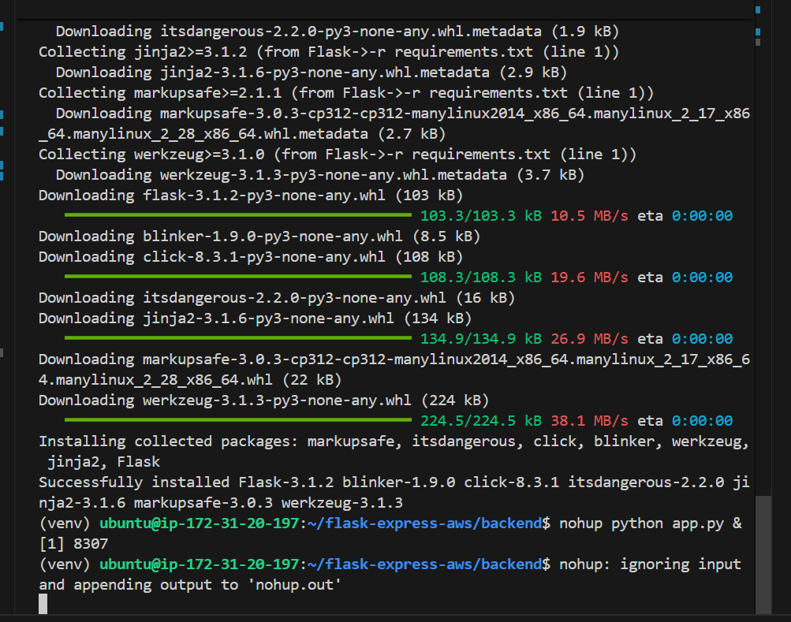

Frontend Security Group Settings
Screenshot for: Frontend Security Group Settings
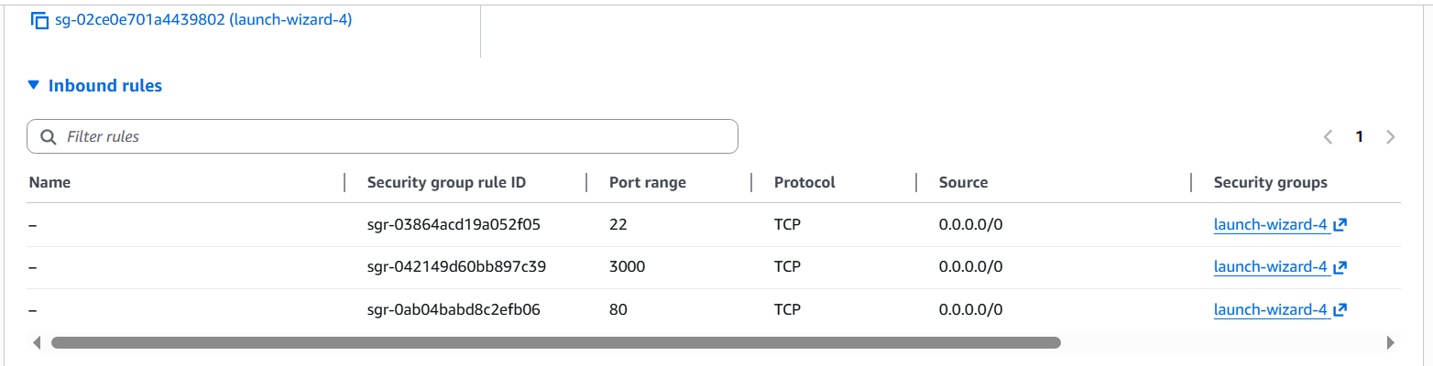

Final Output — Data Sent Successfully
Screenshot for: Final Output — Data Sent Successfully
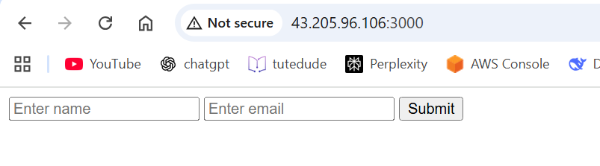
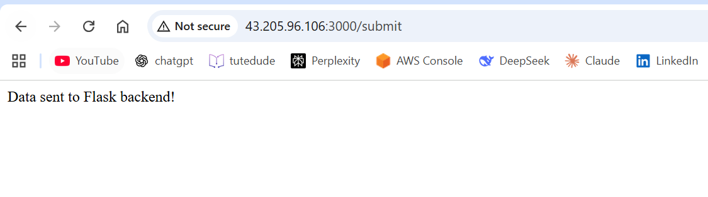

Backend Flask Logs
Screenshot for: Backend Flask Logs
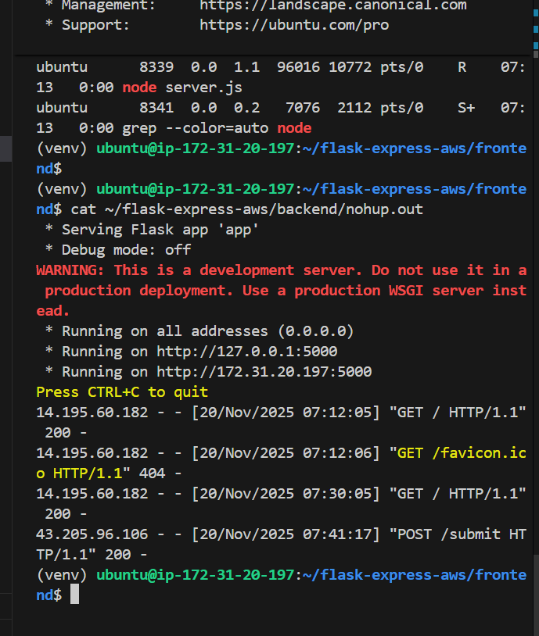

Dockerise:
STEP 1 — Created ECR Repositories
We created two ECR repos:
- flask-backend
- express-frontend
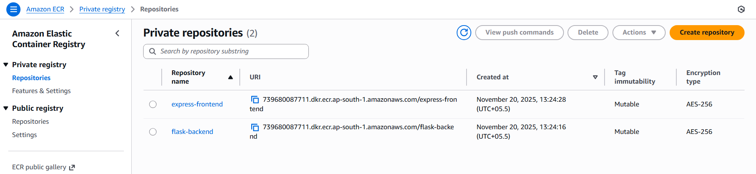
STEP 2 — Build & Push Docker Images
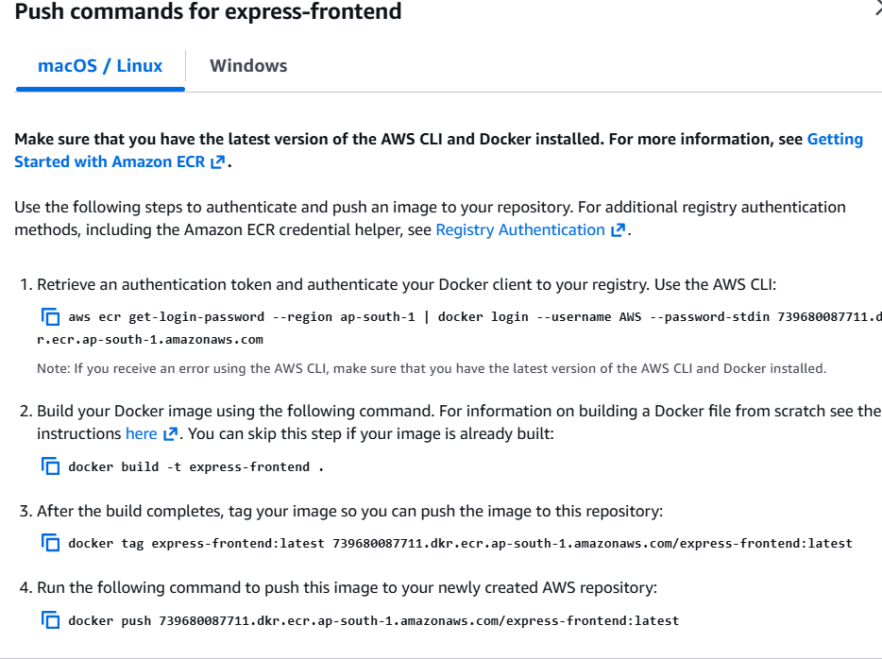
STEP 3 — Created ECS Cluster:
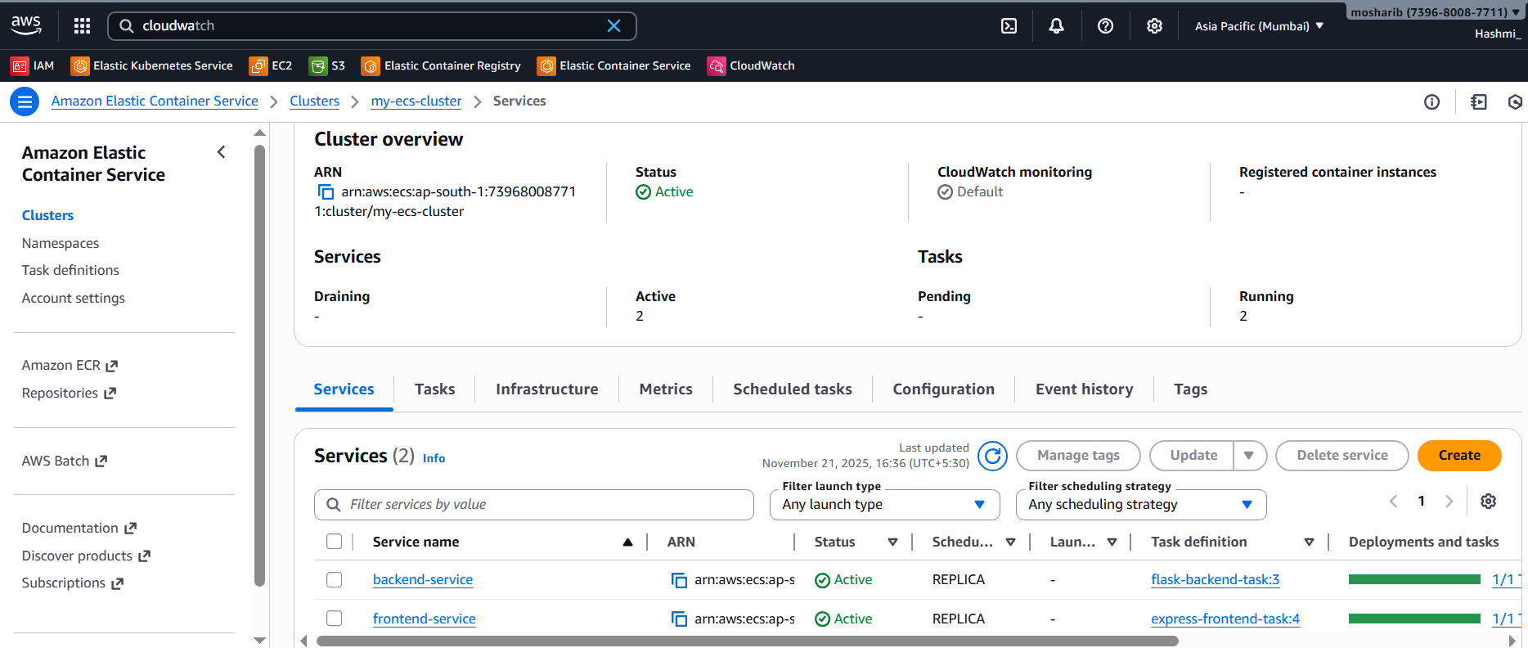
STEP 4 — Create Frontend & Backend Task Definition (Fargate)
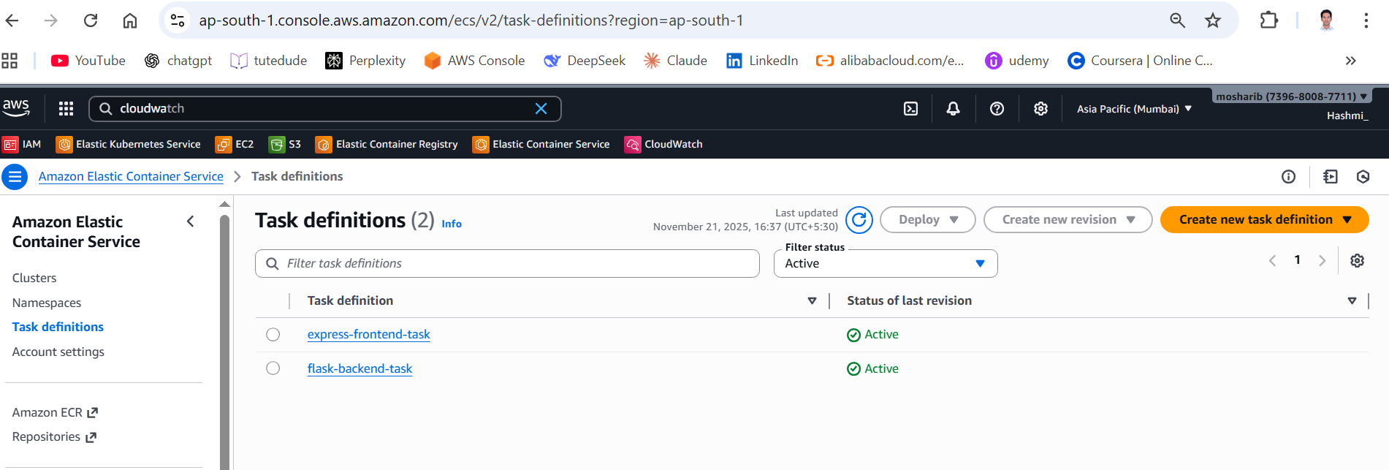
STEP 5 — Create Frontend & Backend Service
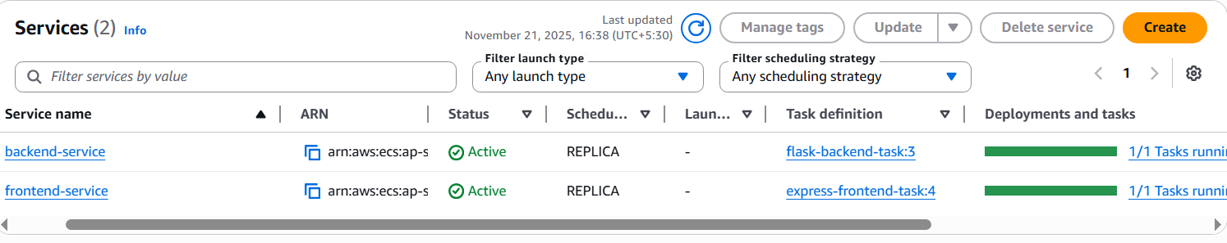
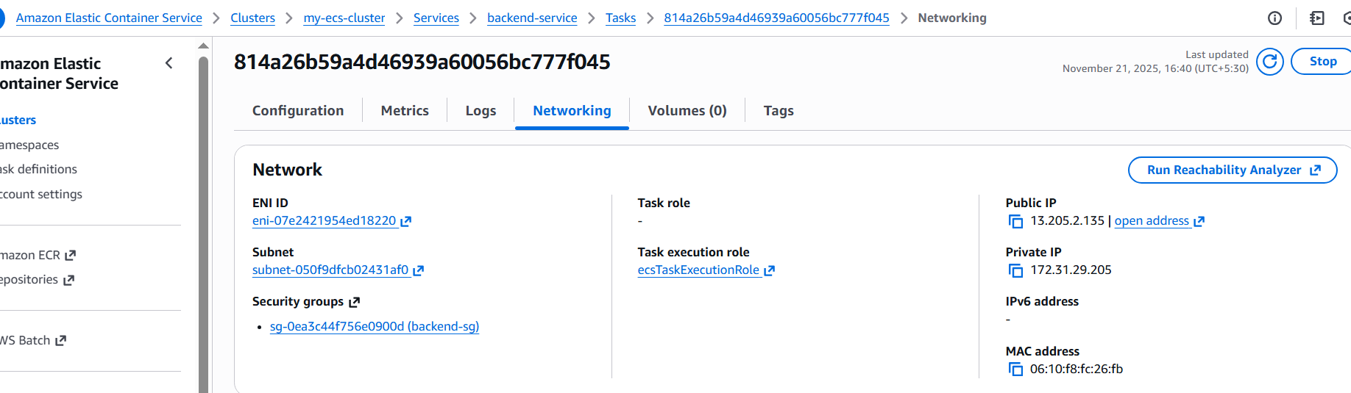
Backend Live URL:
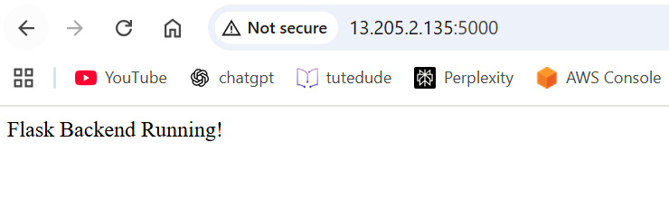
STEP 6 — Create Frontend Service:
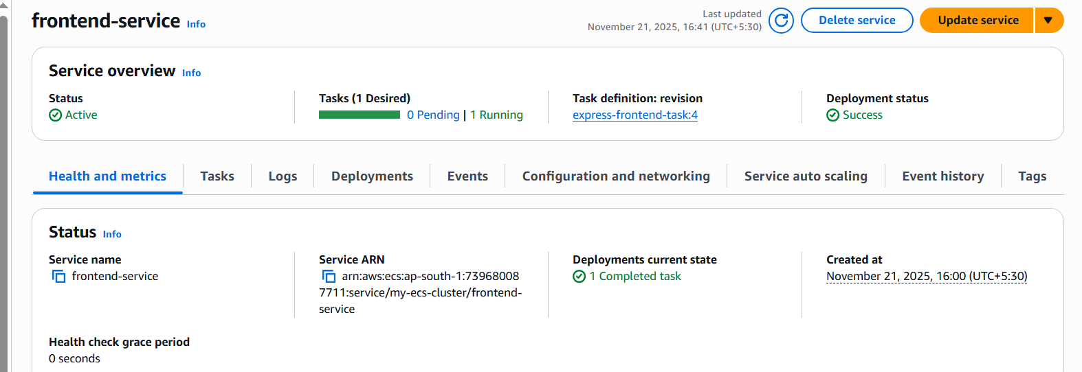
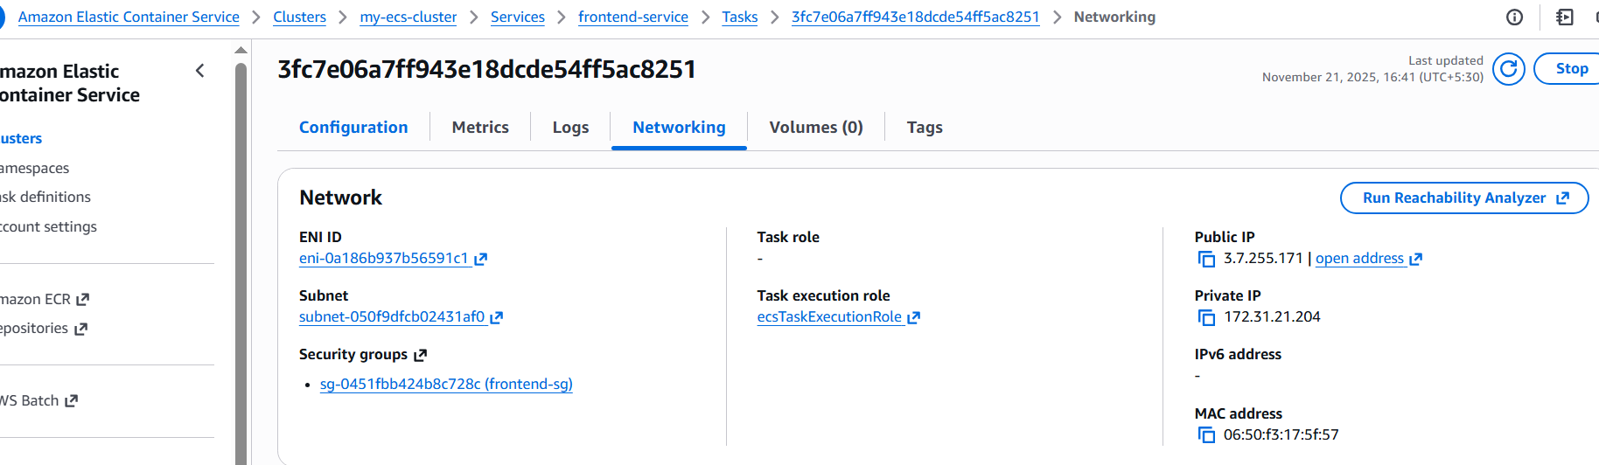
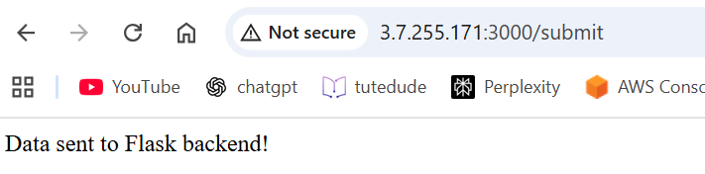
STEP 8 — Connect Frontend to Backend
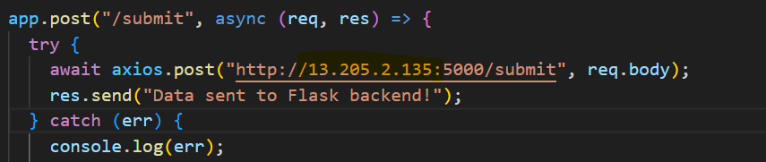
STEP 9: Rebuild & Push New Frontend Image After Code Update
ECS → frontend-service → Force new deployment
STEP 10 — Final Working URLs
Frontend: http://3.7.255.171:3000/submit
Backend: http://13.205.2.135:5000

