Kubernetes Deployment Steps (Flask Backend + Node Frontend on Minikube)
Name: Mosharib Ahmad Hashmi
GitHub: https://github.com/Hashmi64/kubernetes-minikube-project
COMMAND LIST (Frontend + Backend Minikube Deployment):
minikube start
minikube docker-env | Invoke-Expression
docker build -t flask-backend:latest ./backend
docker build -t frontend-app:latest ./frontend
kubectl apply -f k8s/backend-deployment.yaml
kubectl apply -f k8s/backend-service.yaml
kubectl apply -f k8s/frontend-deployment.yaml
kubectl apply -f k8s/frontend-service.yaml
kubectl get pods
kubectl get svc
minikube service frontend-service –url
minikube service flask-backend-service –url
kubectl rollout restart deployment/frontend-app
Build Backend Docker Image:
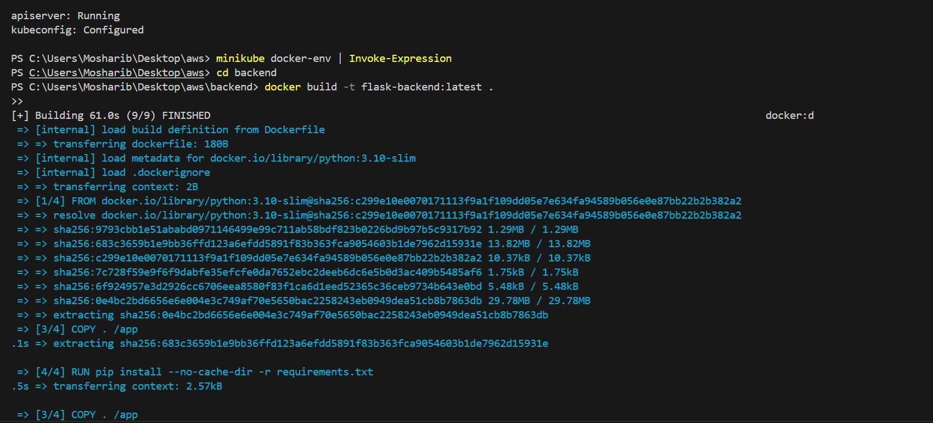
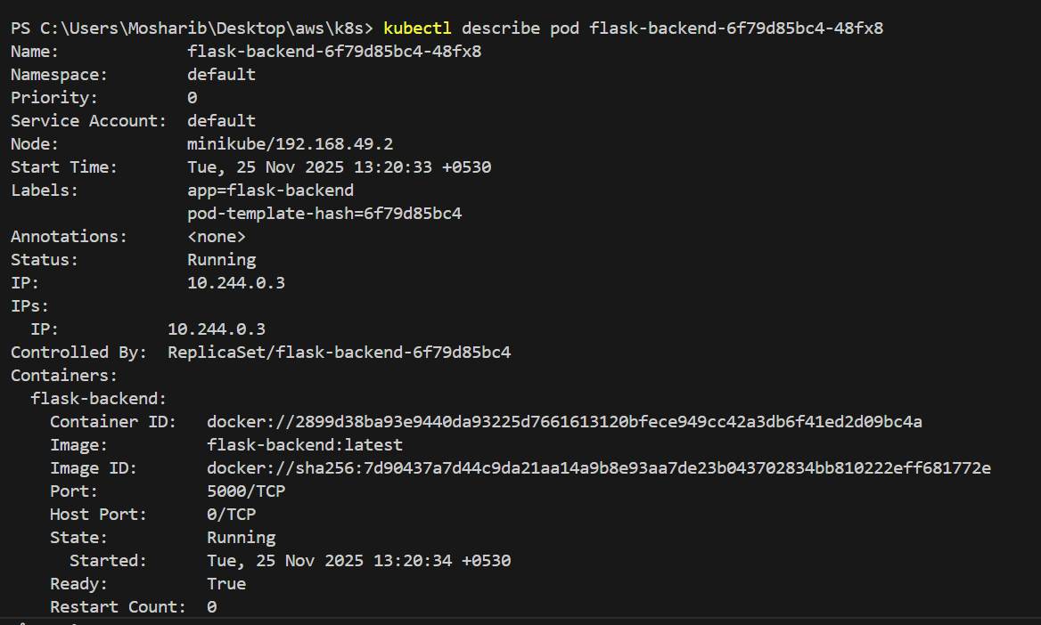
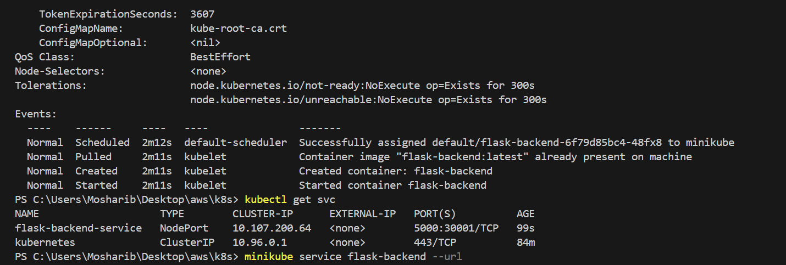
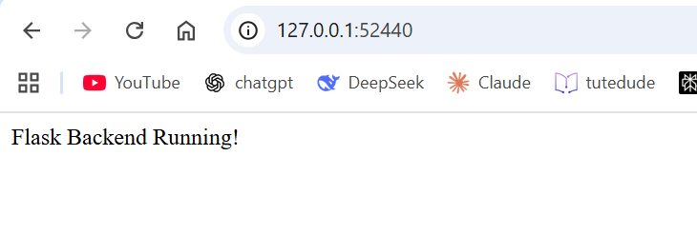

Build Frontend Docker Image:
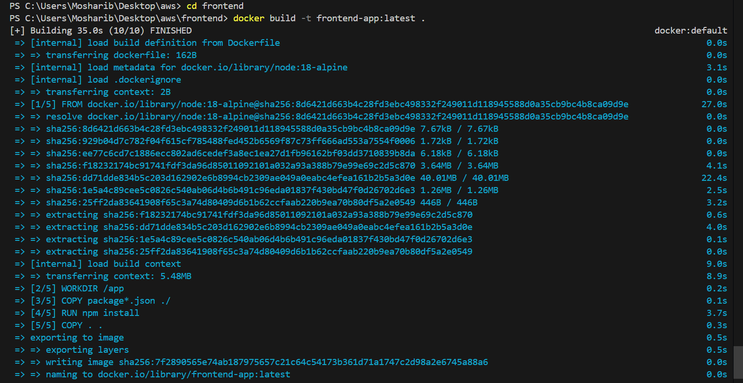
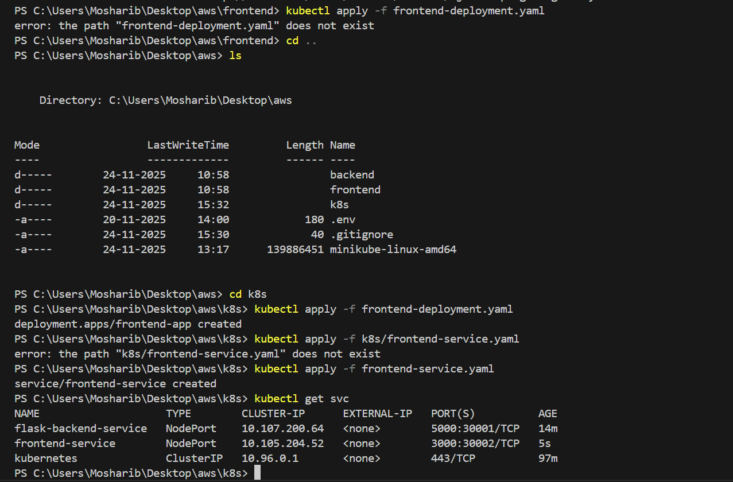

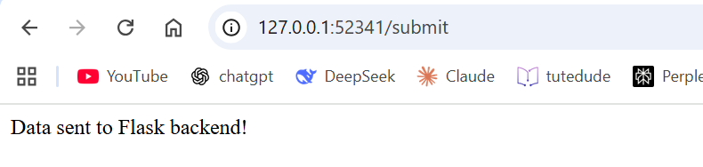
Minkube cluster and docker container is running:
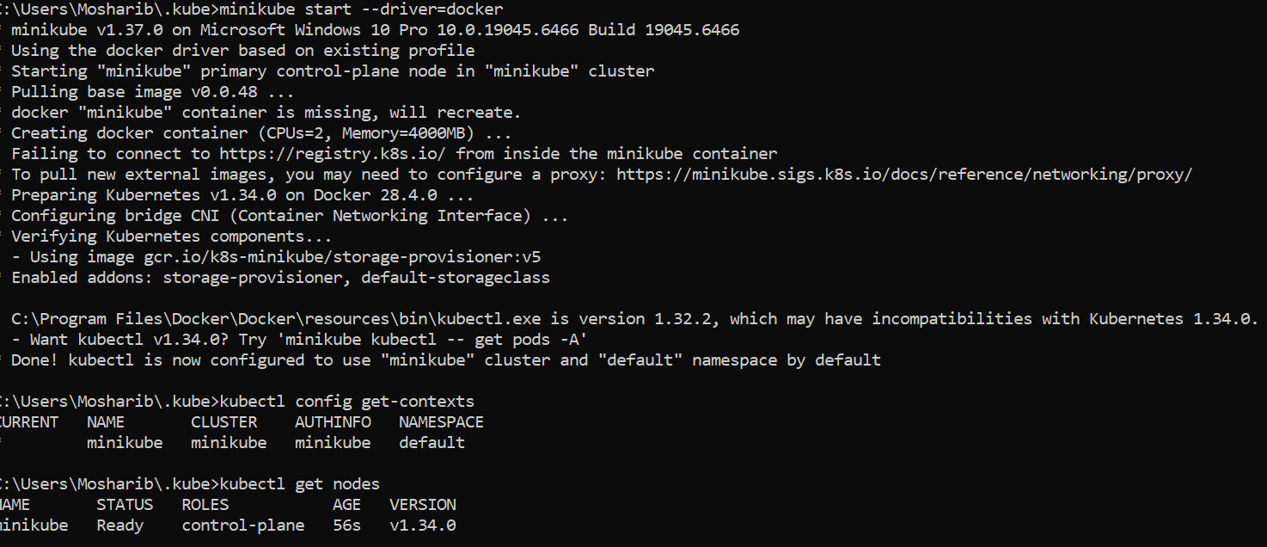
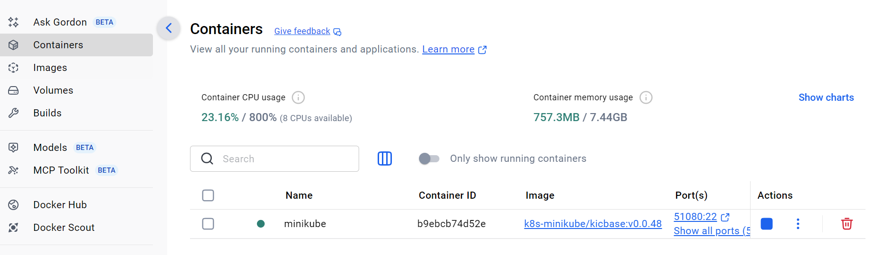
Deployment and service created:
