Automated EC2 Deployment Using Terraform & Configuration Using Ansible
Name: Mosharib Ahamd Hashmi
GitHub: https://github.com/Hashmi64/terraform-project

Part 1: Deploy Both Flask and Express on a Single EC2 Instance
• This project demonstrates fully automated EC2 deployment using Terraform.
• EC2 create hone ke baad server ko configure karne ke liye Ansible use hota hai.
• Tools used: Terraform, Ansible, AWS EC2, Ubuntu, SSH key.
• Goal: Create server → Install required software (Node.js, npm, Python, Git, Curl)
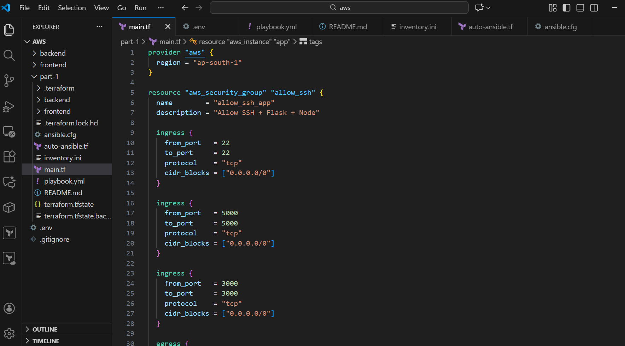
Prerequisites:
• AWS account
• Terraform installed
• Ansible installed
• WSL Ubuntu installed
• VS Code installed
• SSH key generated (.pem)
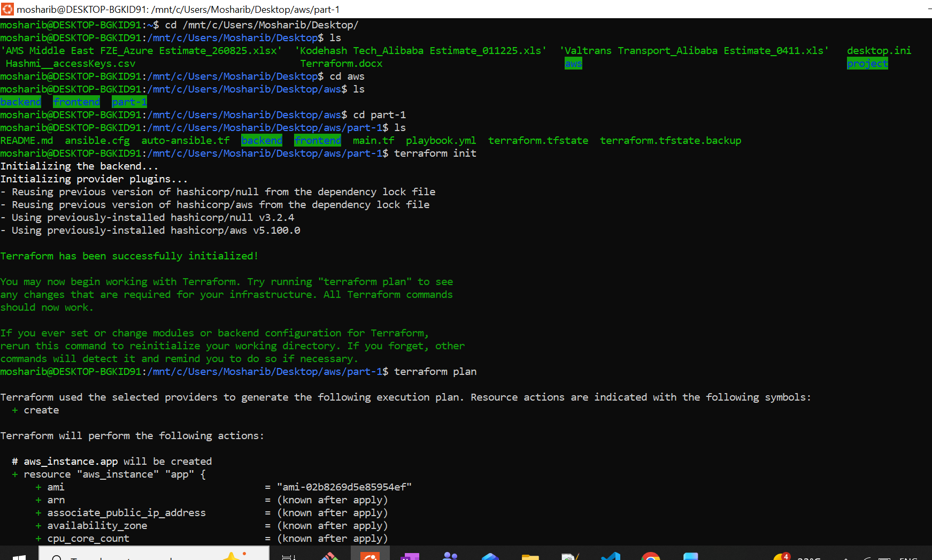
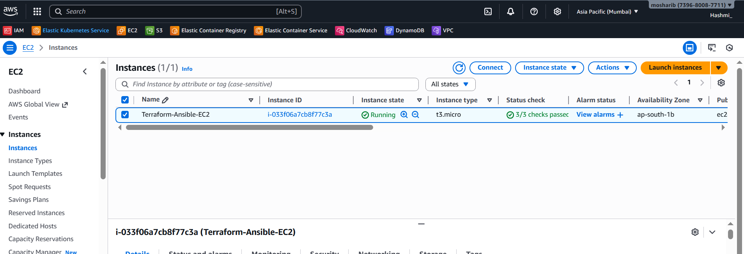
Ansible Inventory File:
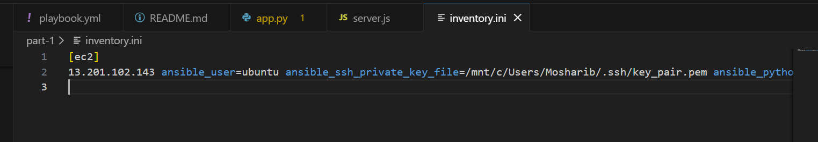
Run Ansible Playbook:
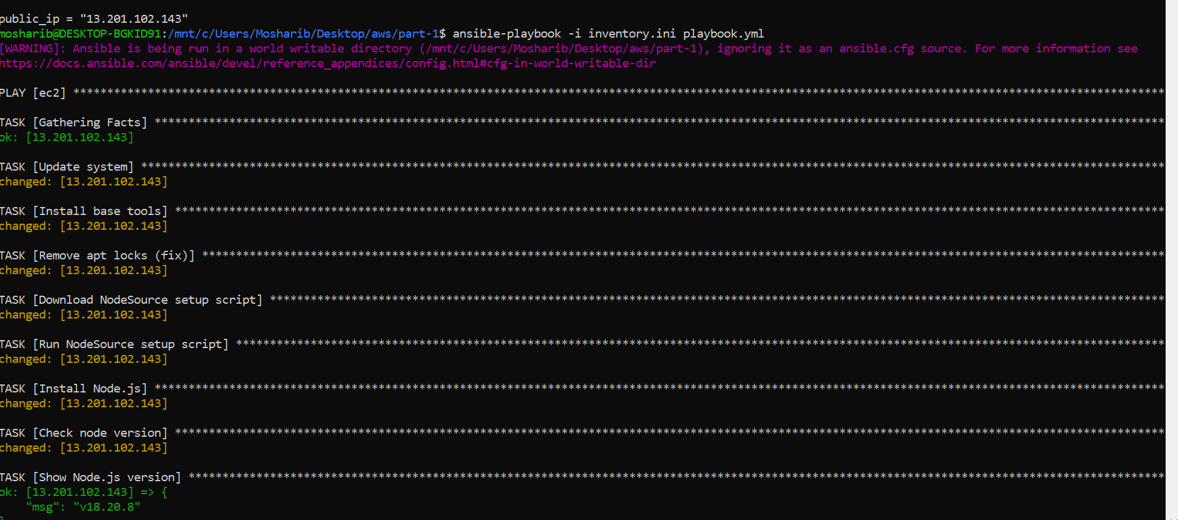
Copying backend files to ec2_server:
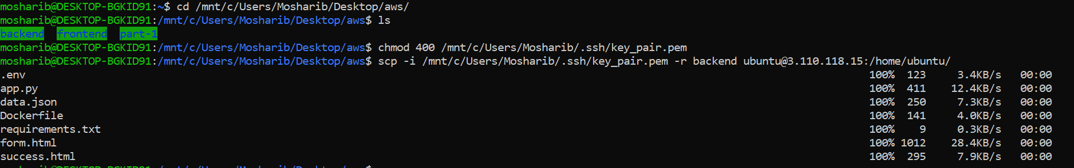
Frontend:
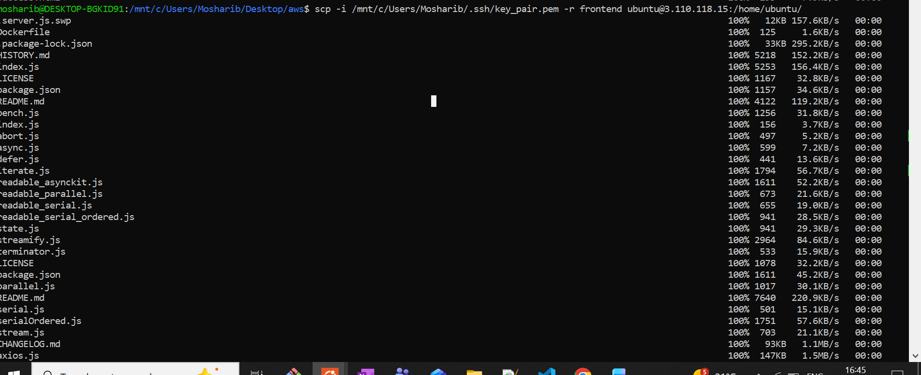
Commands use:
cd /mnt/c/Users/Mosharib/Desktop/aws
chmod 400 /mnt/c/Users/Mosharib/.ssh/key_pair.pem
scp -i /mnt/c/Users/Mosharib/.ssh/key_pair.pem -r backend ubuntu@13.201.102.143:/home/ubuntu/
scp -i /mnt/c/Users/Mosharib/.ssh/key_pair.pem -r frontend ubuntu@13.201.102.143:/home/ubuntu/
Frontend running:
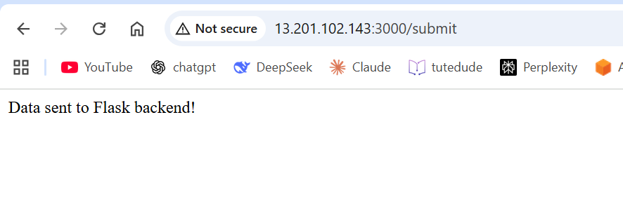
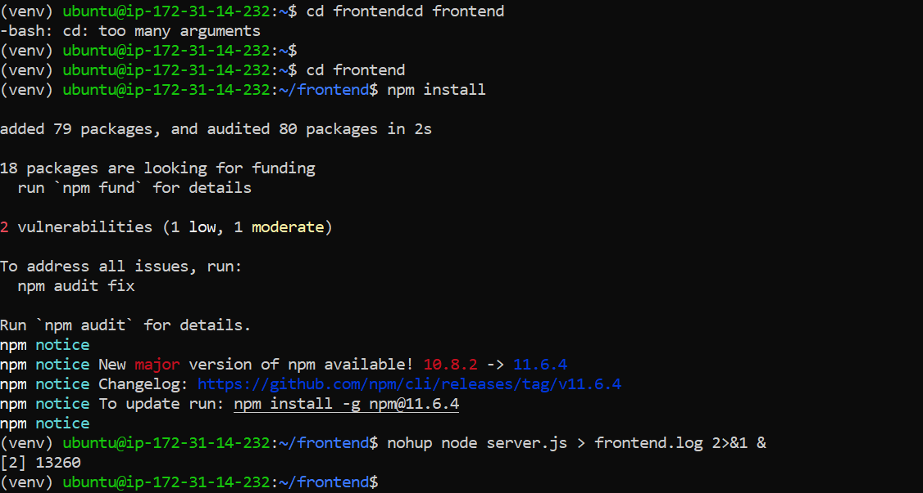
Backend running:
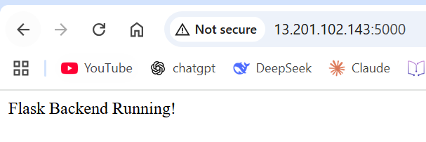
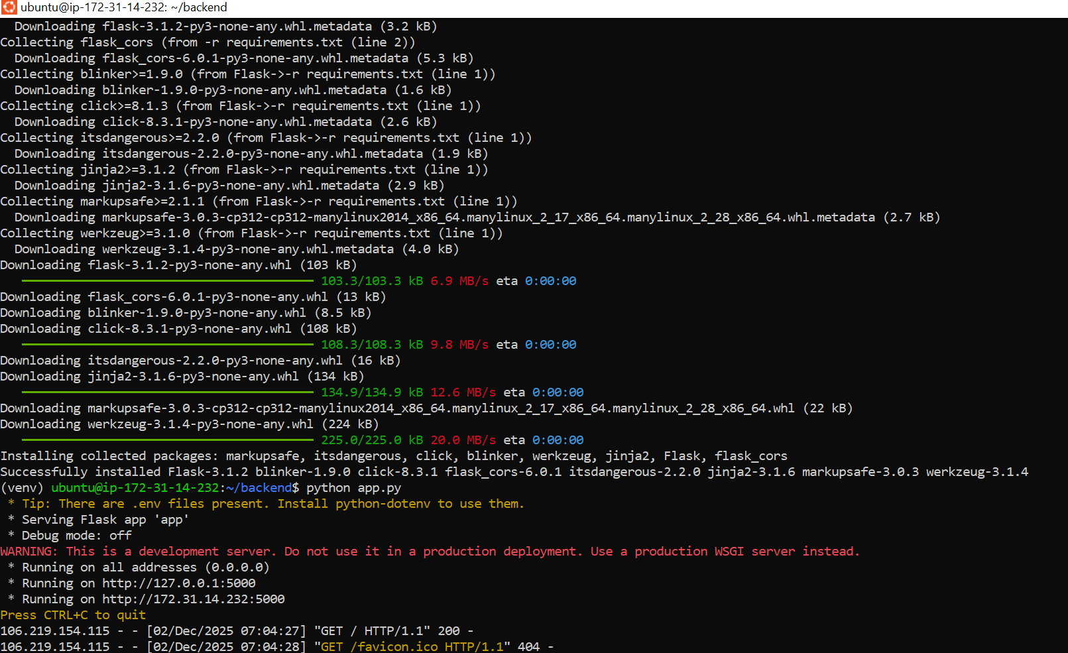

Part 2: Deploy Flask and Express on Separate EC2 Instances
Terraform:
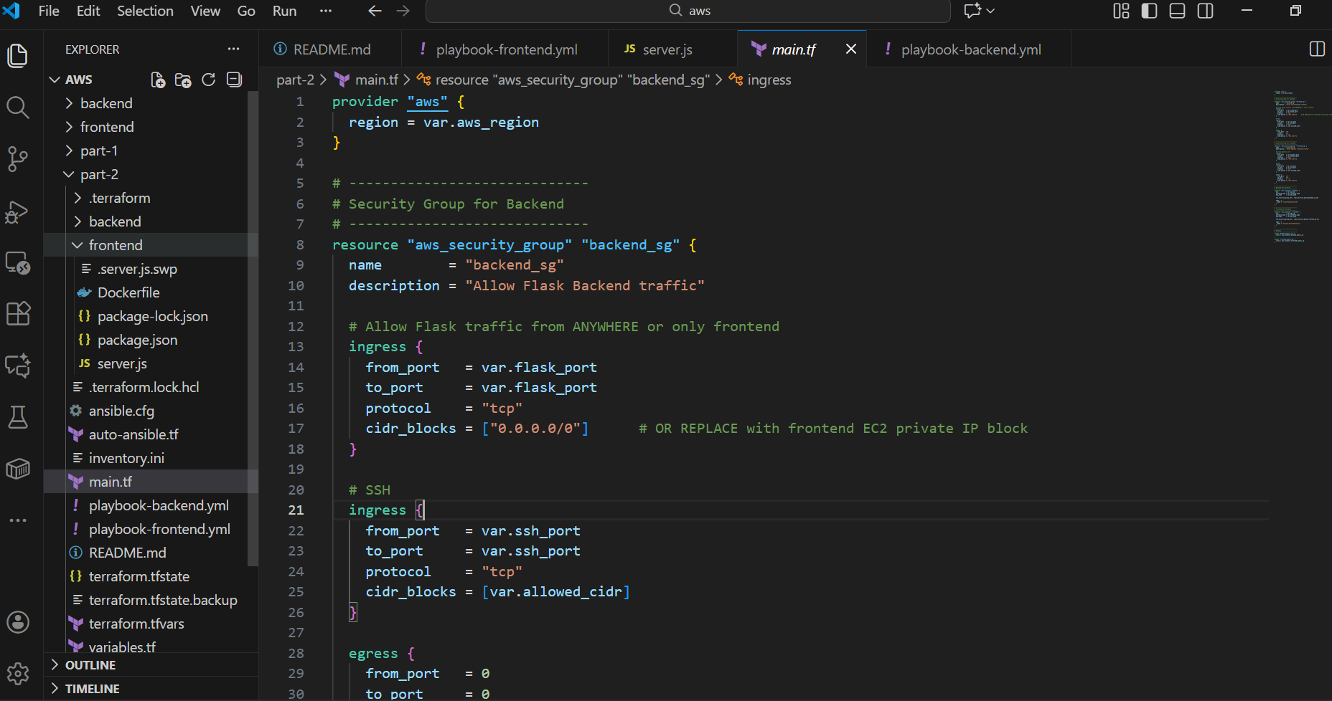
2. Both server running:
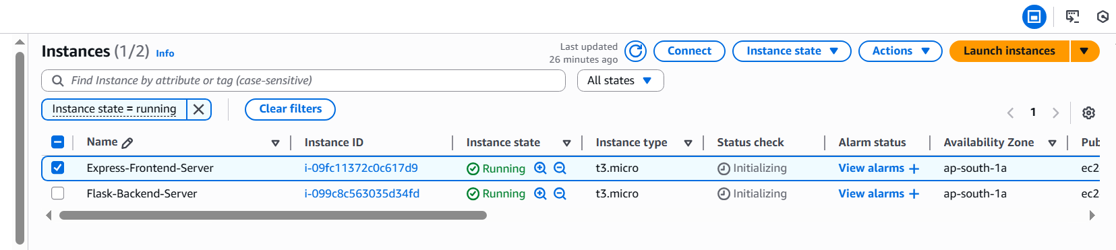
3. Backend Ansible Playbook running:
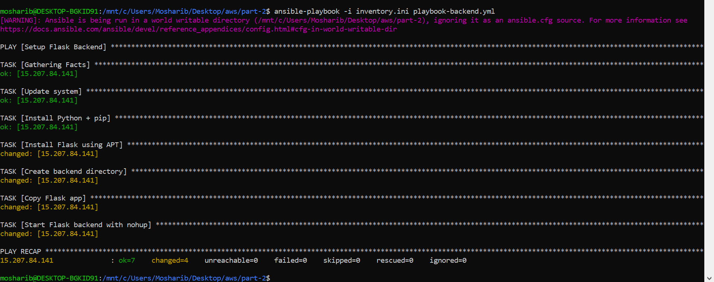
4. Backend running:
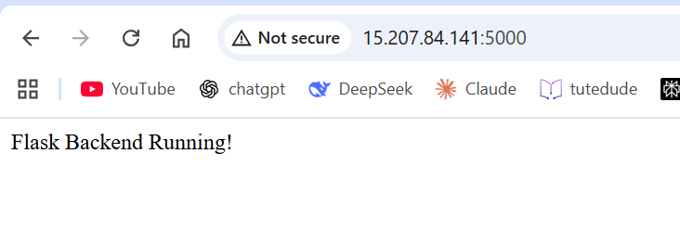
5. Frontend Ansible Playbook running:
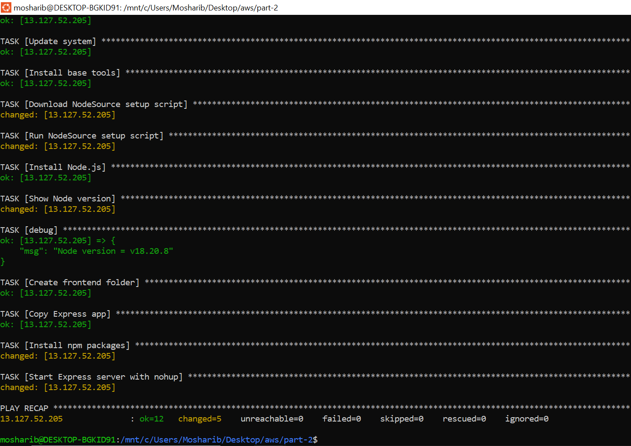

6. Frontend running:
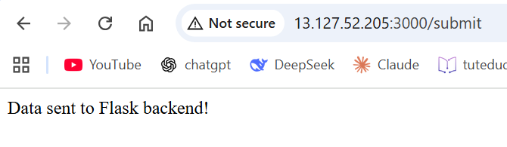
Command used:
terraform init
terraform validate
terraform plan
terraform apply -auto-approve
ansible-playbook -i inventory.ini playbook-backend.yml
ansible-playbook -i inventory.ini playbook-frontend.yml
terraform destroy -auto-approve

Part 3: Deploy Flask and Express Using Docker and AWS Services (ECS & Fargate)
Amazon ECR repositories:
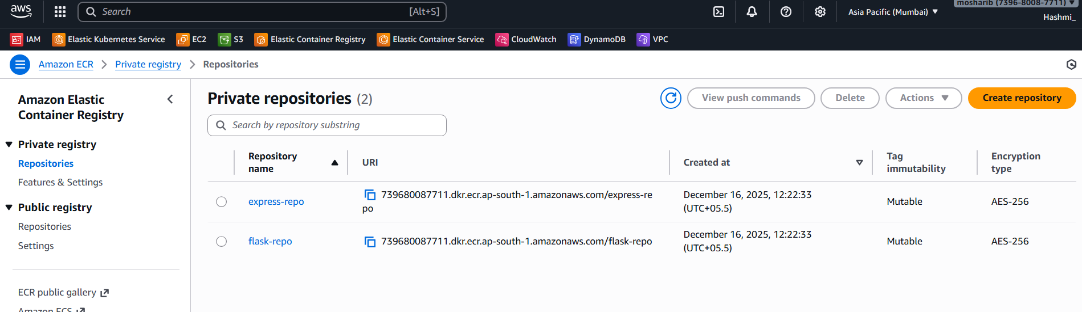
Services running:
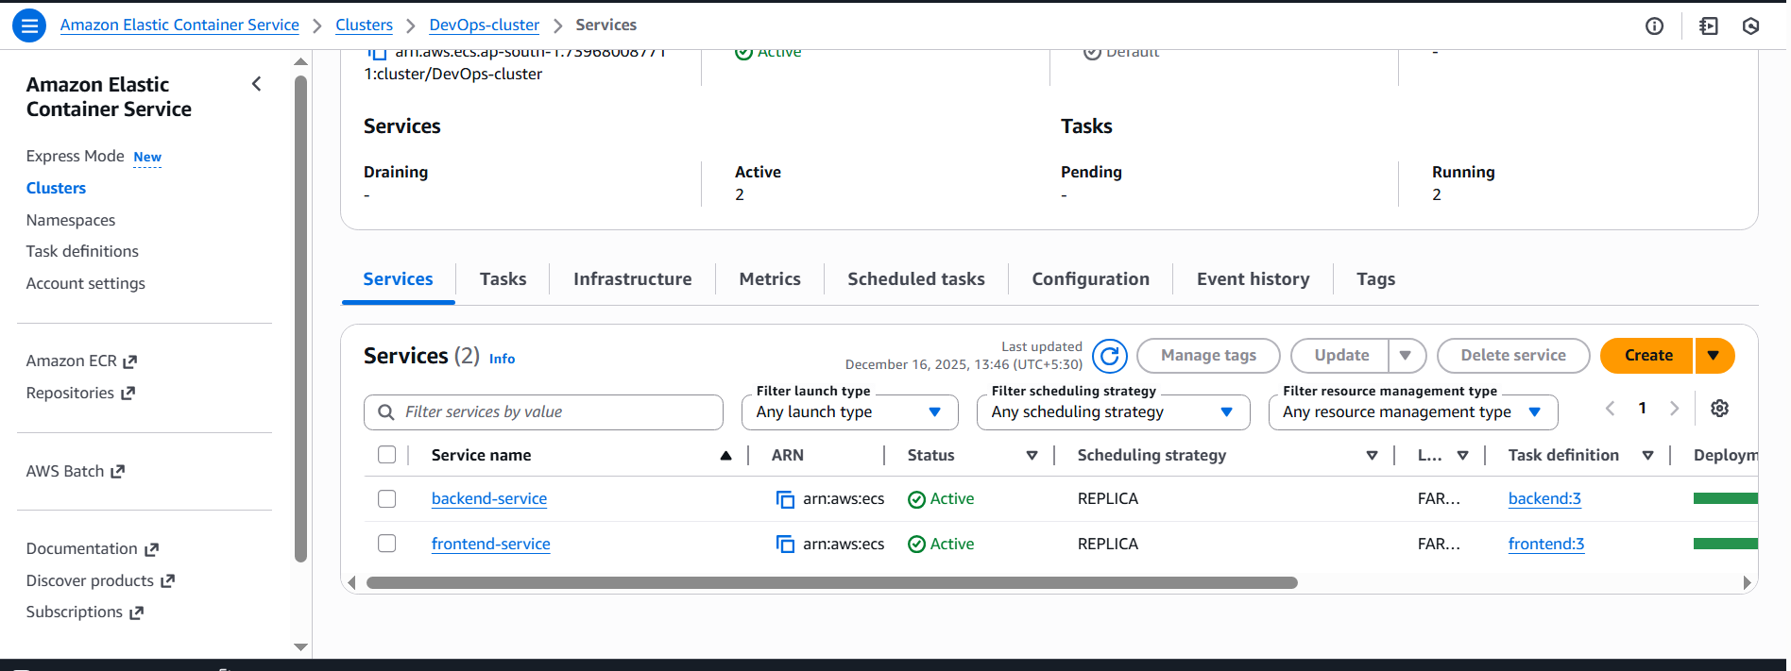
Load Balancer:
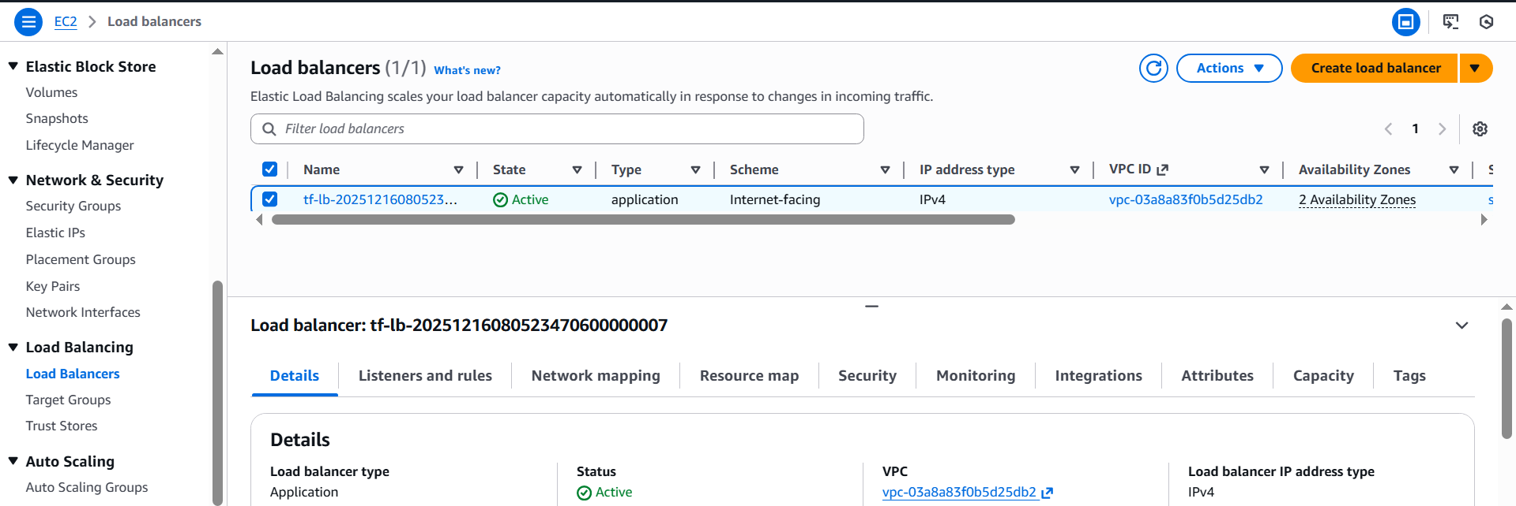
Frontend running:
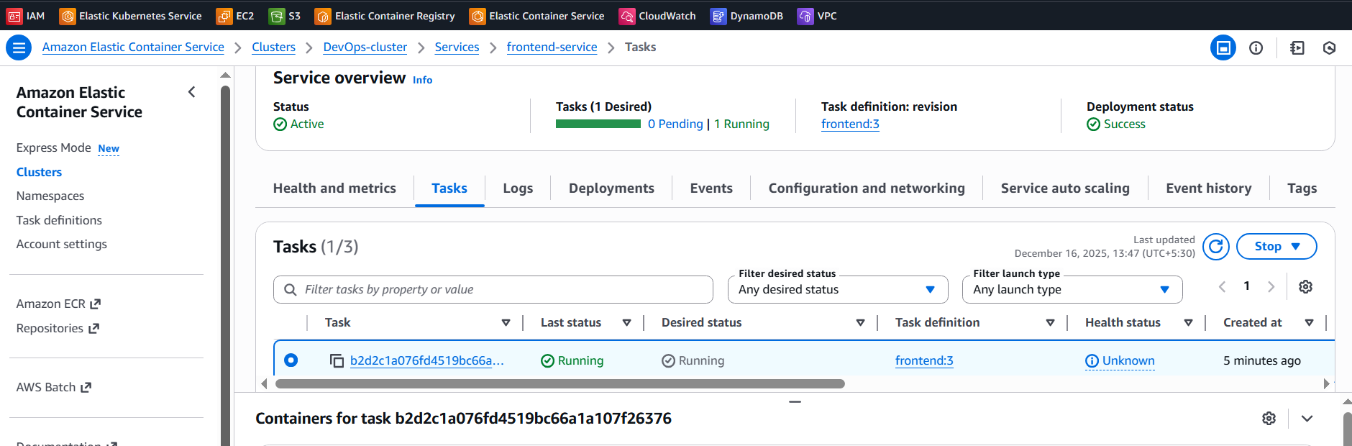

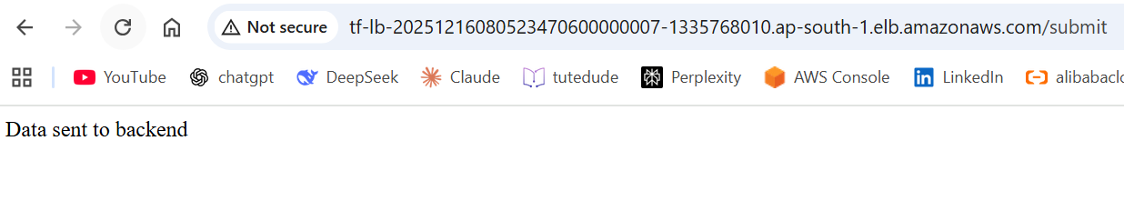
Backend running:
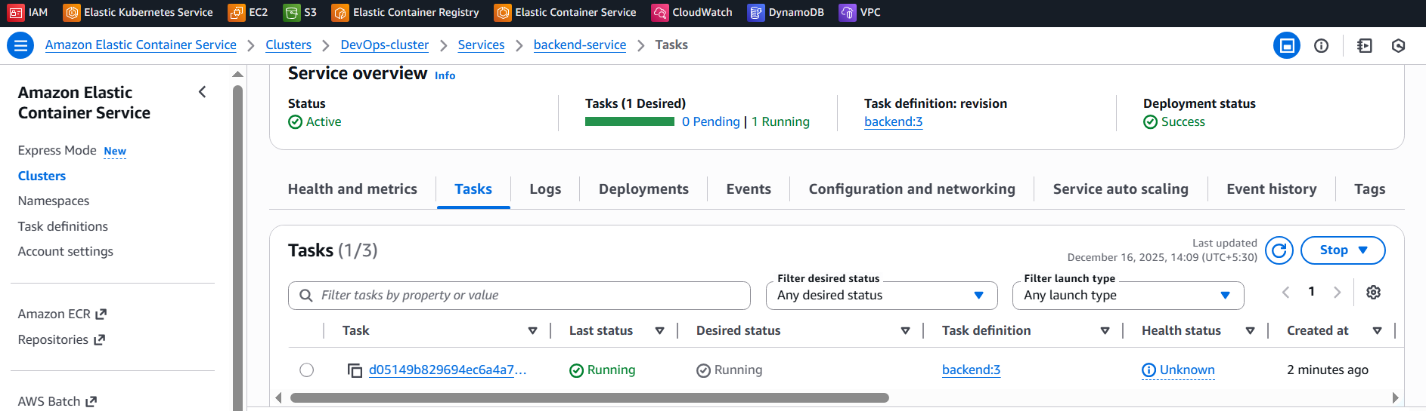

Thankyou

