BLUESTOCK
NIFTY 100 FINANCIAL INTELLIGENCE PLATFORM
• BlueStock Fintech •

Project Name : FinSight N100 | Nifty 100 Financial Intelligence Platform
Prepared by: Hashmil Muhammed | Data Analyst
Email : hashmilmuhammedparammal@gmail.com
Date: 27 July 2026
1. Executive Summary
The Indian equity market, particularly the NSE Nifty 100 index, represents the core of India's corporate growth, characterized by significant market capitalization and high trading volumes. However, the fragmentation of financial data across various statements, annual reports, and platforms makes it challenging for retail investors and equity research analysts to derive actionable, risk-adjusted insights.
This project successfully addresses this gap by developing an end-to-end data engineering and analytics pipeline titled FinSight N100. Over the course of the project, 10 years of historical financial data—encompassing over 11,000 data points across 92 Nifty 100 constituent companies—were ingested, cleaned, and structured into a robust SQL data warehouse. Advanced quantitative metrics—including 50+ Financial Ratios, Banking sector-specific Return on Capital Employed (ROCE) adjustments, and Turnaround Compound Annual Growth Rates (CAGR)—were calculated to assess company performance and valuation. Finally, an interactive 9-page Streamlit dashboard, automated ReportLab PDF tearsheets, and a high-performance FastAPI server were deployed to translate these complex metrics into intuitive business intelligence.

2. Data Description & ETL Architecture
2.1 Data Sourcing
The project utilized a robust data ingestion strategy encompassing 12 distinct datasets:
- Core Financial Data: Provided as 7 raw datasets detailing historical Income Statements (Profit & Loss), Balance Sheets, Cash Flow statements, and qualitative business factors.
- Supplementary Data: 5 supporting datasets covering market capitalization trends, stock price movements, and sector peer categorization mapping.

2.2 ETL Pipeline & Database Design
- Extraction & Transformation: Utilizing the pandas library, historical data anomalies were handled. Ticker symbols were normalized (trimmed and converted to uppercase), and 16 strict Data Quality (DQ) verification rules were applied to ensure mathematical integrity.
- Loading & Warehousing: An analytical Star Schema was designed using SQLite. The architecture features heavily indexed tables linking primary financial records to pre-computed analytical views, optimizing the database for rapid Online Analytical Processing (OLAP) queries handling 10 concurrent requests in under 0.5 seconds.

3. Detailed EDA Findings & Visualizations
Exploratory Data Analysis revealed several critical macroeconomic and fundamental corporate trends within the Nifty 100 universe:
- Capital Allocation Trends: Analysis of Cash Flow statements identified distinct capital allocation phases. Companies were successfully grouped into 8 proprietary categories, such as 'Mature/Cash Cow' and 'Aggressive Growth', based on their CFO, CFI, and CFF sign patterns.
- Sector Dominance and Margins: A clear divergence in Operating Profit Margins (OPM) was observed between asset-heavy industries (e.g., Infrastructure, Energy) and asset-light technology/service sectors.

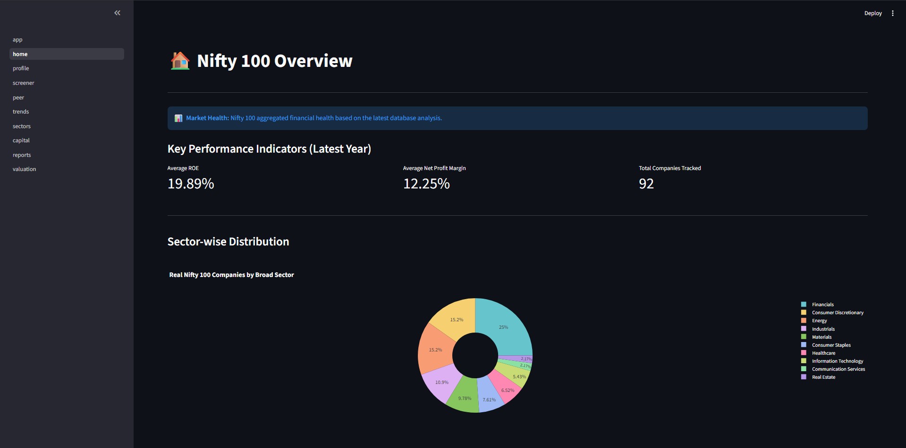
Figure 3.1: Industry Market Cap Growth and Sector Dominance
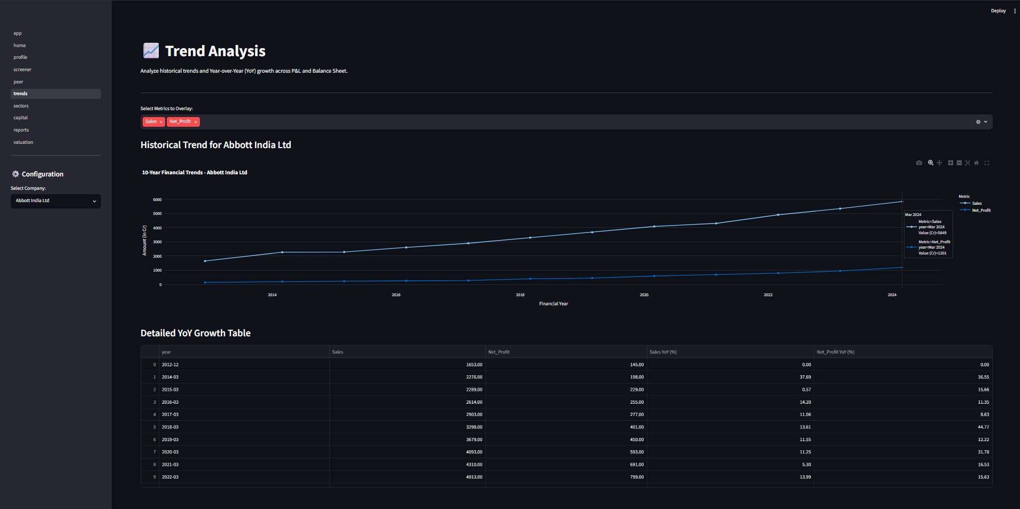
Figure 3.2: 10-Year Revenue and Profitability Trend Analysis
- Financial Distress Indicators: Through the implementation of a custom Distress Rule Engine, several companies actively deleveraging or facing operational crises were flagged dynamically based on rising Debt-to-Equity and falling Interest Coverage Ratios.
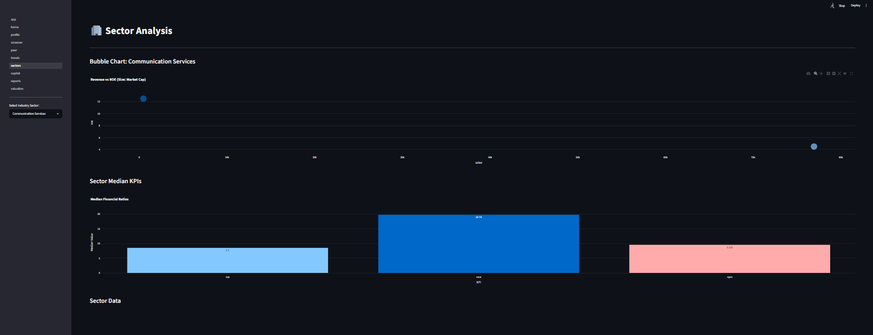
Figure 3.3: Sector Analysis - Margin vs. Market Capitalization Distribution
4. Company Performance & Advanced Analytics
Moving beyond simple point-to-point returns, the project evaluated funds on institutional-grade risk-adjusted metrics.
4.1 Quantitative Performance Metrics
- CAGR & Turnaround Resiliency: Calculated 3Y, 5Y, and 10Y Compound Annual Growth Rates for Revenue, PAT, and EPS. A unique fallback logic was engineered to return "TURNAROUND" instead of mathematical errors when base years were negative.
- Sector-Relative Benchmarking: Created a composite ranking engine weighting Profitability (50%), Growth (30%), and Valuation (20%) to rank companies within their specific sectors.
- Banking Carve-outs: Applied specialized adjustments for the Financial sector, deliberately skipping standard D/E filters and modifying ROCE logic, as debt represents raw inventory for banks rather than traditional leverage.

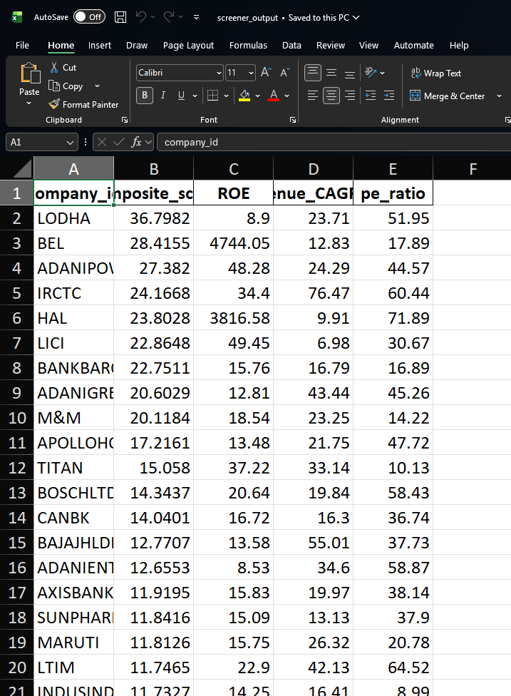
Figure 4.1: Custom Fund Scorecard and Composite Ranking Matrix
4.2 Advanced Risk Analytics (Machine Learning & NLP)
- K-Means Clustering: Applied an unsupervised K-Means algorithm ($k=5$) validated by the Elbow Method to cluster Nifty 100 companies based on metrics like ROE, D/E, and FCF CAGR, automatically grouping them into profiles like "High-Quality Growth" or "Value Cyclicals".
- NLP Sentiment Scoring & Business Tagging: Integrated NLTK VADER sentiment analysis to evaluate qualitative text. A rule-based engine dynamically generated over 130 qualitative Pros and Cons for companies based on 24 KPI thresholds.
- Peer Group Radar Charts: Generated 56 dynamic Plotly radar charts mapping a company's percentile rank across key metrics against its sector median.

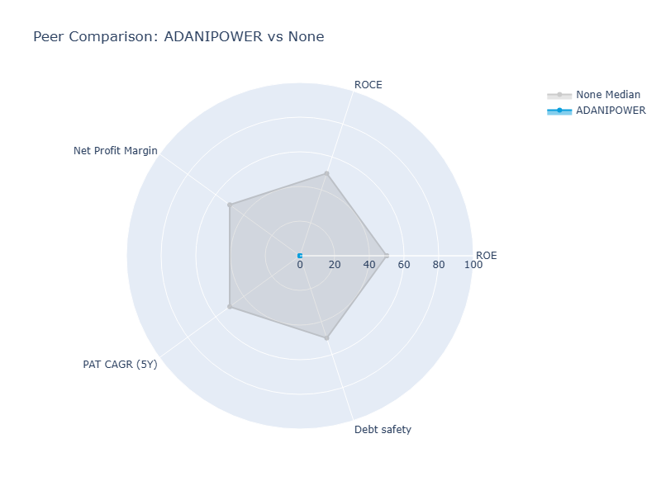
Figure 4.2: Portfolio Structural Risk and Sector Concentration (Radar Chart)
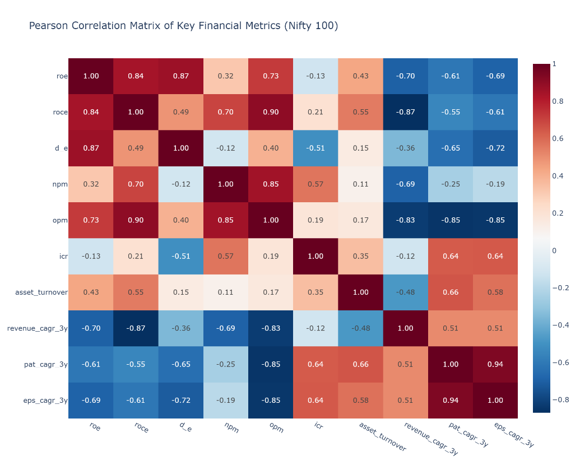
Figure 4.3: Return Inter-dependency & Cross-Correlation Heatmap
5. Dashboard Layout & User Guide
To democratize these insights, a comprehensive interactive dashboard was deployed.
5.1 Dashboard Navigation
- Home / Overview (Page 1): Tracks macro KPIs, market health, and sector-wise distribution.
- Company Profile (Page 2): Features 6-metric KPI tiles, dynamic charts, and executive summaries for deep dives into specific tickers.
- Financial Screener (Page 3): Offers interactive sliders to filter companies based on custom financial parameters like ROE and Debt/Equity.
- Peer Comparison (Page 4): Visualizes sector benchmarking using interactive Plotly Radar Charts.
- Trend Analysis & Sectors (Pages 5-6): Tracks long-term historic trajectories with sparklines and compares aggregate sector metrics using interactive bubble charts.
- Capital Allocation & Valuation (Pages 7 & 9): Classifies business phases via Cash Flow patterns and evaluates market pricing multiples (P/E, EV/EBITDA) with automated 'Discount' flags.
- Automated Reports (Page 8): Allows users to download 1-page executive PDF tearsheets generated via ReportLab.
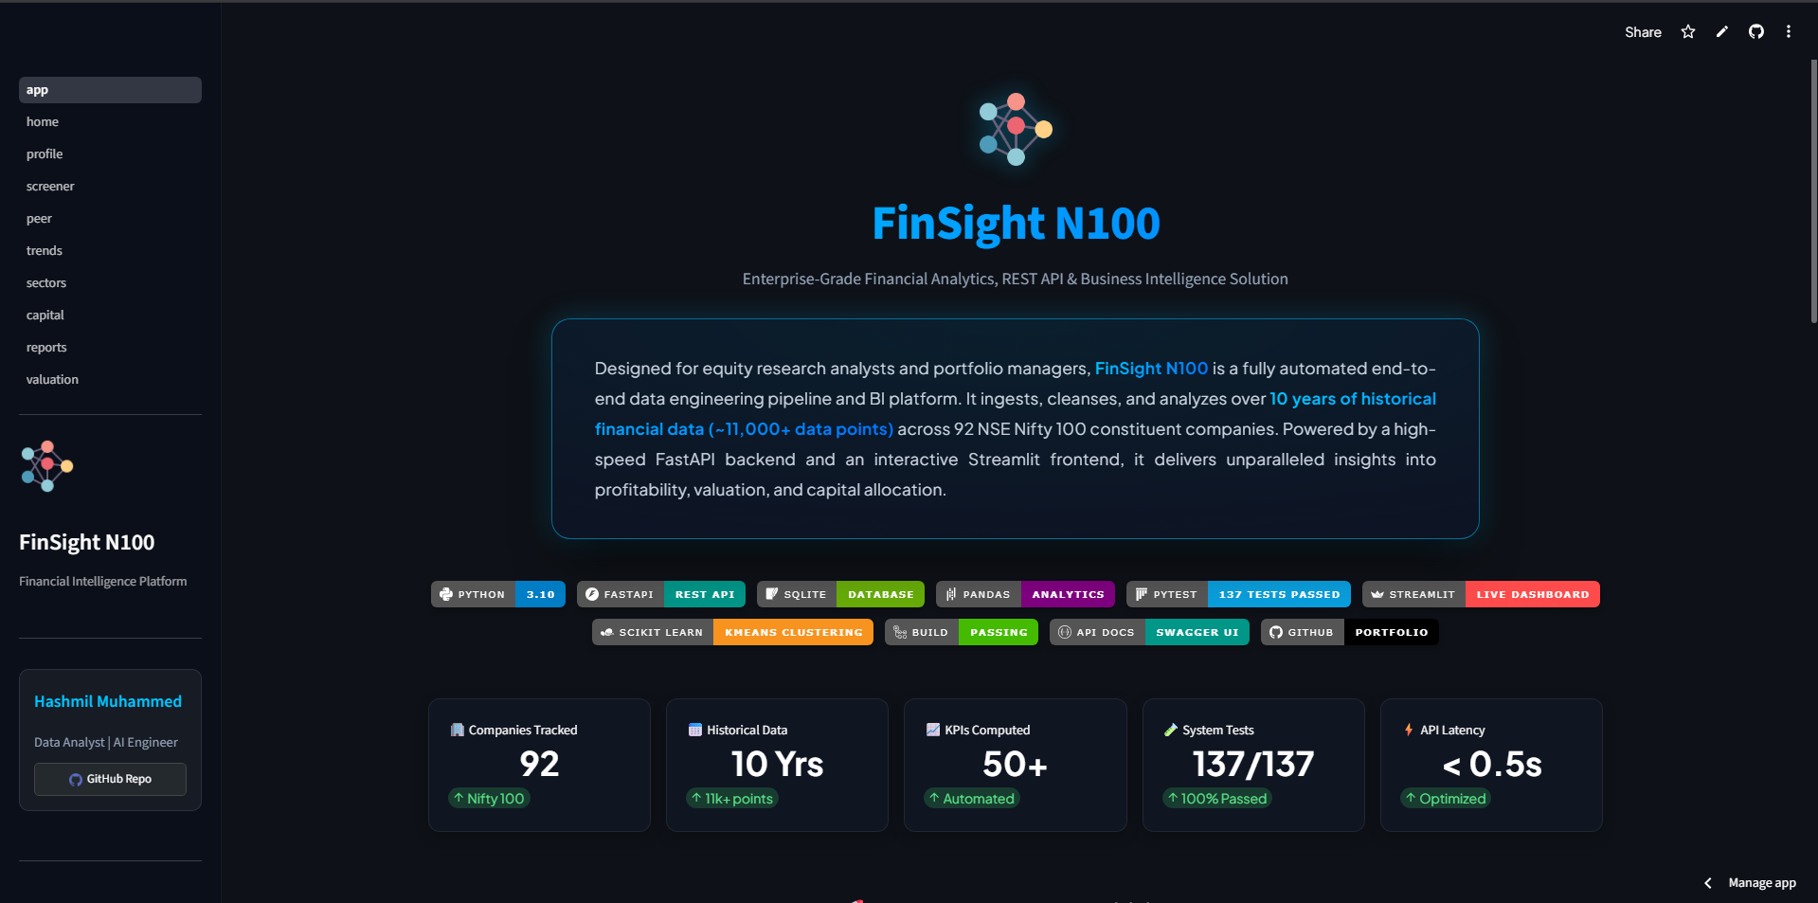
Figure 5.1: Streamlit Interface - Executive Industry KPI Dashboard
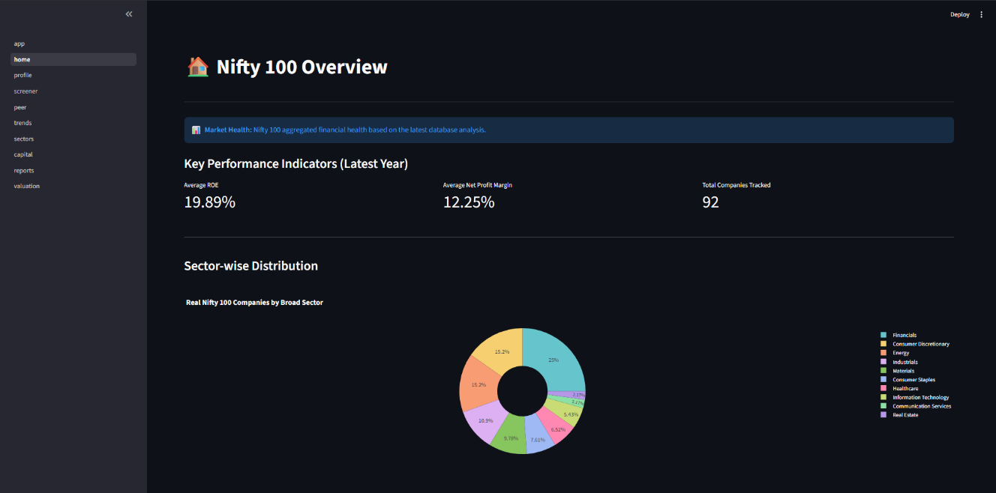
Figure 5.2: Streamlit Interface - Home / Nifty 100 Overview Dashboard
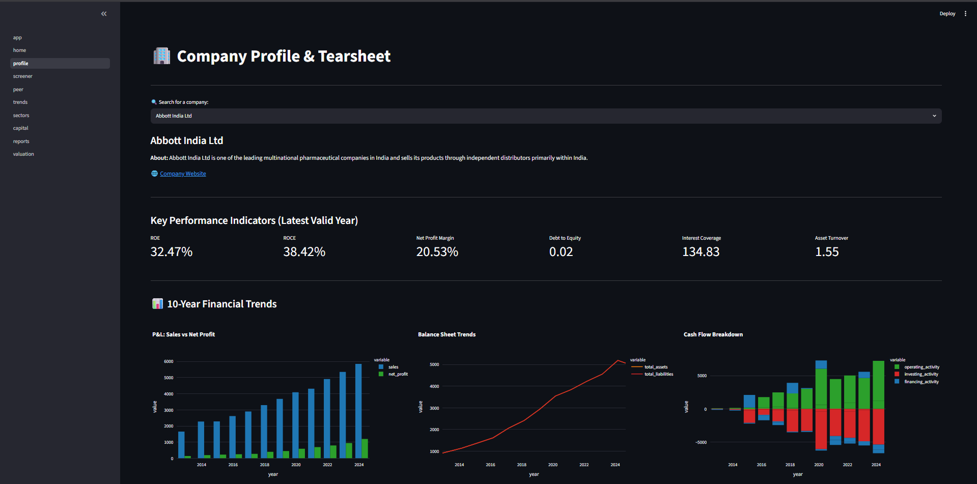

Figure 5.3: Streamlit Interface - Company Profile & Tearsheet
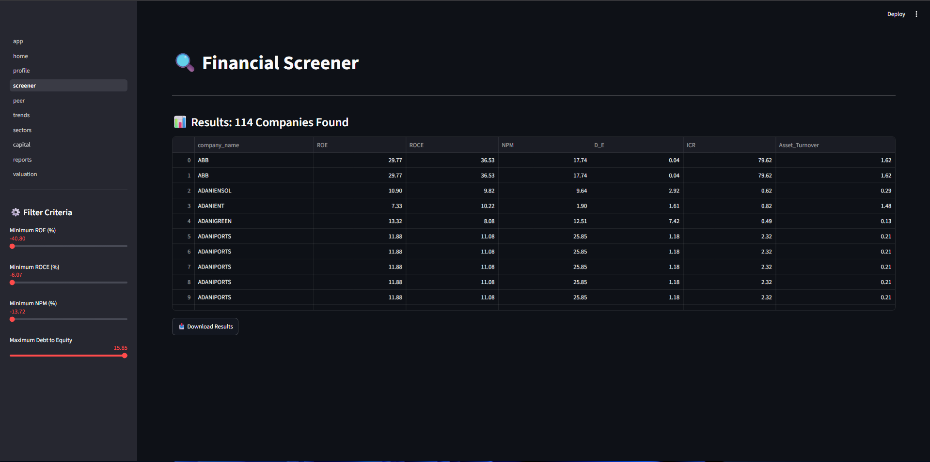
Figure 5.4: Streamlit Interface - Financial Screener

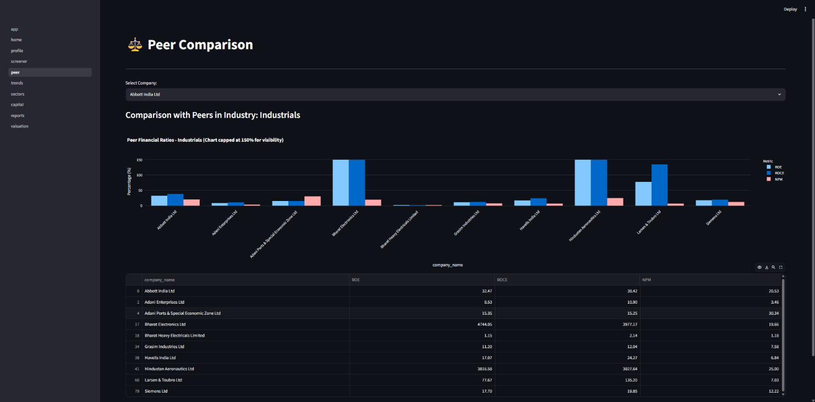
Figure 5.5: Streamlit Interface - Peer Comparison & Radar Charts
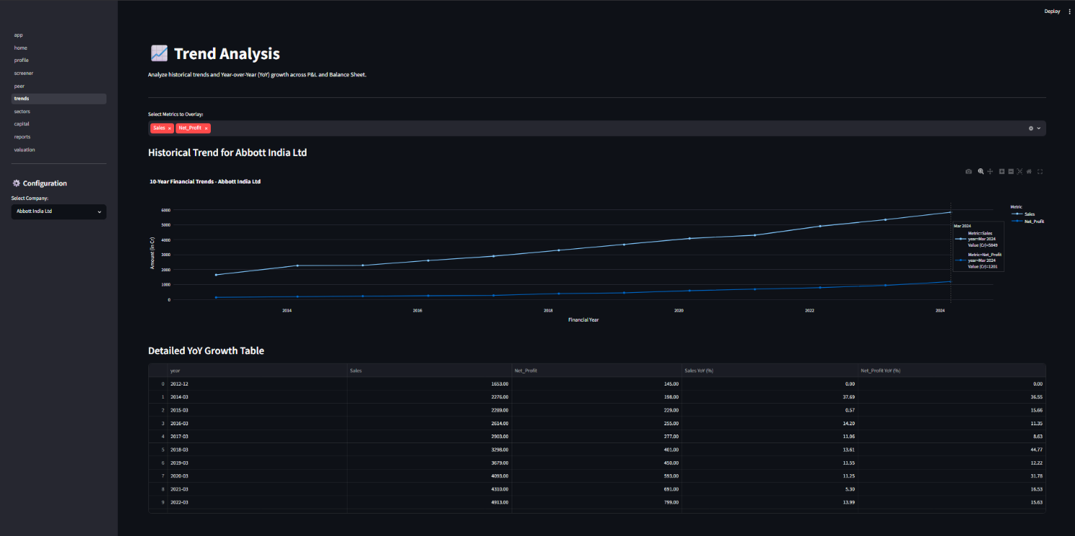
Figure 5.6: Streamlit Interface - 10-Year Trend Analysis

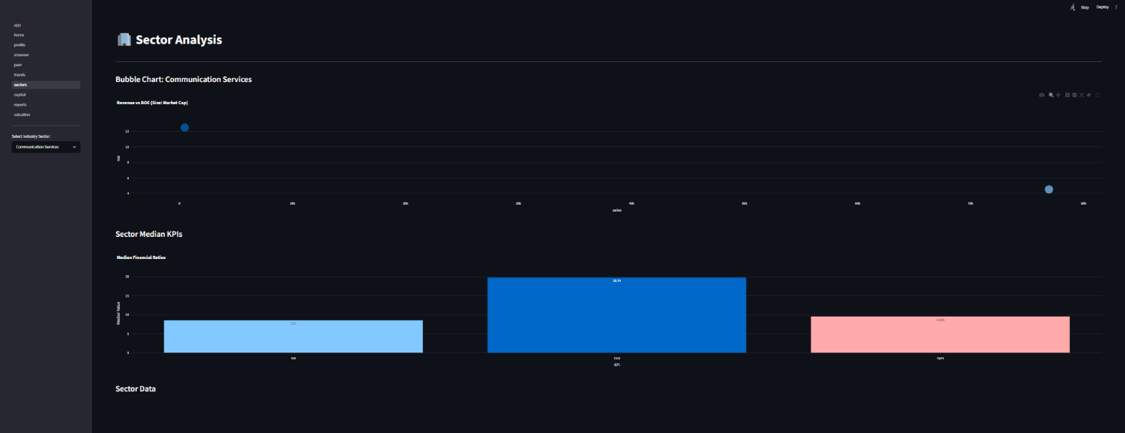
Figure 5.7: Streamlit Interface - Sector Analysis & Median KPIs
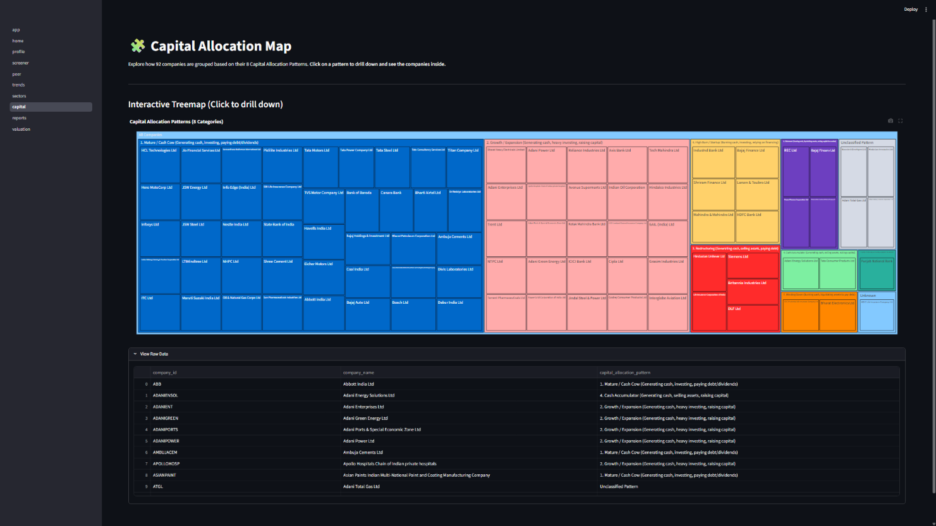
Figure 5.8: Streamlit Interface - Capital Allocation Treemap

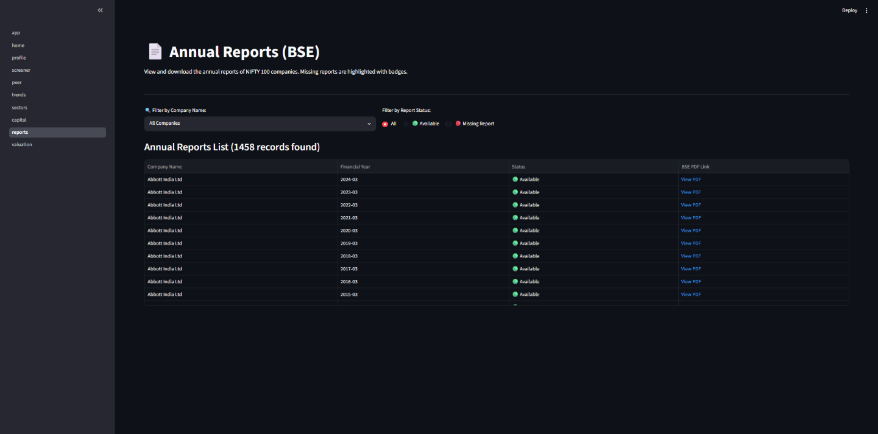
Figure 5.9: Streamlit Interface - Annual Reports (BSE)
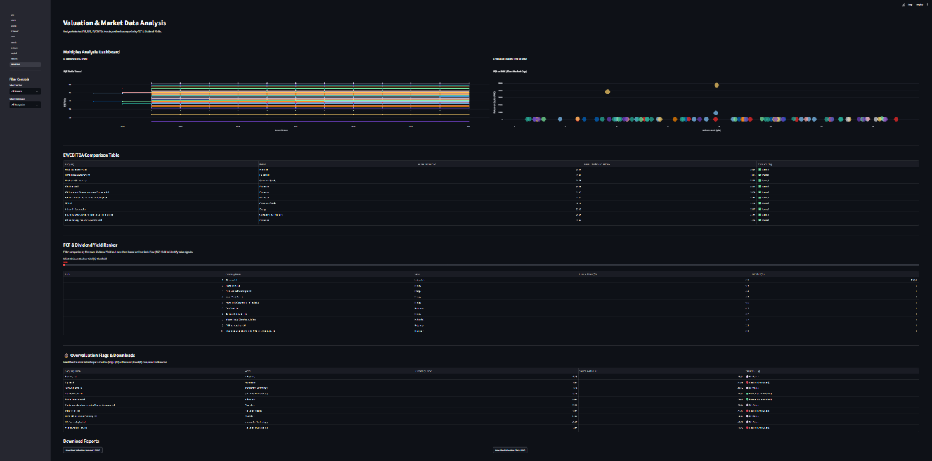
Figure 5.10: Streamlit Interface - Valuation & Market Data Analysis
6. Strategic Recommendations for Bluestock Fintech
Based on the data models and analytics, the following strategies are recommended for business growth:
- Deploy Robo-Advisory Services: Utilize the developed Screener presets and Composite Ranking Engine to offer personalized, automated stock baskets based on an investor’s exact risk appetite (Low/Moderate/High).
- Automated Institutional Reporting: Leverage the ReportLab PDF engine to automatically dispatch 1-page company tearsheets and sector intelligence reports to premium clients, saving thousands of hours in manual equity research.
- Dynamic Risk Alerts: Offer a premium feature that alerts investors when a company's debt metrics or CFO Quality Score crosses distress thresholds, prompting immediate portfolio rebalancing.
7. Project Limitations & Future Scope
- Limitations: The current platform relies on historical trailing 10-year data, which inherently lags behind real-time market sentiment. Additionally, the text analytics module utilizes NLTK VADER, which, while effective, lacks deep contextual understanding of complex financial jargon.
- Future Scope:
  - Machine Learning Integration: Implement advanced transformer models (e.g., FinBERT) for deeper analysis of annual reports, earnings calls, and financial news.
  - Real-Time Data Pipelines: Integrate live stock price streaming using WebSockets to provide real-time valuation metrics and continuously updated dashboards.
  - Docker Containerization: Package the FastAPI backend and Streamlit dashboard into lightweight containers to enable highly scalable cloud deployments.

