## Airplanes : Introduction

The term airplane, which is often shortened to plane, usually refers to any type of power-driven aircraft that has fixed wings and is heavier than air. An airplane moves through the air with the help of its engine and wings. The wings are shaped in a particular way so that air flows over them and gives them lift. By contrast, balloons and airships are lifted by gases that are lighter than air. Helicopters  are lifted by spinning blades.

Types of Airplanes

Airplanes can be grouped into many different categories. One way of classifying them is by the number of wings they have. Many early airplanes were biplanes, meaning that they had two pairs of wings, one above the other. Triplanes were also built in the early days of aviation. Today most airplanes are monoplanes, with one pair of wings.

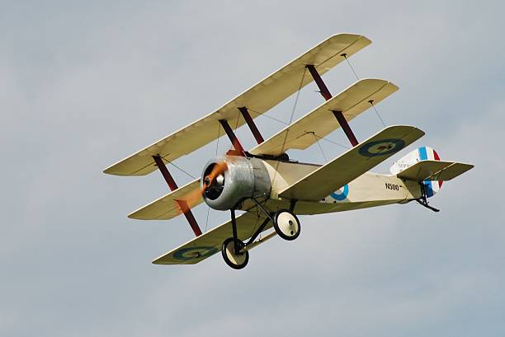 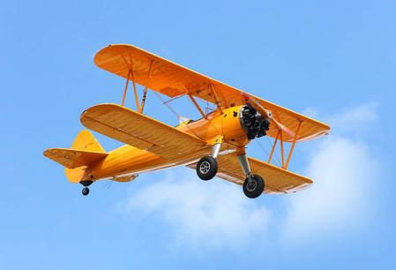

Most airplanes take off and land from dry land, but some operate on water. Seaplanes have special landing gear that supports them in the water.

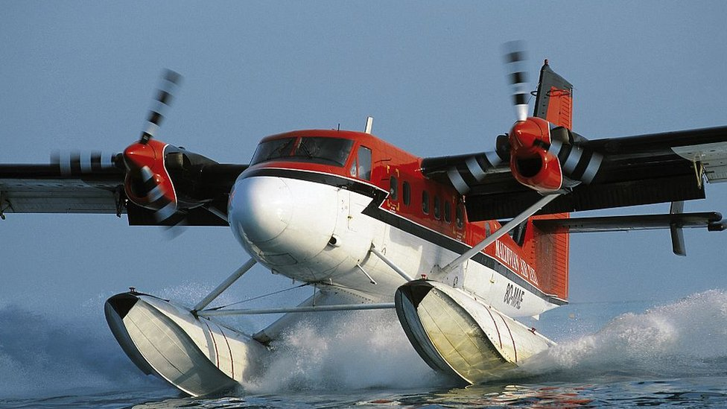

Airplanes can also be grouped by their purpose. Airplanes used for military purposes by the armed forces include fighters, bombers, spy planes, troop transports, and tankers that refuel other military planes while in flight. The familiar airliners that carry large numbers of people from city to city are called civil, or commercial, aircraft.