## Basic parts on an Airplane and its Functions

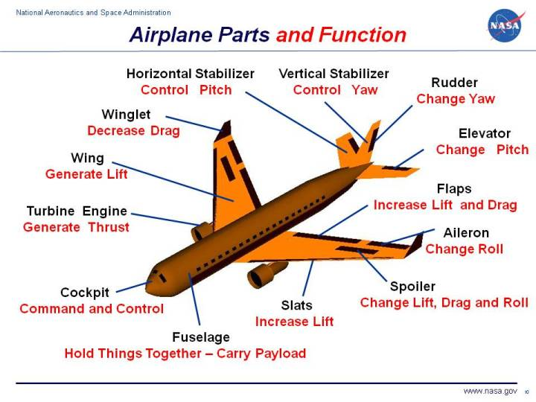

****The Engine****

The engines can also be referred to as the powerplant of the plane. This is the part of the plane that works to generate thrust to lift the plane into the sky. The engine also creates hydraulic and electric power for which the plane uses to operate.

****The Wing****

The wings of the plane are their most identifiable parts. These wings work just like those of a bird to lift the plane into the air and control the airflow as the plane flies. The tilt of the wings is a crucial part of the overall structure of the airplane as they allow the pilot to decrease or increase the descent rate of the plane when flying.

****Aileron****

The ailerons are the hinged surfaces of wings that aids in controlling lateral balance. These work to move the aircraft left or right by allowing the plane to roll in the desired direction. The ailerons work asymmetrically when flying. This means when the right aileron goes up, the left one goes down. When the right goes down, the left aileron goes up.

****Slats****

Slats are identified as the front most portion of the wing. They are adjustable so the pilot can alter the slat to the desired level during lift off of the entire plane

****Horizontal Stabilizer****

At the tail of the plane, there is a horizontal wing-like structure that protrudes out. These are the horizontal stabilizers and help to keep the aircraft’s equilibrium when flying up and down.

****Flap****

Located at the back of the wing, the flaps are included to help increase the lift of the plane into the air. These flaps are fitted to trail the edge of the wing sections. These flaps extend out from the wing and increase the camber of the wings airfoil so that it can lift at low speeds, which is vital to landing successfully.

****Propeller****

Most aircraft have at least one propeller to thrust the plane forward at a specific pitch, depending on the angle of the propeller blades. In smaller crafts, you’ll see the large propeller blades on the front. For commercial crafts, these tend to be integrated into the wings of the plane.

****Spoilers****

Airplane spoilers are located on the top surface of the wing and can be extended upward to reduce airflow. The whole concept of the spoiler is to intentionally reduce the lift of the plane so that it can land properly.

****Elevator****

The elevators work to control the pitch motion of the craft. These are hinged surfaces that are fitted to the rear of the horizontal stabilizers. These work as a symmetrical pair. When the elevators go up, the aircraft goes up. When the elevators go down, the aircraft goes down.

****Fuselage****

This is the centermost piece of the aircraft that is responsible for the structural integrity of the cargo and passengers. Most of the modern day aircraft can hold up to 800 passengers and about 250,000 pounds in the cargo.

****Rudder****

The rudder is responsible for controlling the yaw motion of the aircraft. This is the side to side movement of the nose of the craft. You’ll find the rudder as a hinged section at the rear of the vertical stabilizer of the plane.

Cockpit

A cockpit or flight deck is the area, usually near the front of an aircraft or spacecraft, from which a pilot controls the aircraft. The cockpit of an aircraft contains flight instruments on an instrument panel, and the controls that enable the pilot to fly the aircraft.