## Airplanes : History

[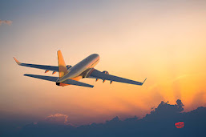](https://blogger.googleusercontent.com/img/a/AVvXsEjW6os1lVN29Utr7sIS-KwDCGDk7ELQMRsABaDhKun5qZwIm3trgqIRrLu8enaXOGsMRHf--dTxZGusYr6TGJurv__MRQDDSY8jM_DL0oEsh8BhHRgMdrnwQj6nCCyKniByQ8iSeqfVZ1PzEBCRMRaC7R83QWG8QpC5B8fHW0O8YuJj02y4S2FyJa3nkg=s612)

The term airplane, which is often shortened to plane, usually refers to **any type of power-driven aircraft that has fixed wings and is heavier than air**. An airplane moves through the air with the help of its engine and wings. The wings are shaped in a particular way so that air flows over them and gives them lift. The airplane **helped people deliver crops and other items faster and more efficiently**. The airplane allowed people to travel larger distances in shorter amounts of time.

**Do you know when was plane invented ??**

### THE EARLIEST CONTRIBUTIONS TO FLIGHT

our timeline begins as far back as around 1000 B.C. when kites first appeared in China. Kites were a significant invention in the history of aviation because they are the oldest known device that is heavier than air and uses lift from the wind to fly. This same principle would be used later to keep airplanes in flight.

### HOT AIR AND GAS BALLOONS

[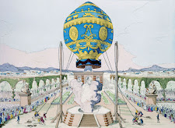](https://blogger.googleusercontent.com/img/a/AVvXsEjE70SATKG24YwxS0sS5ZwELwwNpmB3QI67JUma8ez6KDCz5uHJCL6c0OhoWq_Nm5Nt-a28hJzkj6EcjVuzuq5WG9vNkYNcGTTOw1EmMYCocYcWuDBU0r2XwEEte1BAGW1auPJ_wgLjr7VZPZ6u3THh7NUCwmyJ30smUiOf5QMvYUYYr_H4s4WbZZhIiA=s1600)

In the late 18th century, the hot air balloon arrived on the scene, marking a significant milestone in the history of flight. People were finally able to fly, starting with the first hot air balloon ride in Paris on November 21, 1783.  This balloon, built by the Montgolfier brothers, was made from paper and silk. It raised about 500 feet above the ground and traveled over five miles in 25 minutes.

### POWERED FLIGHT

A great moment in aviation history came in 1903 when Orville and Wilbur Wright — brothers from Dayton, Ohio — successfully executed the first powered and controlled flight for a heavier-than-air flying machine. This famous flight in Kitty Hawk, North Carolina lasted just 12 seconds , but the Wright Brothers quickly refined their machine to make it more functional.

[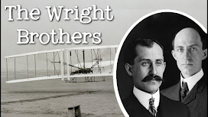](https://blogger.googleusercontent.com/img/a/AVvXsEhEJHDOF_8YBtiAQwnJG-Yop491WBRrbsvvKsB0UzEVdsQ9ft_Y5TnCZgaYyQT2MjW6LA1hV7lMCaqzlQzpryYFd0Y_5B2Zle-dHrss5aeLGJ-55kqjEVnjLKvzWLIzfkhgwAIfY2avbUsn6C5adYEnMzxs2TbVF-6uYbogzXL1HGuAT33sulsgGWte6w=s1280)

### JET-PROPELLED AIRPLANES

The 1930s saw another significant development in flight history: the invention of a jet engine. Frank Whittle is credited with this invention . A German physicist named Hans von Ohain was the first to develop a jet plane. The plane, called the Heinkel He 178, flew for the first time on August 27, 1939.

[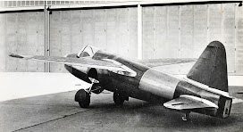](https://blogger.googleusercontent.com/img/a/AVvXsEhY7uf1HcHWI8EawFGTslNOA7xOQAXeeZWdylSTZ-NW9dyR3qr8MRKTg688KLZsoBsvpQ3rZbDdgTHNzzDnGKkA6CC5_ww8LRfBcUxDm0DDgR75K73KK6giR53RD2GiSwrGhINsVPioWXnIGX3dHJ7NEKZWjPJWl6pBRu3H2F7cmQtmoBLstSZpQrUTxg=s1800)

## FAQ'S

### 1. WHO STARTED AVIATION?

A long list of scientists, engineers, inventors and visionaries contributed to aviation’s development, so it’s difficult to credit one person with starting aviation. That said, Orville and Wilbur Wright tend to receive the most credit for ushering in a new era where people could finally fly as they had imagined doing for millennia.

### 2. WHEN WAS THE FIRST MANNED FLIGHT?

The first manned flight in a lighter-than-air device occured onOctober 15 , 1783, when Francois Pilatrê de Rozier stood in a hot air balloon.

### 3. WHAT YEAR DID THE FIRST PASSENGER PLANE FLY?

On 1 jan 1914, the Airboat Line took its inaugural flight — the first-ever scheduled passenger flight. The passenger was Abram C. Pheil, who won the ticket at auction. The flight went from St. Petersburg, Florida to Tampa, Florida.