**3. Calculator Operation**

**Step 1: Perform first 5 steps same as practical 1.**

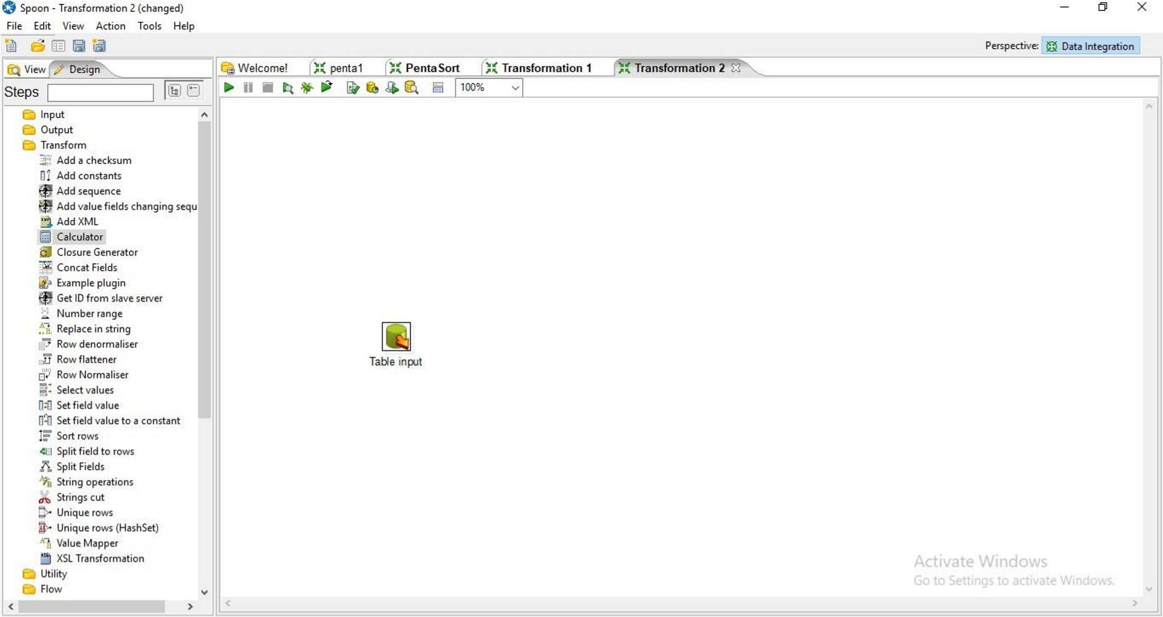

**Step 2: Drag and Drop Calculator from transformation on the panel.**

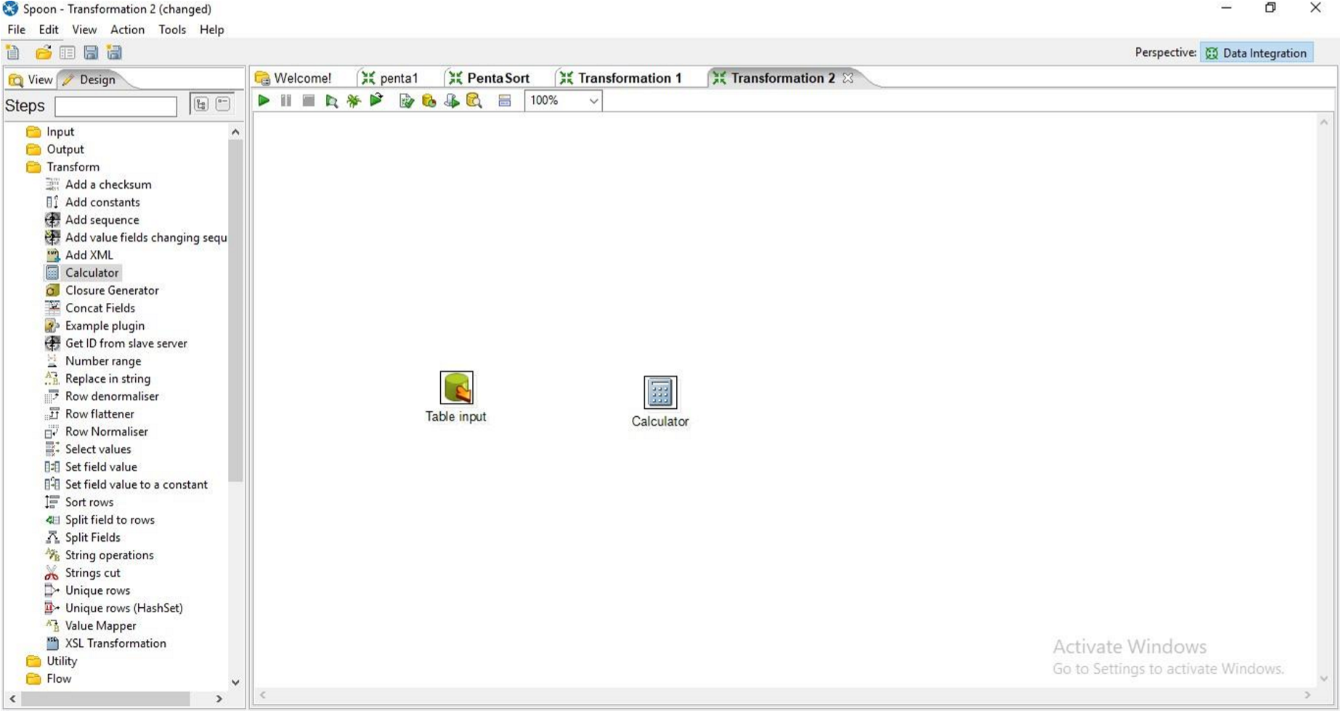

**Step 3: Hold the mouse pointer on the Table input and drag the output connector to the calculator control.**

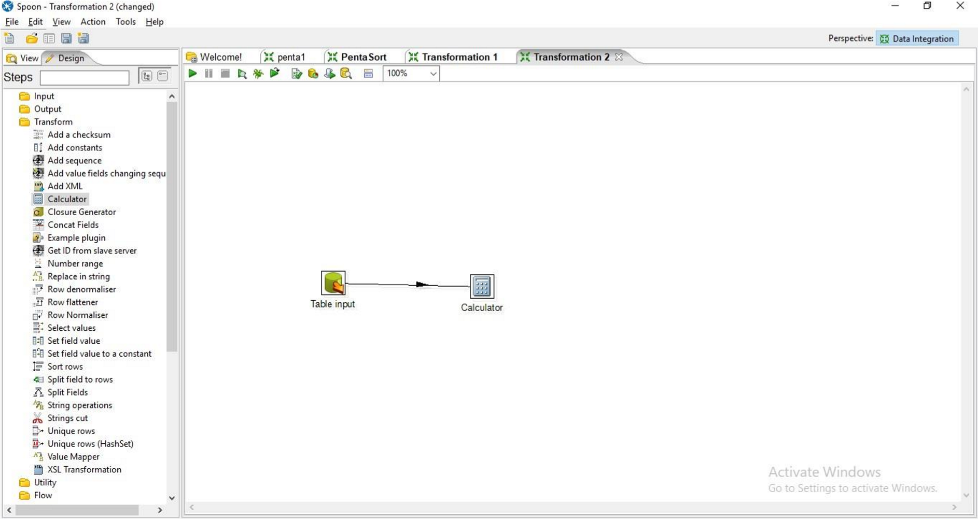

**Step 4: Double Click on the Calculator**

1. specify the new field name
2. select the calculation function.

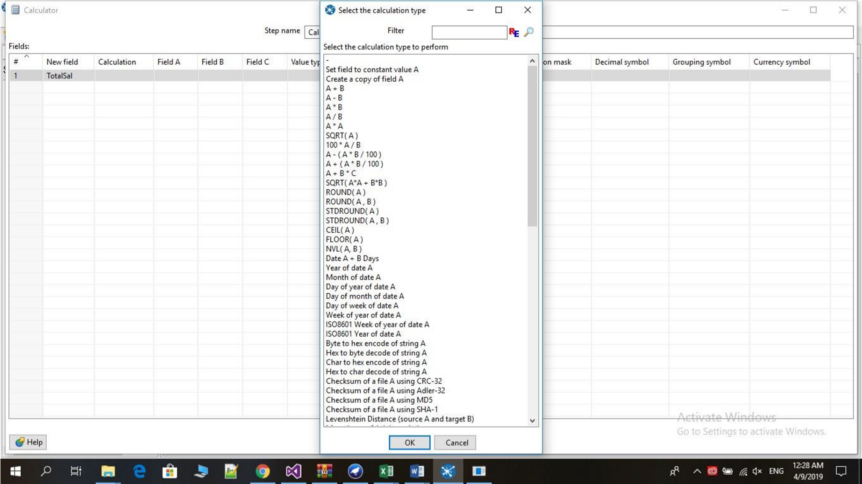

1. Enter Field A, Field B, Value type and Length and press ok.

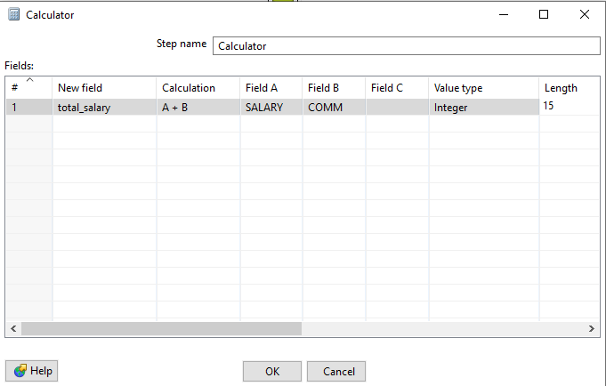

**Step 5: Click on Debug transformation and click on Quick Launch.**

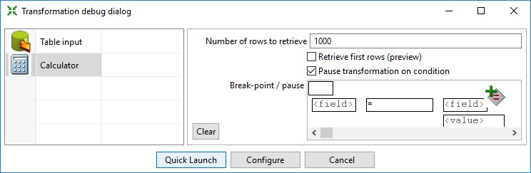

**Preview**

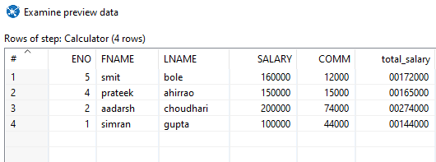

**Step 6: Now Perform the steps 6-10 same as practical 1.**

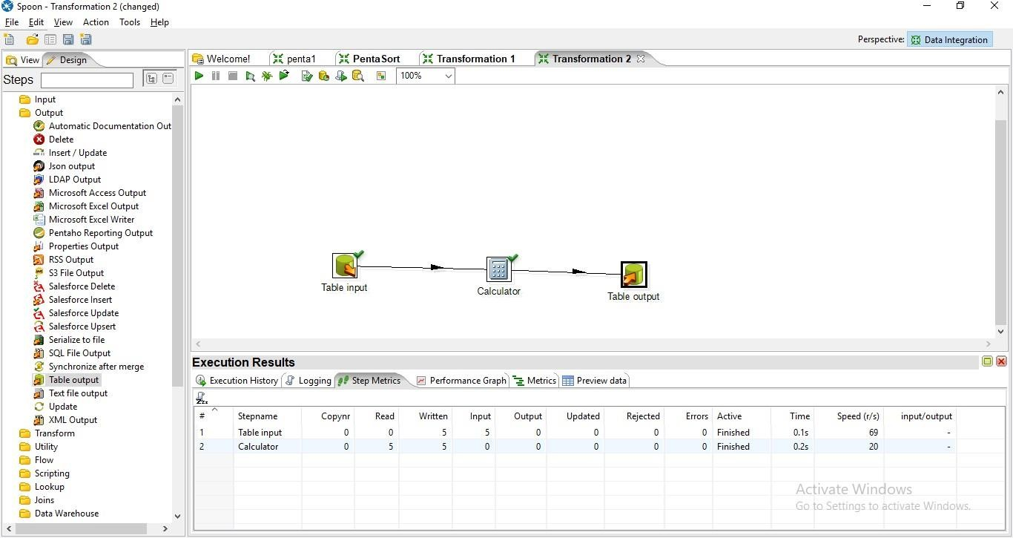

**Step 7: Click on Debug Transformation and then click on Quick Launch**

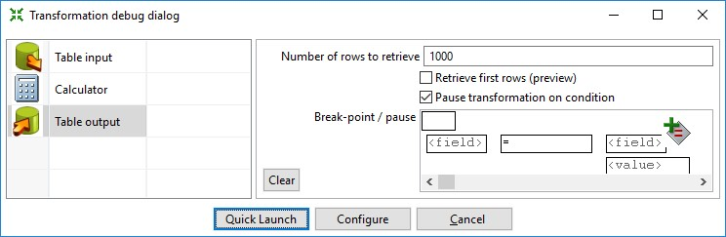

**Output:**

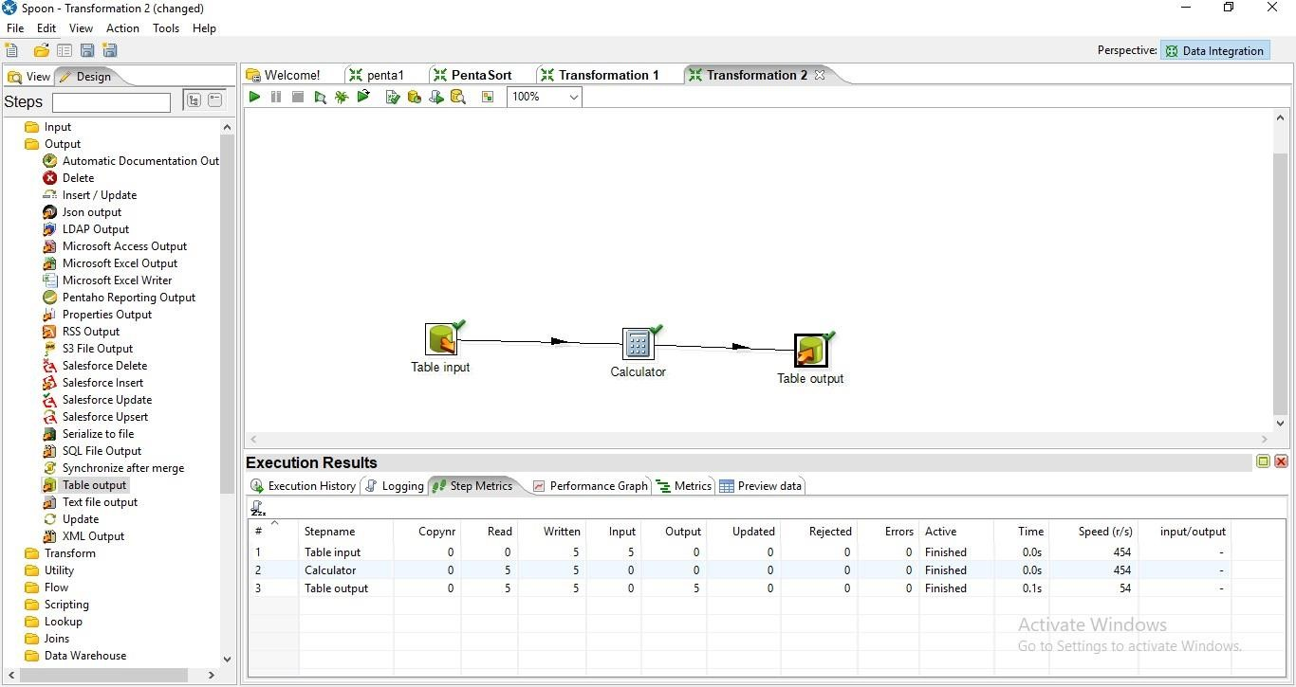

**SQL> select * from emppp13;**

