**Concatenation Operation**

**Step 1: Perform first 6 steps same as practical 1.**

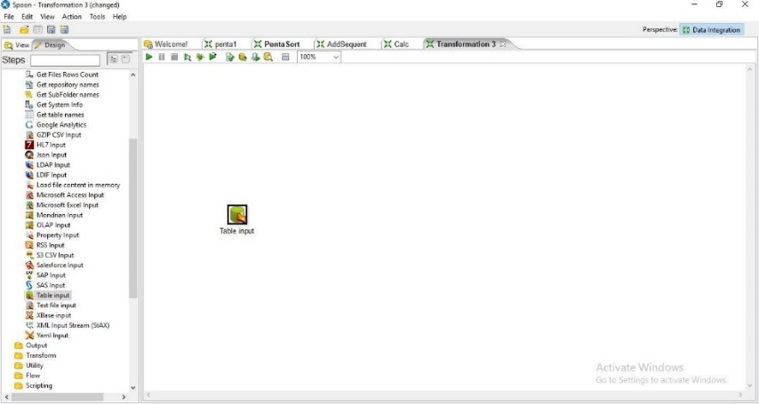

**Step 2: Drag and drop Concat Field**

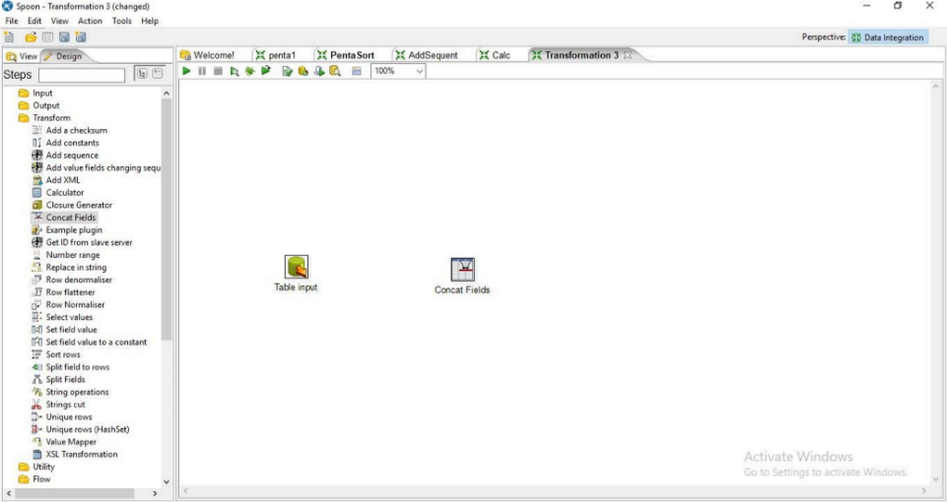

**Step 4: Hold mouse pointer on input table and drag the output connector to the Concat field.**

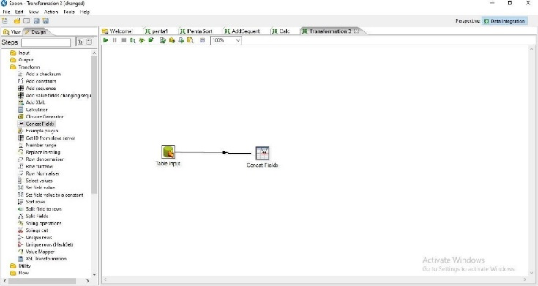

**Step 5: Double Click on Cncat Field**

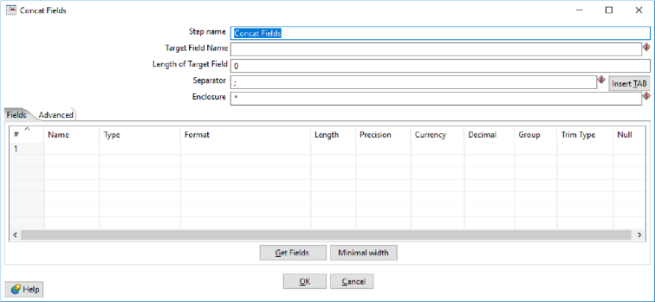

1. Enter the values for Target Field Name, Length of the Target Field and the Seperator and press on Get Fields

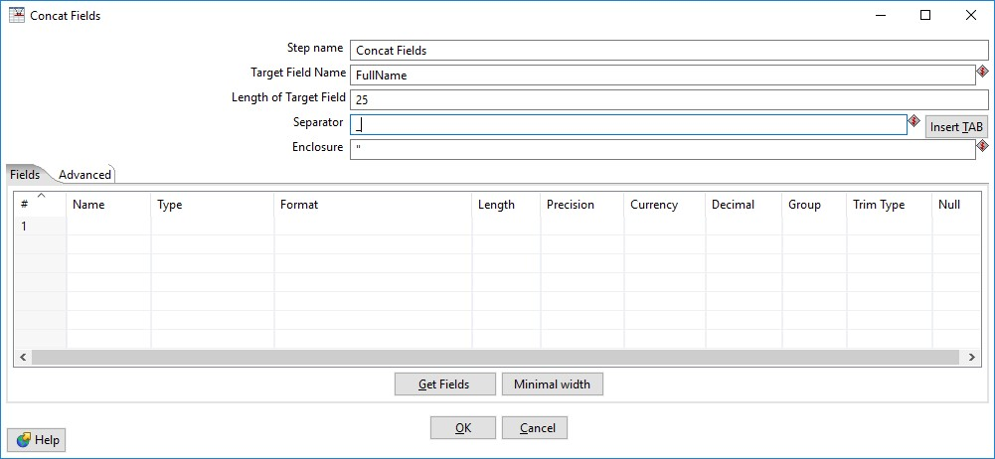

1. Select the columns that you want to concat

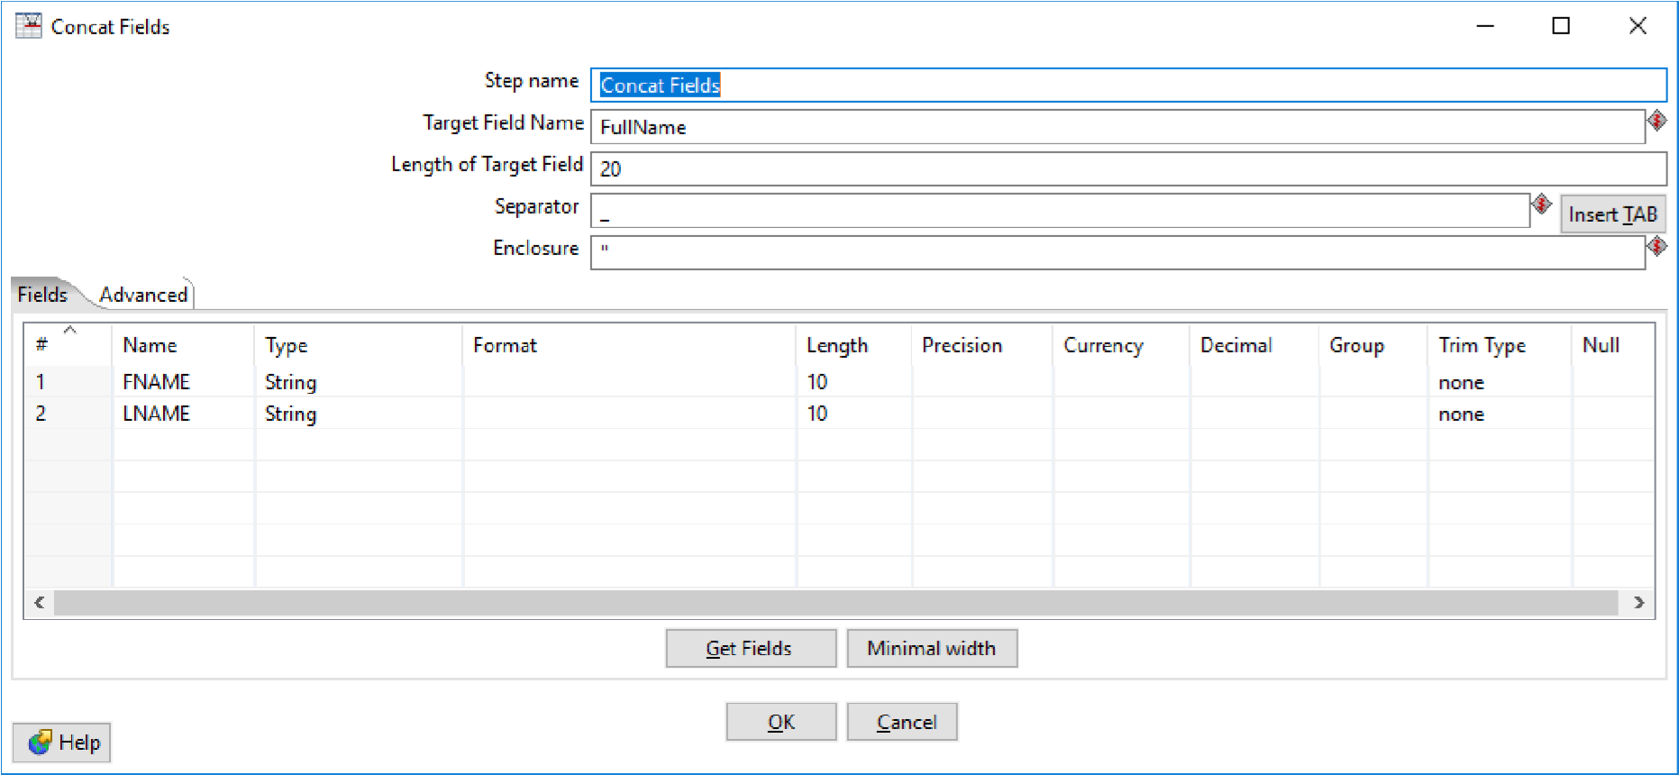

**Step 6: Click on Debug transformation and click on Quick Launch.**

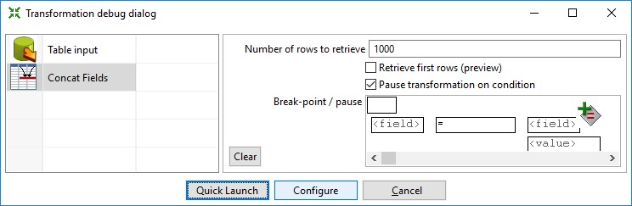

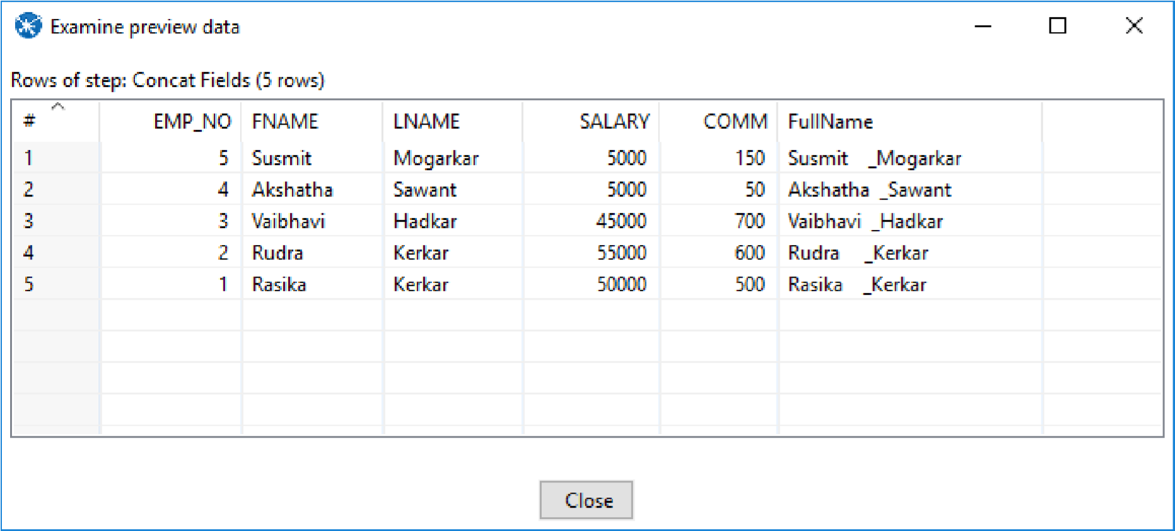

**Step 7:Now Perform the steps 6-10 same as practical 1.**

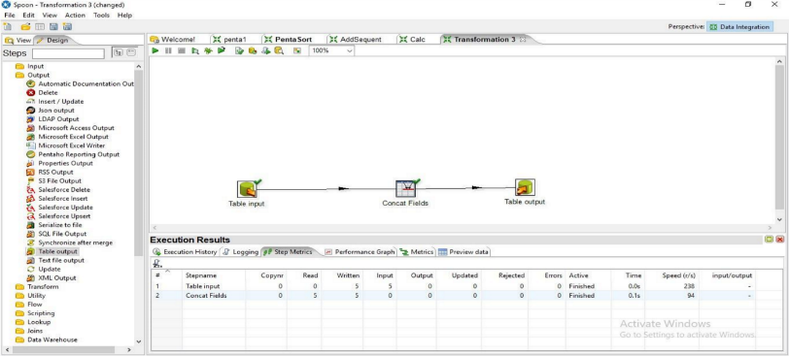

**Step 8: Click on debug Transformation and click on Quick Launch**

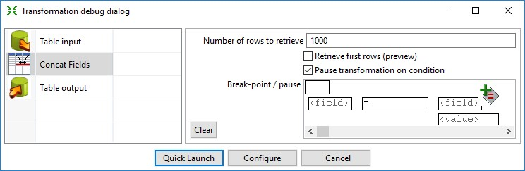

**Output:**

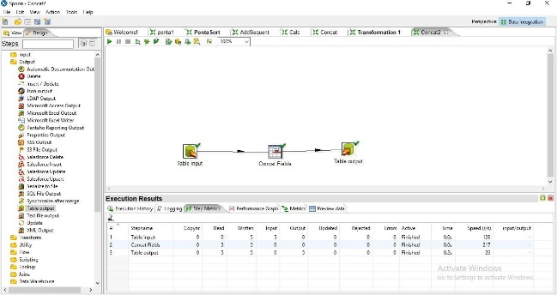

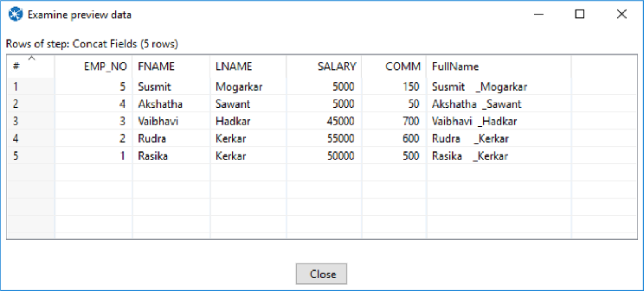

**SQL> select * from Concat;**

