**Copy contents of.CSV file to the target table**

Step1:Drag and drop CSV file input on a panel

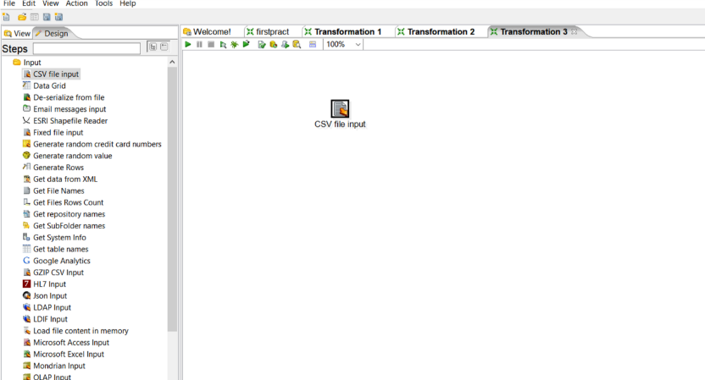

Step2: Double click on it and open respective CSV file, Lazy conversation and

Header row present? Options should be checked, click on Getfield and then ok.

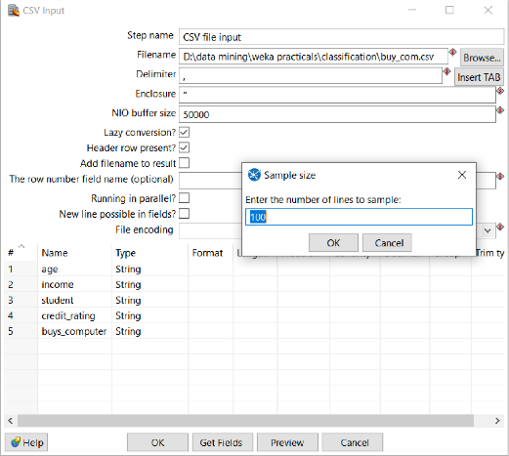

In this step we can change data type and format of CSV files after doing setting click on ok

Step3: Drag and drop Table output and connect it with CSV file.

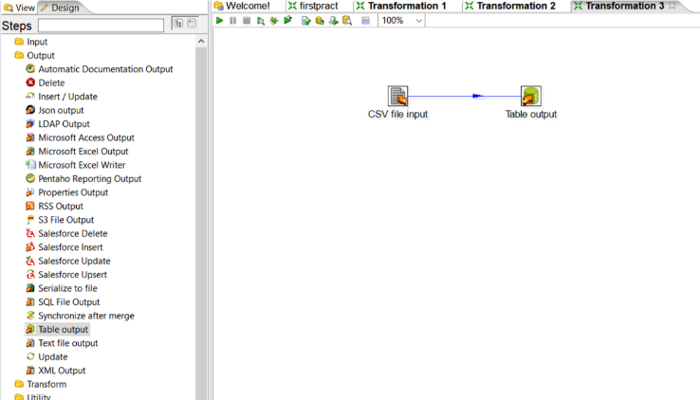

Step4: Double click on Table output and create new connection and follow same stapes like before and launch the transformation.

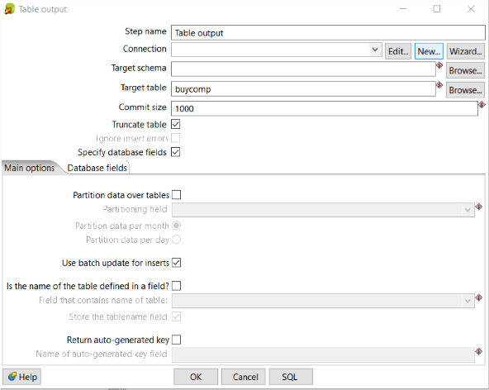

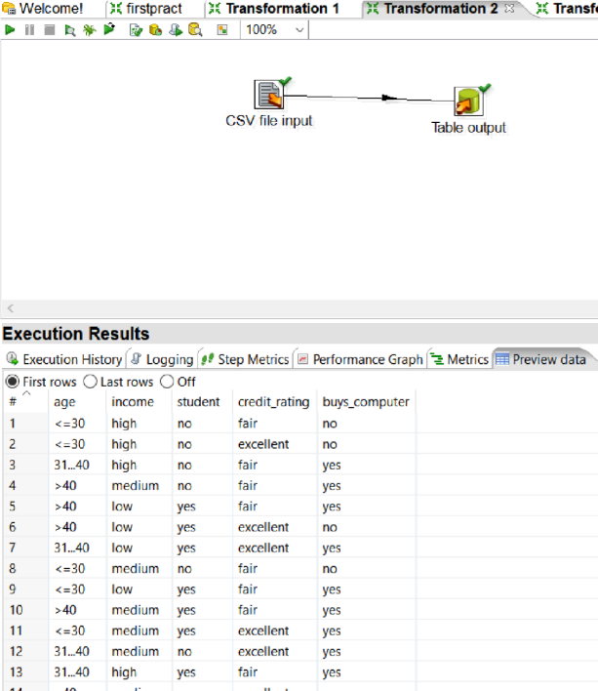

Step 5: Output table created in SQL

