**Implement different data validations on table.**

Step1: Drag and drop Data grid on panel.

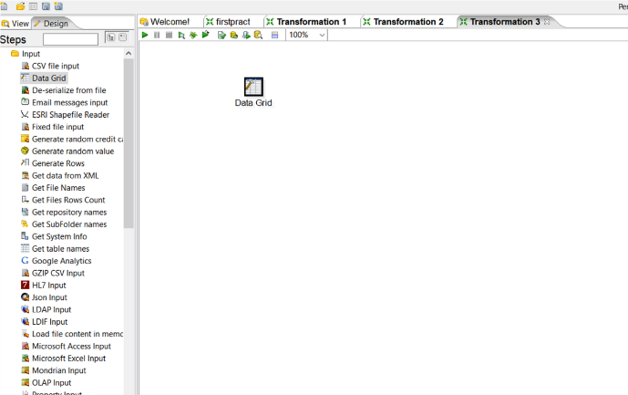

Step2: Double click on Data grid and create product table in Meta tab and enter records into it using Data tab.

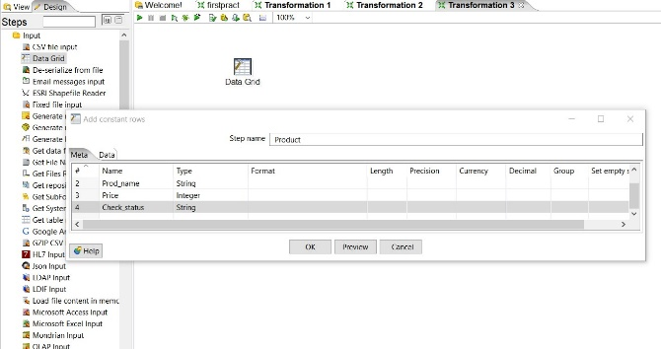

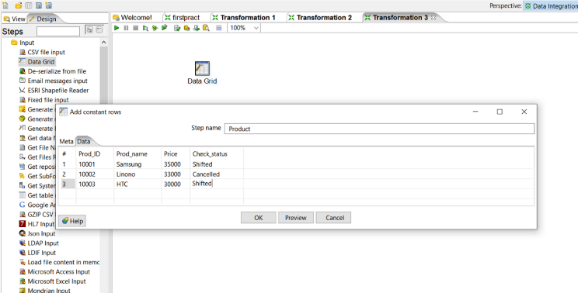

Step3: Go to Validation steps and select, Drag and Drop Data validator on panel and double click on it.

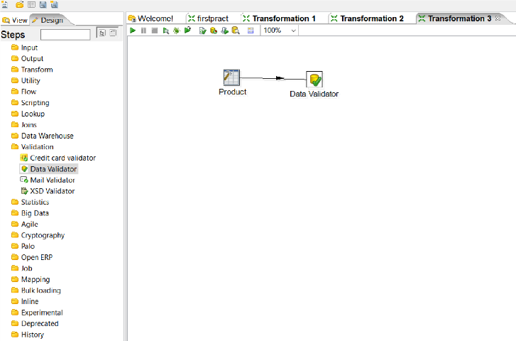

Step4: Click on new validation button and give new name to validation.

Once new validation is created it will appear on left panel, double click on it to set data validation

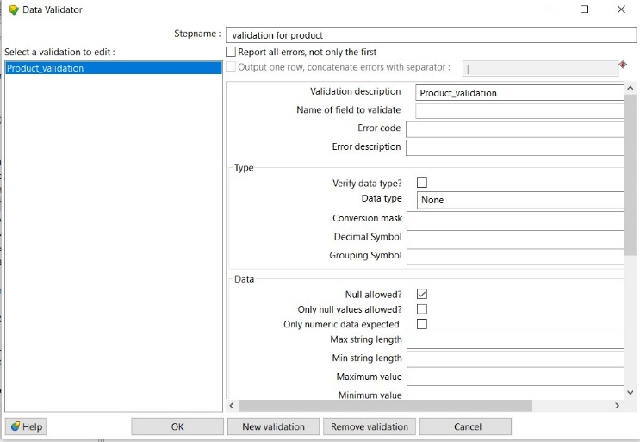

Step5: Set values for Name of field to validate=check status, and Data type =string

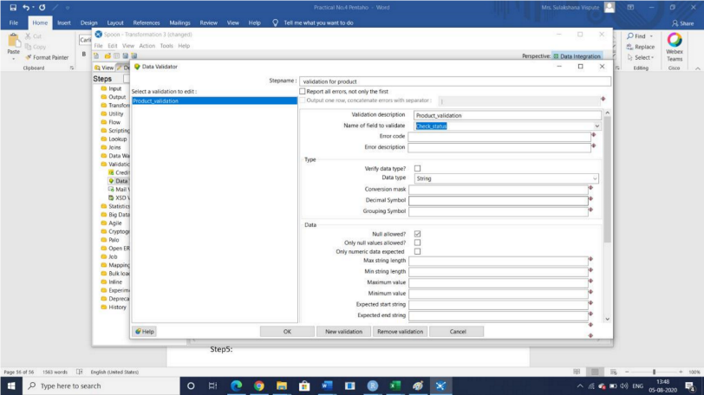

Step6: Click on add to set validation, set it65 to Shifted and press Enter and click on ok.

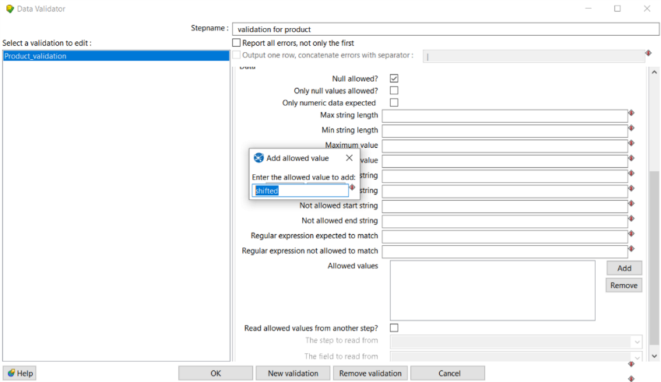

Step7: Select Dummy file from Flow to hold output and connect it with Data validation, while connecting select option “ Main Output of step”

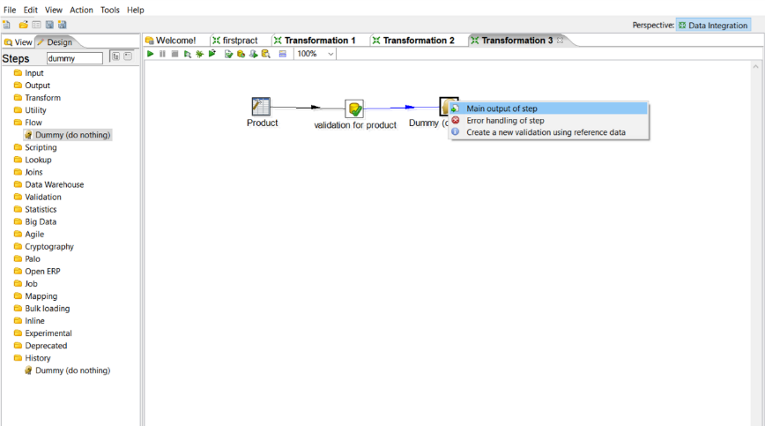

Step8: Select another dummy and connect it to ‘Validation for product’ and while selecting select ‘Error handling of step and in next window click on copy

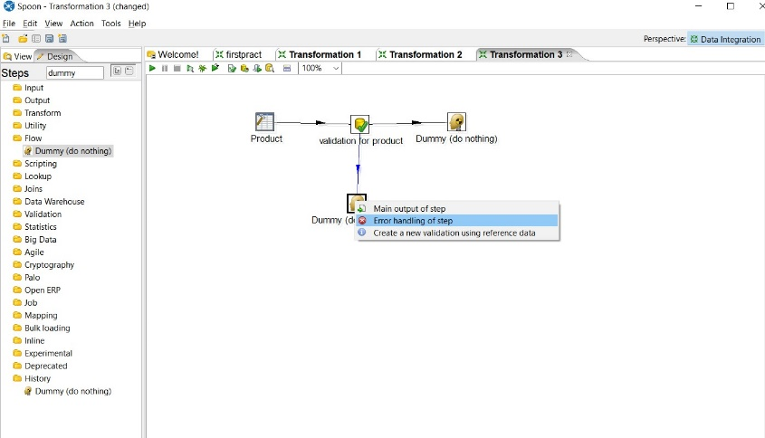

Step 9: launch transformation by selecting one dummy file each.

