**Number Range**

**Step 1: Perform first 6 steps same as practical 1.**

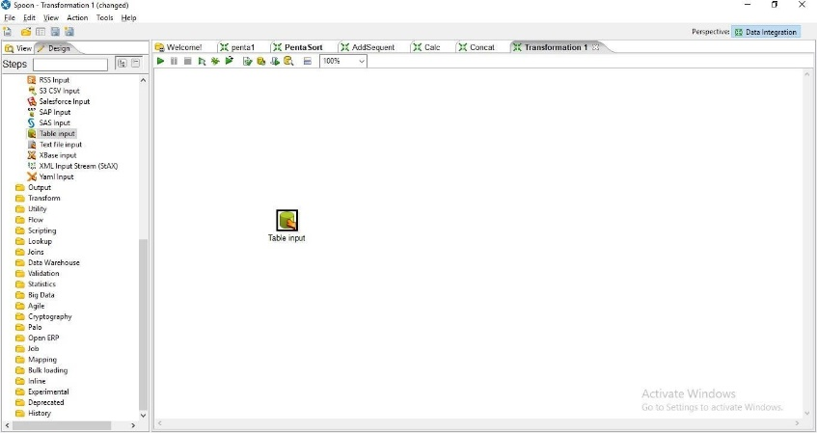

Step2: Drag and drop Number Range transformation and double click on it.

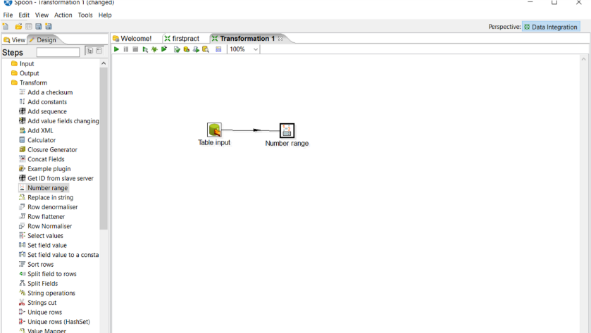

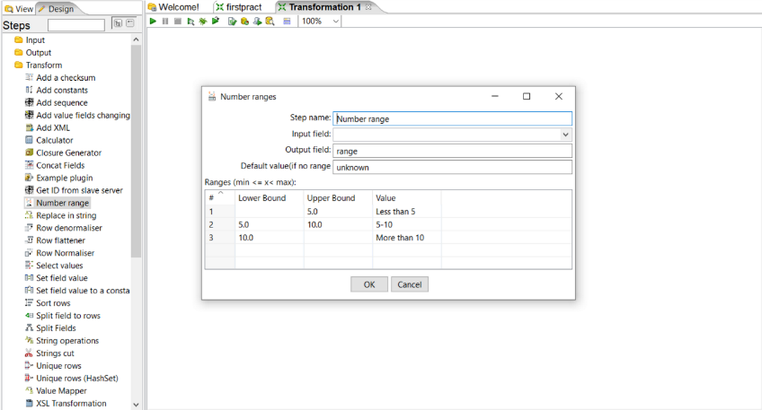

Step3: Set values for Input field, Output field, Lower bound, Upper bound and value according to the values specified in percentage column.

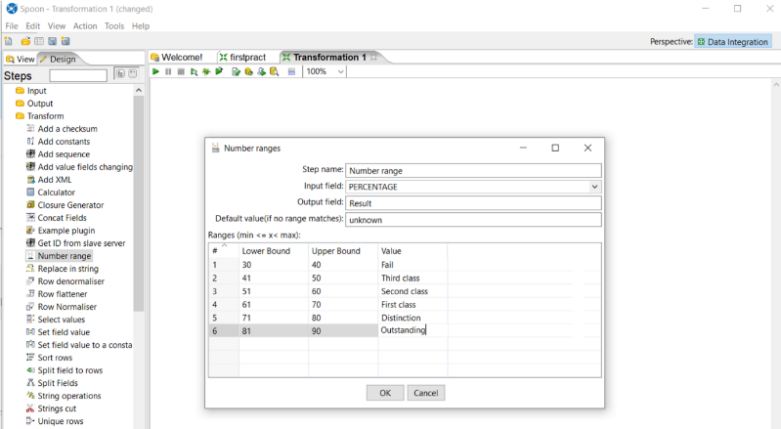

Step4: Click on Quick launch

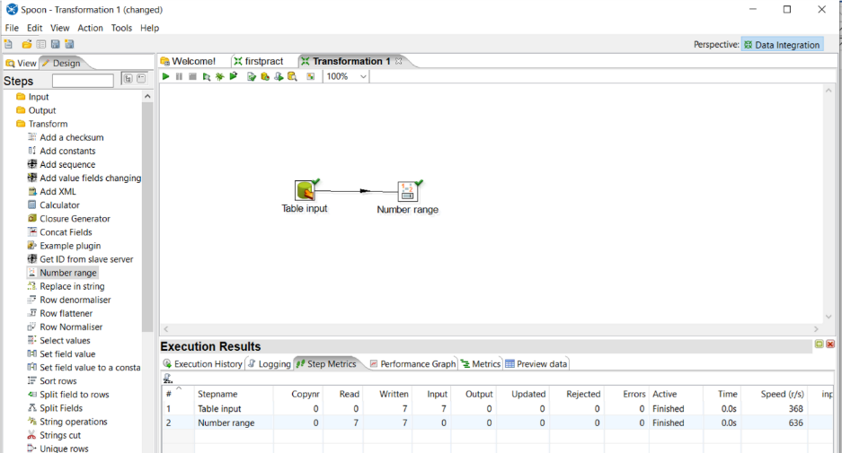

Step 5: Click on Preview data

