**Step 1: input table**

**Step 9: Drag and drop Add sequence on the panel**

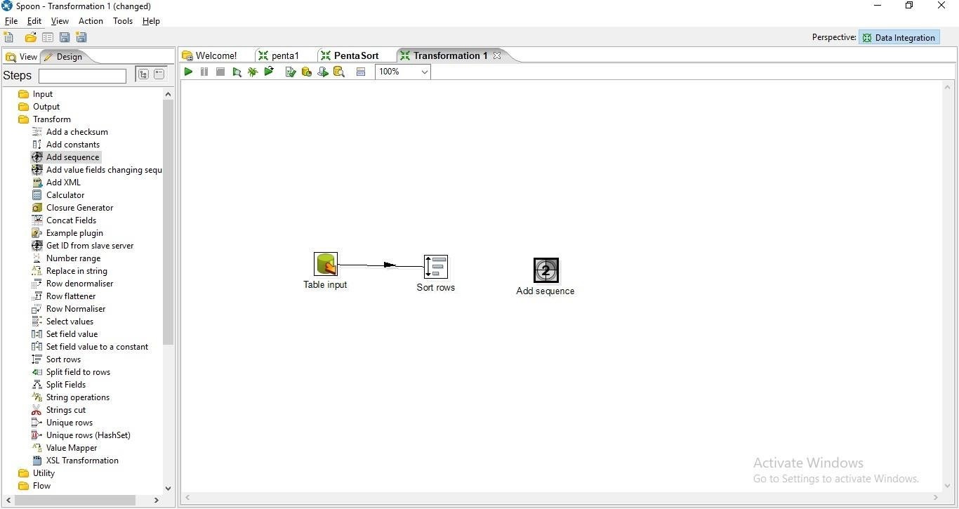

**Step 10: Hold the mous pointer on the sort rows and drag the output connector to the Add sequence control.**

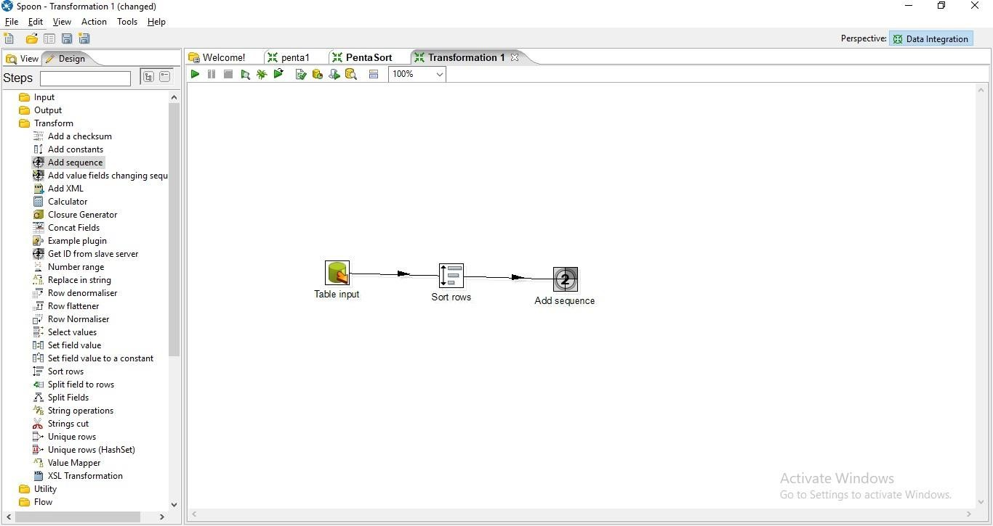

**Step 11: Double Click on Add Sequence Control**

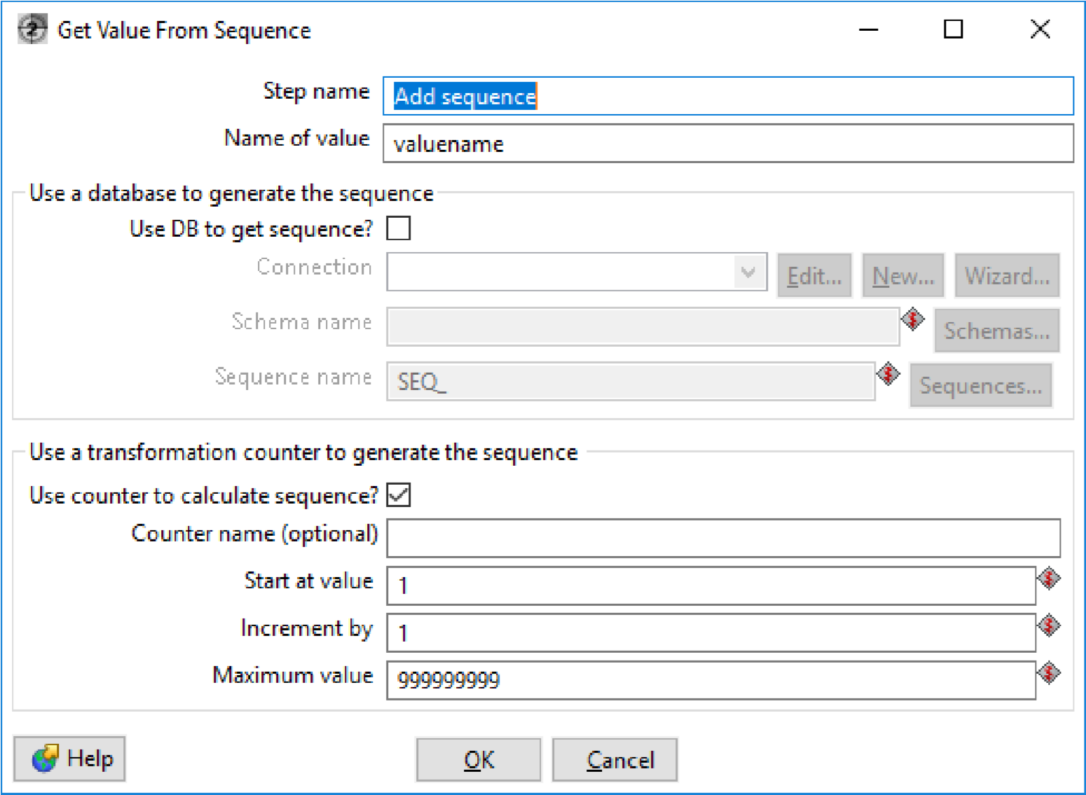

1. Enter the values for Start at Values,Increment by and Maximum Values and press ok.

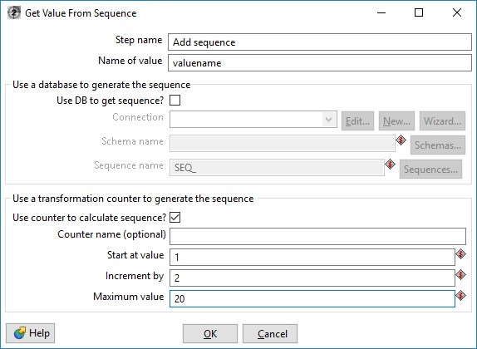

**Step 12: Click on Debug the Transformation and click on Quick Launch**

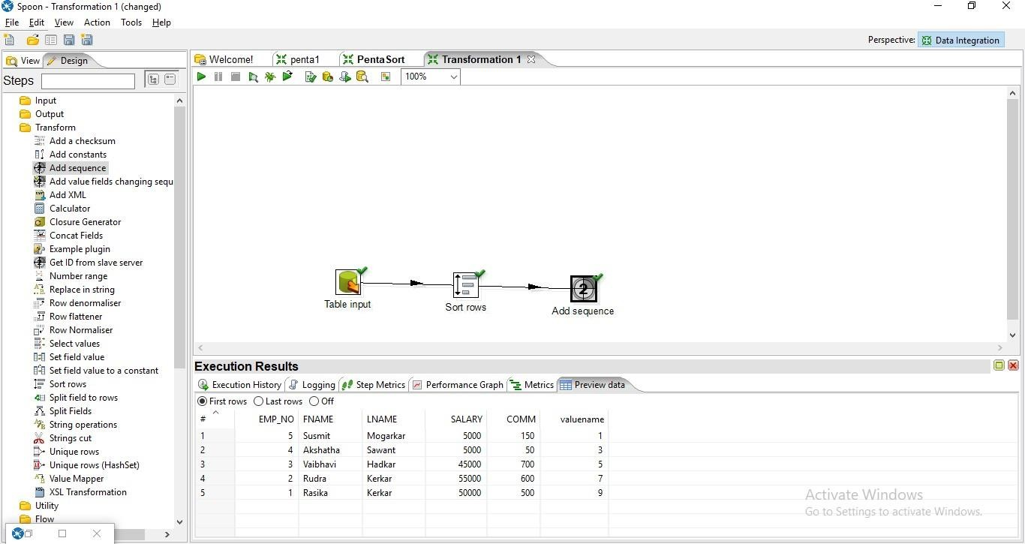

**Step 13: Drag and drop the table output on the panel**

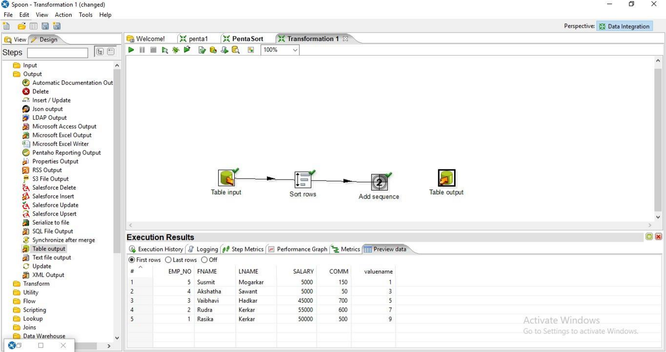

**Step 14: Hold the mouse pointer on the add sequence control and drag the output connector to the table output.**

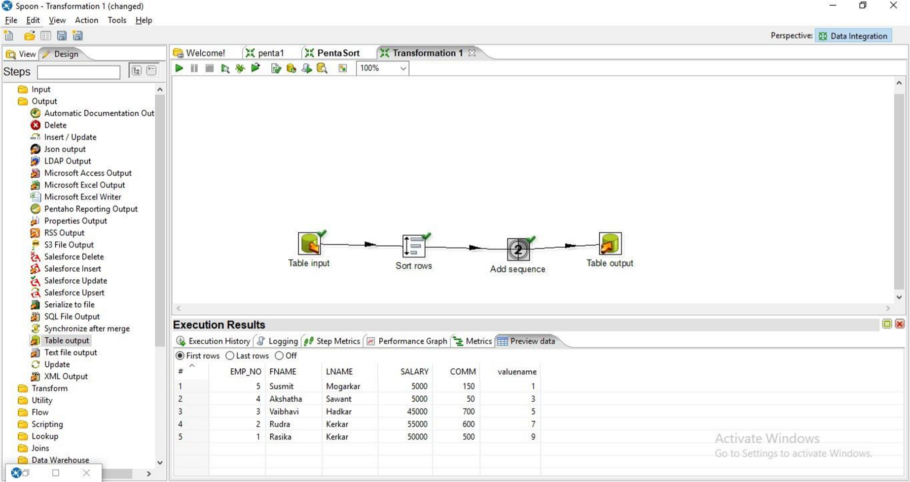

**Step 15: Double Click on the table output.**

1. Click on Database Fields

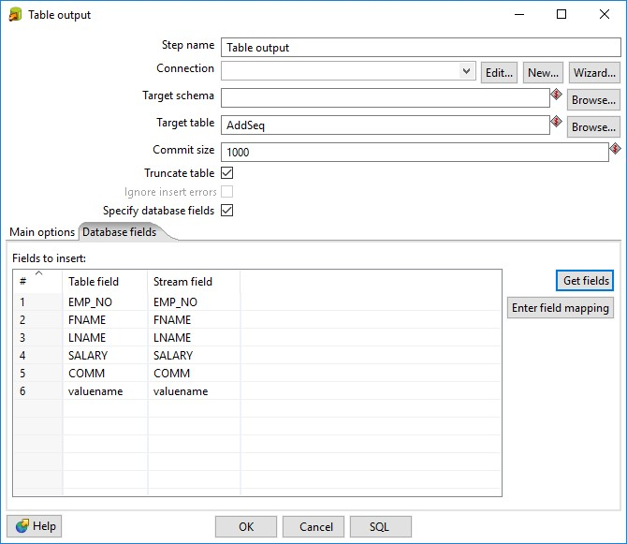

1. Click on SQL

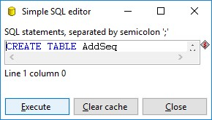

1. Click on Execute an then press ok

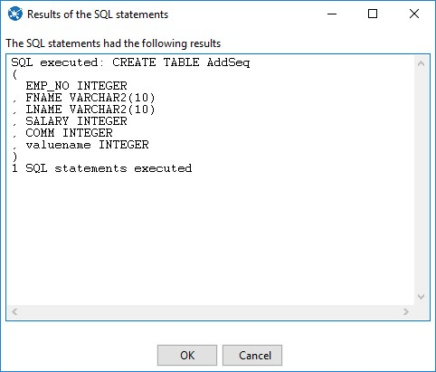

**Step 16: Click on debug Transformation and then quick Launch**

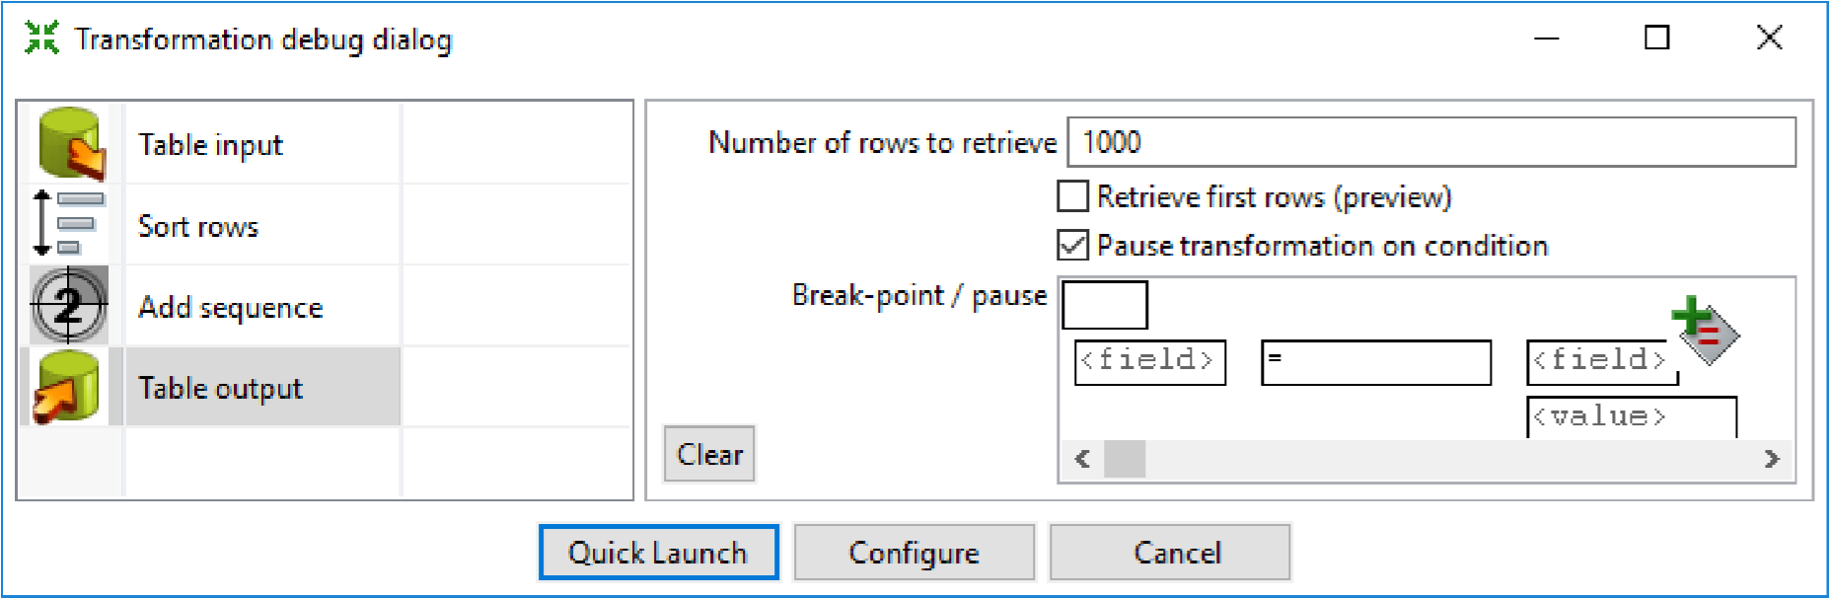

**Output**

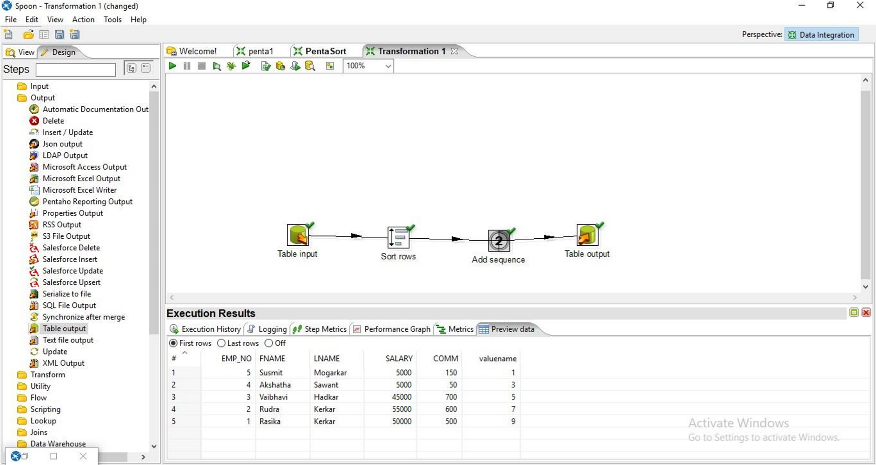

**SQL> select * from empp13;**

