**ETL Implementation through Pentaho**

**Aim :** Perform Transformation on source Table and store the data to Output table in SQL.

Starting with Pentaho

**Step 1. Open Data Integration folder (C:\data-integration)**

**Step 2. Double click on spoon(Windows Batch file)**

**Step 3. Click on cancel.**

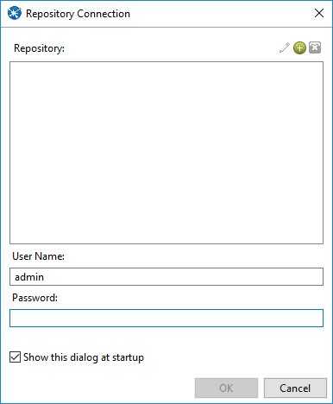

1. Transforming Source Table and storing to Output Table in SQL

**Step1: Go to Pentaho**

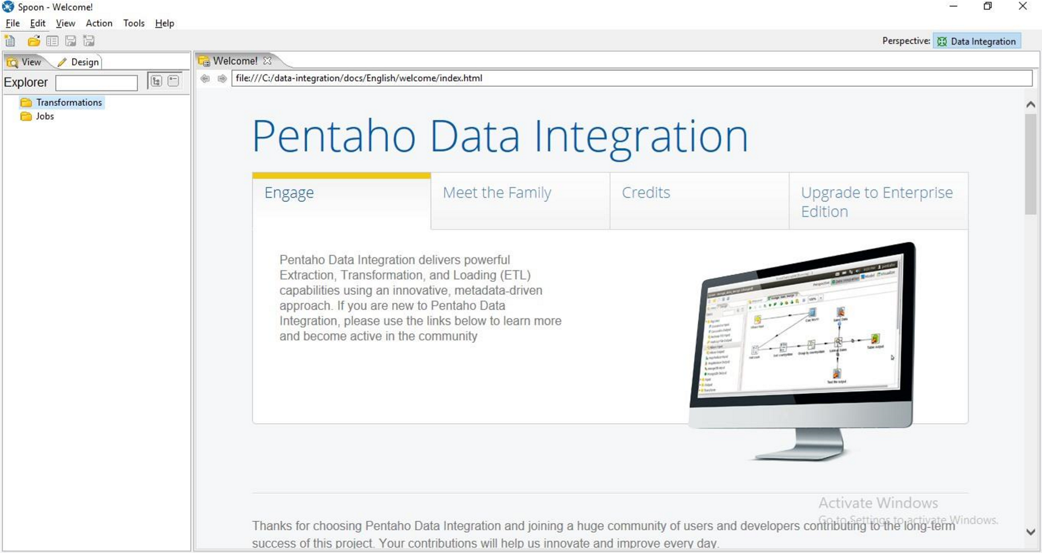

**Step2: Go to file->New->Transformation.**

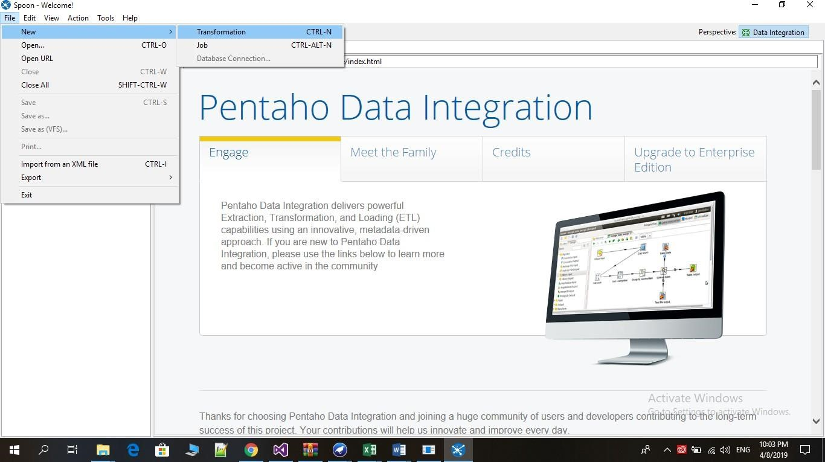

**Step 3: Click on Input**

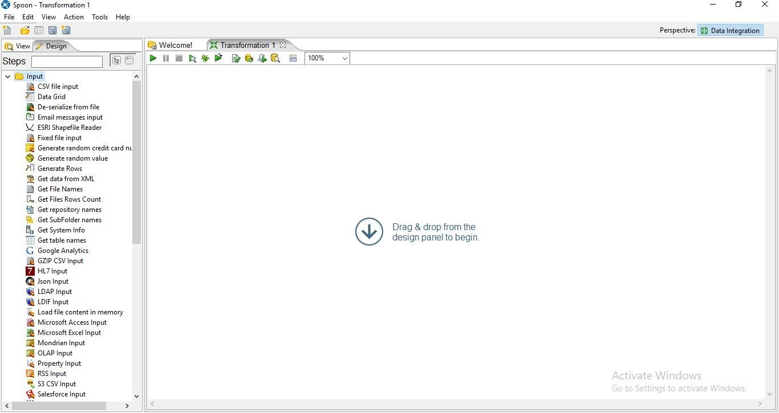

**Step 4: Drag Table Input on the panel**

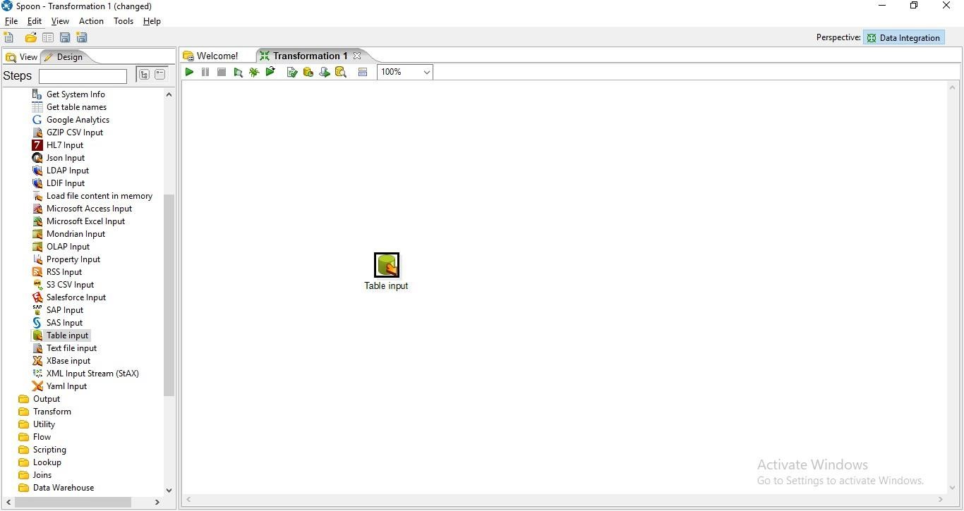

**Step 5: Double Click on Table Input and the following tab will appear.**

1. Click On New

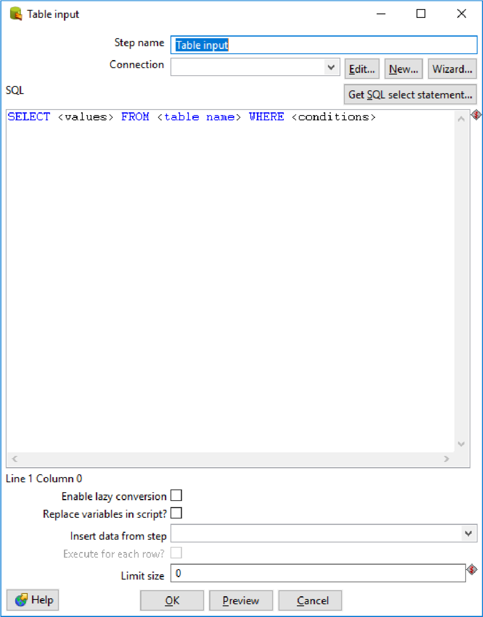

1. Select Oracle in Connection Type and enter Connection Name, Database

Name, User Name and Password and click on Test.

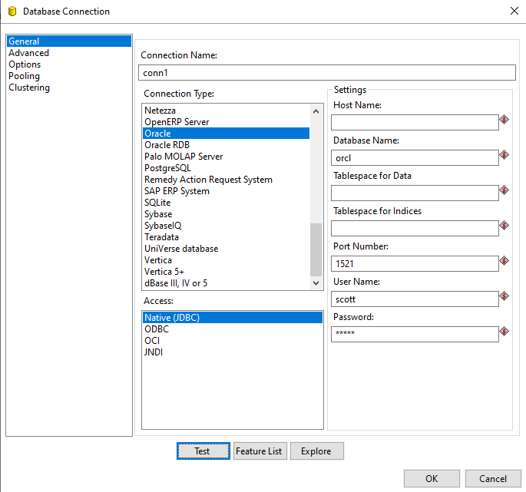

Connection Successful

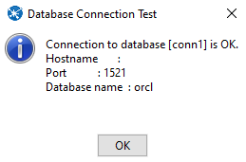

1. Click on get SQL select statement

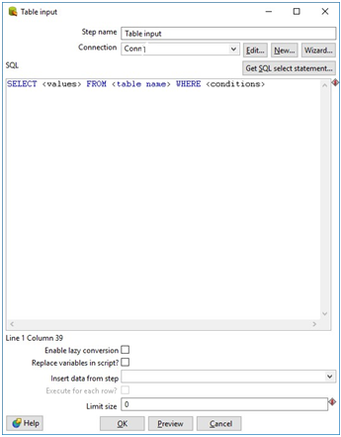

1. Click on database -> table and select the table name.

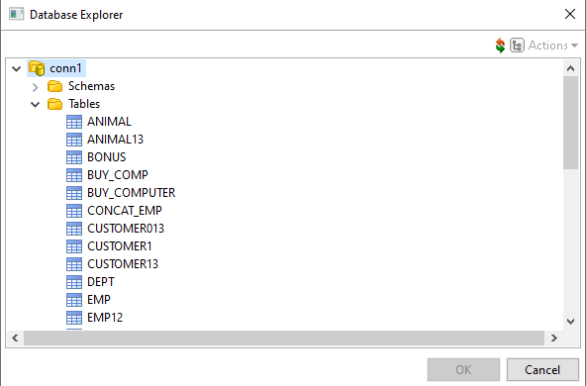

1. Click on get Preview.

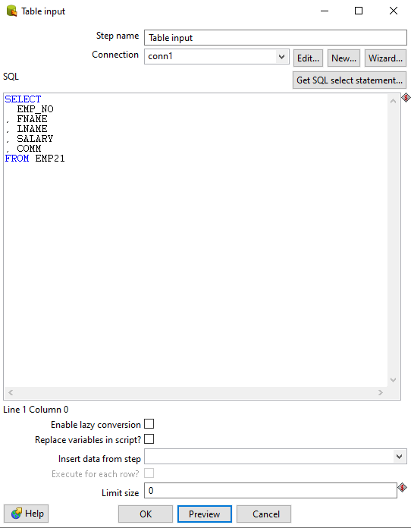

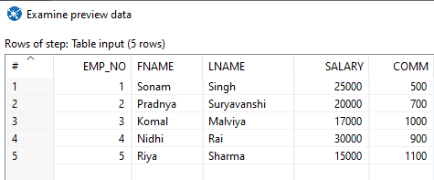

**Step 6: Click on Output and drag table Output.**

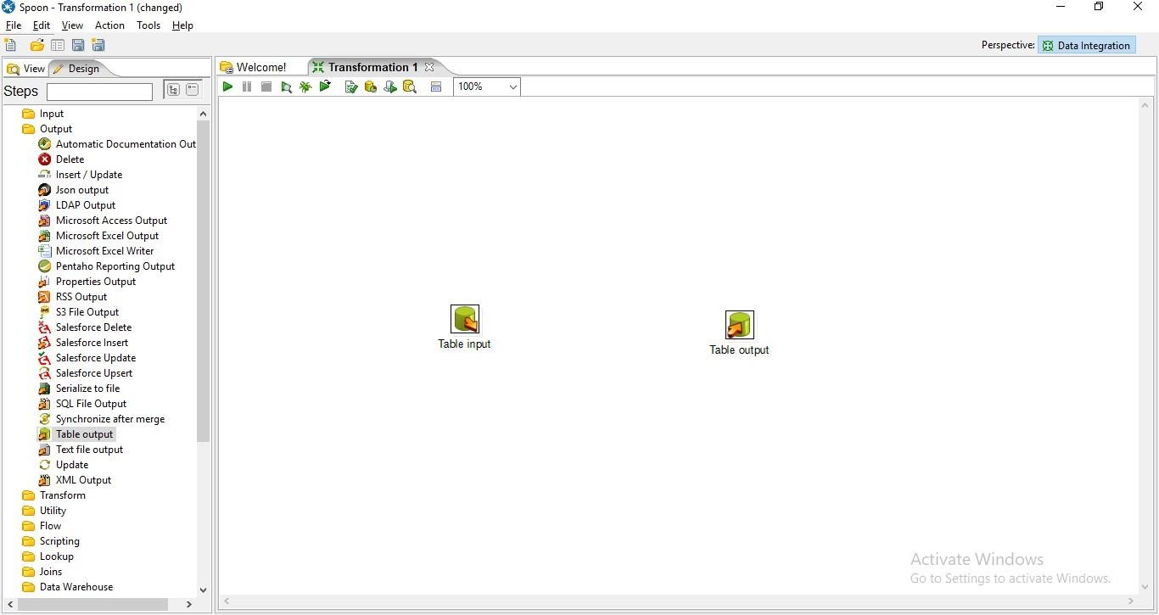+

**Step 7: Hold the mouse Pointer on table input and select and drag the Output connector to the Table output.**

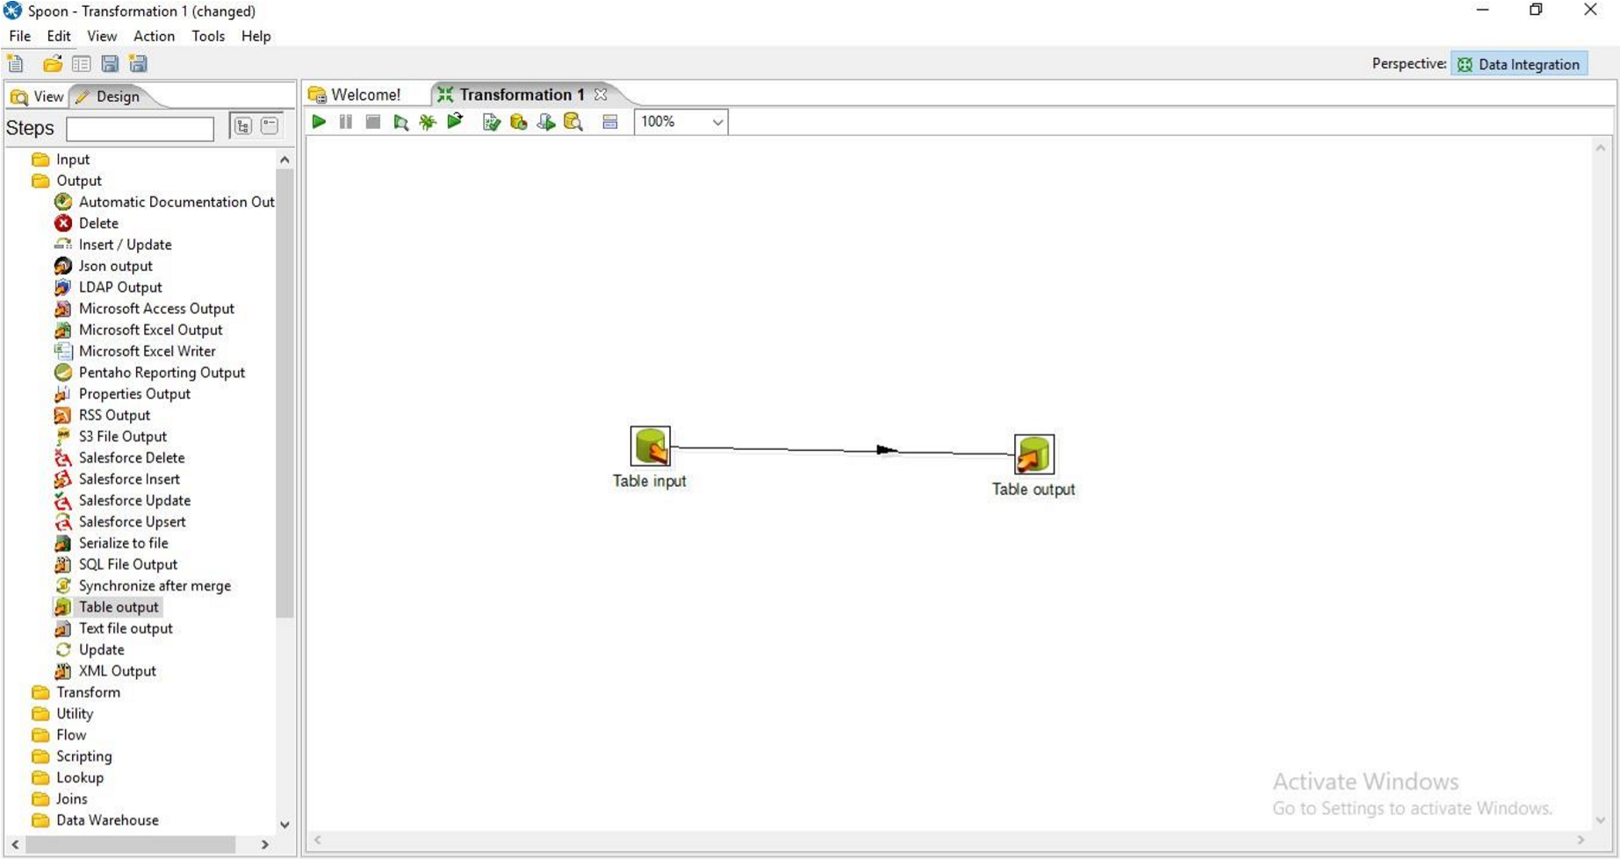

**Step 8: Double Click on target table**

1. Enter the Target table name and check the truncate table and Specify database fields Check Box.

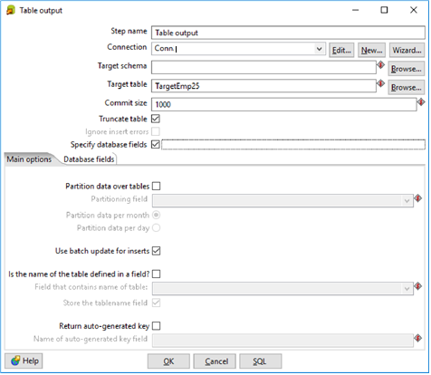

1. Click On Database fields and click on Get fields.

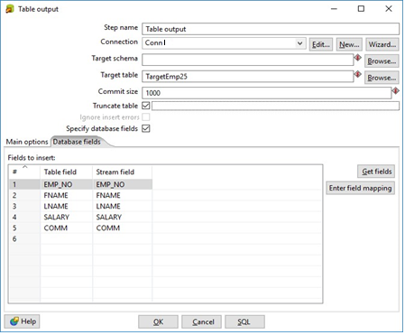

1. Click on SQL and click on Execute.

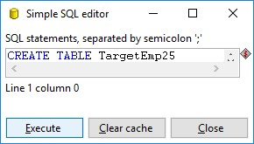

1. Click Ok

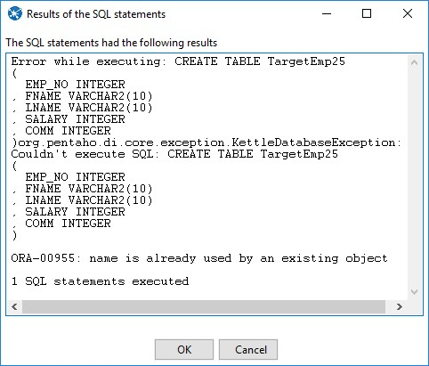

**Step 9: Click on Run Transformation and Click on Launch**

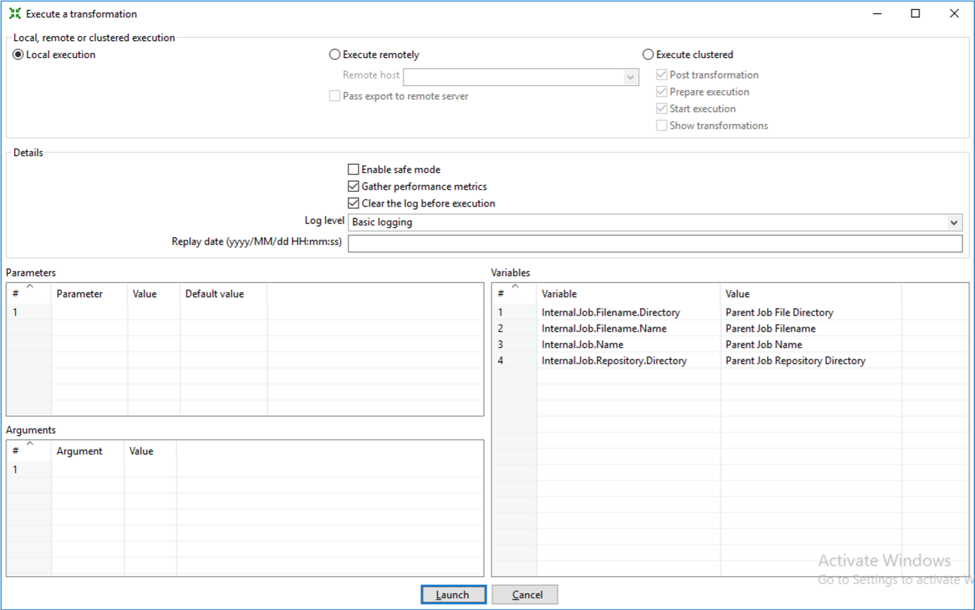

**Step 10: Click on Debug Transformation(Spider) and Click on Quick Launch**

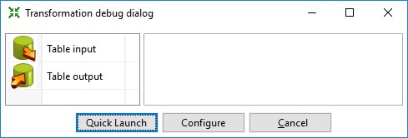

**Output:**

The Green ticks on the table input and table output shows successful transformation.

