**SPLIT FIELDS**

**Step 1: Perform first 6 steps same as practical 1.**

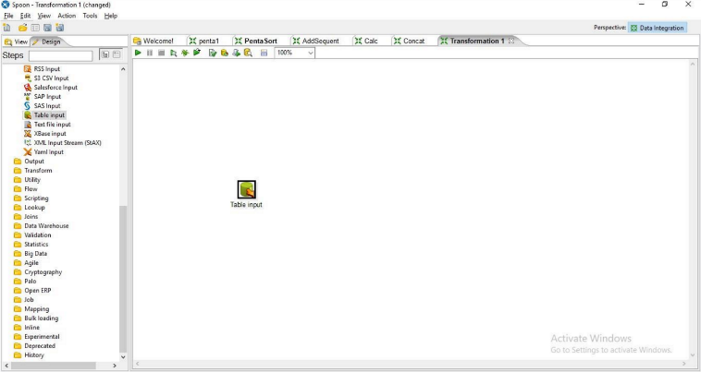

**Step 2: Drag and drop Split Field on the Panel**

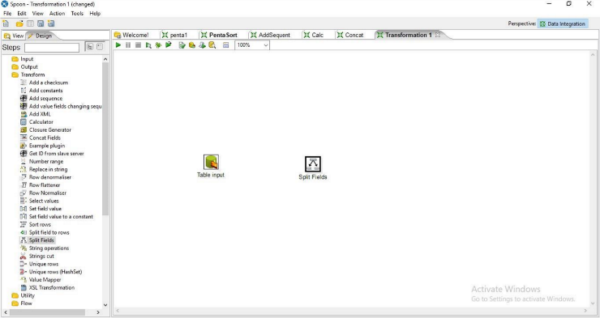

**Step 3: Hold the mouse pointer on table input and drag it to the Split Field.**

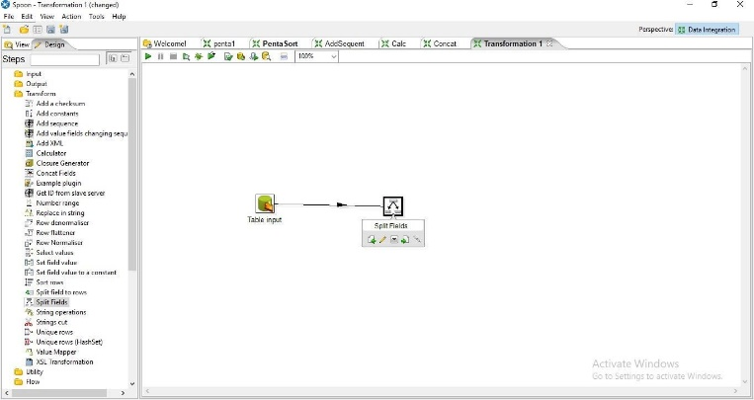

**Step 4: Double Click On Split Field.**

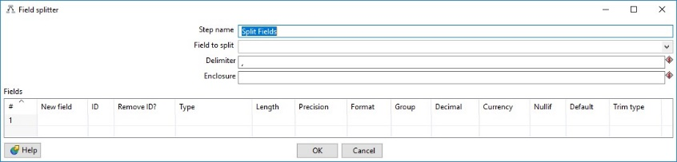

**a. Enter the values For Field to Split, Delimiter and the field names and press ok**

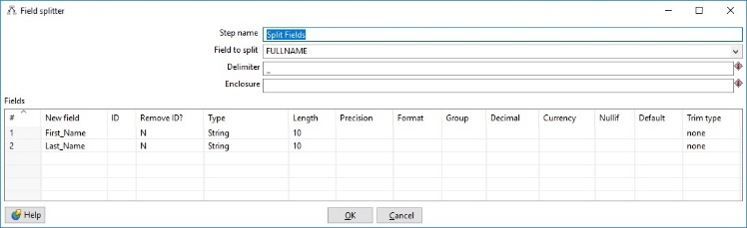

**Step 6: Click on Debug transformation and Click on Quick Launch.**

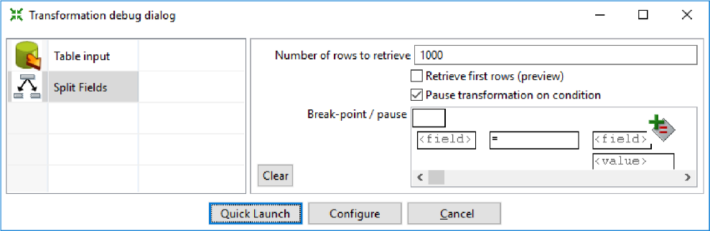

**Step 7: Perform steps 6-10 same as practical 1.**

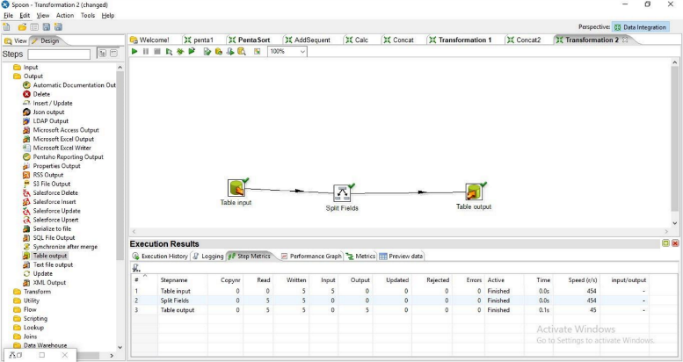

**Step 8: Click on Debug transformation and Click on Quick Launch.**

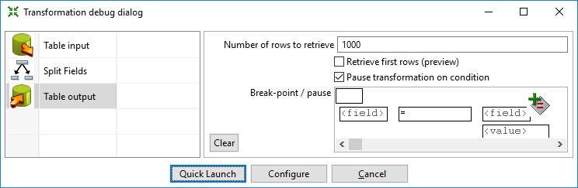

**Output:**

