**String Operation:**

**Required SQL table:**

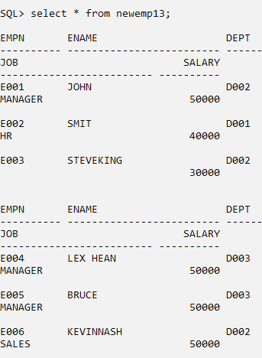

**Step 1: Perform first 6 steps same as practical 1.**

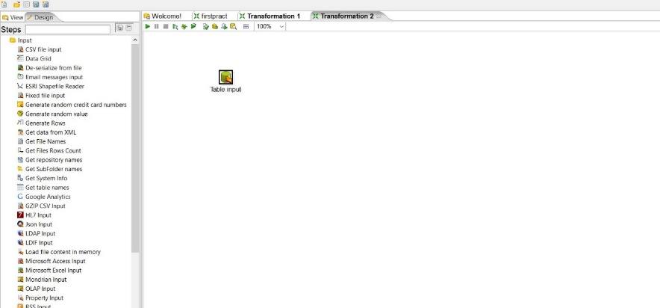

\

Step 2: Drag and drop String operation transformation, make connection between table input and string operation and double click on it.

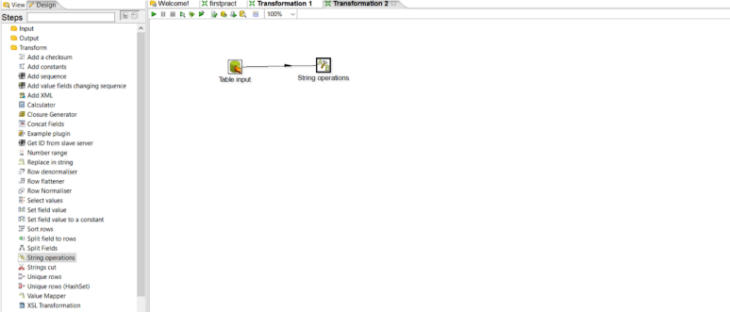

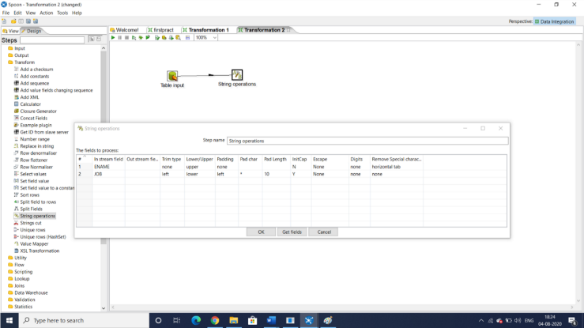Step3: Set values for the parameters

Step 4: Launch the transformation

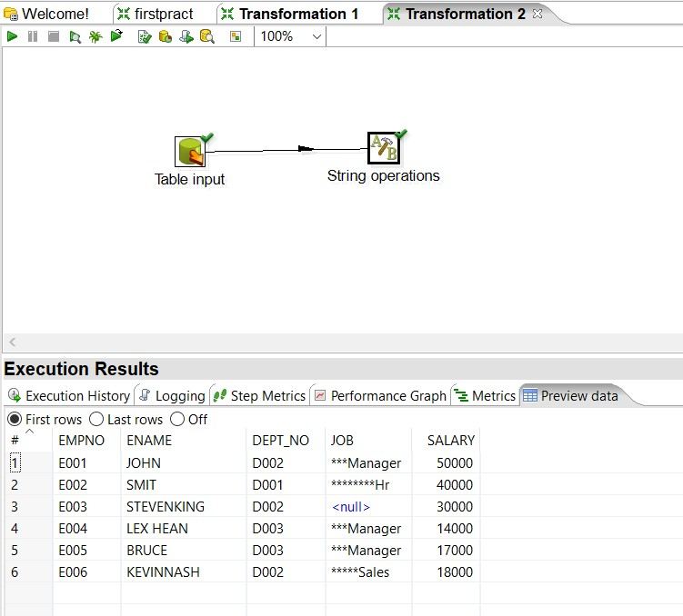

Step 5: Drag and drop output table

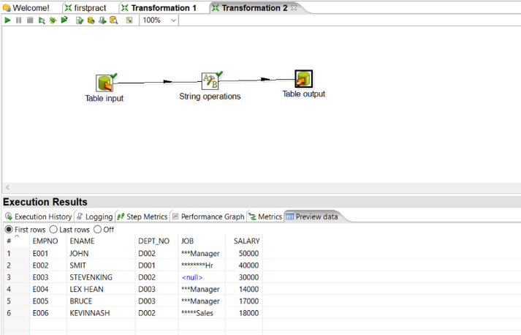

Step 6: Launch the transformation

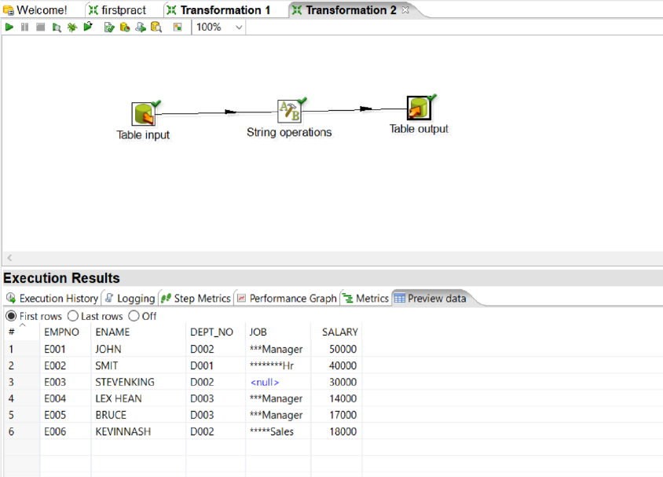

Step 7: In SQL output table

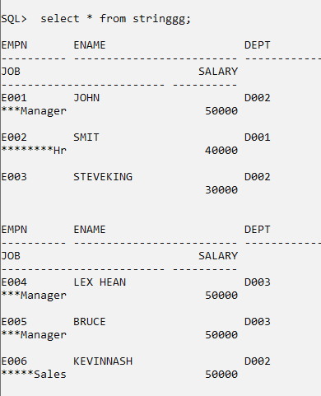

6 rows selected.