**Aim: WAP to Insert and delete records in Student Master.**

**9.1 Insert and delete record**

**Code –**

**student.jsp**

<%@ page language=*"java"* contentType=*"text/html; charset=ISO-8859-1"*

pageEncoding=*"ISO-8859-1"*%>

<!DOCTYPE html>

<html>

<head>

<meta charset=*"ISO-8859-1"*>

<title>Insert title here</title>

</head>

<body>

<h1>student master</h1>

<form action=*"response.jsp"* method=*"post"*>

<table>

<tr><td>Student Name :</td>

<td><input type=*"text"* name=*"text1"* /></td></tr>

<tr><td>Roll No : </td>

<td><input type=*"text"* name=*"text2"* /></td></tr>

<tr><td>Name of the College:</td>

<td><input type=*"text"* name=*"text3"* /></td></tr>

<tr><td>Address :</td>

<td><input type=*"text"* name=*"text4"* /></td></tr>

</table>

<input type=*"submit"* value=*"Submit"* />

</form>

</body>

</html>

**response.jsp (insert)**

<%@ page language=*"java"* contentType=*"text/html; charset=ISO-8859-1"*

pageEncoding=*"ISO-8859-1"*%>

<!DOCTYPE html>

<html>

<head>

<meta charset=*"ISO-8859-1"*>

<title>Insert title here</title>

</head>

<body>

<%@page import=*"java.sql.*"* %>

<%

**try** {

Class.forName("org.postgresql.Driver");

System.out.println("Drivers Registered");

Connection con=DriverManager.getConnection( "jdbc:postgresql://localhost:5433/postgres","postgres","abc");

String t1, t2, t3, t4;

t1=request.getParameter("text1");

t2=request.getParameter("text2");

t3=request.getParameter("text3");

t4=request.getParameter("text4");

PreparedStatement ps;

ps=con.prepareStatement("insert into student(sname,sroll,scoll,sadd) values(?, ?, ?, ?);");

ps.setString(1, t1);

ps.setString(2, t2);

ps.setString(3, t3);

ps.setString(4, t4);

ps.executeUpdate();

out.println("Record inserted successfully.");

Statement st=con.createStatement();

String sql="select * from student";

ResultSet rs=st.executeQuery(sql);

**while**(rs.next())

{

String n1=rs.getString(1);

String n2=rs.getString(2);

String n3=rs.getString(3);

String n4=rs.getString(4);

%>

<br>

<% out.println(n1+" "+n2+" "+n3+" "+n4); }

} **catch**(Exception e){ out.println(e); } %>

</body>

</html>

**Student table**

CREATE TABLE student(

sname varchar(10),

srollno varchar(50),

scoll varchar (50),

sadd varchar(50)

);

select * from student;

**Output –**

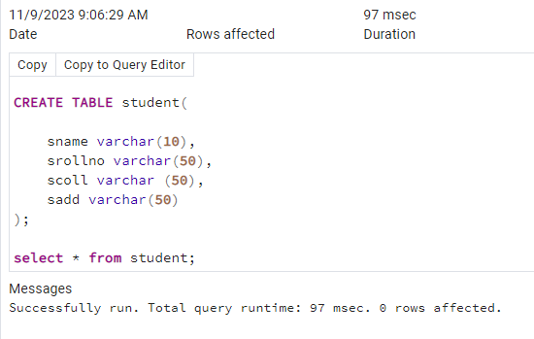

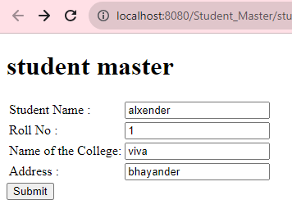

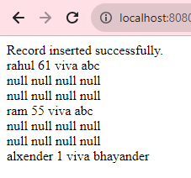

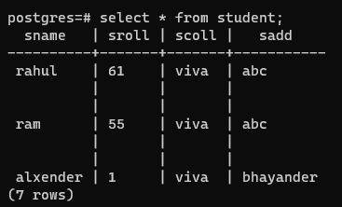

**response1.jsp(delete)**

<%@ page language=*"java"* contentType=*"text/html; charset=ISO-8859-1"*

pageEncoding=*"ISO-8859-1"*%>

<!DOCTYPE html>

<html>

<head>

<meta charset=*"ISO-8859-1"*>

<title>Insert title here</title>

</head>

<body>

<%@page import=*"java.sql.*"* %>

<%

**try** {

Class.forName("org.postgresql.Driver");

System.out.println("Drivers Registered");

Connection con=DriverManager.getConnection( "jdbc:postgresql://localhost:5433/postgres","postgres","abc");

String t1, t2, t3, t4;

t1=request.getParameter("text1");

t2=request.getParameter("text2");

t3=request.getParameter("text3");

t4=request.getParameter("text4");

PreparedStatement ps;

//insert into student(sname,srollno,scoll,sadd) values(?, ?, ?, ?);

ps=con.prepareStatement("DELETE FROM student where sroll= ?;");

ps.setString(1, t2);

/*ps.setString(1, t1);

ps.setString(3, t3);

ps.setString(4, t4);*/

ps.executeUpdate();

//out.println("Record inserted successfully.");

Statement st=con.createStatement();

String sql="select * from student";

ResultSet rs=st.executeQuery(sql);

**while**(rs.next())

{

String n1=rs.getString(1);

String n2=rs.getString(2);

String n3=rs.getString(3);

String n4=rs.getString(4);

%>

<br>

<% out.println(n1+" "+n2+" "+n3+" "+n4 ); }

} **catch**(Exception e){ out.println(e); } %>

</body>

</html>