**Practical No 8**

**8.1 Aim: Write a JSP program that demonstrate the use of JSP declaration, scriptlet, directives, expressions, header and footer (include directive).**

**Code –**

**NewFile.jsp**

<%@ page language=*"java"* contentType=*"text/html; charset=ISO-8859-1"*

pageEncoding=*"ISO-8859-1"*%>

<%@ include file=*"header.html"* %>

<!DOCTYPE html>

<html>

<head>

<meta charset=*"ISO-8859-1"*>

<title>JSP DEMO PAGE</title>

</head>

<body>

<h1>Enter the Message</h1>

<form action=*"response.jsp"* method=*"post"*>

Enter Message: <input type=*"text"* value=*""* name=*"text1"*>

<input type=*"submit"* value=*"submit"* />

</form>

</body>

</html>

<%@ include file=*"footer.html"* %>

**Header.html**

<!DOCTYPE html>

<html>

<head>

<meta charset="ISO-8859-1">

<title>My header file</title>

</head>

<body>

<h1>Welcome to first JSP application</h1>

</body>

</html>

**Footer.html**

<!DOCTYPE html>

<html>

<head>

<meta charset="ISO-8859-1">

<title>Footer file</title>

</head>

<body>

<h1>Hello its me!</h1>

</body>

</html>

**response.jsp**

<%@ page language=*"java"* contentType=*"text/html; charset=ISO-8859-1"*

pageEncoding=*"ISO-8859-1"*%>

<%@ include file=*"header.html"* %>

<!DOCTYPE html>

<html>

<head>

<meta charset=*"ISO-8859-1"*>

<title>My JSP file</title>

</head>

<body>

<% String s1=request.getParameter("text1"); %>

<%=s1 %>

</body>

</html>

<%@ include file=*"footer.html"* %>

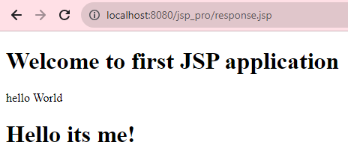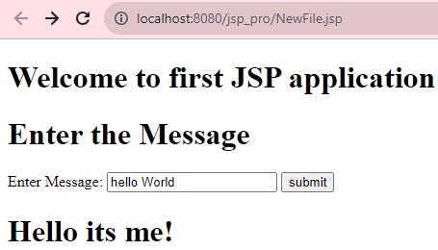**Output –**

**8.1 Aim: Write a JSP program to collect marks of student and declare the result with aggregate percentage (make your own assumption).**

**Code –**

<%@ page language=*"java"* contentType=*"text/html; charset=ISO-8859-1"*

pageEncoding=*"ISO-8859-1"*%>

<!DOCTYPE html>

<html>

<head>

<meta charset=*"ISO-8859-1"*>

<title>Grade Calculator</title>

</head>

<body>

<h2>Grade Calculator-----------Main content of the page</h2>

<form action=*""* method=*"post"*>

<table>

<tr><td>Program: MCA</td>

<td></td></tr>

<tr><td>JAVA (out of 100):</td>

<td><input type=*"text"* value=*""* name=*"text1"*></td></tr>

<tr><td>ADBMS (out of 100):</td>

<td><input type=*"text"* value=*""* name=*"text2"*></td></tr>

<tr><td>SPM (out of 100):</td>

<td><input type=*"text"* value=*""* name=*"text3"*></td></tr>

<tr><td>MATHS (out of 100):</td>

<td><input type=*"text"* value=*""* name=*"text4"*></td></tr>

<tr><td></td>

<td><input type=*"submit"* value=*"Submit"* name=*"Submit"*></td></tr>

</table>

</form>

<% **try**{

String res="";

**int** t1=Integer.parseInt(request.getParameter("text1"));

**int** t2=Integer.parseInt(request.getParameter("text2"));

**int** t3=Integer.parseInt(request.getParameter("text3"));

**int** t4=Integer.parseInt(request.getParameter("text4"));

**float** r, av;

r=t1+t2+t3+t4;

av=r/4;

**if**(av>75 && av<=100){

res="You have passed with O Grade";}

**else** **if**(av>60 && av<=75){

res="You have passed with A Grade";}

**else** **if**(av>50 && av<=60){

res="You have passed with B Grade";}

**else** **if**(av>40 && av<=50){

res="You have passed with C Grade";}

**else**{res="You have failed";}

%>

<%=av %>

<br>

<%=res %>

<%} **catch**(Exception e){} %>

</body>

</html>

**Output –**

