**Practical No 8**

**Aim: -** WAP to simulate Hybrid topology.

**Objective: -**

* Understanding of Hybrid topology
* Implementation of Hybrid topology using NS3

**Theory: -**

Hybrid Topology is the first before going into the topic, we saw that topology may be a connection of varied links and nodes, communicating with one another for the transfer of knowledge. During this process sort of topology, we combine two or more different topologies to make a resultant topology that has good points (as well as weaknesses) of all constituent basic topologies instead of having characteristics of only one specific topology. This mix of topologies is completed and consistent with the wants of the organization.

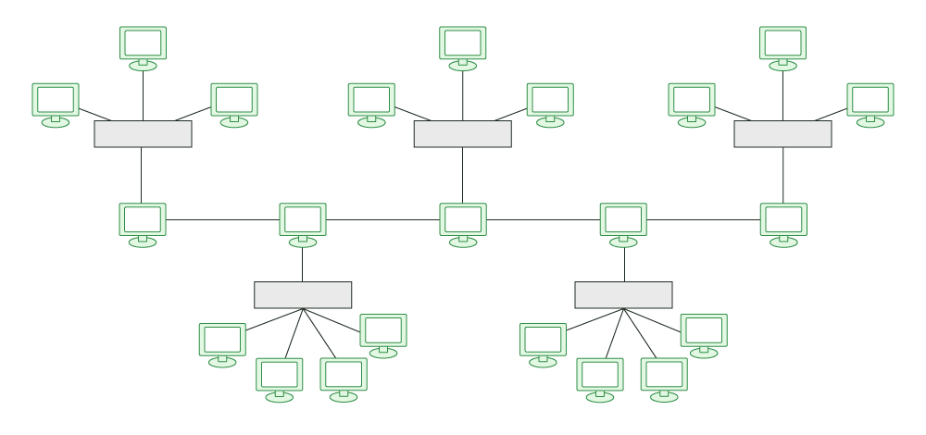

**Advantages of Hybrid topology:**

* This type of topology combines the benefits of different types of topologies in one topology.
* Can be modified as per requirement.
* It is extremely flexible.
* It is very reliable.
* It is easily scalable as Hybrid networks are built in a fashion which enables easy integration of new hardware components.
* Error detecting and troubleshooting are easy.

**Disadvantages of Hybrid topology:**

* It is a type of network expensive.
* The design of a hybrid network is very complex.
* There is a change in the hardware to connect one topology with another topology.
* Usually, hybrid architectures are larger in scale so they require a lot of cables in the installation process.
* Installation is a difficult process.

**Program: -**

#include "ns3/core-module.h"

#include "ns3/point-to-point-module.h"

#include "ns3/network-module.h"

#include "ns3/netanim-module.h"

#include "ns3/applications-module.h"

#include "ns3/mobility-module.h"

#include "ns3/csma-module.h"

#include "ns3/internet-module.h"

#include "ns3/yans-wifi-helper.h"

#include "ns3/ssid.h"

// Default Network Topology

//

// Wifi 10.1.3.0

// AP

// * * * *

// | | | | 10.1.1.0

// n5 n6 n7 n0 -------------- n1 n2 n3 n4

// point-to-point | | | |

// ================

// LAN 10.1.2.0

using namespace ns3;

NS_LOG_COMPONENT_DEFINE ("ThirdScriptExample");

int

main (int argc, char *argv[]){

bool verbose = true;

uint32_t nCsma = 3;

uint32_t nWifi = 3;

bool tracing = false;

CommandLine cmd (__FILE__);

cmd.AddValue ("nCsma", "Number of \"extra\" CSMA nodes/devices", nCsma);

cmd.AddValue ("nWifi", "Number of wifi STA devices", nWifi);

cmd.AddValue ("verbose", "Tell echo applications to log if true", verbose);

cmd.AddValue ("tracing", "Enable pcap tracing", tracing);

cmd.Parse (argc,argv);

if (nWifi > 18){

std::cout << "nWifi should be 18 or less; otherwise grid layout exceeds the bounding box" << std::endl;

return 1;

}

if (verbose){

LogComponentEnable ("UdpEchoClientApplication", LOG_LEVEL_INFO);

LogComponentEnable ("UdpEchoServerApplication", LOG_LEVEL_INFO);

}

NodeContainer p2pNodes;

p2pNodes.Create (2);

PointToPointHelper pointToPoint;

pointToPoint.SetDeviceAttribute ("DataRate", StringValue ("5Mbps"));

pointToPoint.SetChannelAttribute ("Delay", StringValue ("2ms"));

NetDeviceContainer p2pDevices;

p2pDevices = pointToPoint.Install (p2pNodes);

NodeContainer csmaNodes;

csmaNodes.Add (p2pNodes.Get (1));

csmaNodes.Create (nCsma);

CsmaHelper csma;

csma.SetChannelAttribute ("DataRate", StringValue ("100Mbps"));

csma.SetChannelAttribute ("Delay", TimeValue (NanoSeconds (6560)));

NetDeviceContainer csmaDevices;

csmaDevices = csma.Install (csmaNodes);

NodeContainer wifiStaNodes;

wifiStaNodes.Create (nWifi);

NodeContainer wifiApNode = p2pNodes.Get (0);

YansWifiChannelHelper channel = YansWifiChannelHelper::Default ();

YansWifiPhyHelper phy = YansWifiPhyHelper::Default ();

phy.SetChannel (channel.Create ());

WifiHelper wifi;

wifi.SetRemoteStationManager ("ns3::AarfWifiManager");

WifiMacHelper mac;

Ssid ssid = Ssid ("ns-3-ssid");

mac.SetType ("ns3::StaWifiMac",

"Ssid", SsidValue (ssid),

"ActiveProbing", BooleanValue (false));

NetDeviceContainer staDevices;

staDevices = wifi.Install (phy, mac, wifiStaNodes);

mac.SetType ("ns3::ApWifiMac",

"Ssid", SsidValue (ssid));

NetDeviceContainer apDevices;

apDevices = wifi.Install (phy, mac, wifiApNode);

MobilityHelper mobility;

mobility.SetPositionAllocator ("ns3::GridPositionAllocator",

"MinX", DoubleValue (0.0),

"MinY", DoubleValue (0.0),

"DeltaX", DoubleValue (5.0),

"DeltaY", DoubleValue (10.0),

"GridWidth", UintegerValue (3),

"LayoutType", StringValue ("RowFirst"));

mobility.SetMobilityModel ("ns3::RandomWalk2dMobilityModel",

"Bounds", RectangleValue (Rectangle (-50, 50, -50, 50)));

mobility.Install (wifiStaNodes);

mobility.SetMobilityModel ("ns3::ConstantPositionMobilityModel");

mobility.Install (wifiApNode);

InternetStackHelper stack;

stack.Install (csmaNodes);

stack.Install (wifiApNode);

stack.Install (wifiStaNodes);

Ipv4AddressHelper address;

address.SetBase ("10.1.1.0", "255.255.255.0");

Ipv4InterfaceContainer p2pInterfaces;

p2pInterfaces = address.Assign (p2pDevices);

address.SetBase ("10.1.2.0", "255.255.255.0");

Ipv4InterfaceContainer csmaInterfaces;

csmaInterfaces = address.Assign (csmaDevi

address.SetBase ("10.1.3.0", "255.255.255.0");

address.Assign (staDevices);

address.Assign (apDevices);

UdpEchoServerHelper echoServer (9);

ApplicationContainer serverApps = echoServer.Install (csmaNodes.Get (nCsma));

serverApps.Start (Seconds (1.0));

serverApps.Stop (Seconds (10.0));

UdpEchoClientHelper echoClient (csmaInterfaces.GetAddress (nCsma), 9);

echoClient.SetAttribute ("MaxPackets", UintegerValue (1));

echoClient.SetAttribute ("Interval", TimeValue (Seconds (1.0)));

echoClient.SetAttribute ("PacketSize", UintegerValue (1024));

ApplicationContainer clientApps =

echoClient.Install (wifiStaNodes.Get (nWifi - 1));

clientApps.Start (Seconds (2.0));

clientApps.Stop (Seconds (10.0));

Ipv4GlobalRoutingHelper::PopulateRoutingTables ();

Simulator::Stop (Seconds (10.0));

if (tracing == true){

pointToPoint.EnablePcapAll ("third");

phy.EnablePcap ("third", apDevices.Get (0));

csma.EnablePcap ("third", csmaDevices.Get (0), true);}

// Create the animation object and configure for specified output

AnimationInterface anim ("hybridT.xml");

NS_LOG_INFO ("Run Simulation.");

Simulator::Run ();

Simulator::Destroy ();

return 0;

}

**Output: -**

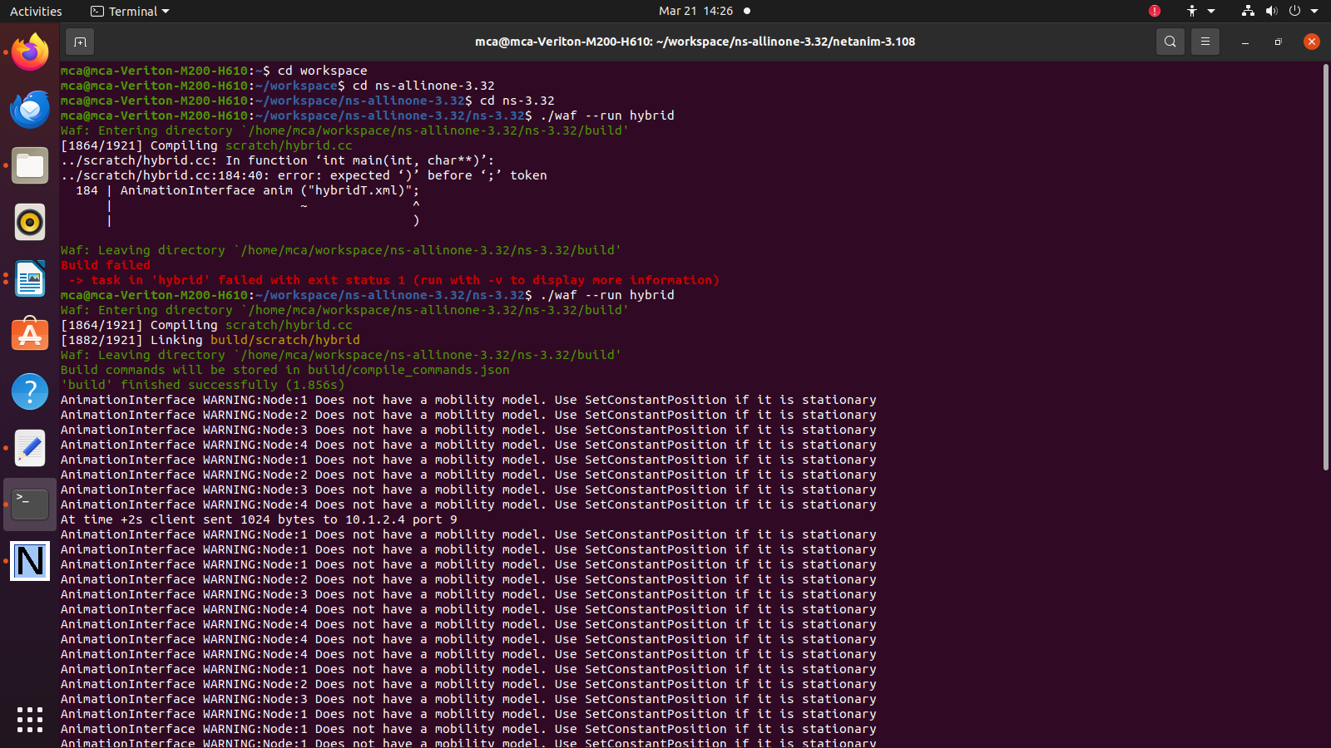

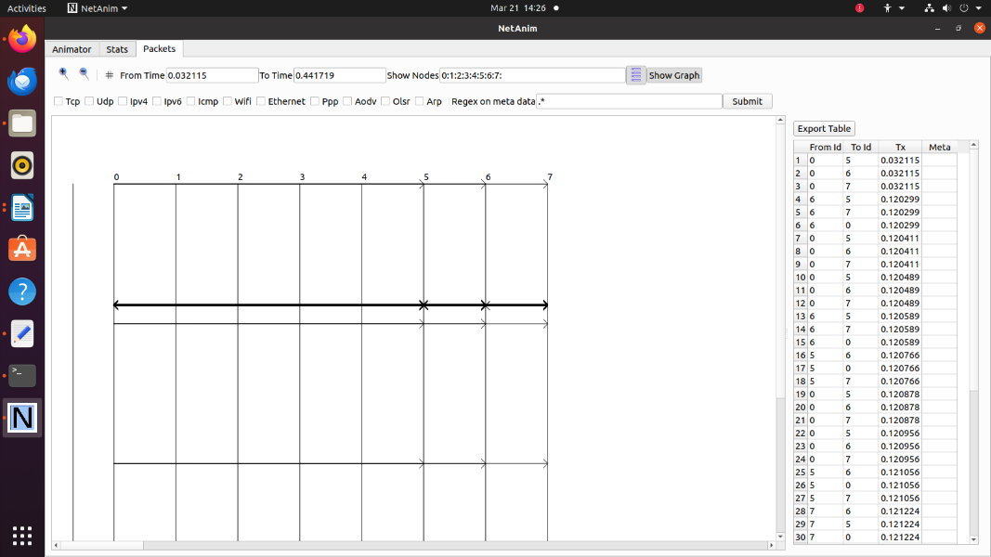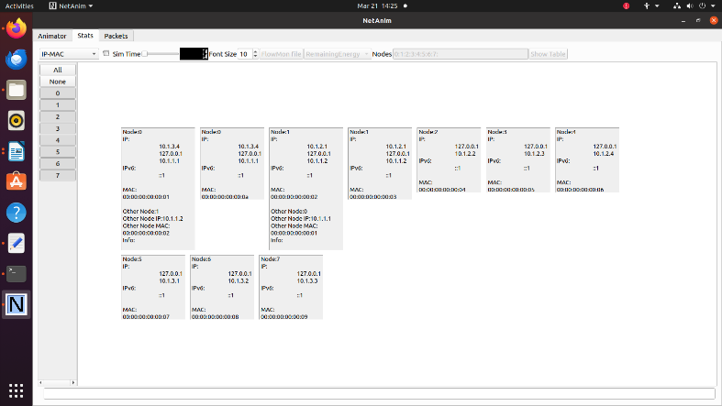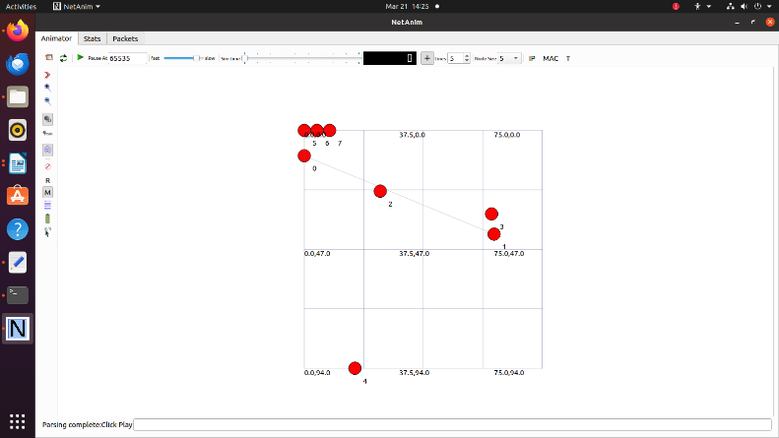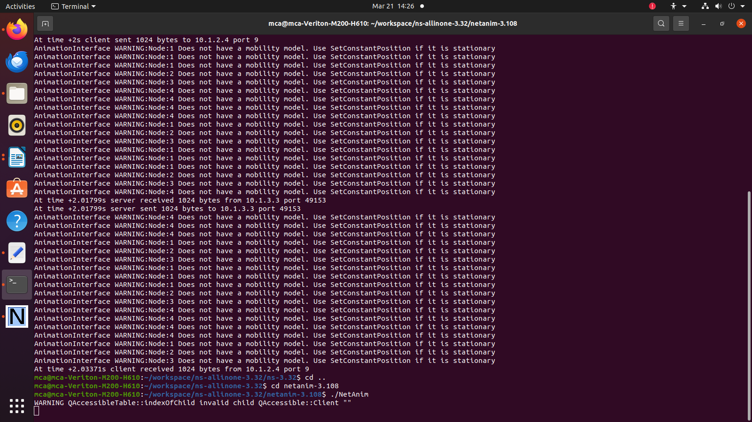

**Conclusion: -**

Successfully implemented Hybrid topology using NS3.