**Practical No 1**

**1.Aim: -** Installation of NS-3

**2.Objective: -** To learn how to install NS-3

**3.Theory: -**

* ns-3 is a discrete-event network simulator, targeted primarily for research and educational use. ns-3 is free software, licensed under the GNU GPLv2 license, and is publicly available for research, development, and use.
* The goal of the ns-3 project is to develop a preferred, open simulation environment for networking research: it should be aligned with the simulation needs of modern networking research and should encourage community contribution, peer review, and validation of the software.

**Simulated entities in ns-3:**

* **Protocol:** it manages connectivity and also a sockets like API exists for applications to send and receive data through protocols
* **Nodes:** entities which also form the network, connected by channels
* **NetDevices:** interfaces protocol stack with channels/physical transmission medium
* **Channels:** transmission medium
* **Packets:** what is also sent across networks
* **Applications:** typically, the final data sending/receiving entities, exist also on nodes.

**4.Program/Output: -**

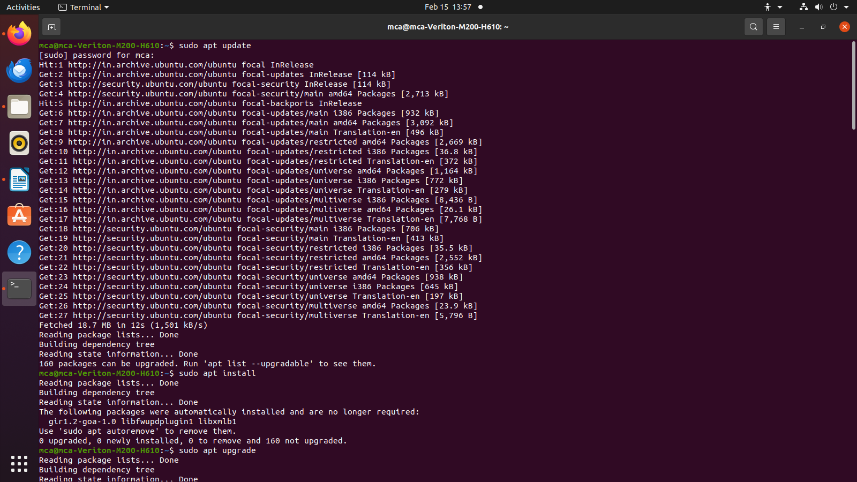



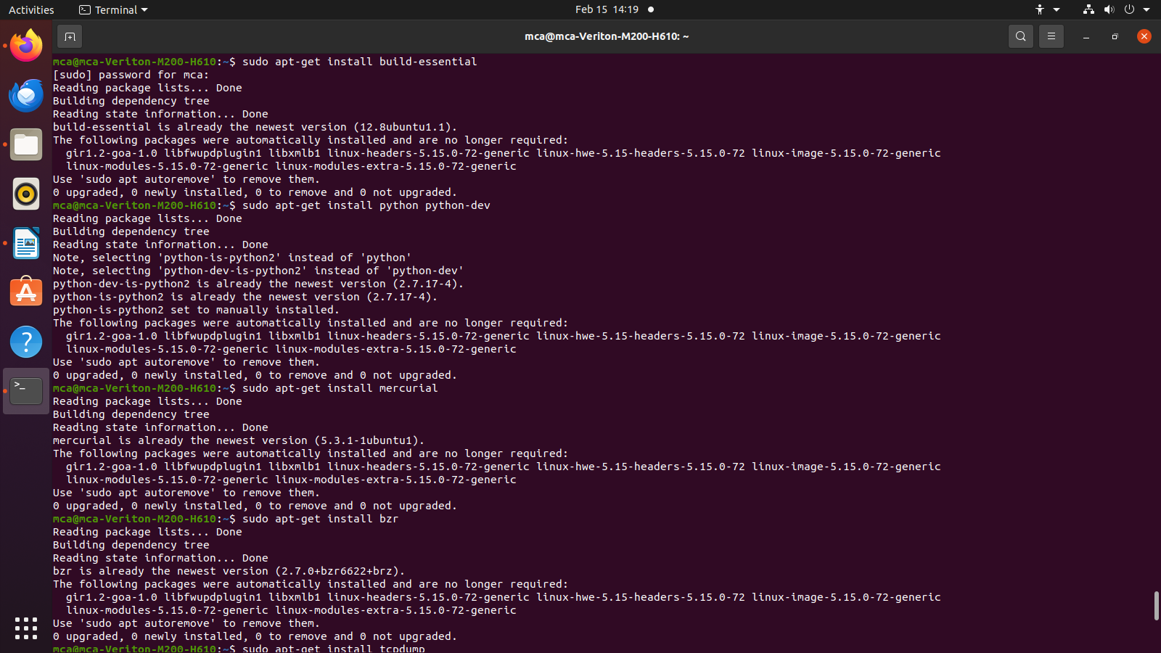







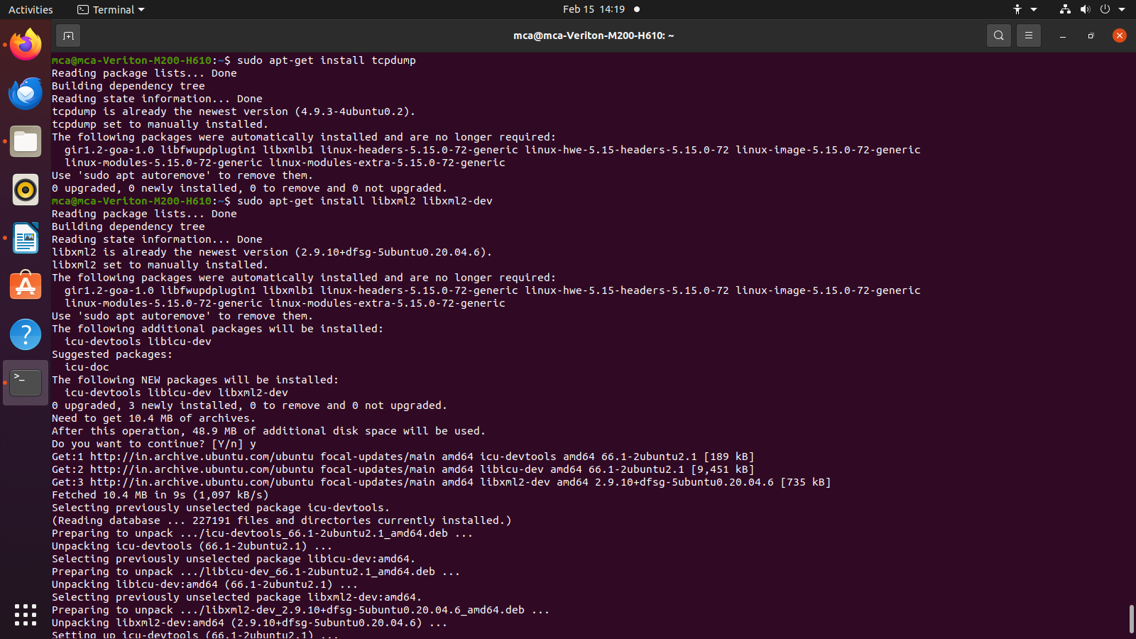



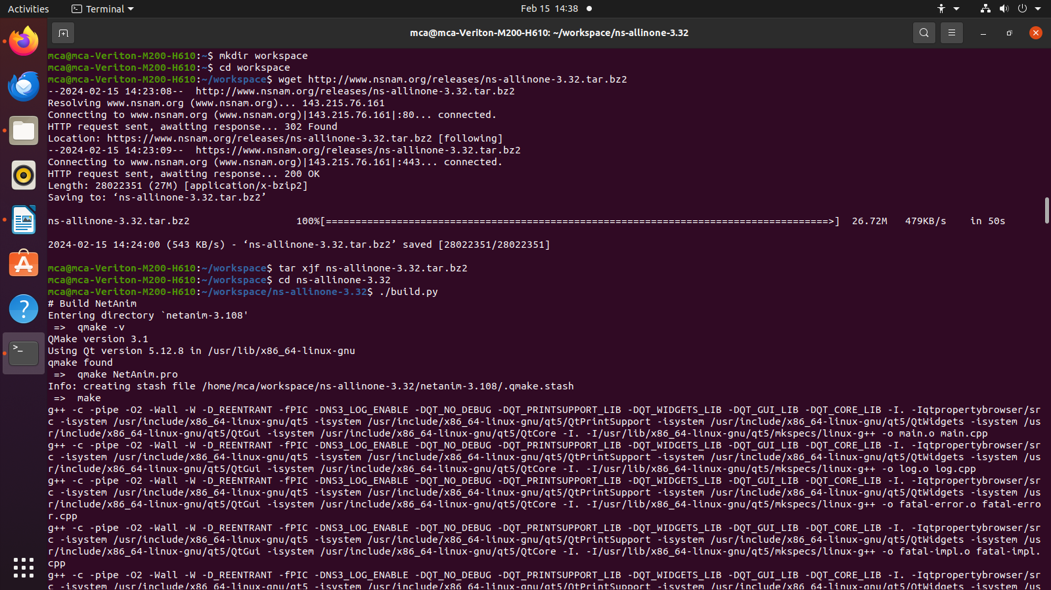



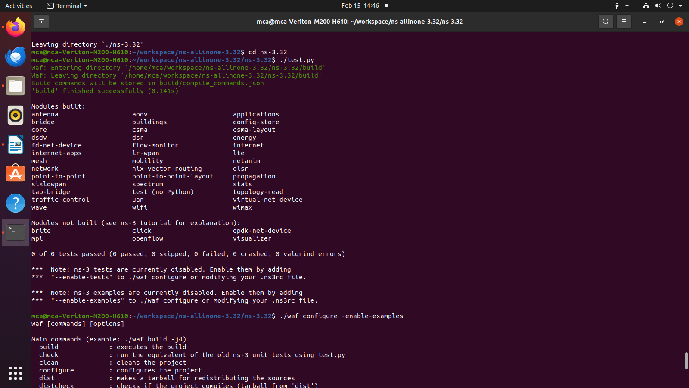



**5.Conclusion: -**

Successfully installed NS-3.

**Practical No 2**

**1.Aim: -** Installation of NetAnim.

**2.Objective: -** To learn how to install NetAnim.

**3.Theory: -**

NetAnim is a stand-alone program which uses the custom trace files generated by the animation

interface to graphically display the simulation. NetAnim is based on the multi-platform Qt4 GUI

toolkit.

The NetAnim GUI provides play, pause, and record buttons. Play and pause start and stop the

simulation. The record button starts a series of screenshots of the animator, which are written to

the directory in which the trace file was run. Two slider bars also exist. The top slider provides a

“seek" functionality, which allows a user to skip to any moment in the simulation. The bottom

slider changes the granularity of the time step for the animation. Finally, there is a quit button to

stop the simulation and quit the animator.

**4.Program/Output:**

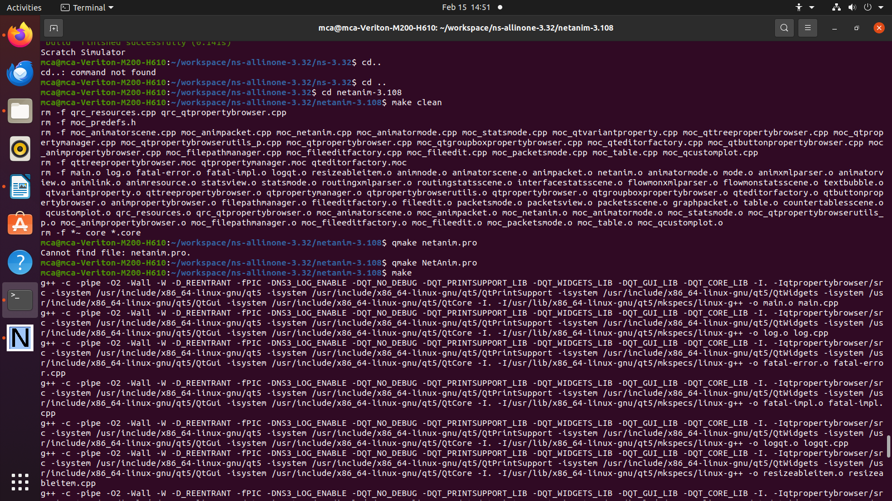



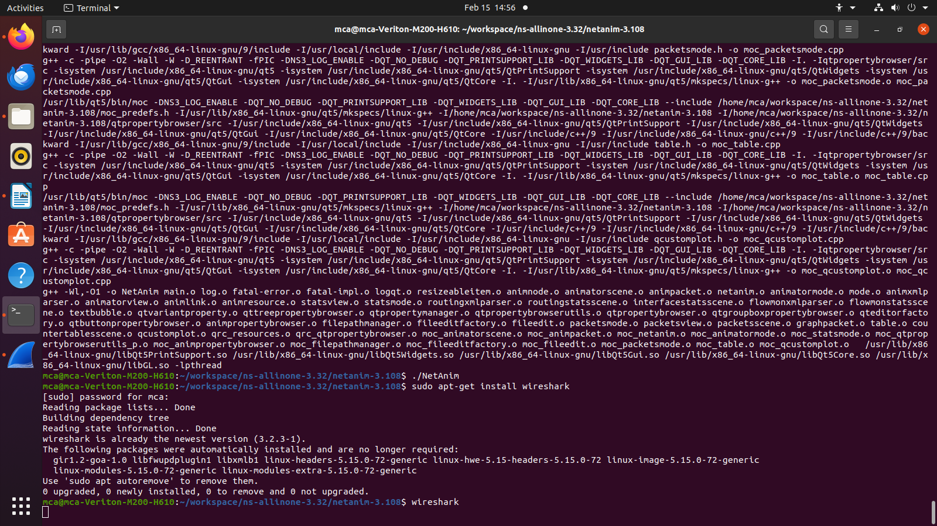

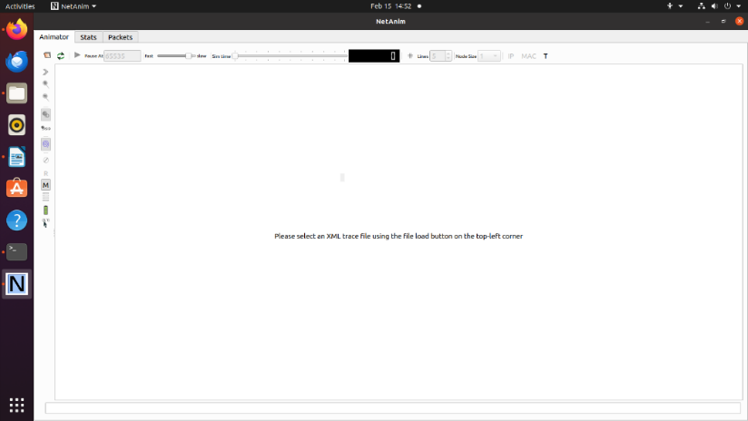

**5.Conclusion: -**

Successfully installed NetAnim.

**Practical No 3**

**1.Aim: -** Installation of Wireshark.

**2.Objective: -** To learn how to install Wireshark.

**3.Theory: -**

**Wireshark** is a network protocol analyzer, or an application that captures packets from a network connection, such as from your computer to your home office or the internet. Packet is the name given to a discrete unit of data in a typical Ethernet network.

Wireshark is the most often-used packet sniffer in the world. Like any other packet sniffer, **Wireshark does three things:**

1. **Packet Capture:** Wireshark listens to a network connection in real time and then grabs entire streams of traffic – quite possibly tens of thousands of packets at a time.
2. **Filtering:** Wireshark is capable of slicing and dicing all of this random live data using filters. By applying a filter, you can obtain just the information you need to see.
3. **Visualization:** Wireshark, like any good packet sniffer, allows you to dive right into the very middle of a network packet. It also allows you to visualize entire conversations and network streams.

**4.Program/Output:**



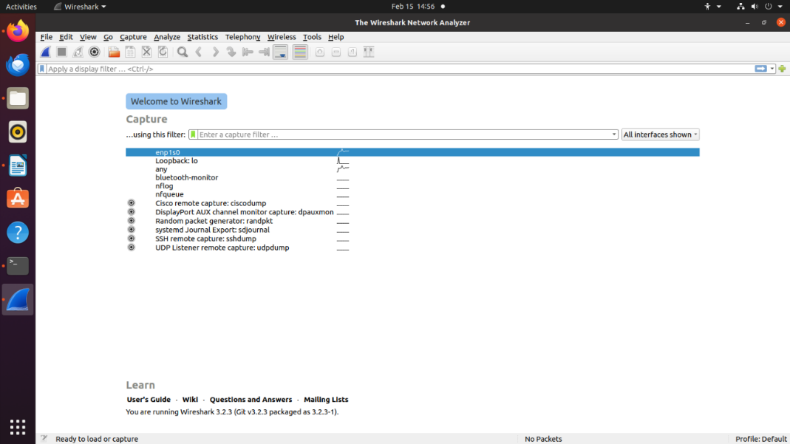

**5.Conclusion: -**

Successfully installed Wireshark.