**Practical No 18**

**Aim: -** Write a program to simulate wifi network using NS-3.

**Objective: -**

Understanding and implementation of wireless wifi network.

**Theory: -**

A Wi-Fi network is a wireless local-area network (WLAN) that uses Wi-Fi. The Wi-Fi standard has achieved nearly universal adoption for supporting WLANs and providing internet access in residential, enterprise, and public settings.



**Program: -**

#include "ns3/command-line.h"

#include "ns3/config.h"

#include "ns3/uinteger.h"

#include "ns3/boolean.h"

#include "ns3/double.h"

#include "ns3/string.h"

#include "ns3/log.h"

#include "ns3/yans-wifi-helper.h"

#include "ns3/ssid.h"

#include "ns3/mobility-helper.h"

#include "ns3/internet-stack-helper.h"

#include "ns3/ipv4-address-helper.h"

#include "ns3/udp-client-server-helper.h"

#include "ns3/packet-sink-helper.h"

#include "ns3/on-off-helper.h"

#include "ns3/ipv4-global-routing-helper.h"

#include "ns3/packet-sink.h"

#include "ns3/yans-wifi-channel.h"

// This is a simple example in order to show how to configure an IEEE 802.11ax Wi-Fi network.

//

// It outputs the UDP or TCP goodput for every HE MCS value, which depends on the MCS value (0 to 11),

// the channel width (20, 40, 80 or 160 MHz) and the guard interval (800ns, 1600ns or 3200ns).

// The PHY bitrate is constant over all the simulation run. The user can also specify the distance between

// the access point and the station: the larger the distance the smaller the goodput.

//

// The simulation assumes a single station in an infrastructure network:

//

// STA AP

// * *

// | |

// n1 n2

//

//Packets in this simulation belong to BestEffort Access Class (AC_BE).

using namespace ns3;

NS_LOG_COMPONENT_DEFINE ("he-wifi-network");

int main (int argc, char *argv[])

{

bool udp = true;

bool useRts = false;

bool useExtendedBlockAck = false;

double simulationTime = 10; //seconds

double distance = 1.0; //meters

double frequency = 5; //whether 2.4, 5 or 6 GHz

int mcs = -1; // -1 indicates an unset value

double minExpectedThroughput = 0;

double maxExpectedThroughput = 0;

CommandLine cmd (__FILE__);

cmd.AddValue ("frequency", "Whether working in the 2.4, 5 or 6 GHz band (other values gets rejected)", frequency);

cmd.AddValue ("distance", "Distance in meters between the station and the access point", distance);

cmd.AddValue ("simulationTime", "Simulation time in seconds", simulationTime);

cmd.AddValue ("udp", "UDP if set to 1, TCP otherwise", udp);

cmd.AddValue ("useRts", "Enable/disable RTS/CTS", useRts);

cmd.AddValue ("useExtendedBlockAck", "Enable/disable use of extended BACK", useExtendedBlockAck);

cmd.AddValue ("mcs", "if set, limit testing to a specific MCS (0-11)", mcs);

cmd.AddValue ("minExpectedThroughput", "if set, simulation fails if the lowest throughput is below this value", minExpectedThroughput);

cmd.AddValue ("maxExpectedThroughput", "if set, simulation fails if the highest throughput is above this value", maxExpectedThroughput);

cmd.Parse (argc,argv);

if (useRts)

{

Config::SetDefault ("ns3::WifiRemoteStationManager::RtsCtsThreshold", StringValue ("0"));

}

double prevThroughput [12];

for (uint32_t l = 0; l < 12; l++)

{

prevThroughput[l] = 0;

}

std::cout << "MCS value" << "\t\t" << "Channel width" << "\t\t" << "GI" << "\t\t\t" << "Throughput" << '\n';

int minMcs = 0;

int maxMcs = 11;

if (mcs >= 0 && mcs <= 11)

{

minMcs = mcs;

maxMcs = mcs;

}

for (int mcs = minMcs; mcs <= maxMcs; mcs++)

{

uint8_t index = 0;

double previous = 0;

uint8_t maxChannelWidth = frequency == 2.4 ? 40 : 160;

for (int channelWidth = 20; channelWidth <= maxChannelWidth; ) //MHz

{

for (int gi = 3200; gi >= 800; ) //Nanoseconds

{

uint32_t payloadSize; //1500 byte IP packet

if (udp)

{

payloadSize = 1472; //bytes

}

else

{

payloadSize = 1448; //bytes

Config::SetDefault ("ns3::TcpSocket::SegmentSize", UintegerValue (payloadSize));

}

NodeContainer wifiStaNode;

wifiStaNode.Create (1);

NodeContainer wifiApNode;

wifiApNode.Create (1);

YansWifiChannelHelper channel = YansWifiChannelHelper::Default ();

YansWifiPhyHelper phy = YansWifiPhyHelper::Default ();

phy.SetChannel (channel.Create ());

WifiMacHelper mac;

WifiHelper wifi;

if (frequency == 6)

{

wifi.SetStandard (WIFI_STANDARD_80211ax_6GHZ);

Config::SetDefault ("ns3::LogDistancePropagationLossModel::ReferenceLoss", DoubleValue (48));

}

else if (frequency == 5)

{

wifi.SetStandard (WIFI_STANDARD_80211ax_5GHZ);

}

else if (frequency == 2.4)

{

wifi.SetStandard (WIFI_STANDARD_80211ax_2_4GHZ);

Config::SetDefault ("ns3::LogDistancePropagationLossModel::ReferenceLoss", DoubleValue (40));

}

else

{

std::cout << "Wrong frequency value!" << std::endl;

return 0;

}

std::ostringstream oss;

oss << "HeMcs" << mcs;

wifi.SetRemoteStationManager ("ns3::ConstantRateWifiManager","DataMode", StringValue (oss.str ()),

"ControlMode", StringValue (oss.str ()));

Ssid ssid = Ssid ("ns3-80211ax");

mac.SetType ("ns3::StaWifiMac",

"Ssid", SsidValue (ssid));

NetDeviceContainer staDevice;

staDevice = wifi.Install (phy, mac, wifiStaNode);

mac.SetType ("ns3::ApWifiMac",

"EnableBeaconJitter", BooleanValue (false),

"Ssid", SsidValue (ssid));

NetDeviceContainer apDevice;

apDevice = wifi.Install (phy, mac, wifiApNode);

// Set channel width, guard interval and MPDU buffer size

Config::Set ("/NodeList/*/DeviceList/*/$ns3::WifiNetDevice/Phy/ChannelWidth", UintegerValue (channelWidth));

Config::Set ("/NodeList/*/DeviceList/*/$ns3::WifiNetDevice/HeConfiguration/GuardInterval", TimeValue (NanoSeconds (gi)));

Config::Set ("/NodeList/*/DeviceList/*/$ns3::WifiNetDevice/HeConfiguration/MpduBufferSize", UintegerValue (useExtendedBlockAck ? 256 : 64));

// mobility.

MobilityHelper mobility;

Ptr<ListPositionAllocator> positionAlloc = CreateObject<ListPositionAllocator> ();

positionAlloc->Add (Vector (0.0, 0.0, 0.0));

positionAlloc->Add (Vector (distance, 0.0, 0.0));

mobility.SetPositionAllocator (positionAlloc);

mobility.SetMobilityModel ("ns3::ConstantPositionMobilityModel");

mobility.Install (wifiApNode);

mobility.Install (wifiStaNode);

/* Internet stack*/

InternetStackHelper stack;

stack.Install (wifiApNode);

stack.Install (wifiStaNode);

Ipv4AddressHelper address;

address.SetBase ("192.168.1.0", "255.255.255.0");

Ipv4InterfaceContainer staNodeInterface;

Ipv4InterfaceContainer apNodeInterface;

staNodeInterface = address.Assign (staDevice);

apNodeInterface = address.Assign (apDevice);

/* Setting applications */

ApplicationContainer serverApp;

if (udp)

{

//UDP flow

uint16_t port = 9;

UdpServerHelper server (port);

serverApp = server.Install (wifiStaNode.Get (0));

serverApp.Start (Seconds (0.0));

serverApp.Stop (Seconds (simulationTime + 1));

UdpClientHelper client (staNodeInterface.GetAddress (0), port);

client.SetAttribute ("MaxPackets", UintegerValue (4294967295u));

client.SetAttribute ("Interval", TimeValue (Time ("0.00001"))); //packets/s

client.SetAttribute ("PacketSize", UintegerValue (payloadSize));

ApplicationContainer clientApp = client.Install (wifiApNode.Get (0));

clientApp.Start (Seconds (1.0));

clientApp.Stop (Seconds (simulationTime + 1));

}

else

{

//TCP flow

uint16_t port = 50000;

Address localAddress (InetSocketAddress (Ipv4Address::GetAny (), port));

PacketSinkHelper packetSinkHelper ("ns3::TcpSocketFactory", localAddress);

serverApp = packetSinkHelper.Install (wifiStaNode.Get (0));

serverApp.Start (Seconds (0.0));

serverApp.Stop (Seconds (simulationTime + 1));

OnOffHelper onoff ("ns3::TcpSocketFactory", Ipv4Address::GetAny ());

onoff.SetAttribute ("OnTime", StringValue ("ns3::ConstantRandomVariable[Constant=1]"));

onoff.SetAttribute ("OffTime", StringValue ("ns3::ConstantRandomVariable[Constant=0]"));

onoff.SetAttribute ("PacketSize", UintegerValue (payloadSize));

onoff.SetAttribute ("DataRate", DataRateValue (1000000000)); //bit/s

AddressValue remoteAddress (InetSocketAddress (staNodeInterface.GetAddress (0), port));

onoff.SetAttribute ("Remote", remoteAddress);

ApplicationContainer clientApp = onoff.Install (wifiApNode.Get (0));

clientApp.Start (Seconds (1.0));

clientApp.Stop (Seconds (simulationTime + 1));

}

Ipv4GlobalRoutingHelper::PopulateRoutingTables ();

Simulator::Stop (Seconds (simulationTime + 1));

Simulator::Run ();

uint64_t rxBytes = 0;

if (udp)

{

rxBytes = payloadSize * DynamicCast<UdpServer> (serverApp.Get (0))->GetReceived ();

}

else

{

rxBytes = DynamicCast<PacketSink> (serverApp.Get (0))->GetTotalRx ();

}

double throughput = (rxBytes * 8) / (simulationTime * 1000000.0); //Mbit/s

Simulator::Destroy ();

std::cout << mcs << "\t\t\t" << channelWidth << " MHz\t\t\t" << gi << " ns\t\t\t" << throughput << " Mbit/s" << std::endl;

//test first element

if (mcs == 0 && channelWidth == 20 && gi == 3200)

{

if (throughput < minExpectedThroughput)

{

NS_LOG_ERROR ("Obtained throughput " << throughput << " is not expected!");

exit (1);

}

}

//test last element

if (mcs == 11 && channelWidth == 160 && gi == 800)

{

if (maxExpectedThroughput > 0 && throughput > maxExpectedThroughput)

{

NS_LOG_ERROR ("Obtained throughput " << throughput << " is not expected!");

exit (1);

}

}

//test previous throughput is smaller (for the same mcs)

if (throughput > previous)

{

previous = throughput;

}

else

{

NS_LOG_ERROR ("Obtained throughput " << throughput << " is not expected!");

exit (1);

}

//test previous throughput is smaller (for the same channel width and GI)

if (throughput > prevThroughput [index])

{

prevThroughput [index] = throughput;

}

else

{

NS_LOG_ERROR ("Obtained throughput " << throughput << " is not expected!");

exit (1);

}

index++;

gi /= 2;

}

channelWidth *= 2;

}

}

return 0;

}

**Output: -**

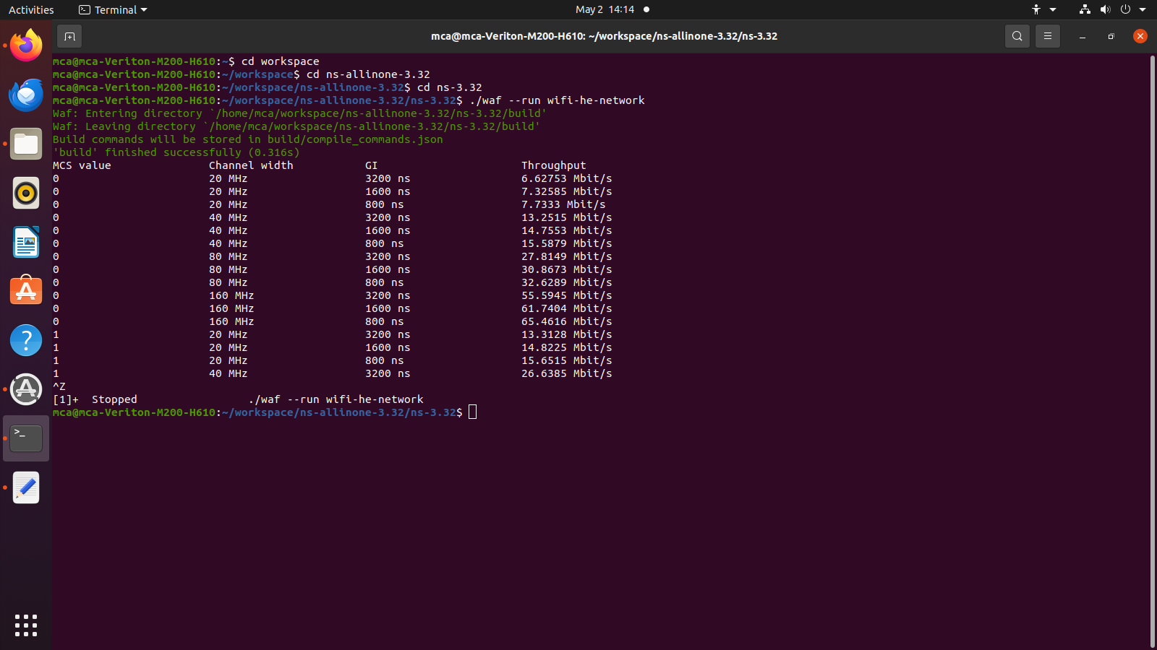

**Conclusion: -**

Successful implementation of wifi network.