**Finite Element Analysis of a Thin Plate with Hole**

CFD and FEA

Module Coordinator: Dr. S.L. Soo

Diljit Singh (2471090)

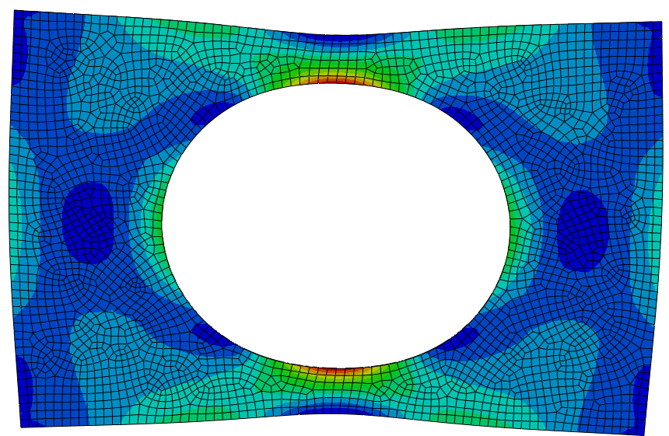

**Section A**

**Introduction**

This report examines the stress distribution in a thin rectangular plate with a central hole under tensile loading using Finite Element Analysis (FEA). The plate is made of Inconel 718, a superalloy widely used in high stress applications such as aerospace and power generation. The plate is subjected to a tensile force of 20,000 N, and later 85,000 N after the optimal mesh density is identified. The study focuses on the influence mesh size has as ‘it closely relates to the accuracy, computing time and efforts required meshing finite element models, which determines the complexity level’ (Shashikant T, 2015). Although the simulation is relatively simple, for more complex and computationally demanding simulations, simplifications and the identification of an optimal mesh density can significantly improve project efficiency.

**Aims**

The primary aims of this report are as follows:

1. Perform a series of simulations using Abaqus CAE on the thin rectangular plate with a central hole under tensile loading with the following mesh sizes:

|  |  |  |  |  |
| --- | --- | --- | --- | --- |
| * 30-60 | * 160-300 | * 600-1200 | * 2500-6000 | * ~9000 |

1. Investigate the influence of mesh density on the predicted maximum stress in the plate.
2. Validate the results using theoretical stress concentration calculations.
3. Repeat the analysis for a load of 85,000 N using the optimal mesh density determined.

Table : Parameters of Thin Plate with Hole

|  |  |
| --- | --- |
| **Parameter** | **Value** |
| Length (L) | 750 mm |
| Width (W) | 500 mm |
| Thickness (t) | 2 mm |
| Diameter (D) | 375 mm |
| Force (F) | 20,000/85,000 N |

Figure :Plate with Central Hole

**Methodology**

**Simplification**

In order to reduce computation times whilst preserving accuracy, a quarter of the plate was modelled due to its symmetry along both the midplanes. This allows for a reduced model complexity whilst making sure we obtain accurate stress predictions.

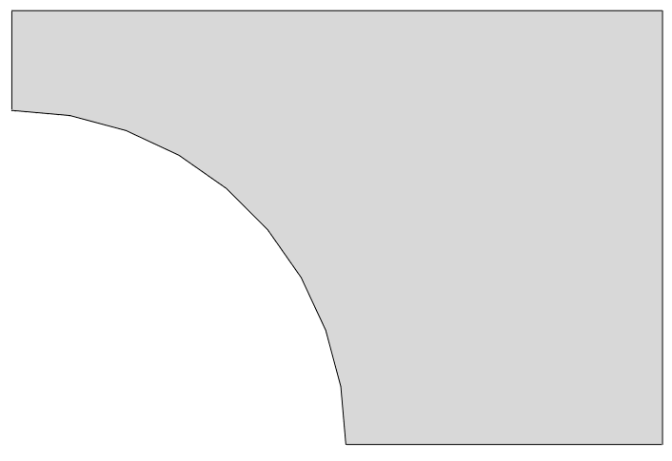

375 mm

250 mm

R192.5 mm

Figure : Simplified Model

**Methodology**

1. **Model Setup:** The plate was modelled using the dimension shown in Figure 2. The material properties of Inconel 718 were inputted as shown in Table 1:

Table : Material Properties of Inconel 718

|  |  |
| --- | --- |
| **Yield Strength** | 1186 MPa |
| **Ultimate Tensile Strength** | 1400 MPa (@ 15% strain) |
| **Young’s Modulus** | 200 GPa |
| **Poisson’s Ratio** | 0.3 |

1. **A blue and grey background

   Description automatically generatedBoundary Conditions and Loading:** Symmetry boundary conditions were applied along the horizontal and vertical midlines, as shown in Figure 3, to restrict movement in these directions. The loading condition of 20,000 N, as a pressure force, was applied to the right face of the plate. The boundary conditions along the midlines would not have had needed to be applied if it was modelled as a full plate since the forces are the same on both sides.

Figure : Boundary conditions on the midlines

1. **Meshing Strategy:** The simulation was done 5 times using 5 mesh densities:

* 30-60 elements
* 160-300 elements
* 600-1200 elements
* 2500-6000 elements
* ~9000 elements

Auto meshing was used across all 5 ranges to ensure consistency. It is the quickest and easiest method. The global mesh size was adjusted for each simulation to achieve the desired element count.

1. **Running the Simulation:** The simulation was executed and the maximum experimental force on the simulated model was recorded. The location of the amount of stress is shown on the render as show in Figure 3. The simulation was performed 4 more times with the rest of the

element sizes, whilst noting down the computational time and maximum stresses.

1. **Post-processing and Results:** Maximum Stress against the number of elements was plotted to generate a visual for determining the optimal mesh size. These results are validated using theoretical stress concentration calculations below.
2. **Regenerate:** The simulation was then repeated using the optimal mesh size with a load of 85,000 N. Then the displacement plot and contours were made.

**Results**

The result of the first mesh size is shown in Figure 4 and the last mesh size in Figure 5. The rest of the simulations are shown in the appendix.

From these figures you can see that as the mesh size increases, the accuracy and precision of the stress distribution increases.

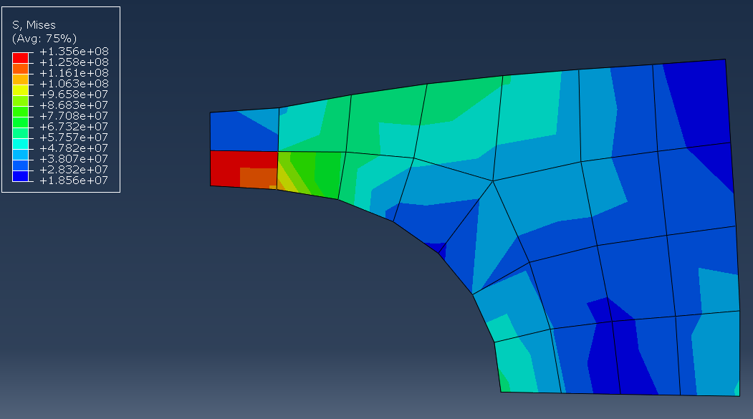

Figure : FEA of Mesh Size 46

1.729e

1.692e

Figure : FEA of Mesh Size 8890

Table 3 shows the results of all the iterations, including the number of elements, the time taken for the simulation to compute and the max predicted stress.

Table : Max Stress Results

|  |  |  |  |
| --- | --- | --- | --- |
| **Range** | **Elements** | **Time (s)** | **Max Stress** |
| **30-60** | 46 | 8 | 1.36E+08 |
| **160-300** | 230 | 8 | 1.59E+08 |
| **600-1200** | 982 | 8 | 1.70E+08 |
| **2500-6000** | 4028 | 10 | 1.72E+08 |
| **~9000** | 8890 | 12 | 1.73E+08 |

Figure 6 shows the graph plotted from Table 3. You can see there is a rapid rise in maximum stress at the start and it starts to plateau at around 1000 elements, therefore, the best mesh density range was 600-1200. The time also starts to increase after that from 8 to 10 seconds.

Figure : Solve Time vs Max Stress vs Number of Elements

Once figuring out the optimal mesh size from Figure 6, the simulation was done again for the force size of 85,000, using 982 elements. This result is shown in Figure 7.

Figure : 85,000 N on Plate using 982 elements

Figure 8 shows a contour plot, which provides a visual representation of how the plate deforms under the applied load, denoted by the legend on the left. The highest displacement occurs on the right, where the load is applied.

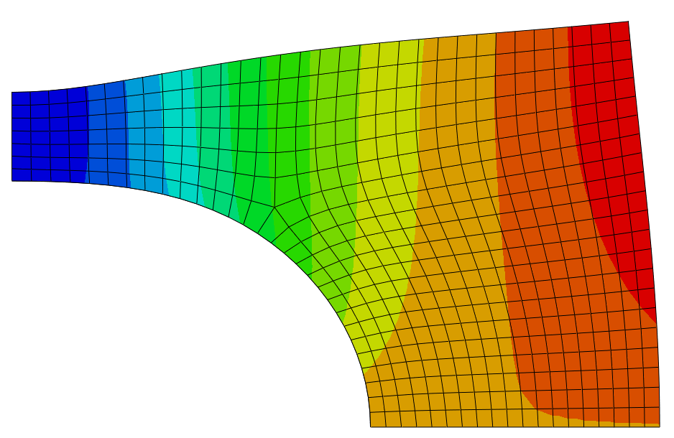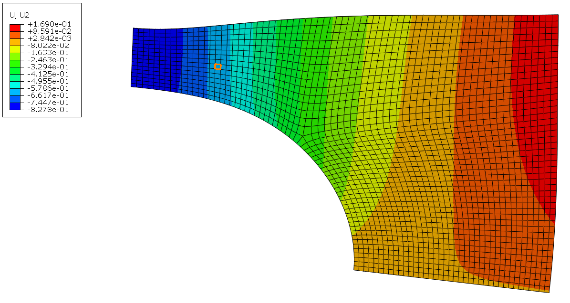

Figure : Contour Plot using 928 elements

This is further confirmed by Figure 9, where the displacement is shown in a graph, which shows a linear relationship.

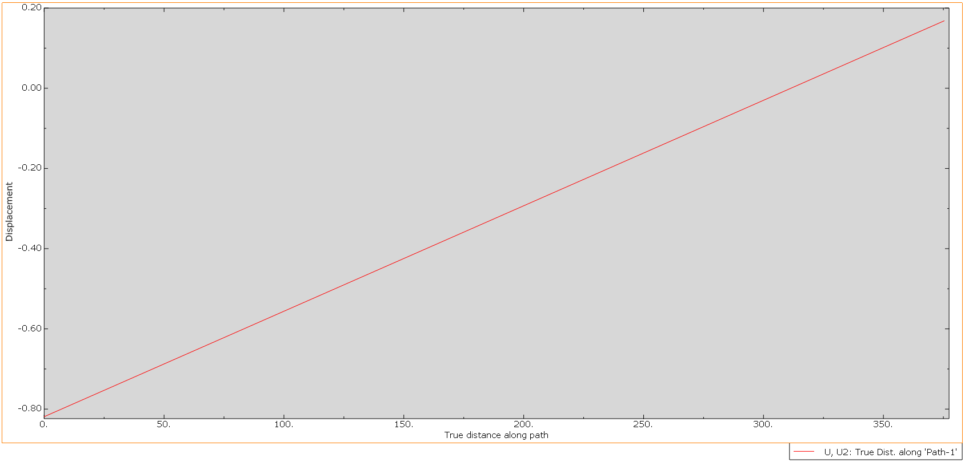

Figure : Displacement Plot

In order to validate these results, the calculations are shown below:

Where W is the plate width in the direction of the force, d is the hole diameter, t is the thickness, is the force applied and is found using equation 2.

The stress concentration is found using equation 3:

The max stress can be worked out using equation 4:

And the answer comes out to be 179,130,434.8 Pa or 1.79x108 Pa

From this answer we can see that the experimental prediction was quite close, with it being a little lower than the theoretical calculation. The slight discrepancies may be due to the assumptions made and also the simplifications in the theoretical calculations.

**Discussion**

The results demonstrate that increasing the mesh density has a significant effect on the precision of the stress predictions. This, however, happens until a certain point, as shown in Figure 4. As the curve starts to plateau at 1000 elements, this shows that going any higher will not have a significant effect on the accuracy but increase the computational time. This mesh density is a balance between accuracy and computational speed. Therefore, this mesh density was used to simulate the plate with 85,000 N. The maximum stress for this simulation was 8.134x108 Pa.

The comparisons between the FEA results and theoretical stress calculations validated the accuracy of these simulations. The slight differences between these 2 results highlight the limitations of model simplifications and the potential need for more complex boundary conditions/constraints.

Another simplification that could have been made was to make the plate 2D, which was done another similar study by Mekalke, G.C. in 2012. This could have reduced the computational time further as there would be less meshing. However, since the plate was so thin in this case, this would’ve made very little different. If this shape was more complex, the FEA simulations could be done via 2D analysis.

Something else that could be considered next time is the meshing type. Auto-meshing was used as it is the quickest and easiest to use. Manual meshing would allow for a much higher accuracy and allows for greater control of the distribution of elements, such as around the hole. ‘This method required good practice. Most of the industry practice uses this type of meshing’ (Mekalke G.C, 2012) While this method would increase computational time, a balance could be made to ensure you get the highest accuracy without increasing the time too much.

**Conclusion**

This study used a simplification of using a quarter model with symmetry boundary conditions to balance computational efficiency and the accuracy of the max stresses. The results demonstrated that the mesh density significantly influences tress prediction accuracy, with a plateau around 1000 elements, therefore the mesh density in the range of 600-1200 was identified as the most optimal range. Any further meshing proved to have no major effect on the accuracy of the stress predictions, and just further increased the times to compute. These were validated using theoretical stress calculations, with minor discrepancies due to assumptions and simplifications. Auto-meshing proved to be efficiency, however, in the future, manual meshing could be utilized to improve the accuracy of the maximum stress predictions. In addition, 2D analysis could provide further improvements to computational timing.

**References**

More, S.T. and Bindu, R.S., 2015. Effect of mesh size on finite element analysis of plate structure. *International Journal of Engineering Science and Innovative Technology*, *4*(3), pp.181-185.

Mekalke, G.C., Kavade, M.V. and Deshpande, S.S., 2012. Analysis of a plate with a circular hole by FEM. *Journal of Mechanical and Civil Engineering*, pp.25-30.

**Appendix**

FEA of the 2nd, 3rd and 4th simulations

1.587e

1.702e

1.682e

1.718e