**Table of Contents**

**Chapter Title Page no.**

**Forwarding letter 3**

**Preface 4**

**Acknowledgement5**

**List of illustrations 2**

**Abstract 6**

**1.0 Introduction7**

**1.1 Background of the study7**

**1.2 Statement of the Problem7**

**1.3 Purpose of the Study7**

**1.4 Types of Social media 8**

**1.5Research Questions 8**

**2.0 Methodology 9**

**2.1 Method used 9**

**2.2 Selection of subjects/participants 9**

**2.3 Data analysis 9**

**3.0 Findings and Analysis12**

**3.1 Findings12**

**3.2Analysis of the result14**

**4.0 Conclusion 14**

**4.1 Summery 14**

**4.2 Limitations 14**

**5.0 Recommendation 15**

**6.0 References 15**

**List of illustration**

**Page**

**Figure: 01-** Why using social media 10

**Figure: 02-**Hours spend on social media 10

**Figure: 03-**Social media effecting study 11

**Figure: 04-**Media used for academic purposes 11

**Figure: 05-**5 Essential for todays’ life 12

11/12/2018

To, Jannatul Farhana, Course Instructor, Business Communication, American International University-Bangladesh

**Subject: Submission of our report**

Dear Madam,

I have the pleasure to submit our report titled ‘Impact of social media in academic life’. The report gave me the opportunity to know the effect of social media in students’ academic life.

My research was on the impact of social media on academic life. I sent questionnaire to couple of university and college going students. So, the data was collected by questionnaire.

From the research I found out that, social media does not have significant effect on academic life. Rather it is quite useful for the students gathering knowledge.

I thank you for giving us the chance to do this report.

Yours sincerely,

Ahmed Tanvir

15-30435-3

On behalf of,

Group-04

**Preface**

In this report we tried to find out how social media is effecting students’ academic life. Mainly we did research on how students using social media for academic purposes and how much time they are using on social media. We categorized the age, usage and made analytical research on it. Our subjects were 10 current students from AIUB, Stamford University Bangladesh, Adamjee Cantonment College,BirshresthaMunshiAbdurRouf Public College, Jalalabad Cantonment College, Sayed Sayeed Uddin University College. We gave them questionnaire and collected quantitative data. From the analysis we made a statistic report and this statistical data’s showed the overall scenario of the impact of social media.

**Acknowledgement**

I am heartily thankful to our course instructor, whose encouragement, supervision and support from the preliminary to the concluding level enabled us to develop an understanding of the subject.

I am thankful to all the students who participated of this study. We greatly appreciate their sincere co-operation.

Also I want to thank some of my friends who helped me with collecting all analytical data.

Lastly, we offer our regards and blessings to all of those who supported us in any respect during the completion of the study.

**Abstract**

Online networking is quickly changing the correspondence setting of the present social world. The new of web based life is altogether affecting the academic life of students. Foundations and academician are consistently attempting with online networking advances wanting to energize basic reasoning abilities, joint effort, and information development. Today internet based life has been acknowledged by higher establishment making it a stage where student interface with their teachers, other students and other higher experts in all cases. This subsequently required the examination to investigate and analyze how internet based life has affected on students’ academic life. The investigation entreated a quantitative methodology in surveying these effects. Survey was sent to tenstudents. Subsequent to concentrate the marvels that were important to the investigation, and interpreting the different reactions of the students the outcome uncovers that online networking is generally utilized by students and that they are in support of the possibility that social media contributes a huge quantity to the advancement of their academic life.

1. **Chapter 1: Introduction**

**1.1 Background of the study**

Social media such as Facebook, Twitter, Google Plus, and Flickr, are being used in learning for the purpose of convenient communication with other students and potentially with others outside the class such as students of the same topic and subject experts. The advent of social media has impacted significantly on how students learn and how instructors teach. Today in education system, social media has influenced instructors, students, and others to cooperate with each other. Social media applications can strengthen class material and positively influence collaborative work and authoring. Educators and researchers are constantly experimenting with social media technologies hoping to stimulate critical thinking skills, collaboration, and knowledge construction. However, the fact that these medias are generally open to the world implies a need to carefully consider its’ benefits, impacts and risks of openness as well as need for ongoing communication with students in order to address their concerns and deal with issues in the use of social media as they arise.

**1.2 Statement of the Problem**

With the explosive growth in the number and use of social media in everyday communication method for individuals and organizations, there has been a corresponding increase of its incorporation in learning in the educational institutions. In view of this, this study examine and assess the impact social media on academic life of students.

**1.3 Purpose of the Study**

This study was purported to assess the impact of social media on students’ academic life. It aims at exploring the kind of social media students are familiar with, how such social media is used by students and the impact it is making on their academic life.

**1.4 Types of Social media**

There are so many social medias out there. But in perspective of Bangladesh,

there are few social media that are very popular. And they are:

* Facebook
* Google+
* Instagram
* WhatsApp
* Viber
* YouTube

**1.5 Research Questions**

The main research question of the study was ’’has social media has distinctive impact on students’ academic life?” To answer this question and analyze how this impact has taken place, the following questions were considered:

* Why do you use social media?
* How many hours you spend on social media?
* What do you prefer to share notes/lectures?
* How is social media is effecting your studies?

1. **Chapter 2: Methodology**

**2.1 Method used**

This section will explain the research methodology used for the research under study. The overall design or strategy that helps in obtaining the desired goals and objectives of the research is referred to as research methodology. It is basically a confirmation that the problem under study has been analyzed and addressed thoroughly. This gives effectiveness and completion to the research.

In this report we used quantitative data.

As a statically analytical report the main method we used is quantitative method. Because we needed to made statistic on hours’ students spend on social media, number of students using it for academic purposes and some other questions to find out more about the impacts and then compared all the data’s. So quantitative should be used to make such an analytical statistic.

**2.2 Selection of subjects/participants**

In this research, qualitative data is involved. The preferences of students to use social media, their usage and duration of use belong to qualitative data. The data for this research study will be collected using a distrusted questionnaire; the data of questionnaire was collected from 10 participants which will be using as the primary source of data for the analysis of this study and that will lead this research study to the investigation of the impact of social networking websites on students’ academic life.

Among the 10 participants, 5 of them are university students and 5 of them are college students. The reason is that they are at a certain level of age where they can understand the cause and will support our study by giving their honest opinions.

**2.3 Data analysis**

In order to extract useful results for reaching a strong conclusion and decision-making, it is important to analyze the data. The procedure of transforming all the obtained data into useful data and then obtaining a clear conclusion about the data is the process of analysis. Analysis process also includes examining the data, building relation of different data types with each other and trends of different factors. The questionnaire was created in the ‘**docs.google.com/forms’** and participants answered them. It is a very friendly tool for doing online survey. After receiving all the data, it automatically created the graphs based on the data.

Graph and analysis:

2.3.1 Why using social media-

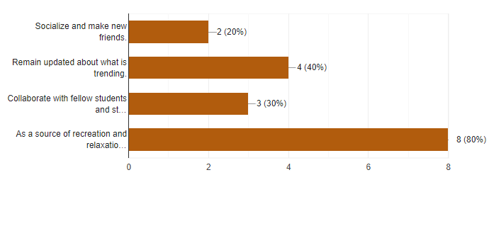

**Figure: 01**

So, as shown in the figure, about 80% of students use it for recreation and relaxation.40% of them use to remain updated and 30% of them only use to connect with other students.

2.3.2Hours spend on social media-

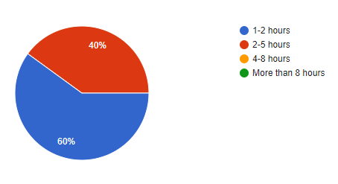

**Figure: 02**

The data showed that most of the students spend 1-2 hours daily on social media. This statistic might be different if we had added school going students.

2.3.3 Social media effecting study-

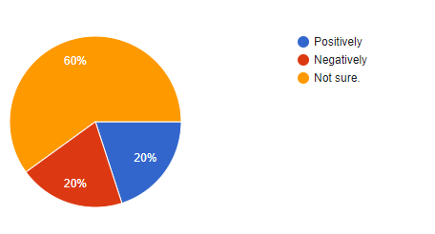

**Figure: 03**

When it was asked how they think social media is effecting their study, they seemed confused. But we also find out that there is a contradiction between how they think it is positively and negatively affecting their study.

2.3.4 Media used for academic purposes-

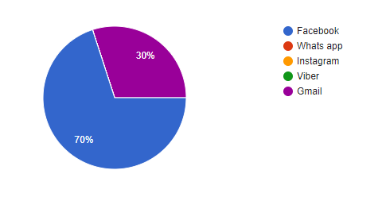

**Figure: 04**

When the students were asked what social media they prefer to share notes/lectures 70% of them choose facebook because of its’ user friendliness. They can attach notes while texting them. Only 30% of them selected Gmail. Students use mostly Gmail for exchanging larger files.

2.3.5 Essential for todays’ life-

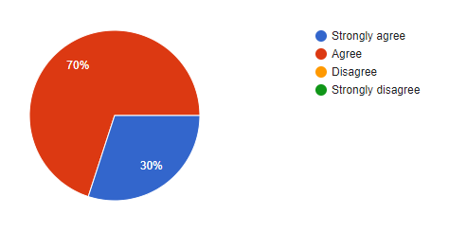

**Figure: 05**

When it was asked about how necessary is social media for todays’ life the results were shocking.70% of student agreed and 30% of them strongly agreed. So everyone thinks it is needed for daily life.

1. **Chapter: Findings and Analysis**

**3.1 Findings**

The reason for using social media from figure 01 we can find the following results:

|  |  |
| --- | --- |
| REASON | PERCENTAGE |
| Socialize and make new friends | 20% |
| Remain updated about what is trending | 40% |
| Collaborate with fellow students | 30% |
| As a source of recreation and relaxation | 80% |

The hours they spend on social media:

|  |  |
| --- | --- |
| HOURS | PERCENTAGE |
| 1-2 hours | 60% |
| 2-5 hours | 40% |
| 4-8 hours | 0% |
| More than 8 hours | 0% |

The effect of social media on study:

|  |  |
| --- | --- |
| EFFECT | PERCENTAGE |
| Not sure | 60% |
| Positively | 20% |
| Negatively | 20% |

The social media they use most for academic purposes:

|  |  |
| --- | --- |
| SOCIAL MEDIA | PERCENTAGE |
| Facebook | 70% |
| Gmail | 30% |
| Whatsapp | 0% |
| Viber  Instagram | 0%  0% |

The response when they were asked about essentiality of social media in todays’ life:

|  |  |
| --- | --- |
| OPTION | PERCENTAGE |
| Agree | 70% |
| Strongly agree | 30% |
| Disagree | 0% |
| Strongly disagree | 0% |

**3.2Analysis of the result**

The results of the current research indicate that most of the students are confused about social media proving to be helpful in their studies. Less than half of them agree on social media proving to have negative effects on their studies by any means. Also about same percentageof the students agree on social media proving to have positive effects on their studies by any means.

**4.0 Chapter: Conclusion**

**4.1 Summery**

This study focused on the impact of social media on students’ academic life. After studying the phenomena that are of interest to the study, and transcribing the various responses of the participants, the results reveals that social media is widely used by students. At least every student makes use of one social media. Moreover, data revealed that, participants are in support of the idea that social media contribute a significant quota to the development of their academic life.

**4.2 Limitations**

A few impediments can be identified for this research project. The study was led with a small group of subjects under study selected from universities and colleges and this may restrict the generalization of the discoveries to the entire educational institutions. Greater investigationsincluding students over all schools, colleges and universities can lead to empower speculation. The focus of the current research work is, however, not generalization but rather an activity research and analyses of the impacts of social media on this particular group of students.

**5.0 Chapter: Recommendation**

The usage of social media does not significantly impact on the students’ real social life and grades as well. As a matter of fact, this study showed that social media can prove to be a helpful research tool for students and can help them in their studies. However, the results of the current study, majority of the students spend at least 2 hours on social media daily. In order to solve this problem, conclusion drawn by Akubugwo, Ijeoma and Maria Burke in their study can be helpful. The study indicated that automatic software program that will shut down after a certain time, should be used to control its utilization by students.

**6.0 References**

[1] Akubugwo, Ijeoma and Maria Burke, “Influence of social media on social behavior of post graduate students. A case study of Salford University, United Kingdom”, IOSR Journal of Research & Method in Education (IOSR-JRME),Volume 3, Issue 6, pages 39-43, 2013

[2] “The history of social media”, [Online] Available: <http://historycooperative.org/thehistory-of-social-media/>

[3] “Social Media Facts and Statistics you should know”, [Online] Available: http://www.jeffbullas.com/2015/04/08/33-social-media-facts-and-statistics-you-shouldknow-in-2015/

[4] Chuck Martin, “Social networking usage and grades among college students, A Study to Determine the Correlation of Social Media Usage and Grades”, [Online] Available: http://www.unh.edu/news/docs/UNHsocialmedia.pdf