**Symmetric coexistence**

1. **Setup**

**Finite Hill coefficient, e.g. $n=5$.**

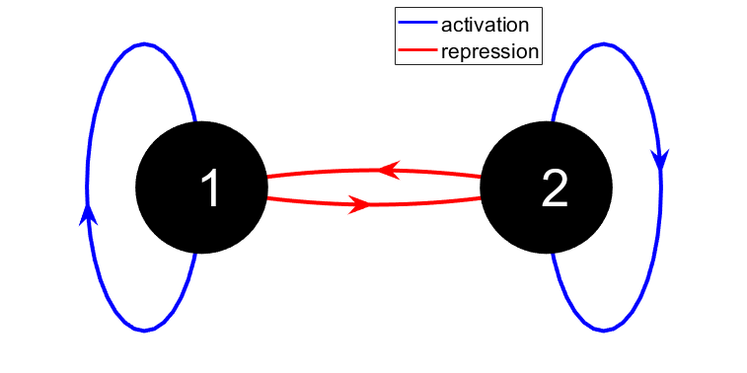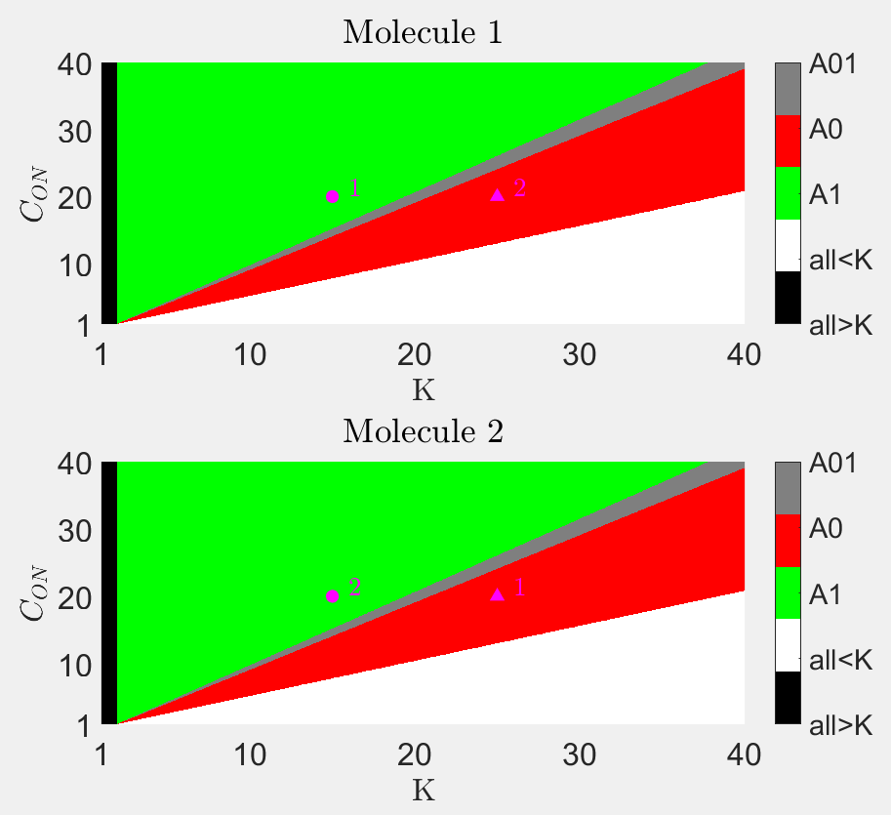

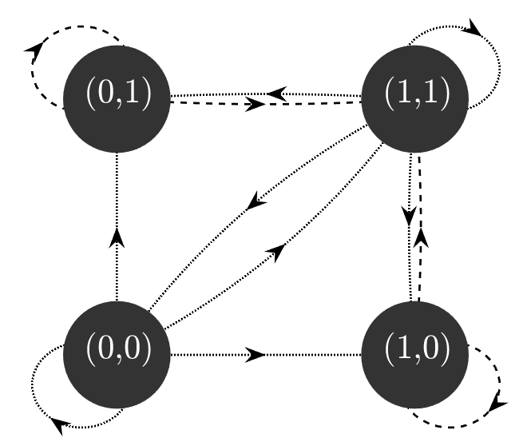

1. Results

Unstable equilibrium? Slightly tweaking the parameters will lead one of the genes to dominate.

1. Slightly changing $λ_{12}≡λ_{2}/λ_{1}$ will shift the balance in favour of the gene with longer diffusion length.
2. System seems more sensitive to $λ_{12}$ than to other parameters that break the symmetry between genes 1 and 2.
3. Adding noise also causes the system to be stochastically driven toward one of the states.
4. Increasing $a_{0}$ leads to quick dominance of one of the species.
5. Decreasing $a_{0}$ leads to deactivation of both (leading to OFF-OFF states).
6. With infinite Hill coefficient, system gets stuck immediately, but introducing noise `liberates’ the system to allow for more dynamical behaviour.
7. System transitions gradually from `smooth’ dynamics to quick equilibration as Hill coefficient is increased.
8. System is also unstable with respect to initial conditions. Having slightly higher initial $p_{i}$ tilts the dynamics in favour of the gene. This is less prevalent with randomized lattices as clusters of the gene with less favourable initial conditions can survive.
9. Hence randomized lattices may help stabilizing coexistence.

Interpretation: stable coexistence can never occur, requires far too fine-tuned parameters.