Made by Md. Hasibur Rahman.

6th Sep, 2021.

XAMPP distribution where

=======================

* Environment setup:-

====================

1. XAMPP Version : 8.0.10

2. Mysql Version: 15.1 Distrib 10.4.21-MariaDB,

3. PHP Version : 8.0.10

Reporting and Logging module installation

=========================================

Add include directory for php into apache configuration file

------------------------------------------------------------

1.For xampp add the following line in php.ini file

include_path = ".;c:\xampp\includes"

Install Zend Framework

----------------------

1. Unzip 'lib/ZendFramework-1.11.5-minimal.zip'

2. take 'library\Zend' folder into 'includes\Zend' directory of xampp directory like 'C:\xampp\includes\Zend'

Install PHPExcel Framework

--------------------------

1. Unzip 'PHPExcel-1.7.6.zip'

2. take all files and folder of 'Classes' into 'includes\PHPExcel' directory of wamp directory like 'C:\wamp\includes\PHPExcel', 'C:\wamp\includes\PHPExcel\PHPExcel.php' and 'C:\wamp\includes\PHPExcel\PHPExcel\*'

==========================

* Development guide:-

==========================

Edit build.properties

---------------------

1. Open /robi-ldma/build.properties

2. Edit the xampp.home directory to the place where your xampp folder is located

Edit global.inc.php

-------------------

1. Open /robi-ldma/classes/common/global.inc.php

2. Find global $baseUrl;

3. Here, now the port selected is 9090. Change it according to the port your tomcat is running.

SQL Database

------------

1. Open /robi-ldma/sql/dbscript.sql

2. Copy whole text inside the file except the first line "drop database if exists robi_ldma;"

3. Open MySql or go to http://localhost:8080/phpmyadmin/ --> click SQL tab --> paste --> press go

4. Go to cmd.

5. C:\xampp\mysql\bin\mysql.exe -u root ldma.20th_sep <C:\Users\user\Downloads\ldma.20th_Sep.sql

6. Run this path on cmd

SQLYOG File Import

(SQLYOG Version-12.3.2 Community Edition)

-------------------

1. Create a new connection on sqlyog than ldma-sp.view- & ldma-functions- file run those two files.

Deploy The Project

------------------

1. Open the build.xml using ANT

2. Run deploy-web

RUN The Program

---------------

1. http://localhost:8080/robi_ldma/view/common/login.php

2. User Name : admin

3. Password : admin

Try these different settings in php.ini

Find:

post_max_size = 8M

upload_max_filesize = 2M

max_execution_time = 30

max_input_time = 60

memory_limit = 8M

Change to:

post_max_size = 750M

upload_max_filesize = 750M

max_execution_time = 5000

max_input_time = 5000

memory_limit = 1000M

Change max_execution_time as the following

max_execution_time = 300

=================================

Datasource, logger, global, mailconfig

Linux Schedular

*/1 * * * * /usr/bin/wget -v -O /var/www/html/robi_ldma/view/temp.txt http://localhost/robi_ldma/view/common/schedular.php

Updated Version Problems-

Problem No -01

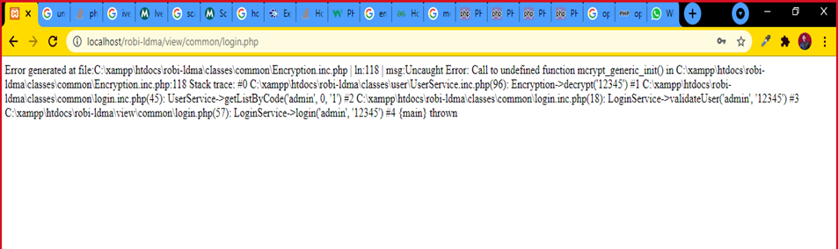

Here Mcrypt functions is no longer support in latest version of PHP so I replace the whole encryption and decryption code with Openssl functions.

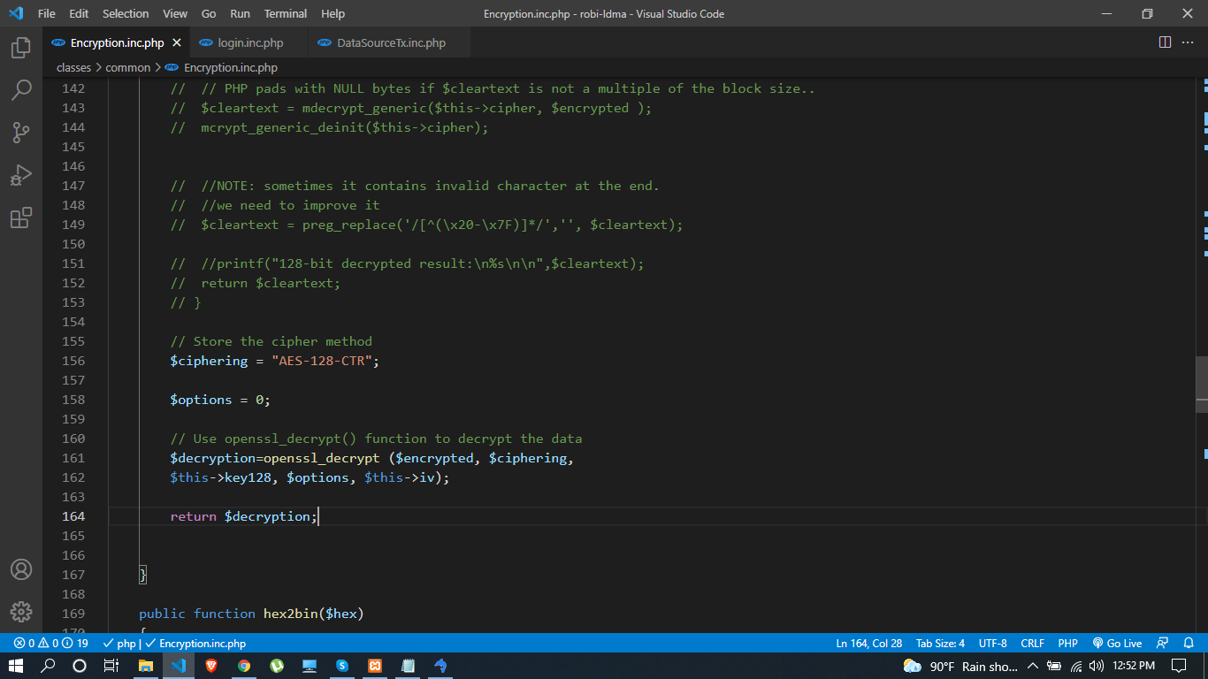

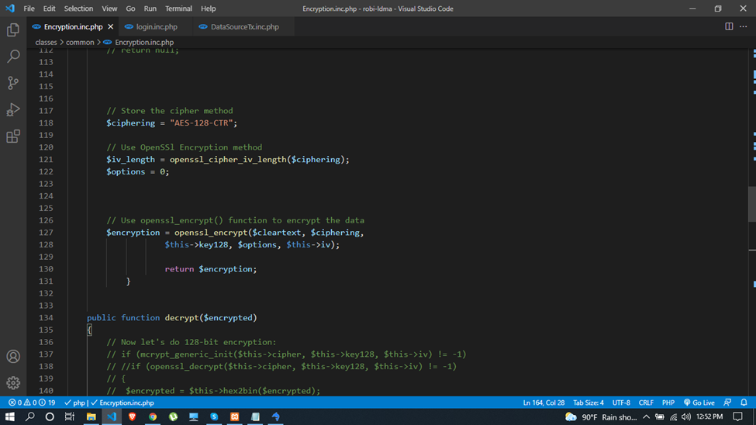

Now problem is new encryption and decryption method is not match with previous login password.

For this I set the password in database which is also same as previous “admin” but with new encrypted value which is (rloUPKY).

And here is my code:-

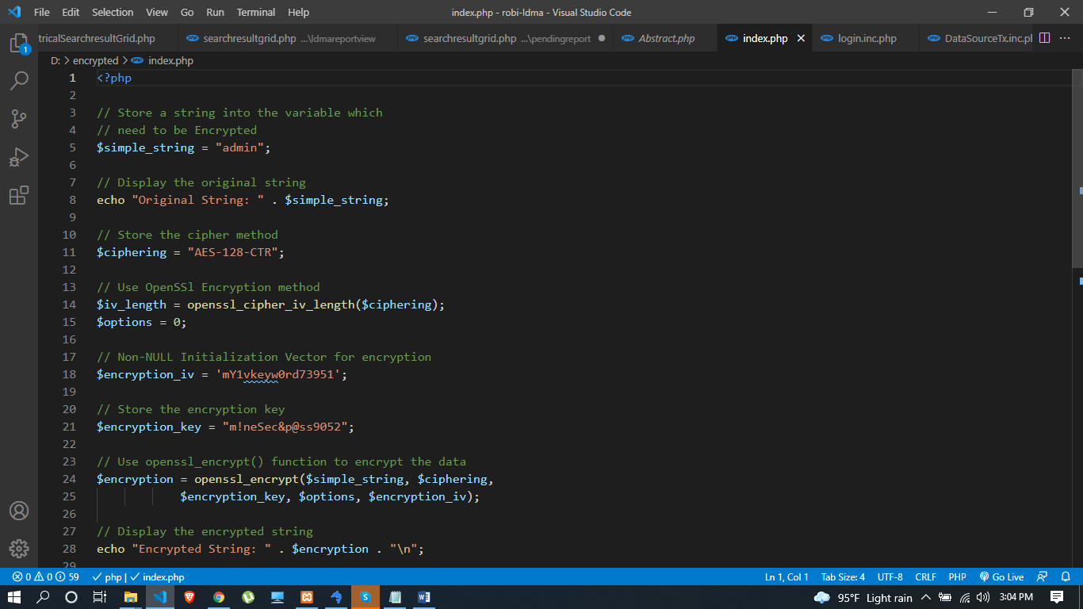

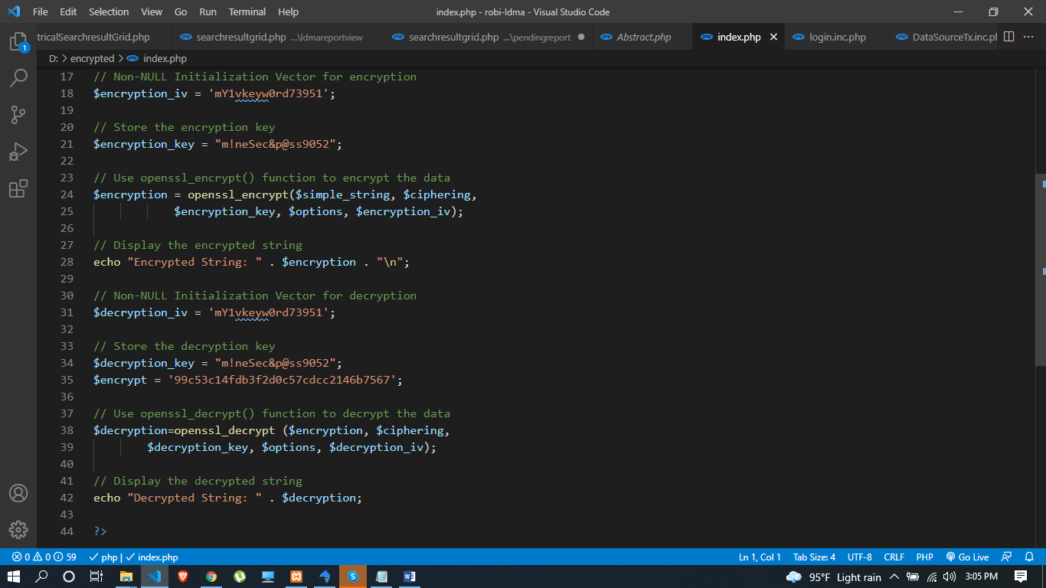

That’s how I solve this problem. Now we just update our previous user’s password and every things will working properly.

Problem No -02

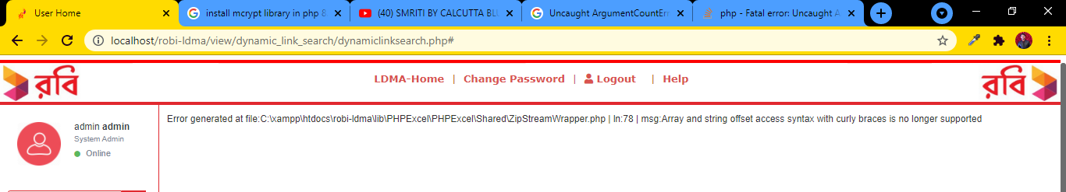

This problem faces in several time.

Array and string offset access syntax with curly braces is no longer supported. So I replace all curly braces with square brackets ([ ]).

Problem No -03

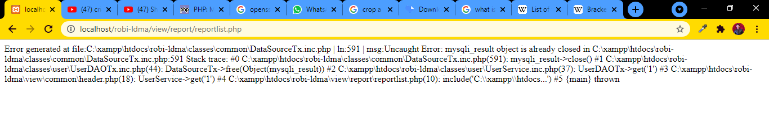

Here, mysqli_result object is already closed, that’s why I commented out the close method. After that it is working fine.

Problem No -04

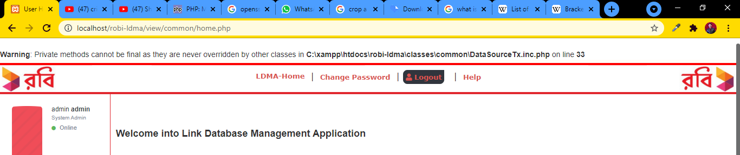

I undo final keyword here than it works properly.

Problem No -05

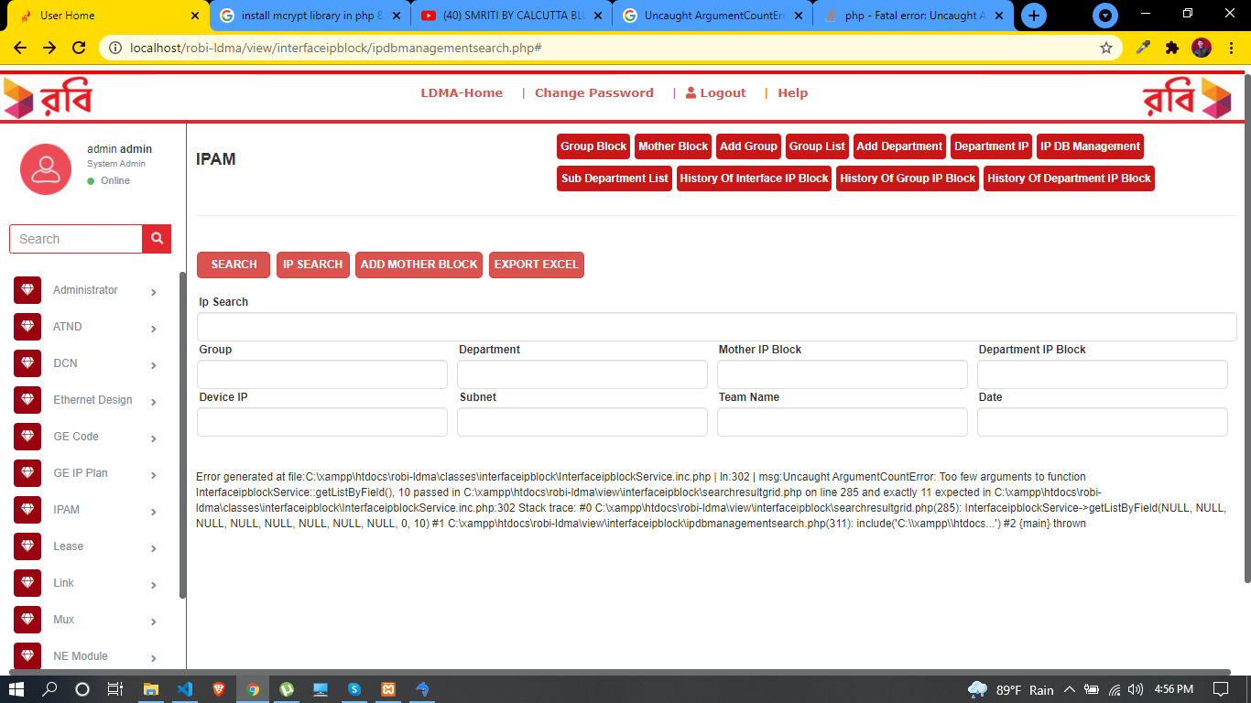

This problem has been generated here because the getListByField () function requires 11 parameters, but here 10 passed. Here $code parameter is missing.

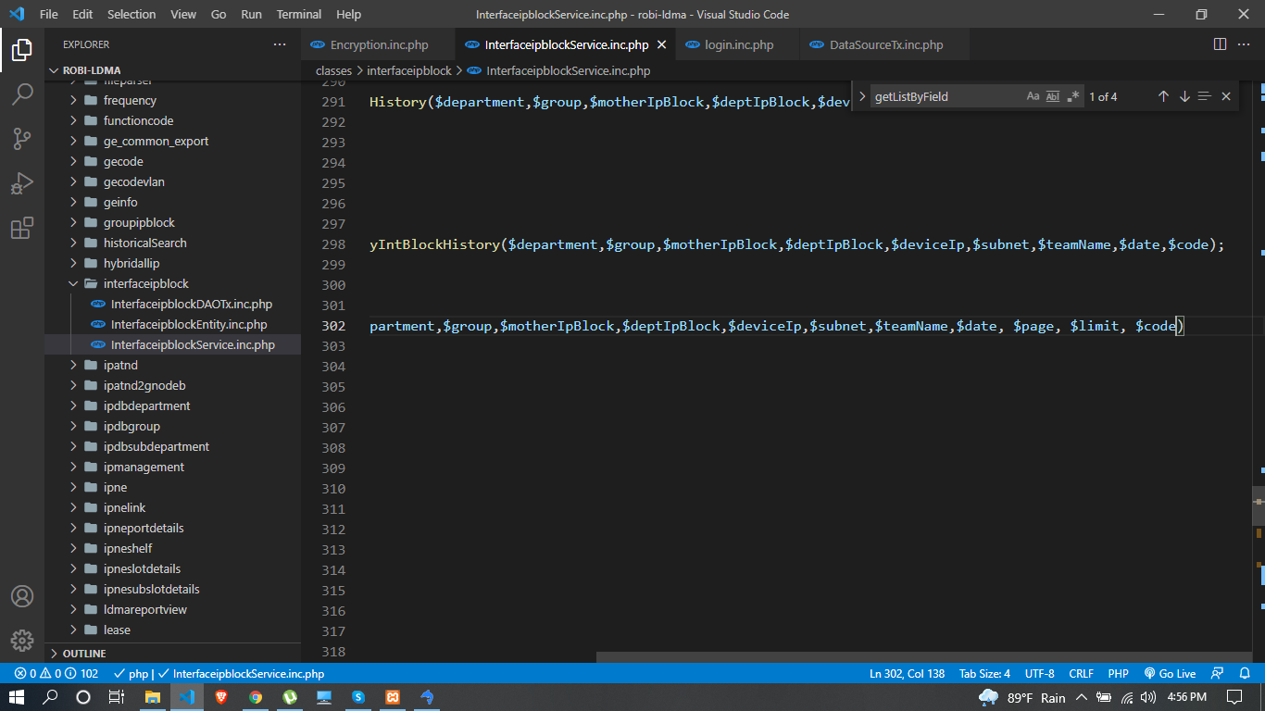

Problem No- 06

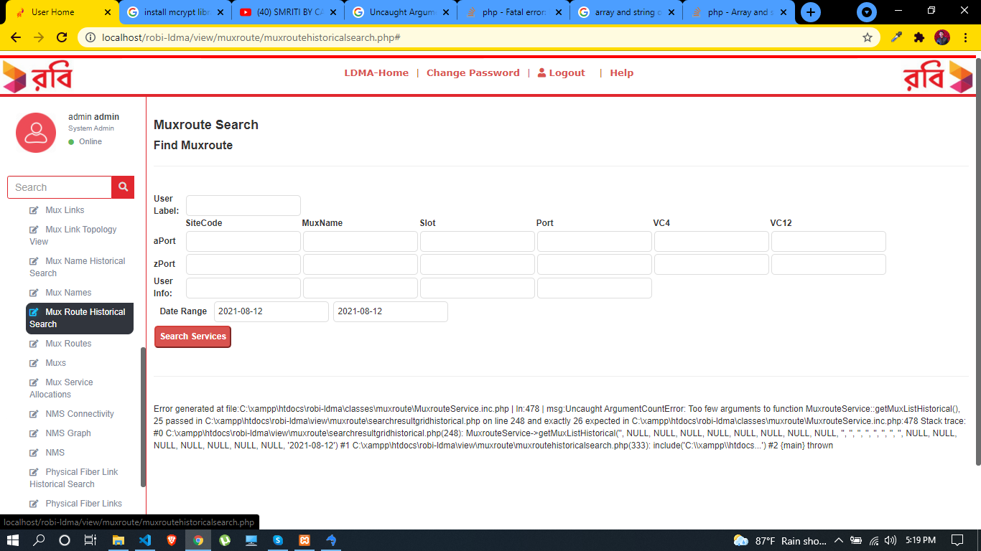

This problem is like as problem no- 05.

Problem No- 07

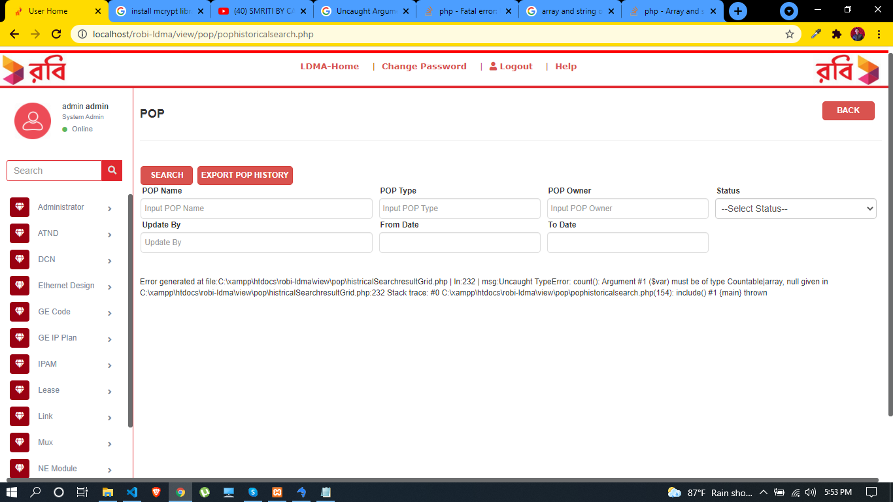

Here, count function need a countable array, but here uncountable array is passed. So I move it in an if condition to check the array is null or not.

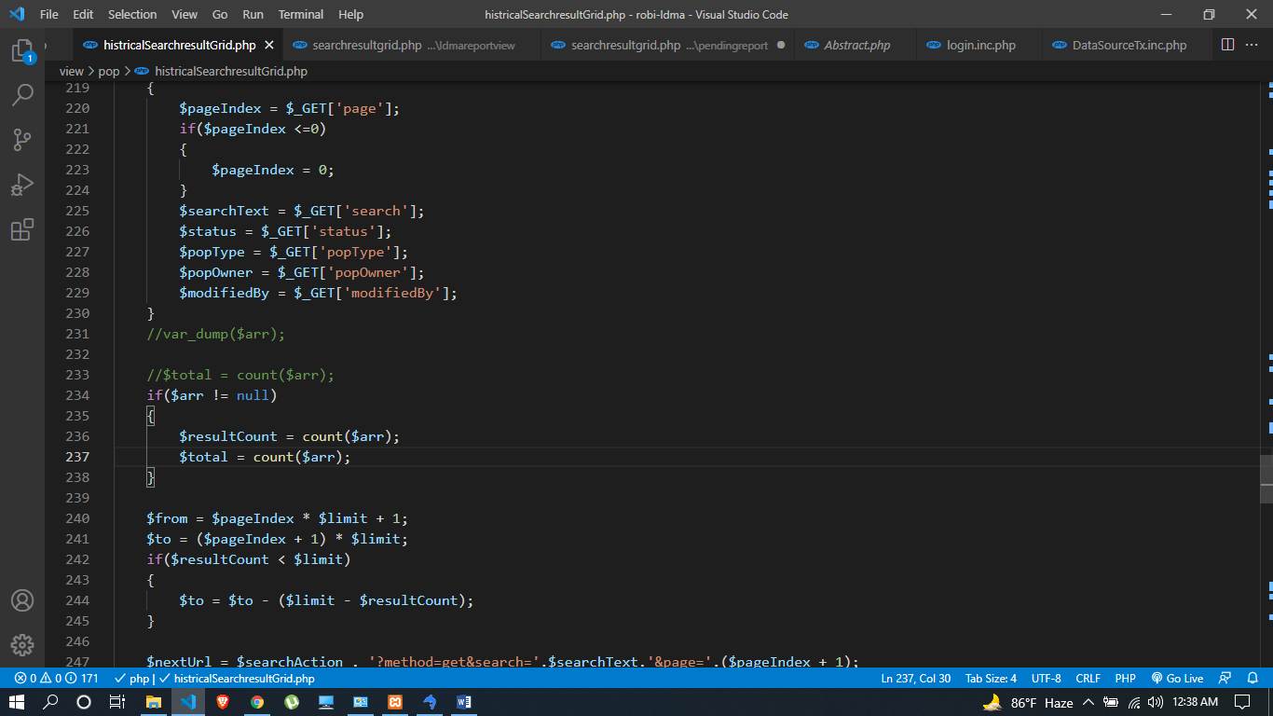

Problem No- 08

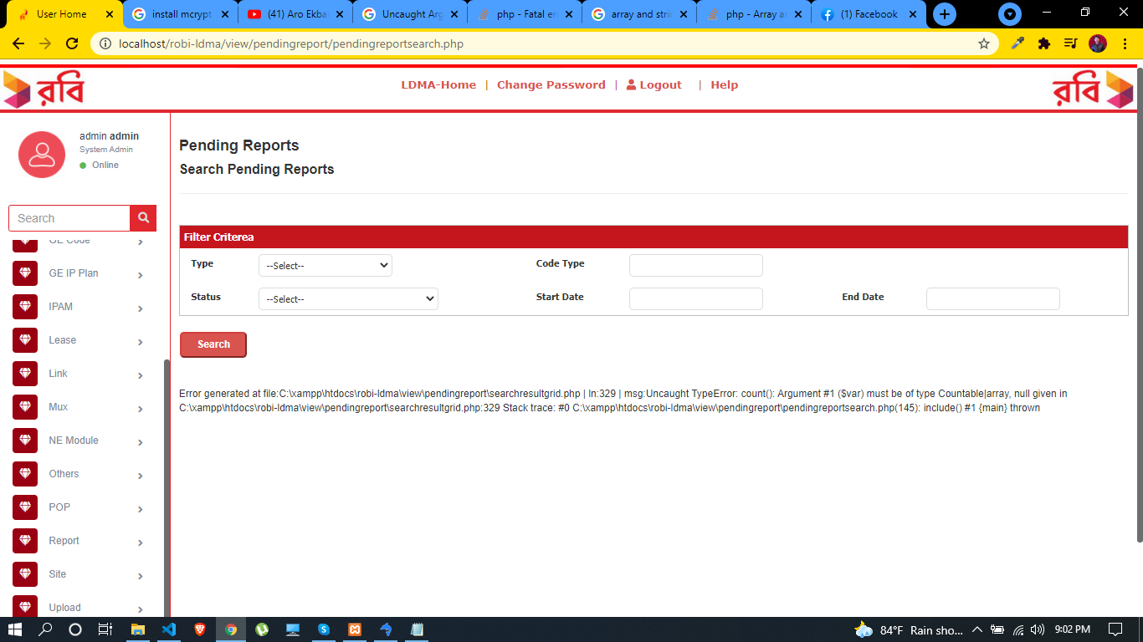

This problem is similar as problem no- 07.

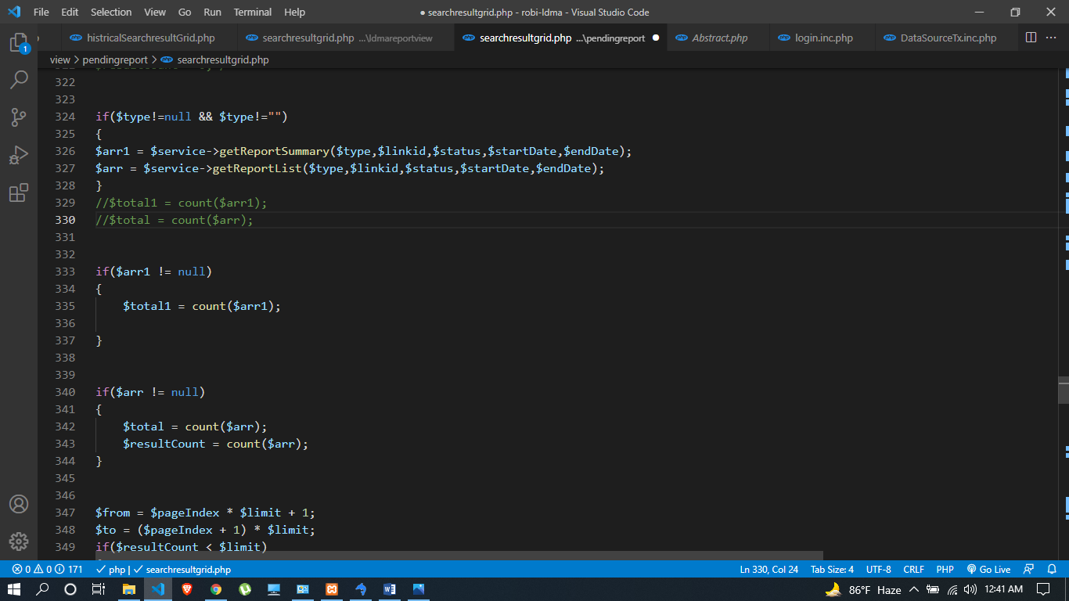

Problem No- 09

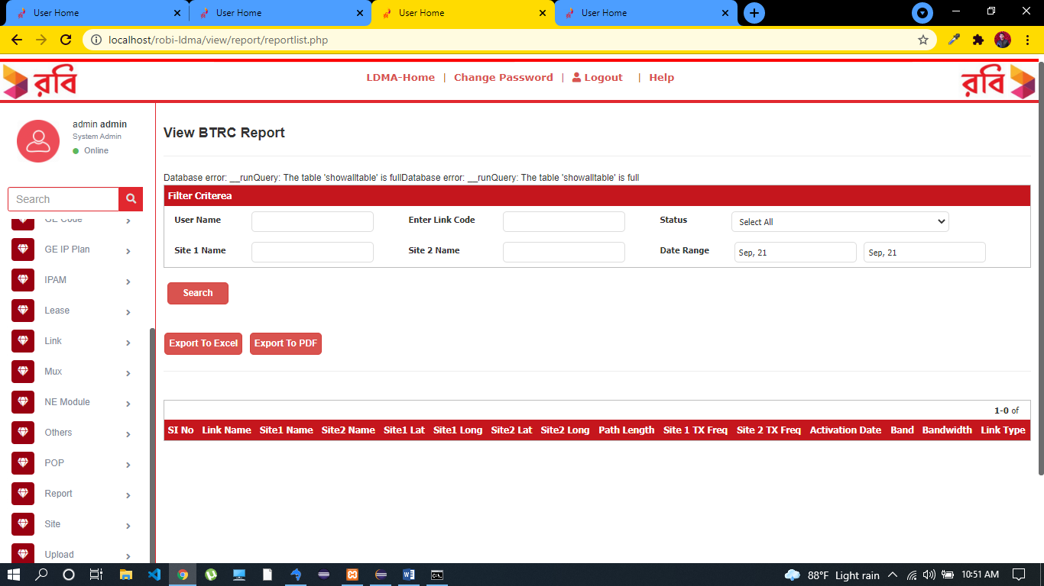

I can’t solve this issue.

Problem No- 10

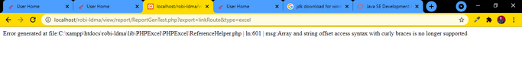

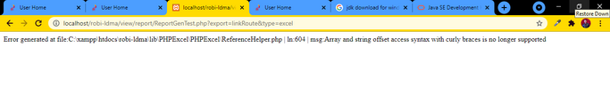

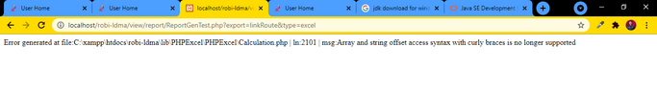

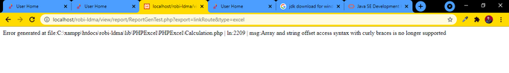

We face this kind of issue several times and we fixed it same way we did before in problem no-02.

Problem No-11

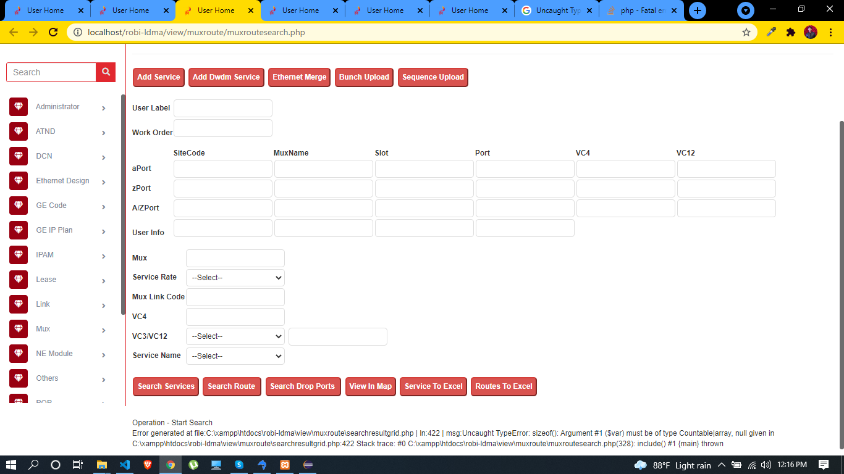

This kind of problem we fased before in problem no-07 & problem no-08.

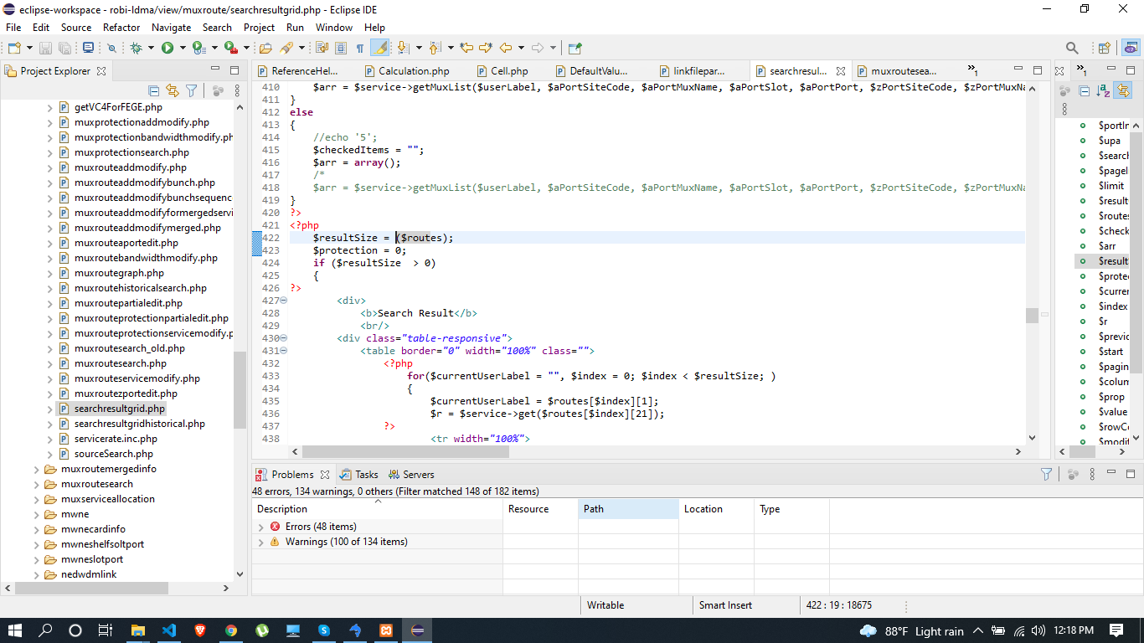

Problem No-12

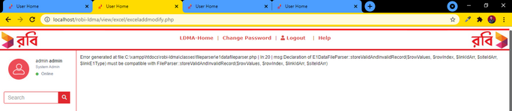

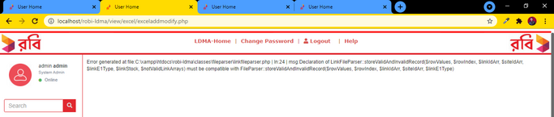

In parent class a method is declared with four parametes but when we call this method in extand classes with more than four parameters it shows those errors. I try to overload this method in patent class with more than four parameters it gives duplicated error message. I am not able to find this solution.

Problem No-13

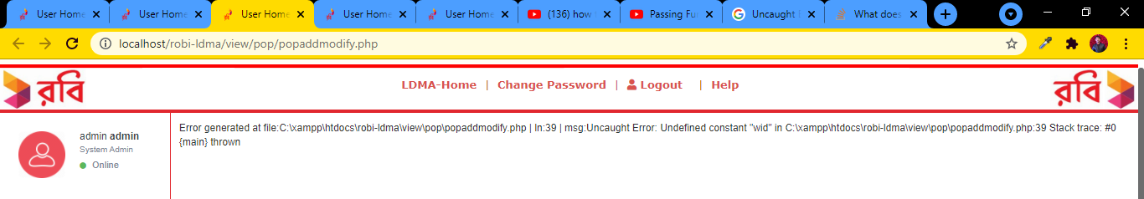

This problem is solved.

Problem No-14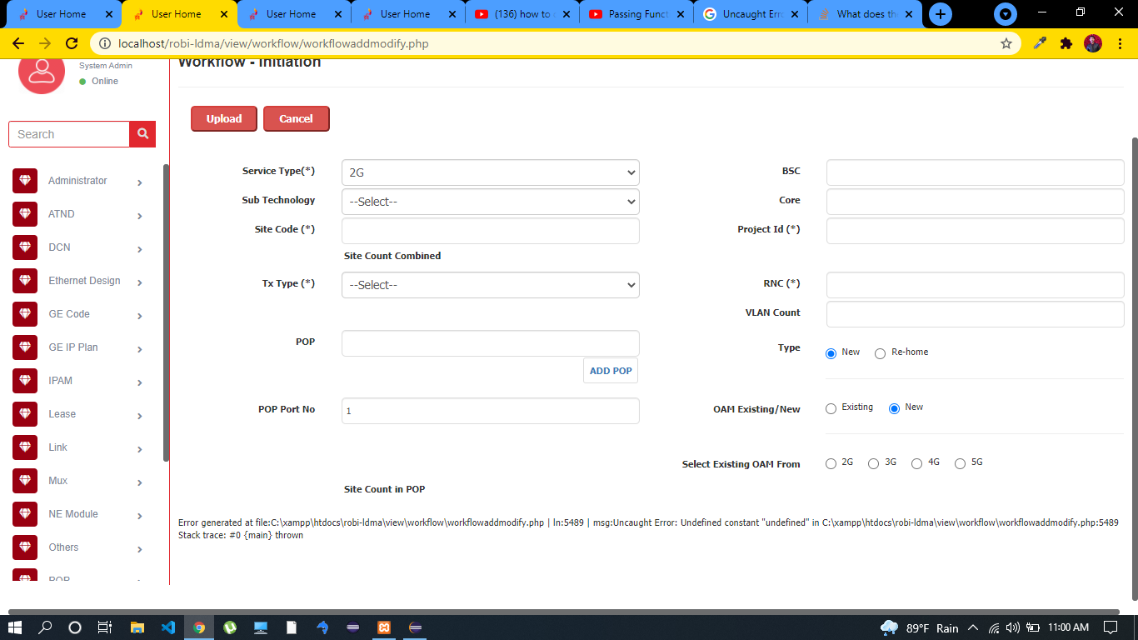

This also solved and this kind of problem find several place all are solved.

Problem No- 15

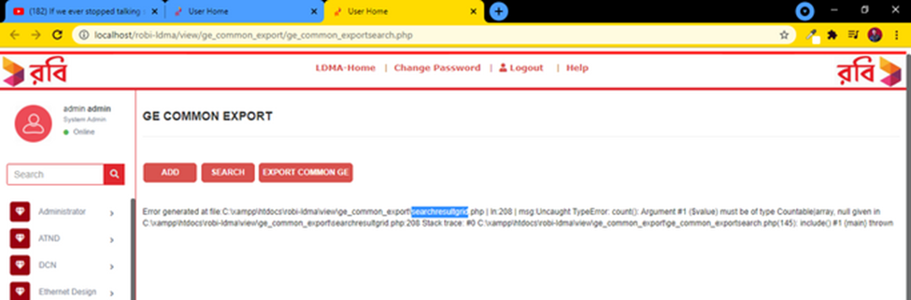

This problem is simmiler as problem no-7.

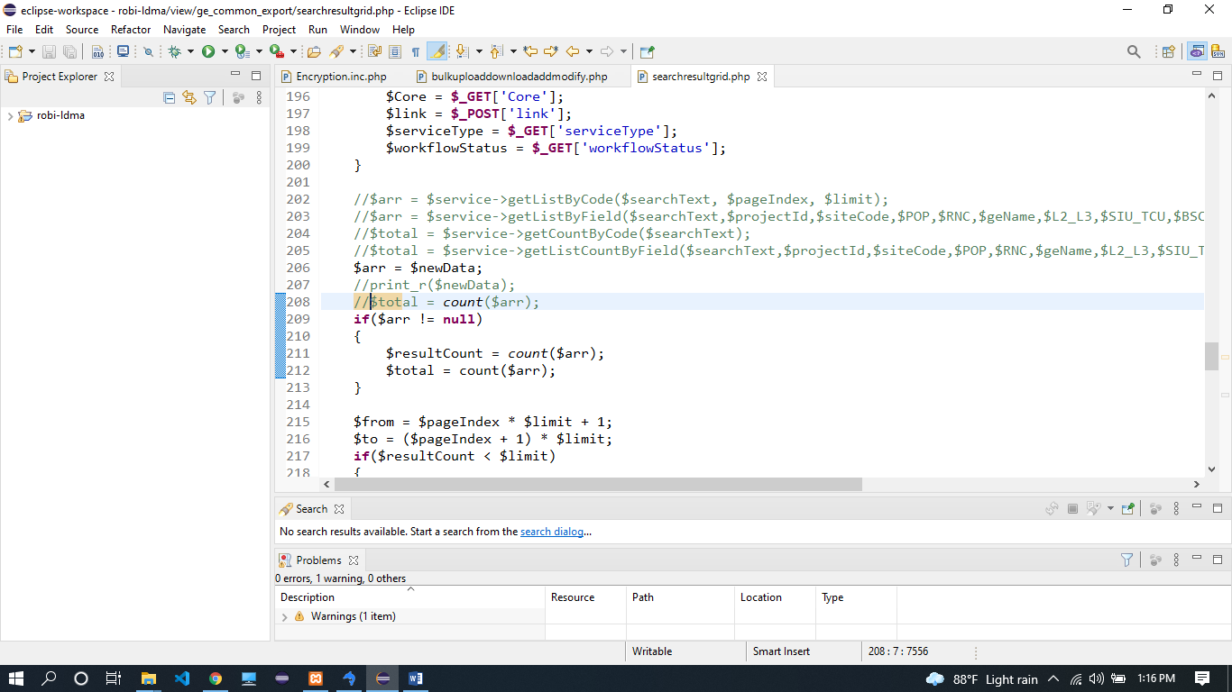

Problem No – 16

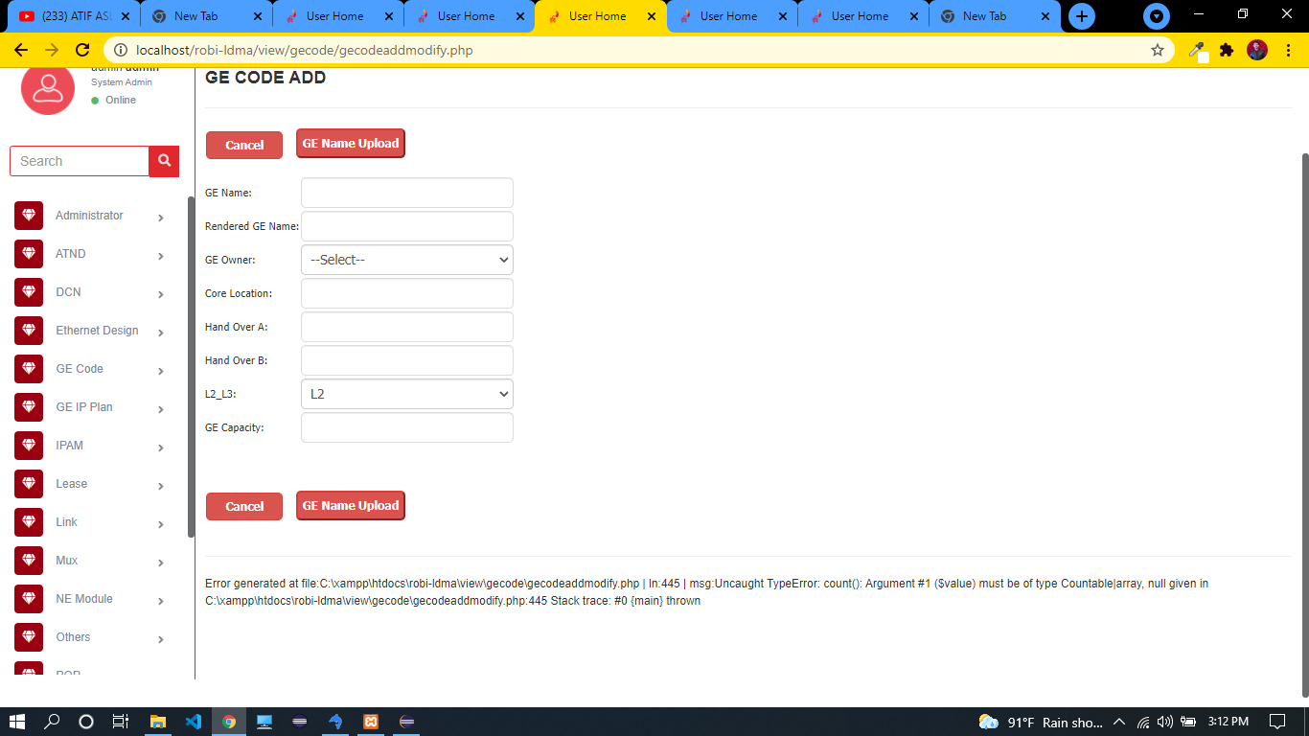

This problem is like previous one and also problem number 7.

Problem No – 17

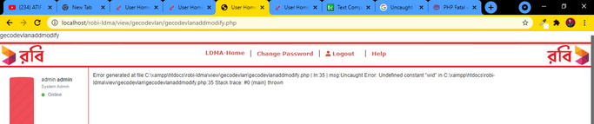

This Problem is like problem no – 13.

Problem No – 18

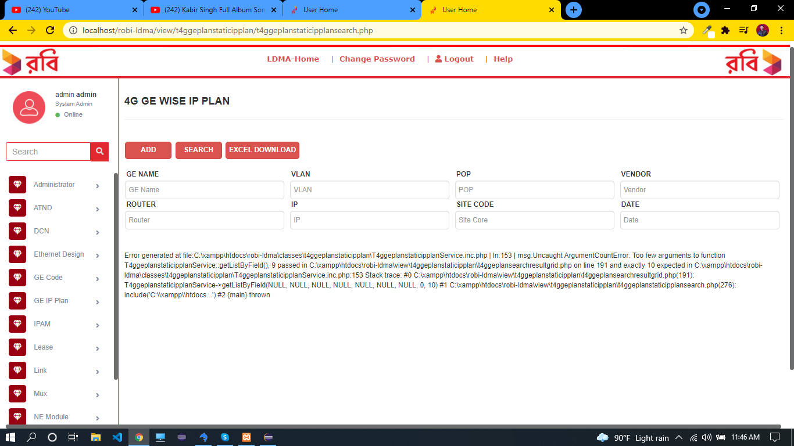

This problem is solved. I declare all 10 parameter.

Problem No – 19

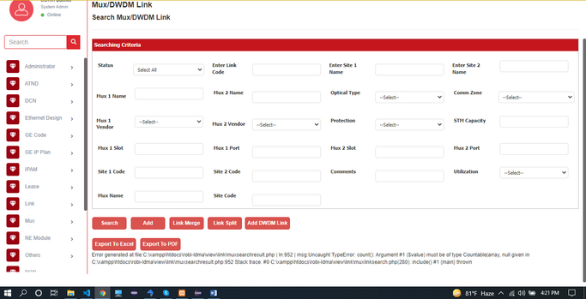

This error occurs because there is no value in “$arr”. So, I just run an if condition.

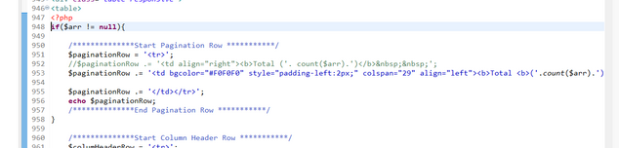

Problem No – 20

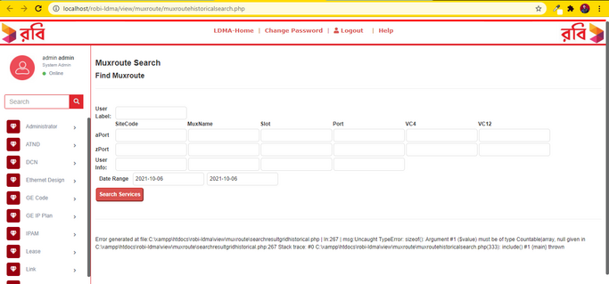

This problem is like previous one.

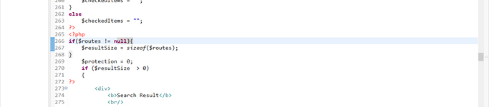

Problem No – 21

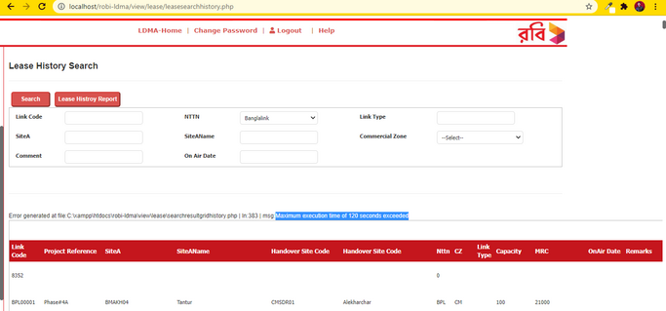

Here, maximum execution time of 120 second was set in php.ini file. So we increase maximum execution time 120 second to 500 second in php.ini file.

