|  |  |  |  |  |  |  |  |  |  |  |
| --- | --- | --- | --- | --- | --- | --- | --- | --- | --- | --- |
| INPUT | | | | OUTPUT | | | | | | |
| N3 | N2 | N1 | N0 | A | B | C | D | E | F | G |
| 0 | 0 | 0 | 0 | 0 | 0 | 0 | 0 | 0 | 0 | 1 |
| 0 | 0 | 0 | 1 | 1 | 0 | 0 | 1 | 1 | 1 | 1 |
| 0 | 0 | 1 | 0 | 0 | 0 | 1 | 0 | 0 | 1 | 0 |
| 0 | 0 | 1 | 1 | 0 | 0 | 0 | 0 | 1 | 1 | 0 |
| 0 | 1 | 0 | 0 | 1 | 0 | 0 | 1 | 1 | 0 | 0 |
| 0 | 1 | 0 | 1 | 0 | 1 | 0 | 0 | 1 | 0 | 0 |
| 0 | 1 | 1 | 0 | 0 | 1 | 0 | 0 | 0 | 0 | 0 |
| 0 | 1 | 1 | 1 | 0 | 0 | 0 | 1 | 1 | 1 | 1 |
| 1 | 0 | 0 | 0 | 0 | 0 | 0 | 0 | 0 | 0 | 0 |
| 1 | 0 | 0 | 1 | 0 | 0 | 0 | 0 | 1 | 0 | 0 |
| 1 | 0 | 1 | 0 | 0 | 0 | 0 | 1 | 0 | 0 | 0 |
| 1 | 0 | 1 | 1 | 1 | 1 | 0 | 0 | 0 | 0 | 0 |
| 1 | 1 | 0 | 0 | 0 | 1 | 1 | 0 | 0 | 0 | 1 |
| 1 | 1 | 0 | 1 | 1 | 0 | 0 | 0 | 0 | 1 | 0 |
| 1 | 1 | 1 | 0 | 0 | 1 | 1 | 0 | 0 | 0 | 0 |
| 1 | 1 | 1 | 1 | 0 | 1 | 1 | 1 | 0 | 0 | 0 |

0001 0000 1001 0011

**Segment A:**

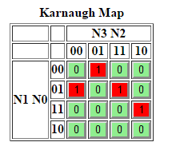

A(N3N2N1N0) = N3’N2’N1’N0 + N3’N2N1’N0’ + N3N2N1’N0 + N3N2’N1N0

**Segment B:**

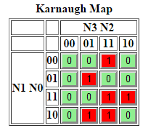

B(N3N2N1N0) = N3N1N0 + N2N1N0’ + N3N2N0’ + N3’N2N1’N0

**Segment C:**

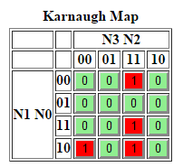

C(N3N2N1N0) = N3N2N1 + N3N2N0’ + N3’N2’N1N0’

ROM Schematic:

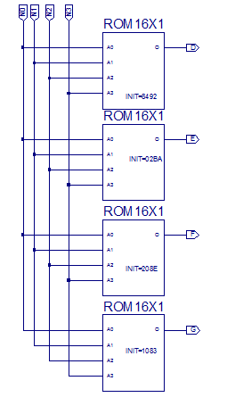

Combinational Logic Schematic:

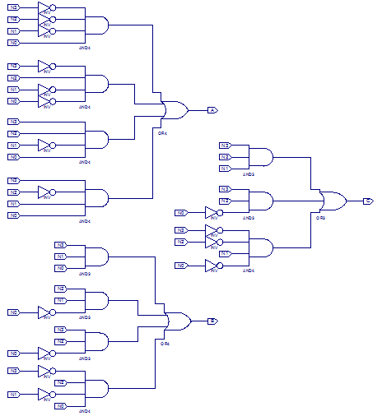

Seven Segment Decoder Schematic:

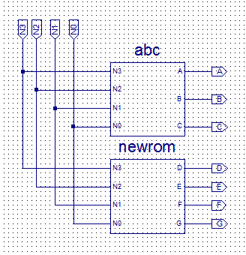

TCL:

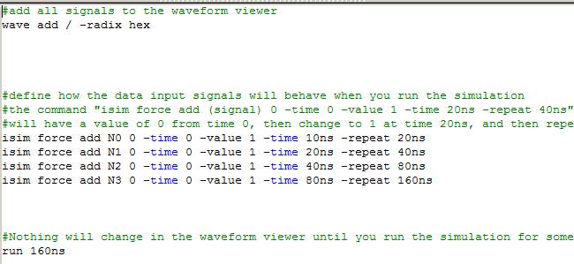

Simulation Waveform:

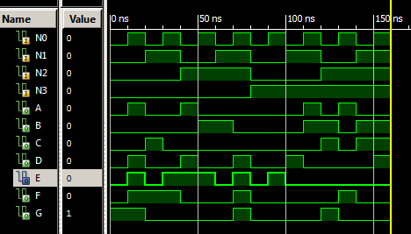

Test Bench Schematic:

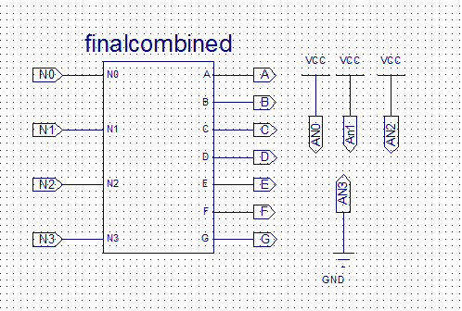

Test Bench UCF:

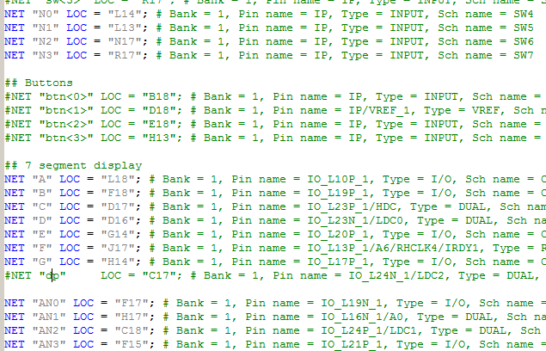

Anomalies:

Even though this week’s lab was probably the most intense so far, it was pretty straight forward. I had a bug in my rom schematic, and regenerating all of the symbols took forever and was basically the worst thing ever.