**Title: Mero Rail Dhaka App**

by, **Group 6**(21-44938-2,21-44923-2,21-45009-2,21-45223-2)

**Lab:1**

**Background:**

Dhaka city, the bustling capital of Bangladesh, is home to an ever-expanding population exceeding 18 million individuals. As the city thrives, the demand for efficient and convenient transportation services has reached unprecedented heights. The metro rail system has emerged as a vital mode of transportation, offering residents an affordable and hassle-free alternative to conventional road-based travel. However, the existing metro rail services have faced criticism for their limited provision of real-time information and suboptimal ticket purchasing options.

A substantial portion of commuters in Dhaka city encounters significant challenges in accessing up-to-the-minute updates on metro rail services. Consequently, missed trains, prolonged waiting periods, and unproductive time utilization have become all too common. Furthermore, the ticket procurement process proves time-consuming and inconvenient, necessitating commuters to endure queues at ticket booths or vending machines. These complications are exacerbated during peak hours and pose an even greater inconvenience for tourists or individuals unfamiliar with the intricacies of the metro rail system.

Considering these considerable obstacles, the urgency for a comprehensive and user-friendly solution for metro rail users in Dhaka city is evident. The development of a mobile application exclusively dedicated to the metro rail system has become an imperative. Such an application would offer real-time information, streamline ticket purchasing options, and greatly enhance the overall user experience. With the metropolis experiencing an escalating demand for convenient transportation services, the implementation of this solution is indispensable to meet the city's evolving needs.

**Problem**:

Passengers in Dhaka city often face problems in acquiring actual-time statistics about metro rail services, main to neglected trains, lengthy wait times, and wasted time. similarly, purchasing tickets may be a time-consuming and inconvenient system, requiring commuters to queue at ticket cubicles or vending machines. those issues are specially reported during height hours and for tourists or site visitors unfamiliar with the metro rail device.

**Requirement Analysis:**

1. Conduct an in-depth study of the existing metro rail services in Dhaka city.
2. Identify and analyze the specific problems faced by commuters in the current metro rail system.
3. Evaluate the needs and requirements of the target audience, including regular commuters and tourists.
4. Understand the preferences, pain points, and expectations of passengers regarding metro rail services.
5. Study and analyze mobile applications implemented in other cities with successful metro rail systems.
6. Identify best practices, innovative features, and functionalities from successful metro rail apps.
7. Incorporate user-friendly features such as real-time information updates, intuitive ticket purchasing options, and navigation assistance.
8. Ensure the mobile application caters to the diverse user base, including different language options and accessibility features.
9. Prioritize the seamless integration of the app with existing metro rail infrastructure and systems.
10. Perform usability testing and gather feedback from users to refine and enhance the mobile application.
11. Continuously evaluate and adapt the app based on user feedback and emerging technological advancements.

**Objective**:

1. Develop a secure and user-friendly login and sign-up functionality for the Dhaka Metro Rail mobile application.
2. Provide real-time information on train schedules, delays, and disruptions to enhance the passenger experience.
3. Simplify the ticket booking process, offering convenient and efficient options like mobile ticketing and integrated e-wallets.
4. Improve the overall experience of metro rail commuters, making their journeys more efficient and convenient.
5. Cater to the needs of tourists and visitors by incorporating features and information specifically designed for them.
6. Continuously gather user feedback and conduct usability testing to refine and optimize the application for maximum user satisfaction.

**Solution:**

1. Scalable technology: The app will be built on industry-standard .NET framework for seamless multi-device functionality.

2. Real-time updates: Passengers will receive live train schedules, route maps, and fare information for efficient journey planning.

3. Easy ticket booking: Users can securely purchase tickets, eliminating physical queues, and enjoy features like mobile ticketing and integrated e-wallets.

4. Integrated mobility: The app will connect with bike-sharing and ride-hailing services, enabling smooth transitions between transportation modes.

5. User-centric design: The app will prioritize user needs, employing usability testing and iterative feedback loops for an exceptional user experience.

6. Collaboration with authorities: Close partnership with Dhaka metro rail authorities will ensure accurate and reliable information, adhering to standards and regulations.

**Target:**

The Metro Rail App caters to a diverse user base, encompassing both regular metro rail commuters and tourists visiting Dhaka. It aims to enhance the commuting experience and alleviate frustrations associated with navigating the metro rail system. Whether users are frequent travelers or occasional riders, the app offers valuable benefits. By utilizing the app, commuters can optimize their time, save money, and alleviate the stress of navigating the metro rail network. The app's user-friendly features empower commuters to streamline their journeys, resulting in a more efficient and enjoyable commuting experience in Dhaka city.

**Functionality:**

* 1. Real-time train schedules and updates for proper journey planning with the Metro Rail App.
  2. Route maps and fare information relevant to Dhaka for convenient navigating.
  3. Ticket purchasing alternatives that are secure for a hassle-free experience.
  4. Use push notifications to notify users of any disruptions or modifications to their schedule.
  5. For convenience, save frequently used routes and payment methods.
  6. Integration with bike-sharing and ride-hailing services for smooth transit.

Project Specifications:

**- Cost Estimation**: The project budget is being reviewed and will be established based on the scope and needs.

**- Estimated effort:** The project will necessitate a dedicated team of 8-10 experts, including developers, designers, and testers, working full-time for an estimated 8-10 months.

**- Resource Allocation:** The team will be divided into sub-teams, each with its own set of resources.

to specific project areas like as design, development, testing, and launch preparations.

**- Scheduling:** The project will adhere to an agile methodology, with sprints occurring on a regular basis. The first six months will be dedicated to design and development, followed by two to three months of testing, and launch preparations. The total duration is projected to be 8-10 months, subject to change dependent on project progress and requirements.

**SDLC Model**

**Lab 2**

The **Incremental SDLC model** is the best fit for the Dhaka Metro Rail App project. The reasons for this are as follows:

* **Progressive iteration:** The incremental approach allows the project to be developed in stages or increments. Because the Metro Rail App project comprises numerous features and capabilities that may be developed in phases, this strategy is suitable.
* **Partial phases:** The Incremental model breaks the project into smaller sub-projects with specific deliverables, facilitating efficient management and progress tracking. It enables focused development, improved coordination, and organized delivery of incremental components.
* **Constant feedback:** The incremental model underscores the importance of regular feedback from stakeholders, including users. This iterative approach ensures that the final product effectively addresses the unique needs and preferences of the target audience.
* **Accelerated introduction of viral features:** The incremental model enables the expedited provision of vital features to the end user. By adopting this approach, essential functionalities can be delivered at an early stage, facilitating thorough testing and refinement prior to the final product's official release. Consequently, this methodology guarantees the fulfillment of the user's requirements in the ultimate version of the product.
* **Flexibility:** The incremental model's flexibility enables seamless integration of new requirements and changes during the development process, facilitating the adaptation of the project to meet evolving needs effectively.
* **Scheduled assessments:** Regular project reviews and adjustments within the incremental model ensure ongoing alignment with objectives, keeping the project on track to meet its intended goals.

So, the incremental model is a suitable approach for the Dhaka Metro Rail App project as it allows for the development of the project in stages, emphasizes frequent feedback and testing, and provides flexibility to adjust to changing requirements.

**Lab:3**

**UML Diagrams**

**Use case Diagram:**

**Sequence Diagram:**

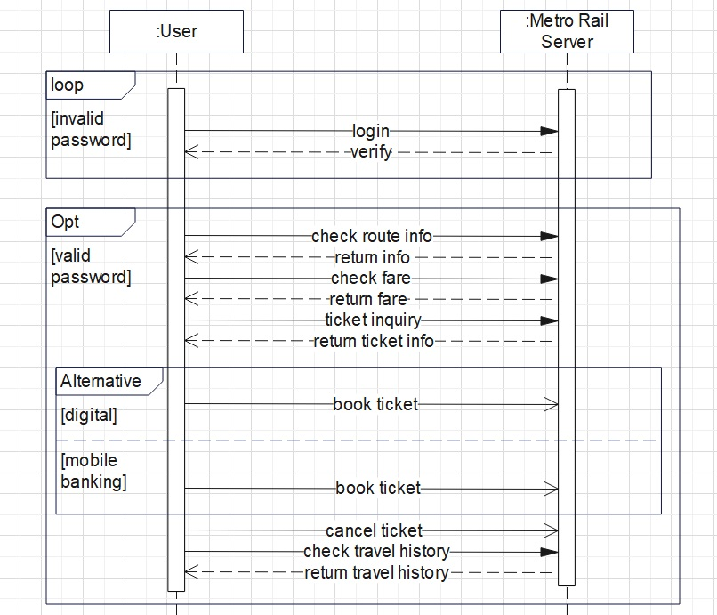

**Class Diagram:**

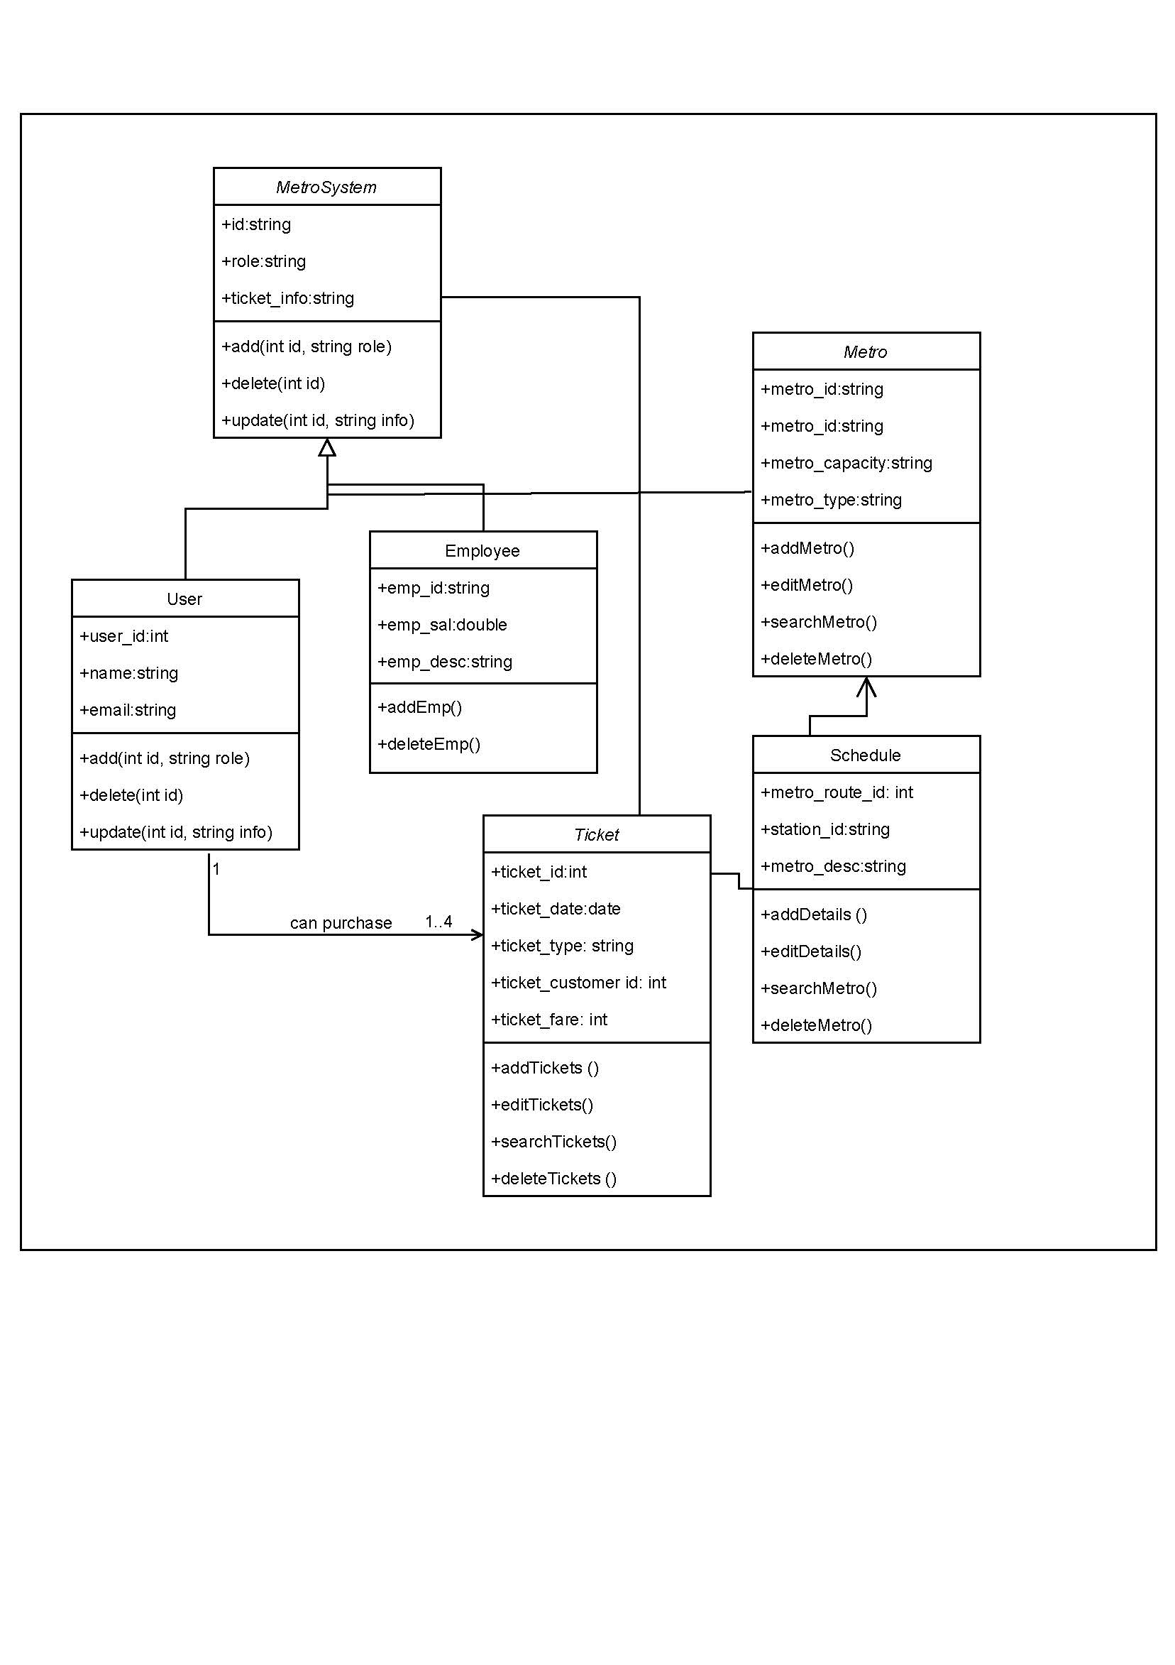

**Activity Diagram:**

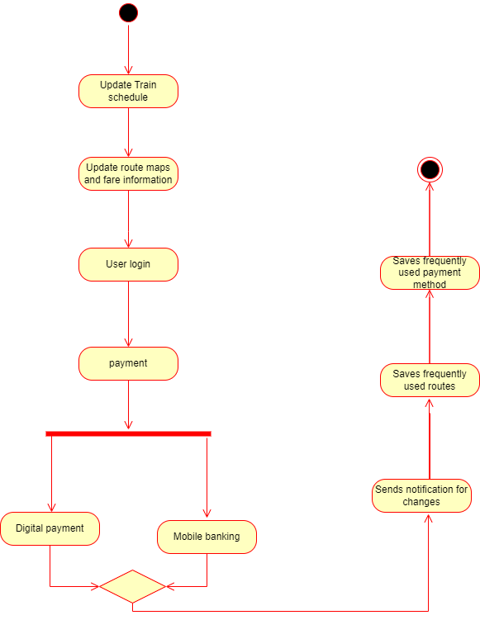

**Lab:4**

**Functional Requirements:**

1. **Software Login functional Requirements**
   1. The software shall allow users to login with their given username and password.
   2. The login credentials (username and password) will be verified with database records.
   3. If the login is successful, the home page of the user account will be displayed.
   4. If the username and/or password has been inserted wrong, the random verification code will be generated and sent to the user’s email address by the system to retry login.
   5. If the number of login attempt exceed its limit (3 times), the system shall block the user account login for one hour [optional function]
2. **Real-time train schedules and updates functional requirements**
   1. The software shall display the current train schedules and updates in real-time.
   2. The train schedules shall be updated automatically and periodically by the system.
   3. The software shall show the expected arrival and departure times of the trains at each station.
   4. The software shall display the train route maps, indicating the different stations and routes.
   5. The software shall provide information on any delays, cancellations, or other disruptions in train services.
   6. The software shall provide information on alternative transport options in case of disruptions.
3. **Route maps and fare information specific to Dhaka city functional Requirements:**
   1. The software shall display the route maps for the Dhaka Metro Rail.
   2. The software shall display the different stations and routes for the Metro Rail.
   3. The software shall provide information on the fares for different routes and stations.
   4. The software shall allow users to select their starting station and destination station to calculate the fare for their journey.
4. **Easy and secure ticket purchasing options functional Requirements:**
   1. The software shall provide easy and user-friendly ticket purchasing options.
   2. The software shall allow users to purchase tickets for their journey using different payment methods.
   3. The software shall provide a secure payment gateway for online ticket purchases.
   4. The software shall allow users to view their ticket purchase history and receipts.
5. **Push notifications for any disruptions or schedule changes functional Requirements:**
   1. The software shall send push notifications to users in case of any disruptions or schedule changes in train services.
   2. The software shall provide users with real-time updates on the status of their journey.
   3. The software shall allow users to opt-out of push notifications if they prefer not to receive them.
6. **Option to save frequently used routes and payment methods functional Requirements:**
   1. The software shall allow users to save their frequently used routes and payment methods for faster and easier ticket purchases.
   2. The software shall allow users to edit or delete their saved routes and payment methods.
   3. The software shall store the saved routes and payment methods securely and ensure their privacy.
7. **Integration with other transportation services such as bike-sharing and ride-hailing functional Requirements:**
   1. The software shall integrate with other transportation services, such as bike-sharing and ride-hailing services, to provide users with seamless and convenient travel options.
   2. The software shall display information on the different transportation services available, including their schedules, fares, and availability.
   3. The software shall allow users to book and purchase transportation services directly from the app.

**Lab:5**

