

IUBAT - INTERNATIONAL UNIVERSITY OF BUSINESS AGRICULTURE AND TECHNOLOGY

Experiment: Identifying Types and Amount of RAM

Lab Report No : 04

Course Number : CSC 348 Section : H

Submitted To : Engr.Md.Hasibul Islam

Senior Lecturer in the Department of Computer Science & Engineering at International University of Business Agriculture and Technology

Submitted By : Shaifur Rahman ID : 22103199

SL 24

Program : BCSE

Date : 27-03-24

# Determine the amount of RAM in a PC :

## Here are several ways we can find RAM information on our PC:

System Information Tool:

* + Press Windows key + R to open the Run dialog.
  + Type msinfo32 and press Enter.
  + In the System Information window, navigate to "System Summary."
  + Look for the "Installed Physical Memory (RAM)" field to view the total amount of RAM installed on your system, along with other details such as the memory type and speed.

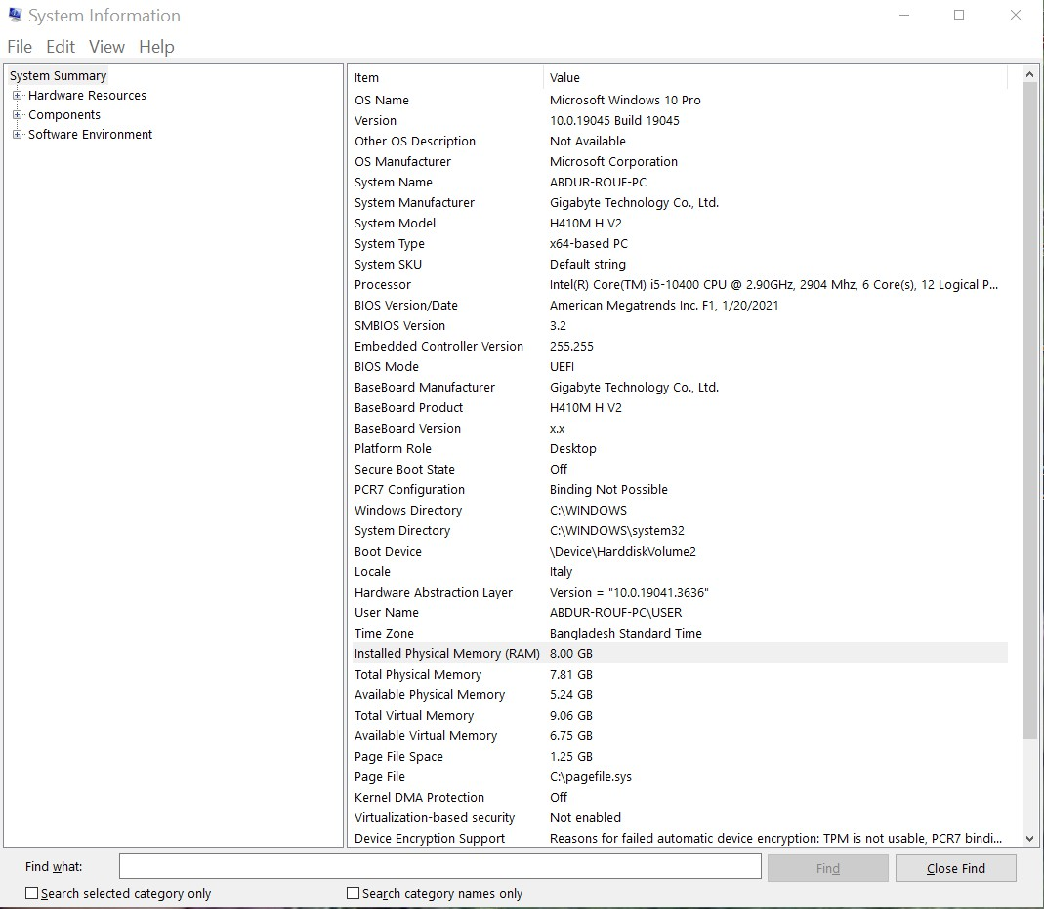

Task Manager:

* + Right-click on the taskbar and select "Task Manager."
  + In the Task Manager window, go to the "Performance" tab.
  + Under "Memory," you'll see information about the total amount of RAM installed, its usage, and other memory-related details

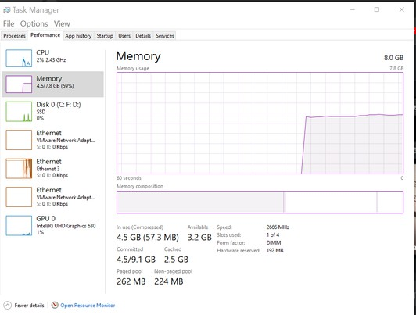

Control Panel:

* + Open the Control Panel.
  + Click on "System and Security" (or "System," depending on your Windows version).
  + Select "System."
  + Under the "System" section, you'll find information about your installed RAM, including the total amount of memory.

Command Prompt:

* + Press Windows key + R to open the Run dialog.
  + Type cmd and press Enter to open the Command Prompt.
  + In the Command Prompt window, type wmic memorychip get Capacity, Speed, DeviceLocator, BankLabel and press Enter.
  + This command will display detailed information about each installed RAM module, including capacity, speed, device location, and bank label.

# Identifying Type of Ram :

I use the Corsair Vengeance Micron 8GB DDR4 3200MHz RAM module is designed for high- performance overclocking on both Intel motherboards. Here's a detailed specification overview for this memory module:

Capacity: 8GB

Memory Type: DDR4 Speed: 3200MHz

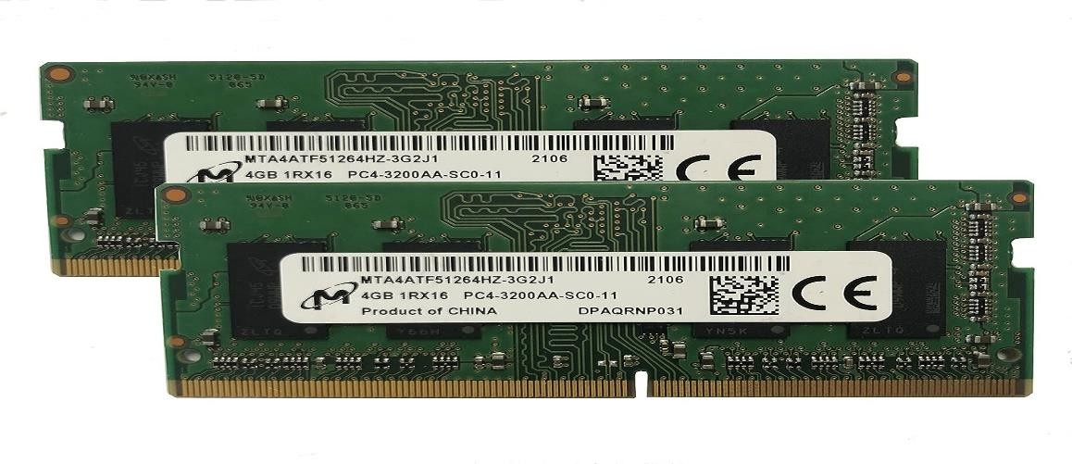

Tested Latency: The exact tested latency may vary, but for DDR4-3200, it could typically be around CL16-18-18-36.

Voltage: Commonly operates at 1.35V for a balance between performance and power consumption.

Manufacturer: Micron Technology, a reputable semiconductor company known for producing high-quality memory modules.

Compatibility: Designed for compatibility with various computer systems supporting DDR4 memory. Always verify compatibility with your motherboard's specifications.

Features: Offers reliable performance and efficiency for a wide range of computing tasks, including gaming, content creation, and multitasking.

Warranty: Typically comes with a limited warranty provided by Micron Technology, ensuring peace of mind regarding product reliability.

## Secondary Memory Storage

Model: HP EX900 Capacity: 250GB

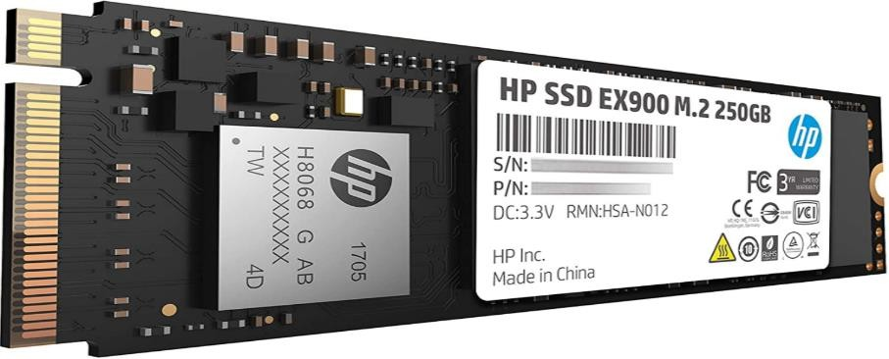

Figure: HP EX900 250GB M.2 SSD

Form Factor: M.2 2280 (22mm wide by 80mm long), providing a compact design suitable for modern laptops and desktops.

Interface: PCIe Gen3 x4 NVMe 1.3, offering high-speed data transfer rates compared to SATA SSDs.

Sequential Read Speed: Up to [Speed1] MB/s, enabling quick boot times, rapid application loading, and fast data transfer.

Sequential Write Speed: Up to [Speed2] MB/s, ensuring efficient performance for writing large files and handling write-intensive tasks.

NAND Type: 3D TLC (Triple-Level Cell), providing a balance between performance, cost, and endurance.

Controller: Utilizes an HP controller aimed at delivering a balance between performance and reliability.

Endurance: The Total Bytes Written (TBW) rating reflects suitability for medium to heavy daily usage over several years. Refer to product documentation for precise figures.

Power Consumption: Optimized for efficiency, with lower power consumption compared to traditional hard drives and some SSDs, benefiting laptop users seeking to extend battery life.

Features: Incorporates an HP controller with 3D NAND Flash, offering improved workload efficiency, higher speeds, and increased reliability.

Warranty: Typically comes with a 3-year limited warranty from HP, covering defects in materials and workmanship, providing assurance of reliability and support.

# Removing the Existing RAM Module:

* + - Prepare the Workspace: Turn off the computer and disconnect all cables. Place it on a stable surface with plenty of workspace.



* + - Open the Computer Case: Use a screwdriver to remove the screws securing the side panel of the computer case. Slide or lift off the side panel to access the internal components.

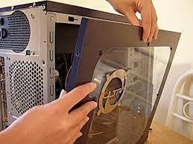

* + - Locate the RAM Slots: Identify the RAM slots on the motherboard. These are typically long, narrow slots near the CPU.

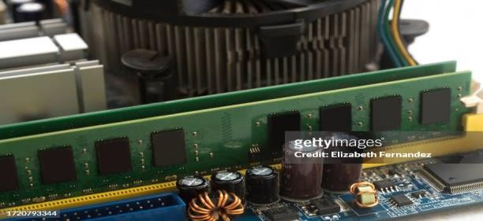

* + - Release Retaining Clips: Gently press or pull the retaining clips or levers away from the sides of the RAM module to release it from the slot. The clips/levers are usually located at the ends of the RAM module.

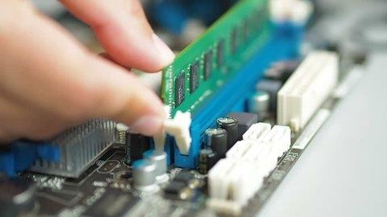

* + - Remove the RAM Module: Carefully grasp the sides of the RAM module and pull it traight out of the slot. Avoid touching the gold contacts on the module.

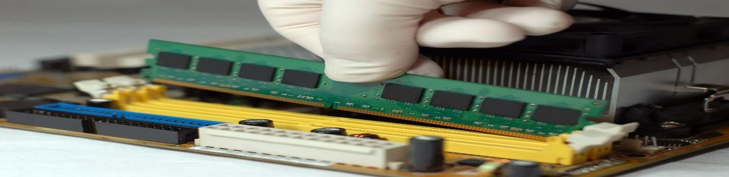

# Installing the RAM Module:

* + - Prepare the New RAM Module: If installing multiple RAM modules, ensure they are correctly oriented according to the notches on the module and the slot.
    - Align the Module: Align the notch on the new RAM module with the key in the slot. Hold the module at a 45-degree angle.

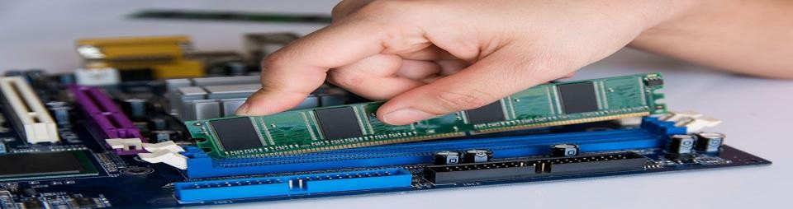

* + - Insert the Module: Insert the RAM module into the slot, ensuring it is fully seated. Press down firmly on both ends of the module until the retaining clips/levers snap into place.

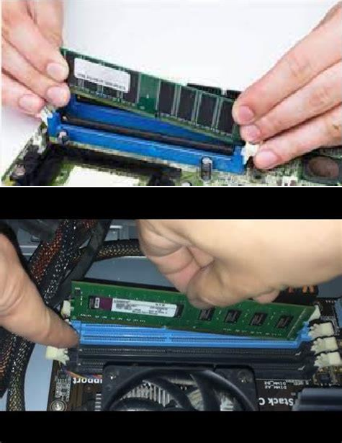

* + - Close the Computer Case: Replace the side panel of the computer case and secure it with screws.

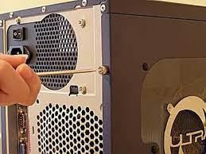

* + - Power On the Computer: Reconnect all cables and peripherals. Power on the computer and access the operating system.



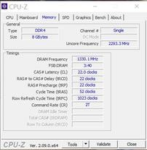

## TYPE DDR4:

it means that the computer's RAM modules are utilizing DDR4 technology. DDR4 (Double Data Rate 4th Generation) is a type of memory that offers faster data transfer rates, lower power

consumption, and increased memory density compared to older DDR3 memory. This designation in CPU-Z informs users about the specific type of memory technology being used in their

system.

## SIZE :

A memory size of "8 GBytes" indicates that the memory module has a capacity of 8 gigabytes, providing ample storage for running various applications and processes on the computer. This size is typical for modern RAM modules, offering sufficient memory for smooth multitasking and performance in most computing tasks.

## Channel single:

denotes a memory configuration where a single memory channel is utilized for data transfer between the memory modules and the memory controller. This configuration is common in

systems with only one memory module installed, offering basic memory functionality without the benefits of dual-channel or quad-channel setups.

## Uncore frequency :

The "uncore frequency" of 2293.3 MHz refers to the clock speed of the uncore portion of the CPU. The uncore includes various components such as the memory controller, cache, and other system-level functions that operate independently of the CPU cores. This frequency affects the performance of these components and indirectly impacts overall system performance,

particularly in memory-intensive tasks and data transfer between the CPU and RAM.

## DRAM frequency

A "DRAM frequency" of 1330.1 MHz indicates the speed at which the Dynamic Random-

Access Memory (DRAM) modules are operating. It represents the rate at which data can be read from or written to the DRAM chips, measured in millions of cycles per second (MHz). A higher DRAM frequency typically indicates faster memory performance, which can improve overall

system responsiveness and efficiency, especially in tasks that involve heavy memory usage such as gaming, video editing, and multitasking.

## FSB:DRAM

The ratio "FSB:DRAM 3:40" indicates the relationship between the Front Side Bus (FSB) speed and the Dynamic Random-Access Memory (DRAM) frequency. In this case, for every 3 cycles of the FSB, the DRAM operates for 40 cycles. This ratio determines how the system

synchronizes the speed of the FSB, which connects the CPU to other components, with the speed of the DRAM, which stores and retrieves data. A higher ratio generally means faster memory

performance relative to the FSB speed.

## A CAS# Latency (CL)

A CAS# Latency (CL) of 9, equivalent to 22.0 clocks, indicates the number of clock cycles

required for the memory module to respond to a read command. Lower CL values signify faster memory access, resulting in improved system performance, particularly in tasks that rely heavily on memory speed such as gaming and content creation.

## RAS# to CAS# Delay (tRCD) of 22 clocks

RAS# to CAS# Delay (tRCD) of 22 clocks signifies the number of clock cycles required for the memory module to access data after activating a row. This delay parameter is crucial for memory performance, as it determines the timing coordination between activating a row and accessing

data in that row. Lower tRCD values typically indicate faster memory access and better system performance, particularly in tasks that demand rapid data retrieval from memory.

## cycle time (tRAS) of 52 clocks

A cycle time (tRAS) of 52 clocks denotes the minimum number of clock cycles that must elapse before a memory row can be deactivated. This parameter is vital for memory stability and

performance, ensuring proper coordination between memory operations. A higher tRAS value allows for more relaxed memory timings, which can improve stability but may slightly decrease performance in certain scenarios.

## TRFS : 1023 clocks

A TRFS (Time RAS to FFS) value of 1023 clocks represents the time it takes for a memory row to be refreshed after it has been activated. This parameter is crucial for maintaining data integrity in dynamic random-access memory (DRAM) modules, ensuring that stored information is

periodically refreshed to prevent data loss due to leakage. Higher TRFS values indicate a longer refresh cycle, which can affect overall memory performance and system responsiveness.

## Command Rate

A Command Rate (CR) of 2T indicates a delay of two clock cycles between memory commands, providing a balance between performance and stability in memory operations. This setting is

commonly used to ensure reliable memory operation in various computing environments.