
SCHOOL OF COMPUTER SCIENCE AND ENGINEERING (SCOPE)

FINAL PROJECT REPORT

VocabARy
An AR/VR-Based Multilingual Object Recognition and Gesture-Driven Language Learning System

Submitted by
Hasika MD (23MID0228) and Dhishitha M (23MID373)

Integrated M.Tech Computer Science and Engineering
Course: CSI4005 – Augmented Reality and Virtual Reality

Vellore Institute of Technology, Vellore, India
Academic Year: 2026

ABSTRACT
Vocabulary learning can be difficult when words are taught in isolation from the objects and situations to which they refer. This project presents VocabARy, a browser-based prototype that combines computer vision and multimodal interaction to support contextual vocabulary practice. The documented design combines YOLOv5s object detection, a tiered translation approach, Indic-script and Japanese romanization support, browser speech interfaces, MediaPipe hand-landmark tracking, canvas-based air-writing, and Tesseract optical character recognition (OCR). A Django application provides the web layer, while a local dictionary is intended to reduce dependence on external translation services for common object classes. The proposed learning sequence is to detect a visible object, display its translated label and pronunciation aid, let the learner practise speaking, and optionally practise writing through a fingertip-controlled canvas. The supplied draft reports prototype figures of 32.4 ms per detection frame, 91.2% mAP@0.5, 95.6% transliteration fidelity, 89.4% speech-recognition accuracy, and 82.6% air-writing character-match accuracy. These are treated as reported preliminary values rather than independently verified results because the supplied materials do not contain the complete test dataset, sample counts, scripts, or repeatable evaluation protocol. The report distinguishes the system design, reported measurements, limitations, and a reproducible validation plan. VocabARy's principal contribution is the integration of object-centred vocabulary, pronunciation practice, and gesture-based writing in one accessible web prototype; its educational effectiveness requires validation through a controlled learner study.
Keywords—Augmented Reality, language learning, YOLOv5s, multilingual translation, transliteration, MediaPipe Hands, air-writing, OCR, speech recognition, Django.

TABLE OF CONTENTS
- 1. Introduction
- 2. Literature Survey and Research Gap
- 3. Requirements and System Design
- 4. Proposed Methodology and Implementation
- 5. Testing and Experimental Evaluation
- 6.Proposed methodology
- 7. Results and Discussion
- 8. Comparison with Existing Approaches
- 9. Limitations, Privacy, and Future Work
- 10. Conclusion
- References
- Appendix A – Suggested Demonstration Checklist
- Appendix B – Final Submission Checklist
Note: Update page numbers and insert Word's automatic table of contents after the report content is finalized.

1. INTRODUCTION

1.1 Background
Learning vocabulary in a second or additional language involves connecting a word's meaning, written form, pronunciation, and real-world referent. Flashcards, bilingual dictionaries, and word lists are useful study aids, but they can separate vocabulary from the physical context in which a learner encounters an object. Camera-based object recognition offers a way to present a vocabulary item in context by identifying a familiar object and displaying its name in a target language.

1.2 Problem Statement
Many entry-level vocabulary tools focus on translation or passive label display. Some augmented-reality learning experiences depend on pre-authored scenes, markers, or dedicated applications. Learners who are unfamiliar with a target script may also need romanized pronunciation guidance, opportunities to speak, and a way to practise spelling. The project therefore explores an integrated workflow that combines object recognition, multilingual label presentation, speech practice, and gesture-driven writing in a browser-oriented prototype.

1.3 Aim
To develop a camera-based, multimodal vocabulary-learning prototype that connects everyday objects with multilingual vocabulary and optional speech and gesture-based practice.

1.4 Objectives
- Recognize common objects from a live camera stream using the YOLOv5s model.
- Display target-language labels for supported languages: Tamil, Telugu, Kannada, Hindi, French, and Japanese.
- Provide romanized pronunciation aids where supported by the relevant transliteration library.
- Offer browser-based speech playback and speech recognition where the browser supports them.
- Track fingertip movement for canvas-based air-writing and evaluate the drawn result using OCR where the pipeline works.
- Use a modular web architecture that can be demonstrated and evaluated on ordinary camera-enabled devices.

1.5 Scope
The documented prototype targets common objects within the detector's class vocabulary and the six languages listed in the supplied materials. Its behaviour depends on the detection model, dictionary coverage, translation sources, browser speech support, camera conditions, and runtime environment. The current system should be described as a camera-overlay or AR-inspired learning prototype unless true spatial anchoring through WebXR is implemented and demonstrated.

1.6 Project Contribution
The contribution is primarily system integration: object-centred vocabulary prompts, multilingual labels, romanization, speech practice, and gesture-driven writing are brought together in one browser-oriented workflow. This is not a claim that the project introduces a new object-detection algorithm or that it has already proved improved learning retention.

2. LITERATURE SURVEY AND RESEARCH GAP

2.1 Research Themes
The supplied paper connects VocabARy to research in augmented reality for education, real-time object detection, speech interfaces, hand tracking, optical character recognition, and multimodal learning. These areas provide the technical and pedagogical motivation for the prototype.
Theme | Role in VocabARy | Caution
AR and contextual learning | Connects vocabulary prompts to visible objects. | Engagement does not automatically prove long-term retention.
YOLOv5 object detection | Identifies supported everyday object classes. | Performance depends on dataset, environment, model, and hardware.
Translation and transliteration | Shows target-language labels and pronunciation aids. | Translation quality and romanization need language-specific checking.
Browser speech interfaces | Supports audio playback and speech-to-text practice. | Browser and locale support vary; text similarity is not full pronunciation assessment.
MediaPipe Hands and OCR | Enables fingertip-driven canvas strokes and text comparison. | Gesture strokes can be noisy and OCR may fail on sparse handwriting.

2.2 Research Gap
The project targets the integration gap between tools that recognize or translate objects and tools that provide active language practice. VocabARy combines live object labels with transliteration, speech practice, and gesture-driven writing. The focus on regional Indian languages alongside French and Japanese is a stated design priority. The strength of this contribution should be established through a verified literature review and a fair comparison against relevant alternatives.

2.3 Literature Survey Requirement
The faculty instruction requires 30 research papers for the team, with 15 papers per student. The supplied draft contains 20 reference entries and discusses a smaller subset in its survey table. Consequently, the literature survey is not yet complete against the stated requirement. Add at least 10 distinct, relevant, verified papers, assign 15 papers to each student, and cite the papers in the body of the report. Verify every author, title, venue, year, volume, pages, and DOI or stable URL against the publisher or a scholarly index. Remove any source that cannot be verified.

2.4 Summary of Technical Foundations
YOLOv5 provides the object-detection component [1]. MediaPipe provides a framework for perception pipelines and hand-landmark tracking [2]. Tesseract is an OCR engine [3]. Dual-coding theory provides a theoretical rationale for combining verbal and visual representations [4]. These sources support the selection of components, but do not independently validate VocabARy's own reported performance or learning outcomes.

3. REQUIREMENTS AND SYSTEM DESIGN

3.1 Functional Requirements
ID | Requirement | Acceptance evidence
FR-01 | The system captures a camera frame when the user grants permission. | Camera preview starts and a visible stop/permission state is shown.
FR-02 | The system identifies supported object classes. | Label and bounding box appear for a known test object.
FR-03 | The learner selects a target language. | Displayed label changes to the selected language where a mapping exists.
FR-04 | The system displays transliteration where supported. | Romanized text appears for a verified test word.
FR-05 | The system offers speech playback or recognition where supported. | A controlled test confirms the browser capability and feedback.
FR-06 | The learner can draw with fingertip tracking or a touch/mouse fallback. | Canvas stroke is visible and can be cleared.
FR-07 | The system can compare the drawn result with a target using OCR when available. | OCR output and comparison score are shown for test examples.
FR-08 | Progress may be saved if the score-storage module is enabled. | A test score persists and can be cleared according to the implementation.

3.2 Non-Functional Requirements
- Usability: the main camera, language, audio, and drawing controls should be discoverable.
- Performance: detection should be responsive on the documented test hardware; latency must be measured rather than assumed.
- Reliability: failures of external translation services should be handled without crashing the application.
- Portability: the application should document supported operating systems and browsers.
- Privacy: camera and microphone permissions must be clear; unnecessary raw media should not be stored.
- Maintainability: detection, language handling, speech, and gesture modules should be separable for debugging.

3.3 High-Level Architecture
Stage | Component | Output
1 | Camera capture / OpenCV | Video frames
2 | YOLOv5s inference | Class label, bounding box, confidence
3 | Local dictionary and translation fallbacks | Target-language word
4 | Transliteration and browser audio | Romanized aid and optional speech feedback
5 | MediaPipe Hands and HTML canvas | Fingertip coordinates and strokes
6 | Tesseract OCR and text comparison | Recognized text and comparison feedback
7 | Django web layer / optional SQLite | Application interface and optional progress data

3.4 Data Flow
The intended data flow begins with camera frames. The detector identifies an object and returns a class label with a confidence value. The language layer maps the label to a selected language, using the local dictionary first and external services as fallbacks where configured. The interface displays the result and may offer pronunciation playback or speech input. In drawing mode, the fingertip coordinates are rendered on a canvas; the resulting image may be sent to OCR for text comparison. Each stage should fail gracefully so that a failure in a secondary feature does not stop object recognition.
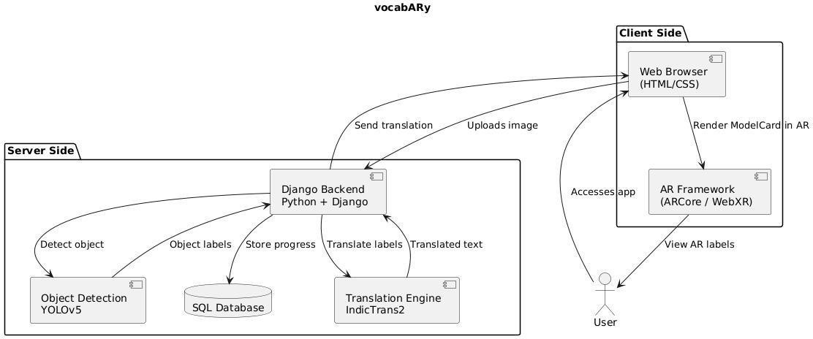

3.5 Technology Stack
Technology | Intended role
Python and Django | Server-side application and web routing
OpenCV | Camera capture and frame processing
PyTorch / YOLOv5s | Object detection
JavaScript and HTML canvas | Browser interaction and drawing
MediaPipe Hands | Hand landmark tracking
Tesseract OCR | Recognizing text from the drawing raster
Browser Speech APIs | Speech playback and speech recognition where supported
Local dictionary and external translation services | Target-language lookup and fallback
SQLite | Optional persistent score/progress storage

4. PROPOSED METHODOLOGY AND IMPLEMENTATION

4.1 Object Detection
The supplied implementation description uses OpenCV to capture frames at 640 × 480 resolution, converts frames from BGR to RGB, and passes them to YOLOv5s. The detector returns class labels, bounding boxes, and confidence values. A confidence threshold of 0.35 is stated in the draft. Annotated frames or overlays are then presented to the user. Performance may vary with lighting, occlusion, object size, camera quality, and the model's fixed class vocabulary.

4.2 Multilingual Translation Pipeline
The documented design uses three tiers: (1) a local dictionary for common object classes; (2) a GoogleTranslator-based fallback; and (3) a MyMemory fallback. The local tier can work without a network for words already present in the dictionary, while external tiers require connectivity. The system therefore should not be described as fully offline or as guaranteeing 100% availability. The dictionary's coverage and language mappings should be tested explicitly.

4.3 Transliteration
The project materials describe use of an Indic transliteration library for supported Indic scripts and pykakasi for Japanese romanization. Transliteration helps learners read an approximate pronunciation using familiar Latin characters, but it is not a guarantee of native-like pronunciation. Language-specific examples should be reviewed by competent speakers and the exact supported input/output path should be documented.

4.4 Speech Practice
The supplied draft describes browser speech recognition and text-to-speech. It computes a normalized edit-distance similarity score between recognized text and a target string: Score = [1 − d(reference, hypothesis) / max(length(reference), length(hypothesis))] × 100, where d is Levenshtein edit distance. This is a text-similarity proxy, not a validated phonetic pronunciation score. Results can be affected by the speech recognizer, locale, noise, accents, and acceptable pronunciation variants.

4.5 Gesture-Driven Air-Writing
MediaPipe Hands tracks 21 landmarks, and landmark 8 (the index fingertip) is used to track drawing movement. When drawing mode is active, the sampled coordinates are rendered onto an HTML canvas. The raster can then be passed to Tesseract OCR and the recognized string compared with a target. OCR may perform poorly on sparse or irregular mid-air strokes; stroke smoothing, scaling, thresholding, morphology, and clear/undo controls should be tested. Touch or mouse drawing is a useful fallback.

4.6 Privacy and Responsible Use
Camera and microphone access should be requested only when needed. The interface should show when the camera or microphone is active and provide a clear stop control. Avoid retaining raw audio or video unless it is necessary and users have been informed. If scores are stored, explain which data is saved, where it is stored, and how it can be cleared. Any classroom user study should follow institutional consent and privacy requirements.

5. TESTING AND EXPERIMENTAL EVALUATION

5.1 Testing Strategy
Test type | Purpose | Example test
Functional | Check each feature against requirements. | Open camera, detect a cup, change language, draw a stroke.
Integration | Check data flow across modules. | Detected label reaches translation and appears in the interface.
Performance | Measure responsiveness and resource use. | Record frame latency and memory use under stated conditions.
Compatibility | Check browser/device differences. | Repeat camera and speech tests in documented browsers.
Failure handling | Check network/API errors. | Disable network and verify local dictionary behaviour.
Usability/accessibility | Check clarity and alternative input. | Use touch/mouse drawing and test camera/mic controls.

5.2 Reproducible Evaluation Protocol
- Object detection: state model version, evaluation split, number of images, class-wise precision/recall, IoU threshold, and mAP calculation.
- Latency: separate warm-up from measured runs; measure several hundred frames and report median and 95th percentile.
- Translation: use a manually checked set of object-language pairs and report exact-match rate and human-rated correctness.
- Transliteration: use native-speaker-reviewed reference forms and define the scoring rule.
- Speech: use consented and labelled utterances from multiple speakers; report sample counts and distinguish speech-to-text accuracy from pronunciation quality.
- Air-writing: define users, characters/words, ground truth, OCR normalization, and edit-distance calculation.
- Learning outcomes: compare pre-test and post-test scores against a baseline group using the same vocabulary and learning time; report sample size and variability.

5.3 Test Environment
The original draft mentions an AMD Ryzen 9 5900HS / Intel Core i5 environment and 16 GB RAM, but it does not clearly identify which processor was used for each reported measurement. Before submission, replace this ambiguous description with the exact test machine, operating system, browser version, Python version, package versions, model weights, and whether inference ran on CPU or GPU.

5.4 Evidence Status
The supplied materials do not include the full raw dataset, test scripts, number of trials, speech recordings, handwriting samples, or confidence intervals. Therefore, the numerical figures below are reproduced as reported in the draft and should not be represented as independently verified in this report.

6.Proposed Methodology
The architecture of the VocabARy system is modular and composed of five core components: object detection, multilingual translation, transliteration, speech recognition, and AR visualization. Each module plays a critical role in ensuring that the vocabulary learning experience is real-time, interactive, and engaging.

Object Detection Using YOLOv5
The first step in the system involves detecting real-world objects using the YOLOv5 (You Only Look Once) model. Specifically, the lightweight yolov5s version is implemented to balance performance and speed. It processes the camera feed in real-time, identifies common objects, and draws bounding boxes around them. With a confidence threshold of 0.4, the model filters out low-confidence predictions to ensure accuracy. The detected labels from YOLOv5 serve as the input vocabulary for the remaining modules in the system.

Multilingual Translation with Google Translate API
Once objects are identified, their labels are passed to the Google Translate API using the deep_translator library. The system supports multiple Indian languages such as Tamil, Telugu, Kannada, and Hindi, along with international languages like French and Japanese. This multilingual capability ensures that users from diverse linguistic backgrounds can learn vocabulary in the language of their choice. The translations are retrieved quickly and displayed in real-time over the detected objects in the AR interface.

Text Transliteration
To help users pronounce words correctly, the translated text undergoes transliteration. For Indian languages, the system uses the indic_transliteration library to convert native scripts to phonetic Latin characters. For Japanese, the pykakasi library converts Kanji or Kana characters into romaji (Romanized Japanese). This step makes it easier for learners to read and speak the translated words, especially if they are unfamiliar with the script of the target language.

Speech Recognition for Pronunciation Feedback
VocabARy includes an interactive speech recognition feature that allows users to pronounce the translated words aloud. The system leverages the Web Speech API, configured for Indian English (en-IN), to process spoken input and match it against the expected pronunciation. If the pronunciation is correct, the system offers positive feedback; if not, it suggests corrections. This active learning mechanism reinforces correct speech patterns and improves the learner’s speaking ability over time.

Augmented Reality-Based Visualization
The final step involves visualizing all the data using AR in the user’s browser. The frontend is developed using React and handle the AR rendering. Detected objects are highlighted with labels that include translated text, transliterations, and speaker icons for audio playback. Gamification elements such as quizzes and progress tracking are also integrated into the interface to maintain engagement. The entire system runs in-browser, making it easily accessible across desktops and mobile devices with camera support.

7. RESULTS AND DISCUSSION
Metric | Value reported in supplied draft | Evidence required before final claim
YOLOv5s detection latency | 32.4 ms/frame | Hardware, warm-up, number of frames, timing code
Object detection mAP@0.5 | 91.2% | Labelled dataset, split, evaluation script, class coverage
Local dictionary lookup latency | 0.85 ms | Repeated lookup protocol and timing method
Indic transliteration fidelity | 95.6% | Reference words, language coverage, scoring rules
Speech recognition accuracy | 89.4% | Utterance count, speakers, noise conditions, metric
Speech feedback response time | 410 ms | Defined start/end timestamps and repeated trials
Air-writing character-match rate | 82.6% | Sample count, target characters, OCR normalization
Memory footprint | 680 MB | Process scope, tool, runtime conditions

7.1 Interpretation
If reproduced using a documented protocol, the reported detection latency could be consistent with interactive use on the tested machine. However, object-detection mAP does not measure language-learning gains; transliteration fidelity does not establish native-like pronunciation; speech-to-text similarity does not fully measure phonetic correctness; and OCR string similarity does not necessarily measure handwriting quality. Technical results and learner outcomes must be reported separately.

7.2 Expected Project Outcomes
- A browser-oriented workflow that links supported everyday objects with target-language labels.
- Pronunciation aids through transliteration and optional browser speech functionality.
- An experimental gesture-based writing interaction using fingertip tracking and OCR.
- A modular platform that can be extended with more vocabulary, languages, and validated learning activities.
These are project-level intended outcomes. Claims of improved retention, learning speed, or superiority over existing tools require a controlled learner evaluation.
Screenshots:
- Home Page (index.html):
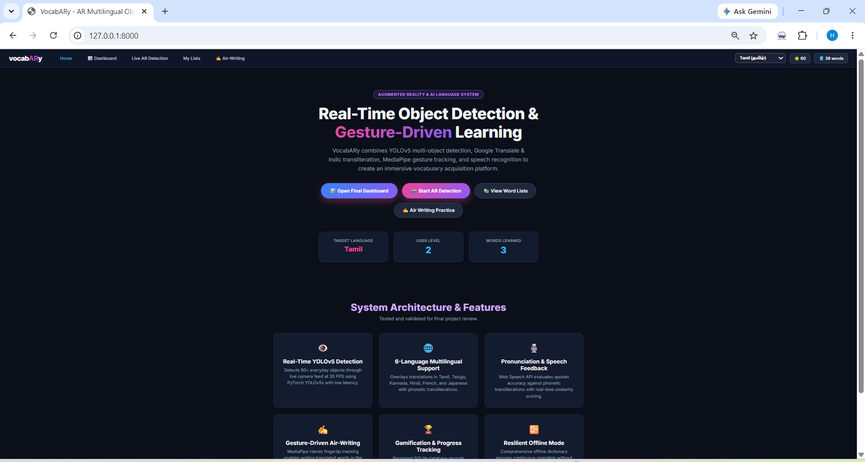

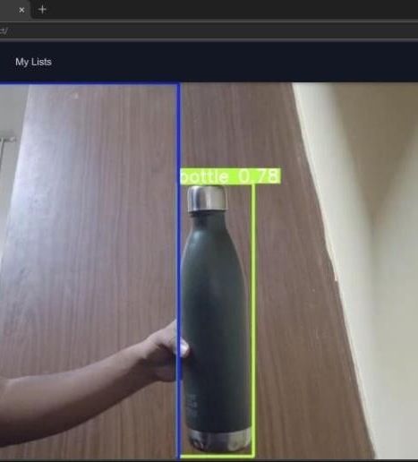
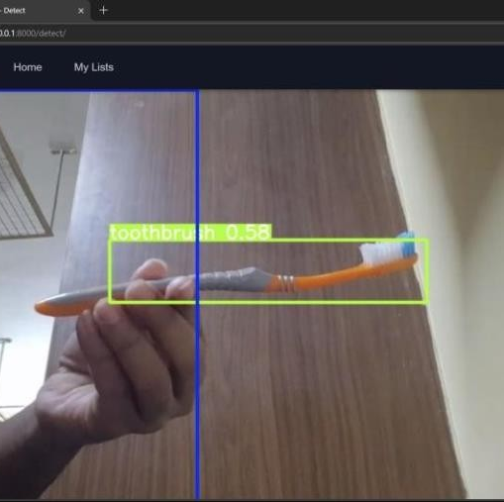
- Object Detection in Action:

- Multilingual Support:

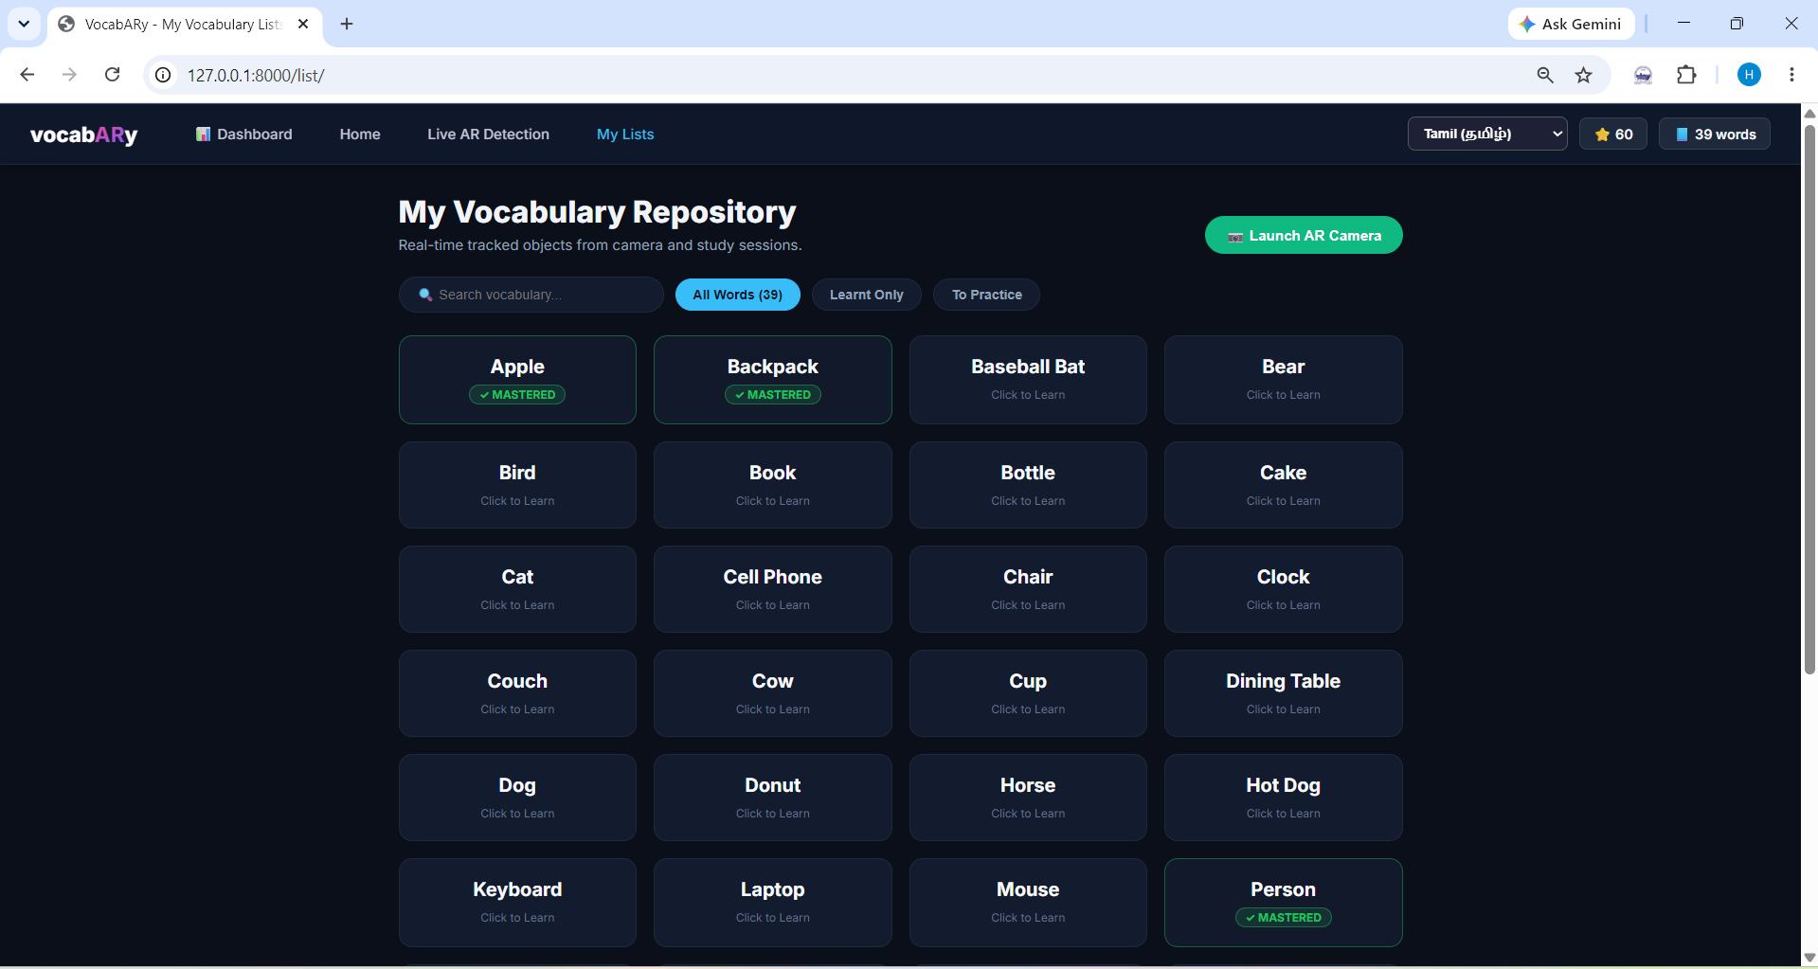
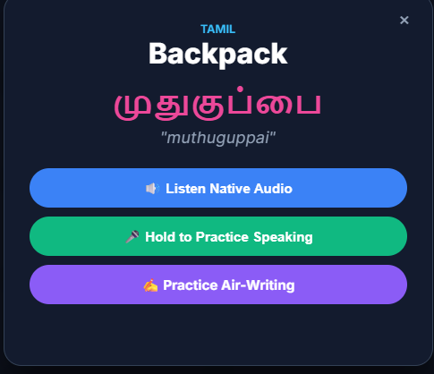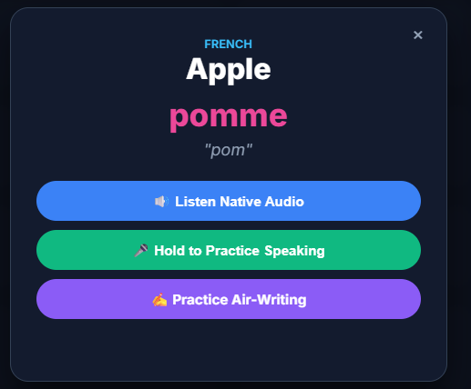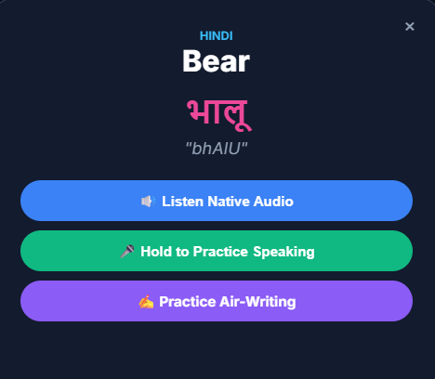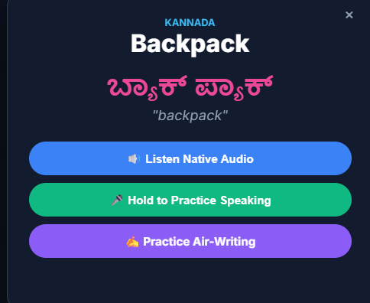

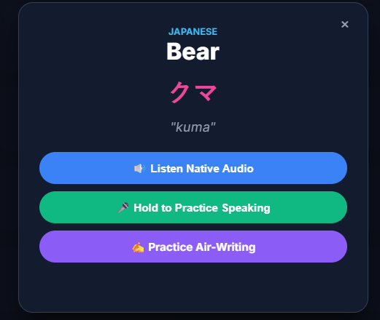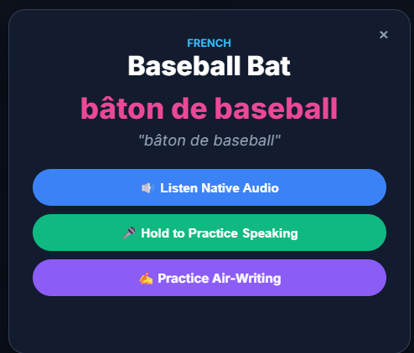

8. COMPARISON WITH EXISTING APPROACHES
Feature | Traditional flashcards | General visual translation tools | VocabARy target workflow
Physical object detection | No | Depends on product and mode | Live camera detection for supported model classes
Multilingual vocabulary | Prepared by learner/teacher | Often available; product-dependent | Configured target-language mappings and fallbacks
Pronunciation aid | Teacher/audio if provided | Product-dependent | Transliteration and optional browser speech
Gesture-based writing | No | Not a core workflow in general | MediaPipe fingertip canvas and OCR prototype
Offline use | Generally possible | Varies; often network-dependent | Local dictionary only for covered terms; APIs need internet
Evidence of learning gains | Must be evaluated | Must be evaluated for the selected tool | No controlled learner study provided in supplied materials

8.1 Comparative Discussion
Flashcards are inexpensive and can be used offline but do not automatically detect live objects or integrate speech and gesture feedback. General visual translation tools can help with visual translation, but their exact capabilities and network requirements vary by product and version. Language-learning applications may provide structured lessons and audio exercises, but their workflows differ. VocabARy aims to combine these functions in one prototype. Avoid absolute statements that no other system offers a feature unless supported by a current, documented comparison using equivalent test conditions.

9. LIMITATIONS, PRIVACY, AND FUTURE WORK

9.1 Technical Limitations
- YOLOv5s is limited to its trained classes and may fail on small, occluded, or unfamiliar objects.
- External translation services depend on network connectivity, rate limits, and service availability.
- Browser speech features vary across browsers, operating systems, languages, and locales.
- Transliteration rules may not fully represent pronunciation differences or dialects.
- Tesseract OCR may perform poorly on noisy, sparse, or irregular air-writing strokes.
- A camera label overlay is not necessarily full spatial AR; spatial anchoring must be implemented and demonstrated before claiming it.

9.2 Evaluation Limitations
The supplied materials do not include raw predictions, a labelled evaluation dataset, participant details, trial counts for speech and writing, statistical tests, confidence intervals, or a controlled learning study. Consequently, the numerical values are preliminary reported results rather than conclusive evidence. The existing comparison table also requires date- and version-specific evidence and equivalent testing.

9.3 Future Work
- Verify and expand the literature survey to 30 distinct papers, with 15 papers per student.
- Publish a repeatable test protocol and report aggregate results with sample counts.
- Improve translation quality with curated vocabulary and confidence-aware handling.
- Improve air-writing with smoothing, normalization, preprocessing, and accessible input alternatives.
- Conduct a controlled pre-test/post-test study and, if feasible, a delayed recall test.
- Explore WebXR spatial anchoring if true spatial AR is a required project outcome.
- Explore on-device multilingual speech recognition for improved privacy and offline operation.

10. CONCLUSION
VocabARy is a browser-oriented multimodal vocabulary-learning prototype that combines camera-based object detection with multilingual translation, transliteration, speech practice, and gesture-driven writing. Its potential value is the connection between words and visible objects, with optional auditory and kinesthetic practice on common devices. The project is particularly oriented toward supporting regional Indian languages alongside French and Japanese. The supplied draft reports promising technical measurements, but those figures need a transparent, repeatable evaluation protocol. The next priority is to validate technical performance, document the working modules, and measure actual learning outcomes before claiming improved retention or superiority over existing approaches.

REFERENCES
[1] G. Jocher et al., “ultralytics/yolov5: v7.0 - YOLOv5 SOTA Real-Time Object Detection,” Zenodo, 2022, doi: 10.5281/zenodo.7347926.
[2] F. Lugaresi et al., “MediaPipe: A Framework for Building Perception Pipelines,” arXiv:1906.08172, 2019.
[3] R. Smith, “An Overview of the Tesseract OCR Engine,” in Proc. Ninth Int. Conf. Document Analysis and Recognition (ICDAR), 2007, vol. 2, pp. 629–633.
[4] A. Paivio, “Dual coding theory: Retrospect and current status,” Canadian Journal of Psychology, vol. 45, no. 3, pp. 255–287, 1991.
[5] P. Cipresso, I. A. C. Giglioli, M. A. Raya, and G. Riva, “The Past, Present, and Future of Virtual and Augmented Reality Research: A Network and Cluster Analysis of the Literature,” Frontiers in Psychology, vol. 9, p. 2086, 2018.
[6] L. Ismail and R. Buyya, “Metaverse: A Vision, Architectural Elements, and Future Directions for Scalable and Realtime Virtual Worlds,” arXiv:2308.10559, 2023.
[7] E. Bottani and G. Vignali, “Augmented Reality Technology in the Manufacturing Industry: A Review of the Last Decade,” IISE Transactions, vol. 51, no. 3, pp. 284–310, 2019.
[8] P. Dhar et al., “Augmented Reality in Medical Education: Students’ Experiences and Learning Outcomes,” Medical Education Online, vol. 26, no. 1, p. 1953953, 2021.
[9] D. Buhalis, D. Leung, and M. Lin, “Metaverse as a Disruptive Technology Revolutionising Tourism Management and Marketing,” Tourism Management, vol. 97, p. 104724, 2023.
[10] D. N. Nasser, “Augmented Reality in Education Learning and Training,” in Proc. JCCO Joint International Conference on ICT in Education and Training, 2018, pp. 1–7.
[11] M. Idul and S. Syaiful, “Augmented Reality in the Classroom: Revolutionizing Vocabulary Teaching for High School Language Learners,” Journal of Educational Technology, vol. 8, no. 3, pp. 245–256, 2024. Bibliographic record must be verified before submission.
[12] L.-O. Tran, J.-L. Chang, and H.-T. Hung, “Systematic review of AR in technology-enhanced language learning over 15 years,” Computers & Education, vol. 195, p. 104712, 2024. Bibliographic record must be verified before submission.
[13] J. T. Hustanto, P. Setyosari, and H. Praherdhiono, “Using Mobile Augmented Reality to Increase Student English Language Learning,” International Journal of Interactive Mobile Technologies, vol. 18, no. 15, pp. 78–92, 2024. Bibliographic record must be verified before submission.
[14] R. Rintaningrum et al., “Utilize Augmented Reality Technology to Improve Listening Skills in Foreign Languages,” IEEE Access, vol. 12, pp. 102341–102352, 2024. Bibliographic record must be verified before submission.
[15] K. Ravichandran et al., “Gamifying Language Learning: Applying Augmented Reality and Gamification Strategies,” Educational Information Technologies, vol. 29, pp. 8812–8829, 2024. Bibliographic record must be verified before submission.
[16] N. S. Mohd Nabil et al., “Immersive language learning: evaluating augmented reality filter for ESL speaking fluency teaching,” Language Learning & Technology, vol. 28, no. 2, pp. 45–62, 2024. Bibliographic record must be verified before submission.
[17] L. Bryant, B. Bailey, and B. Hemsley, “Developing and evaluating an immersive augmented reality application for children with developmental communication disability,” Disability and Rehabilitation: Assistive Technology, vol. 19, no. 6, pp. 2110–2122, 2024. Bibliographic record must be verified before submission.
[18] M. A. Amrulloh, “Implementation of augmented reality learning media in Arabic language courses,” Journal of Language and Linguistic Studies, vol. 20, no. 3, pp. 112–125, 2024. Bibliographic record must be verified before submission.
[19] S. Chenna, “Augmented Reality and AI: Enhancing Human-Computer Interaction in the Metaverse,” SSRN Electronic Journal, art. no. 4324629, 2023. Bibliographic record must be verified before submission.
[20] A. Elsharkawy, K. Naheem, D. Koo, and M. S. Kim, “A UWB-Driven Self-Actuated Projector Platform for Interactive Augmented Reality Applications,” Applied Sciences, vol. 11, no. 6, p. 2871, 2021.

APPENDIX A – SUGGESTED DEMONSTRATION CHECKLIST
- Start the project using the verified run script or documented Django command.
- Open the local URL in a supported browser and grant camera permission.
- Show a common object and explain the label, bounding box, and confidence score.
- Change the target language and check a known translation.
- Demonstrate transliteration and audio/speech functionality only if it works in the current browser.
- Enable air-writing, draw a simple test character, and show OCR feedback if available.
- Explain which functions are implemented, experimental, or future work.
- Stop the camera/microphone before ending the demonstration.

IDE–VisualStudioCodeInstallation
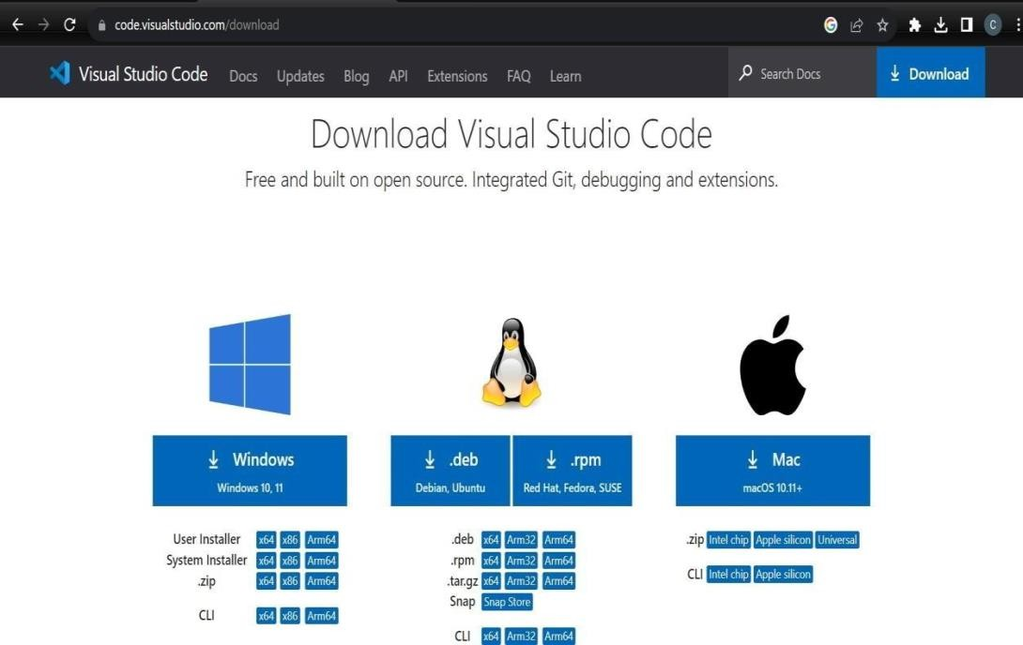

SourcetodownloadVSCode:code.visualstudio.com/download

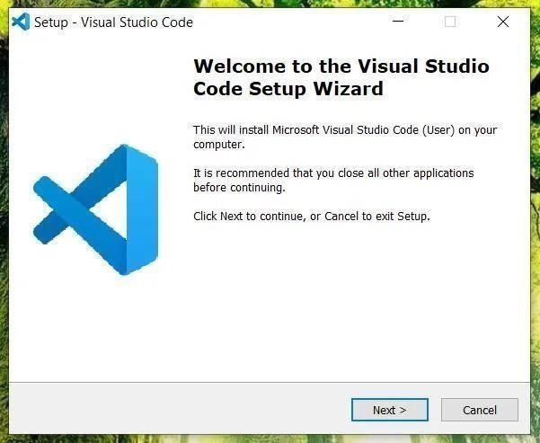

GitSetup
VSCodeSetup

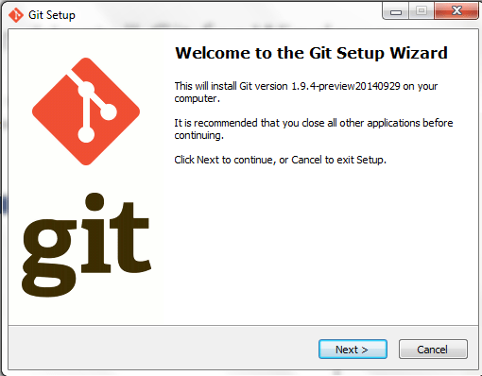
GitSetup

Github link: https://github.com/Echo2f13/vocabARy

Use the below command to clone the repository
>git clone https://github.com/Echo2f13/vocabARy

APPENDIX B - SOFTWARE USAGE PROCESS

Navigate to the root folder
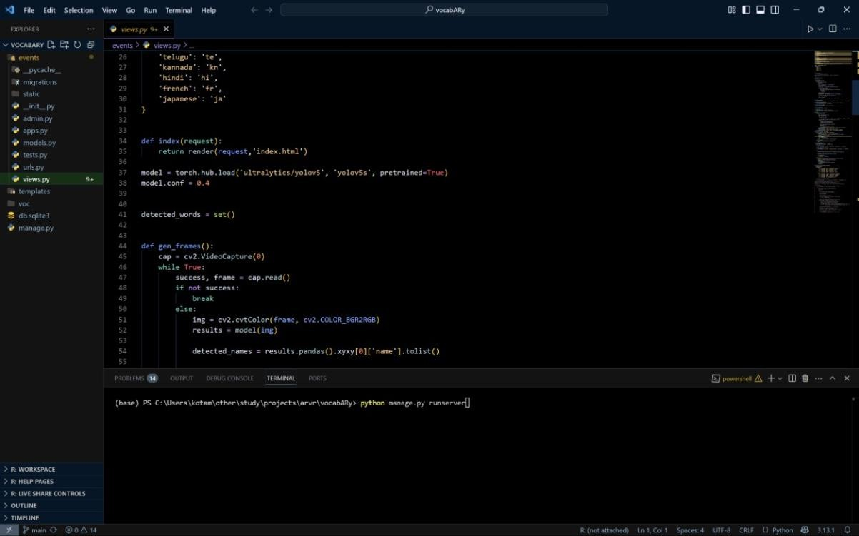

Navigating to the main folder

Head to the root folder and open terminal, then user this command

- python manage.py runserver
your website will be active right way.Before you run the program make sure you have installed every module from requirments.txt.
or just download the below mentioned packages use this command:
>pip install Django
>pip install django-jsonresponse
>pip install pillow
- pip install opencv-python
>pip install torch
>pip install ultralytics
- pip install indic-transliteration

