**Scenario**

Your company wants to distribute their content in the form of a website to their global offices. However, due to some legal restrictions, you cannot distribute the content in France and Australia. You need to find a way to prevent these offices from accessing the data.

The content does not change very often; however, some of the files are very large, and you have to find a solution to minimize end user latency.

The last requirement is that the audit department wants to track whoever is accessing the website.

Set up a static website using Amazon S3.

o Create a bucket and enable static website hosting.

o Enable logging.

• Set up a CloudFront distribution for the static website with Access Logs enabled.

• Set up Geo Restrictions to prevent users in France and Australia from accessing the data.

• Verify that logging is working.

1. First I will go for Storage and Open S3 Bucket and Register The Static Website

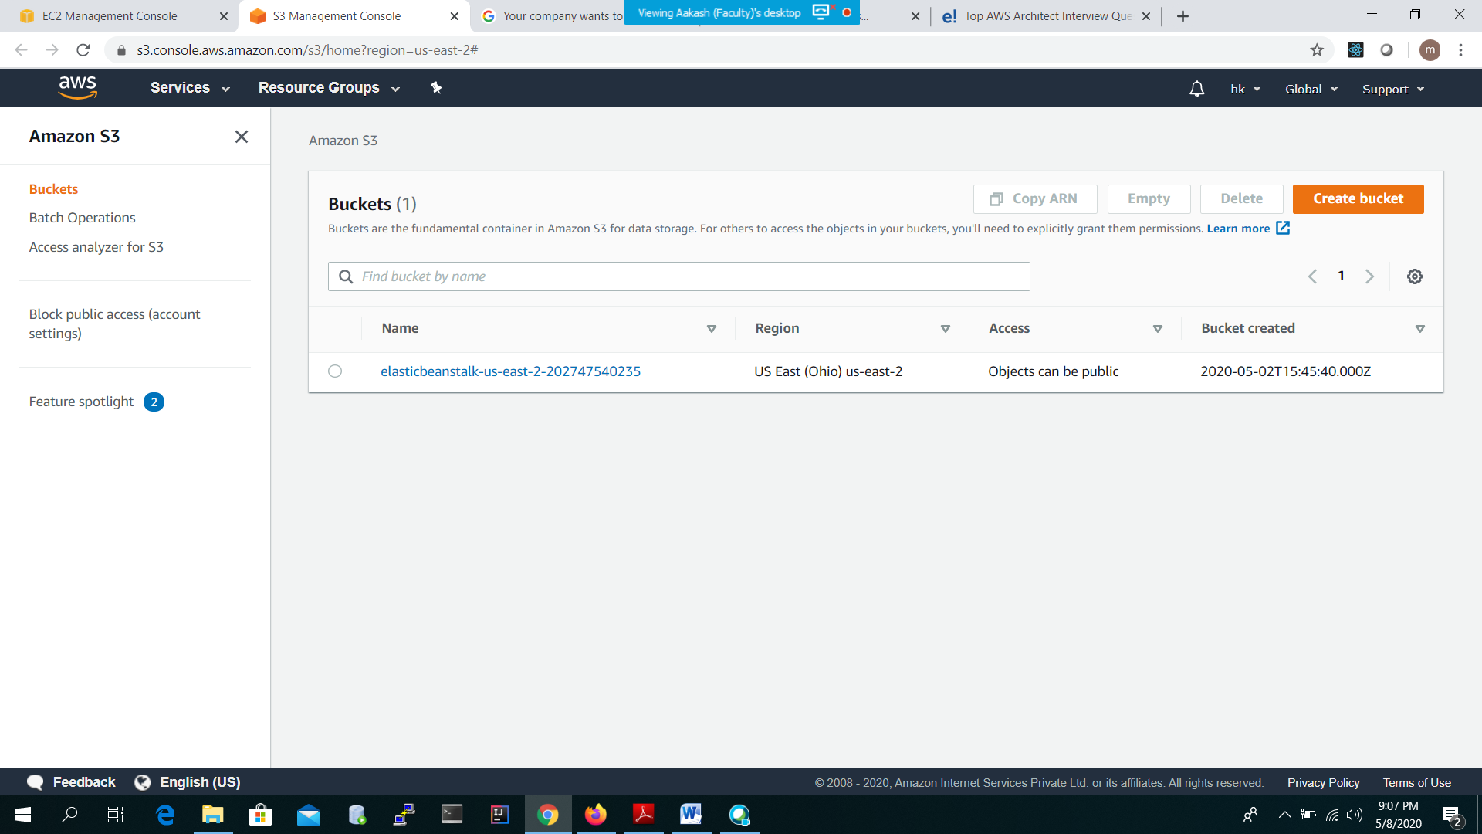

1. **Block all public access--------🡪Enable-----🡪Create Bucket**
2. **Then Upload option--🡪then Add Your File--🡪Upload the Static website ---🡪Make it public**
3. Go to --🡪 myaws1712 bucket-🡪 click on properties🡪 then click on Static Web hosting-🡪 Use this bucket to host a website----and then okay
4. Then Enable the Logging----got o🡪 Server access logging🡪Enable logging--🡪ok
5. Open CloudFront distribution---🡪 put s3 bucket name-🡪 and then okay
6. After That open the Distribution Settings---🡪 Restrictions tab--🡪Edit -🡪Edit Geo-Restrications
7. And make it blacklist France and Australia. Then okay
8. URL for Static website---<http://myaws1712.s3-website.us-east-2.amazonaws.com/>

