Freight rate prediction
  - How I explored the data, built the model, and checked the December forecast

1. Exploratory data analysis
I started with 48,000 labelled loads from January–October 2025 and 12,000 unlabelled loads from November–December. Distance explained most of the rate, but the data also had several traps: 677 labels (1.41%) sat in separate bands at roughly 0.2–0.5× or 2–5× the lane-and-equipment norm; 292 training weights and 145 validation weights were negative; and weights piled up at 47,500 lb. Weight was missing in 0.63% / 1.4% of train / validation rows, and market_index in 0.78% / 2.1%.
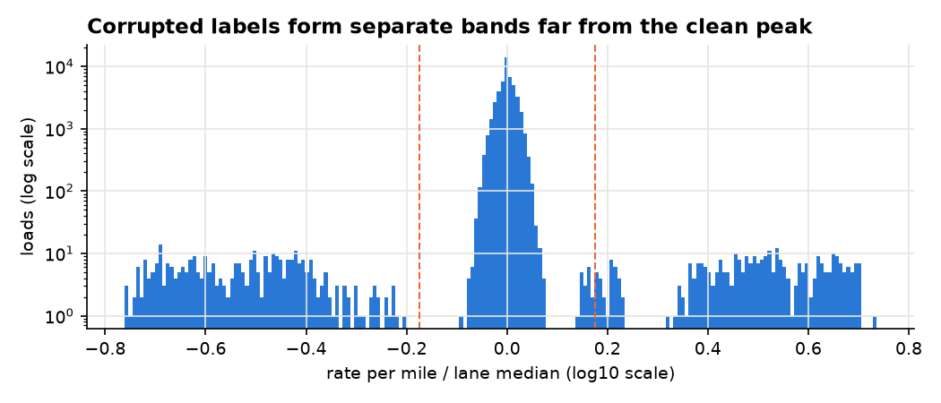
The label-ratio distribution separates the clean peak from the corrupted tails.
market_index turned out to be a real daily index, not just a date proxy. Its weekly swing ran from −9% on Sunday to +9% on Thursday, while composition-adjusted prices moved in the same direction by about −1.1% to +1.0%. By contrast, quote_signal copied or mirrored the target in different training months, then behaved like noise in validation: its daily-mean standard deviation was 0.016 and its lag-1 autocorrelation was 0.03. I left it out of the final model.
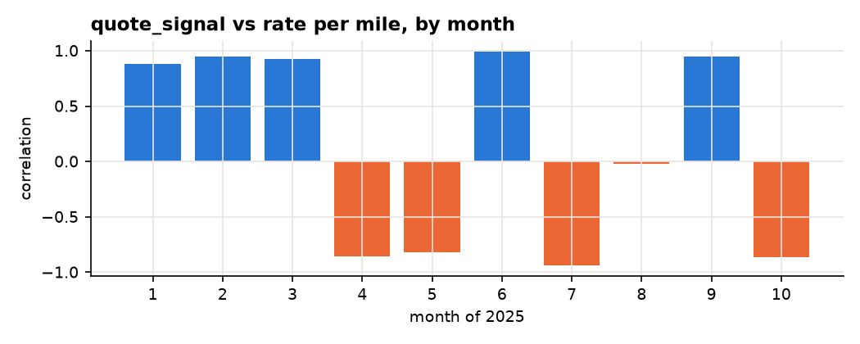
The quote_signal relationship changes sign across training months.
I also found a rate ramp in March, June and September that grew toward quarter-end, plus an upward drift beyond the market index. Eight cities were new in validation, touching 12.06% of its rows; Laredo was south of every training city. Those findings shaped the time split and the location features.

2. Preprocessing
I corrected negative weights with their absolute values (292 training rows; 145 validation rows) and marked weights at the 47,500 lb cap (1,204 training rows; 301 validation rows). I filled the 300 missing training weights and 165 missing validation weights with 31,000 lb for ridge, while LightGBM kept them as missing. For the 374 and 249 missing market_index values, I used that day's mean across the file. The 48 training and 21 validation distances at the 70-mile floor were genuine short hauls, so I left them alone.
For labels, I used a two-pass screen based on a ridge fit and removed training rows outside 0.67–1.5× of the fitted lane-and-equipment rate. It flags about 1.4% of each training fold. The screen is fit inside each fold and never applied to assessment rows; those labels remain in the all-row metrics. Removing the screen raises dev wMAE_clean by $14.18.

3. Feature engineering
I kept B-splines for log distance, weight and all four coordinates, plus the cap flag and equipment indicators. Replacing the splines with straight lines cost $10.4. Coordinates carried across to unseen cities: novel-city dev MAE was $40.9 versus $42.5 for seen cities. City categories did worse on novel cities in the feature study (MAE 186 versus 124), so I used coordinates instead of city IDs.
I split market_index into its daily mean and per-load deviation. Removing the market features cost $34.11; removing the time trend cost $13.34; removing the quarter-end ramp by equipment cost $28.99. By month-end, the ramp added 2.3% for Dry Van, 5.0% for Reefer and 7.8% for Flatbed. The distance-by-market interaction added a smaller $0.28 gain (95% CI 0.19–0.33, 5/5 folds). Ridge alone was $1.30 worse than the hybrid, and removing market features from the residual trees cost $0.86, so I kept both stages.
I dropped weekday dummies because adding them cost $3.00 once the weekly market swing was present. I also dropped per-load quote_signal (the feature study found removal helped in 2/3 folds, with clean MAE 114 versus 120), load_id, city names, and month or day-of-year features in the trees. The last group had no useful support for forecasting beyond October.
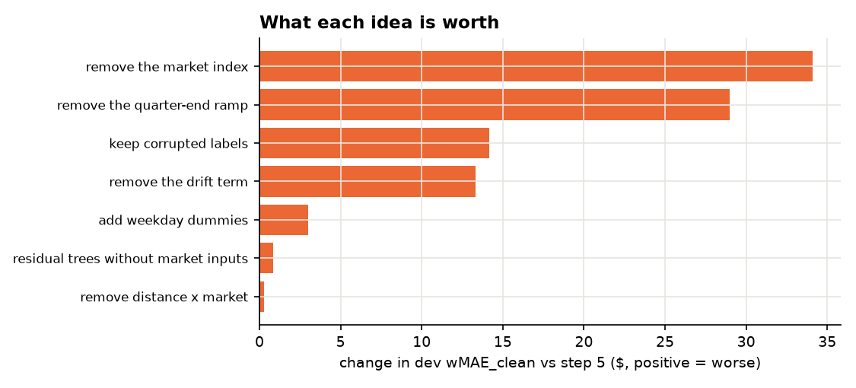
Ablations: positive changes mean worse dev wMAE_clean; adding weekday dummies also costs accuracy.

4. Model selection and training: the improvement journey
The first feature-study lookup was simple: equipment, distance and a rate-per-mile average. On its 3-fold development run, clean weighted MAE was $119.7. Corrupted labels pulled raw-target LightGBM to $161.5. A log target alone reached $122.3; adding the in-fold label screen brought it to $72.2.
Then I gave ridge a better description of the problem. In that same study, clean weighted MAE moved from $75.7 with the basic linear features to $71.7 after splines, $59.5 after coordinate splines, $53.3 after splitting the market index, $51.4 after adding a daily quote-signal mean and trend, $49.4 after distance-by-market, and $47.5 after residual LightGBM. Those early numbers use the feature study's 3 folds; after the validation shift showed quote signal was noise, I left it out of the final model. The later five-fold comparisons are below.
The earlier CatBoost submission and PDF-report model scored $111.25 and $85.18 on the final dev folds. The log-and-screen LightGBM with market, calendar and trend reached $63.77; structural ridge reached $44.01; and the default ridge-plus-LightGBM hybrid reached $42.67. A MARS follow-up looked promising against an older, weaker ridge comparison ($40.96 versus $43.71 on its 3 folds), but on the common five folds its best version reached $46.06. It did not beat the selected hybrid.
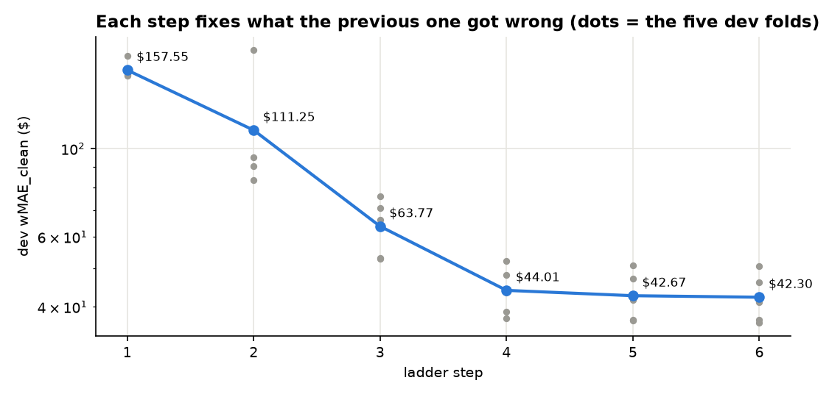
Five-fold development scores across the main model-building steps; gray dots show fold scores.
Final dev leaderboard | wMAE_clean
CatBoost submission | $111.25
PDF-report model | $85.18
Log-and-screen LightGBM, market + calendar + trend | $63.77
MARS + LightGBM follow-up (best M3) | $46.06
Structural ridge | $44.01
Default hybrid | $42.67
Tuned hybrid | $42.30

5. Hyperparameter tuning
I used Optuna's TPE sampler for 60 trials on the five dev folds, minimizing mean wMAE_clean. I searched ridge strength and spline knot counts, residual-tree count, learning rate, leaves, minimum child size, and whether to use recency weighting. The best result improved from $42.67 to $42.30. In the forward-nested check, the gain was $0.50 on fold F4 and $0.48 on F5. That is a small difference: the tuned and default models are practically equivalent.

6. Final evaluation
I used five expanding-window dev folds with 61-day horizons and hid 8 cities in each fold. The locked test trained through August 31 and assessed September 1–October 31, covering 9,523 loads.
Locked Sep–Oct test | wMAE_clean | MAE_clean | MAPE_clean | MAE_all
Tuned hybrid | $38.14 | $38.27 | 1.56% | $91.86
Default hybrid | $37.88 | $37.85 | 1.55% | $91.45
Structural ridge | $39.40 | $39.31 | 1.60% | $92.88
PDF-report model | $49.69 | $49.71 | 2.08% | $103.13
CatBoost submission | $64.31 | $65.62 | 3.74% | $118.79
Cross-section + naive index | $73.98 | $73.72 | 3.07% | $126.82

On paired test comparisons, the CatBoost model was $27.35 worse (95% CI $22.60–$32.21), the PDF model $11.44 worse ($6.56–$19.34), and the naive-index baseline $35.45 worse ($28.68–$44.51). The untuned hybrid was $0.42 better than the tuned one ($0.05–$0.81), another sign that tuning made little practical difference.
Dev-derived intervals covered 84.7% of clean rows at the 80% level and 96.9% at the 95% level; coverage on all rows was 83.5% and 95.5%. The 80% interval averaged ±2.6%.

7. December forecast
The December chart for Lexington–Fort Wayne, 360 miles, Dry Van and 32,000 lb ranges from $829 to $878. The chart rows do not include coordinates or a market index, so I filled coordinates from the city lookup and each date's market index from that day's validation mean. I assumed the quarter-end ramp would return: by December 31 it adds 2.3% for Dry Van, giving $878 instead of $858 without the ramp. There are no December labels to confirm that assumption.
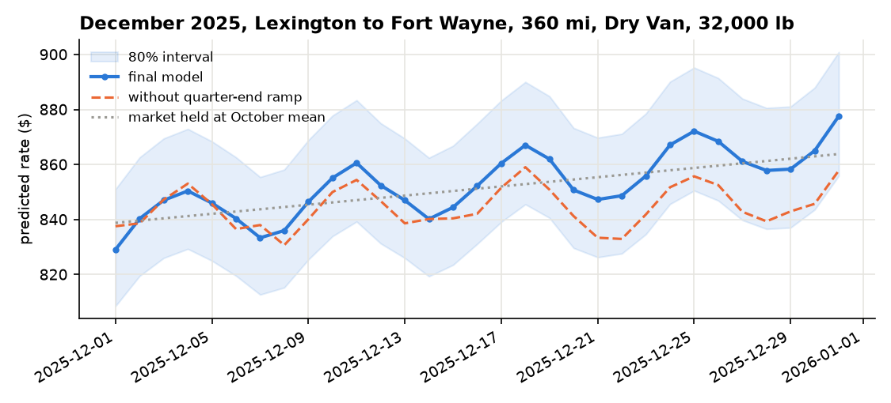
December predictions with the 80% interval, the no-ramp comparison, and the market held at its October mean.

8. Setting up MLflow and viewing results
Clone the project, create .env for local secrets, then run docker compose up. Open the MLflow UI; its port is not stated, so check in docker-compose.yml.
The reports identify freight-07-locked-test as the Sep–Oct evaluation and freight-08-final as the final training run. They name freight-00 through freight-08 as the experiment range, but do not describe freight-00 through freight-06 individually; check their descriptions in MLflow. In the model registry, look for models:/freight-rate-model@champion (v2; v1 is superseded).
Use scripts/predict.py to create outputs/validation_predictions.csv, then use score.py with that prediction file and the filled december_chart_inputs.csv. score.py checks format and fixed December inputs, not accuracy. The project reports do not give the command-line syntax for either script.

