GraphRec
A Multi-Tenant Recommendation System Platform as a Service
Technical Report
SE - 801 - Software Project Lab III
Supervised by:
Dr Rezvi Shahariar
Associate Professor
Institute of Information Technology
University of Dhaka

Submitted by:
Hasin Ahmed
Roll: BSSE1415

Submitted to:
SPL 3 Program Committee Submission

Submission Date:

2 AUGUST , 2026

Institute of Information Technology
University of Dhaka

Abstract
E-commerce businesses increasingly depend on personalized product recommendations to improve product discovery, customer engagement, and conversion. Building such a capability independently, however, requires specialized data collection, model training, evaluation, serving, version management, and operational monitoring. GraphRec addresses this difficulty as a multi-tenant recommendation platform through which independent e-commerce businesses can manage their own product catalogs, submit customer-interaction events, train tenant-specific recommendation models, and request real-time Top-N recommendations.
The platform treats every business as an isolated tenant. Tenant identity is derived from authenticated credentials, and tenant-owned customers, products, events, training jobs, datasets, model versions, deployments, recommendation records, usage records, and audit records remain separated. GraphRec uses a DGSR-inspired approach as its primary personalized recommendation model. Offline processing prepares tenant-specific snapshots, constructs time-ordered customer-product interaction graphs, trains and evaluates the model, and registers immutable model versions. The real-time path accepts identified-customer or anonymous-session context, produces eligible candidates, applies DGSR relevance scoring, and returns deterministically ordered recommendations. Safe popularity-based or last-known-good results may be returned when personalized service is unavailable and fallback is permitted.
Tenant administrators can request training, view progress and quality metrics, activate an eligible model version, and roll back to a previous version . Tenant applications can submit recommendation impressions, clicks, and conversions as feedback. Usage limits, quotas, model status, service status, failures, and audit information are visible according to role. The design supports controlled capacity adjustment under increased request demand while preserving tenant and model-version consistency.
GraphRec is specified as a limited-capacity educational platform rather than a production-grade high-availability service.
Contents
List of Tables 4
List of Figures 6
1. Introduction 7
1.1 Purpose 7
1.2 Motivation 7
1.3 Scope 7
1.4 Purpose of Document 8
2. Project Description 9
2.1 Stakeholder Identification 9
2.2 Actor Identification 10
3. Quality Function Deployment 11
3.1 Normal Requirements 11
3.2 Expected Requirements 12
3.3 Exciting Requirements 13
3.5 Project User Story 14
4. Requirements Modeling 15
4.1 Scenario-Based Modeling 15
4.2 Use-Case Diagram Concepts 15
4.3 Level-0 Use-Case Diagram 15
4.4 Level-1 Use-Case Diagram 16
4.5 Module-Level Use-Case Diagrams and Scenarios 17
4.6 Activity Diagrams 24
5. Data-Based Modeling 38
5.1 Entity-Relationship Modeling 38
5.2 Logical Entities 38
5.3 Relationship Summary 47
5.4 Logical ER Diagrams 49
6. AI Engineering Pipeline Architecture 51
6.1 Offline Model Training Pipeline 51
6.2 Online Inference Pipeline 52
6.3 Qdrant Vector Store Contract 54
6.4 Pipeline Comparison 54
8. Conclusion 56

List of Tables
Table 1: Assumptions 5
Table 2: Constraints 6
Table 3: Stakeholder Identification 7
Table 4: Actor Identification 8
Table 5: Normal Functional Requirements 9
Table 6: Normal Non-Functional Requirements 10
Table 7: Expected Functional Requirements 11
Table 8: Expected Non-Functional Requirements 12
Table 9: Exciting Functional Requirements 13
Table 10: Exciting Non-Functional Requirements 14
Table 11: Level 1.1 - Tenant Registration and Authentication Use-Case Summary 15
Table 12: Level 1.2 - Product and Customer-Event Management Use-Case Summary 16
Table 13: Level 1.3 - Model Training Management Use-Case Summary 17
Table 14: Level 1.4 - Model-Version Management Use-Case Summary 19
Table 15: Level 1.5 - Recommendation and Feedback Management Use-Case Summary 20
Table 16: Level 1.6 - Usage, Quota, and Status Monitoring Use-Case Summary 21
Table 17: Level 1 - Complete GraphRec Interaction Use-Case Summary 22
Table 18: Level 1.1 - Tenant Registration and Authentication Use-Case Summary 23
Table 19: Level 1.2 - Product and Customer-Event Management Use-Case Summary 24
Table 20: Level 1.3 - Model Training Management Use-Case Summary 25
Table 21: Level 1.4 - Model-Version Management Use-Case Summary 26
Table 22: Level 1.5 - Recommendation and Feedback Management Use-Case Summary 27
Table 23: Level 1.6 - Usage, Quota, and Status Monitoring Use-Case Summary 28
Table 24: Pricing Plan Logical Entity Attributes 29
Table 25: Tenant Logical Entity Attributes 30
Table 26: Tenant User Logical Entity Attributes 31
Table 27: API Credential Logical Entity Attributes 32
Table 28: Customer Logical Entity Attributes 34
Table 29: Product Logical Entity Attributes 35
Table 30: Interaction Event Logical Entity Attributes 36
Table 31: Training Job Logical Entity Attributes 37
Table 32: Dataset Snapshot Logical Entity Attributes 38
Table 33: Model Version Logical Entity Attributes 39
Table 34: Model Deployment Logical Entity Attributes 40
Table 35: Recommendation Request Logical Entity Attributes 41
Table 36: Recommendation Result Logical Entity Attributes 42
Table 37: Recommendation Feedback Logical Entity Attributes 43
Table 38: Usage Record Logical Entity Attributes 44
Table 39: Audit Record Logical Entity Attributes 45
Table 40: Relationship Summary 46
Table 41: Offline Training versus Online Inference Pipeline Comparison 48

List of Figures
Figure 1: GraphRec Level-0 Use-Case Diagram 14
Figure 2: GraphRec Level-1 Use-Case Diagram 16
Figure 3: Tenant Registration and Authentication Use-Case Diagram 17
Figure 4: Product and Customer-Event Management Use-Case Diagram 19
Figure 5: Model Training Management Use-Case Diagram 20
Figure 6: Model-Version Management Use-Case Diagram 22
Figure 7: Recommendation and Feedback Management Use-Case Diagram 24
Figure 8: Usage, Quota, and Status Monitoring Use-Case Diagram 25
Figure 9: GraphRec Activity Diagram - Level 1 27
Figure 10: Tenant Registration and Authentication Activity Diagram 28
Figure 11: Product and Customer-Event Management Activity Diagram 30
Figure 12: Model Training Management Activity Diagram 32
Figure 13: Model-Version Management Activity Diagram 33
Figure 14: Recommendation and Feedback Management Activity Diagram 35
Figure 15: Usage, Quota, and Status Monitoring Activity Diagram 36
Figure 16: Tenant, Identity, Catalog, and Interaction Logical ERD 38
Figure 17: Training, Model, Recommendation, Usage, and Audit Logical ERD 40
Figure 18: GraphRec System Architecture & Data Layer Overview 41
Figure 19: Offline Training Pipeline Detailed Sequence Diagram 43
Figure 20: Offline Training Job State Lifecycle Diagram 44
Figure 21: Pinned Inference Pod Initialization (Init Container Pattern) 46
Figure 22: Four-Stage Online Recommendation Serving Funnel 48

1. Introduction

1.1 Purpose
GraphRec provides reusable recommendation capabilities to independent e-commerce businesses. It enables each tenant to register, manage integration credentials, synchronize products, collect customer interactions, train and evaluate a tenant-specific DGSR model, control model versions, receive real-time Top-N recommendations, submit feedback, and observe usage and service status. The central purpose is to reduce the cost and complexity of building separate recommendation infrastructure for every business while preserving strict separation of tenant data and behavior.

1.2 Motivation
Product catalogs often contain more items than a customer can conveniently explore. Relevant recommendations reduce search effort and help a business present useful products at the correct moment. Developing a dependable recommendation service is difficult because it combines data quality, temporal modeling, model evaluation, low-latency serving, failure handling, security, and operational control.
A reusable platform allows several businesses to benefit from one coherent service while retaining tenant-specific data, models, rules, quotas, and results. Tenant isolation is essential because customer behavior and commercial data are confidential and because one tenant's model or load must not influence another tenant's outputs. The semester implementation must therefore demonstrate the important behavior without attempting unlimited scale or enterprise operational complexity. GraphRec uses bounded data volumes, one principal learned model family, controlled training concurrency, and a clear separation between offline preparation and online recommendation serving.

1.3 Scope

In Scope
GraphRec includes tenant registration and authentication; tenant-user and API-credential management; product creation, update, synchronization, and disablement; customer-interaction submission; training requests; tenant-specific DGSR model training and evaluation; training-status and result viewing; model-version viewing; model activation, archive, and rollback; identified-customer and session-aware Top-N recommendation requests; recommendation feedback; usage and quota viewing; model and service status; tenant and platform administration; audit history; and monitoring.

Out of Scope
The semester project excludes real-time online model training, real payment processing, multi-region operation, unlimited tenant scaling, enterprise disaster recovery, enterprise-grade high availability, complex production infrastructure, arbitrary tenant-supplied model code, and multiple unrelated primary learned recommendation-model families.

Assumptions
Table 1: Assumptions
ID | Assumption
ASM-01 | The demonstration begins with two tenants and supports no more than four simultaneously active tenants.
ASM-02 | Product catalogs and event volumes remain educational in scale.
ASM-03 | Model training is offline, batch-oriented, and limited to one resource-intensive training job at a time across the demonstration platform.
ASM-04 | Every active tenant retains at least one ready recommendation-service instance.
ASM-05 | Model quality is evaluated offline; observed clicks and conversions are informational and do not automatically activate a model.

Constraints
Table 2: Constraints
ID | Constraint
CON-01 | DGSR shall remain the primary learned personalized recommendation approach.
CON-02 | The system shall use a shared logical data model with tenant ownership and enforced tenant-level access controls.
CON-03 | The project shall use at most three small processing nodes in the optional distributed demonstration.
CON-04 | Recommendation requests shall remain synchronous; long-running preparation and training shall occur separately.
CON-05 | The platform shall be presented as a limited-capacity educational system, not as a production-ready high-availability service.

1.4 Purpose of Document
This report defines GraphRec's stakeholders, direct actors, Normal requirements, Expected requirements, Exciting requirements, business rules, simplified Quality Function Deployment, use cases, activity diagrams, logical entities, logical Entity-Relationship Diagrams.

2. Project Description
GraphRec is a shared recommendation platform serving multiple independent e-commerce tenants. Tenant and identity management controls accounts, roles, and credentials. Product management maintains the active catalog. Interaction-event management accepts and validates customer behavior such as views, clicks, cart actions, purchases, and ratings. Training management creates immutable tenant-specific dataset snapshots, trains the DGSR model, evaluates quality, and records model versions. Model-version management supports eligibility review, activation, archive, and rollback. Recommendation management produces tenant-specific results for identified users or anonymous sessions and records feedback. Usage and quota management measures plan consumption, while administrative monitoring exposes model, service, failure, and audit status.
GraphRec separates offline and online responsibilities. Offline work prepares data, trains and evaluates models, and constructs versioned recommendation artifacts. Online work performs only bounded request validation, tenant-specific recommendation preparation, eligibility enforcement, ordering, and response delivery. This separation keeps real-time requests responsive without introducing online training.

2.1 Stakeholder Identification
Table 3: Stakeholder Identification
Stakeholder | Description | Main interests | Responsibilities
Tenant Business Owner | Business decision-maker for a tenant using GraphRec. | Recommendation value, predictable limits, customer experience, and business continuity. | Approves adoption, selects service plan, reviews outcomes, and assigns tenant administrators.
Tenant Administrator | Authorized user who configures and operates the tenant account. | Easy administration, training visibility, model quality, safe activation, rollback, usage, and status. | Manages tenant users, requests training, reviews models, activates or rolls back versions, and monitors tenant operations.
Tenant Developer | Technical user integrating the tenant's e-commerce application. | Clear integration, stable credentials, reliable submissions, useful errors, and dependable recommendation responses. | Manages integration credentials, synchronizes products, submits events and feedback, and handles service responses.
E-Commerce Customer | Shopper who receives recommendations through the tenant's application. | Relevant, available, diverse, and non-repetitive product suggestions. | Interacts with the tenant application and generates behavioral feedback indirectly.
Platform Administrator | Operator responsible for the shared GraphRec platform. | Tenant safety, fair resource use, service health, failure visibility, and auditability. | Manages tenant states, plans, quotas, platform status, failures, and authorized administrative actions.

2.2 Actor Identification
Table 4: Actor Identification
Actor | Input supplied to GraphRec | Output received or viewed
Tenant Administrator | Registration and authentication information, tenant configuration, training requests, model activation or rollback requests. | Training status and results, model versions and quality, active-model status, usage, quotas, service status, and tenant monitoring information.
Tenant Developer | Product data, synchronization requests, credential requests, customer events, feedback, and integration actions. | Credential status, validation errors, submission confirmations, event-processing status, and recommendation responses.
Tenant E-Commerce Application | Product data, interaction events, identified-user or session recommendation requests, context, exclusions, and feedback. | Recommendation results, validation responses, confirmations, errors, and limit-related responses.
Platform Administrator | Tenant-management commands, plan and quota configuration, and platform administrative actions. | Platform and tenant status, usage, failure information, audit records, and system-level monitoring information.

The E-Commerce Customer is an important stakeholder because recommendations affect the shopping experience. The customer normally communicates with the tenant's e-commerce application rather than directly with GraphRec; therefore, the customer is not modeled as a direct GraphRec actor.

3. Quality Function Deployment

3.1 Normal Requirements
Normal requirements are explicitly requested capabilities.

Normal Functional Requirements
Table 5: Normal Functional Requirements
ID | Requirement | Main stakeholder
NR-F-01 | GraphRec shall allow a business representative to register a tenant and initial administrator account. | Tenant Administrator
NR-F-02 | GraphRec shall authenticate tenant users and provide role-appropriate access. | Tenant Administrator
NR-F-03 | GraphRec shall allow authorized users to create, rotate, view the status of, and revoke API credentials. | Tenant Developer
NR-F-04 | GraphRec shall allow a tenant to add, update, list, and disable products. | Tenant Developer
NR-F-05 | GraphRec shall accept a bounded product synchronization request and report accepted and rejected items. | Tenant Developer
NR-F-06 | GraphRec shall accept single and batch customer-interaction submissions with a tenant-local event identifier. | Tenant E-Commerce Application
NR-F-07 | GraphRec shall allow an authorized tenant administrator to request tenant-specific model training. | Tenant Administrator
NR-F-08 | GraphRec shall display training state, progress, failure information, and final result. | Tenant Administrator
NR-F-09 | GraphRec shall display the tenant's model versions, status, creation time, and quality summary. | Tenant Administrator
NR-F-10 | GraphRec shall allow an authorized administrator to activate an eligible model version. | Tenant Administrator
NR-F-11 | GraphRec shall allow an authorized administrator to roll back to an allowed historical model version. | Tenant Administrator
NR-F-12 | GraphRec shall accept a Top-N recommendation request for an identified customer. | Tenant E-Commerce Application
NR-F-13 | GraphRec shall accept a recommendation request based on anonymous session context. | Tenant E-Commerce Application
NR-F-14 | GraphRec shall accept recommendation impression, click, and conversion feedback. | Tenant E-Commerce Application
NR-F-15 | GraphRec shall display tenant usage, plan limits, remaining quota where calculable, and reset period. | Tenant Administrator
NR-F-16 | GraphRec shall display active-model and recommendation-service status to authorized tenant users. | Tenant Administrator

Normal Non-Functional Requirements
Table 6: Normal Non-Functional Requirements
ID | Requirement | Main stakeholder
NR-NF-01 | GraphRec shall prevent a tenant from reading or changing another tenant's resources. | Tenant Business Owner
NR-NF-02 | GraphRec shall derive tenant identity from authenticated credentials rather than trusting a tenant identifier supplied by a public request. | Platform Administrator
NR-NF-03 | GraphRec shall provide clear success, validation, conflict, limit, and temporary-unavailability responses. | Tenant Developer
NR-NF-04 | GraphRec shall target P95 recommendation responses below 300 ms at supported demonstration load. | E-Commerce Customer
NR-NF-05 | GraphRec shall ensure that repeated submission of the same tenant event identifier has one durable effect. | Tenant Developer
NR-NF-06 | GraphRec shall return a traceable error reference for failed requests without exposing credentials or another tenant's information. | Tenant Developer
NR-NF-07 | GraphRec shall support straightforward server-to-server integration using documented requests and responses. | Tenant Developer
NR-NF-08 | GraphRec shall keep at least one ready recommendation capability for each active tenant under normal supported conditions. | Tenant Business Owner

3.2 Expected Requirements
Expected requirements are capabilities stakeholders assume a reliable recommendation platform will provide.

Expected Functional Requirements
Table 7: Expected Functional Requirements
ID | Requirement | Main stakeholder
ER-F-01 | GraphRec shall construct every training dataset from one tenant's validated data only. | Tenant Business Owner
ER-F-02 | GraphRec shall create tenant-specific DGSR model parameters and artifacts. | Tenant Administrator
ER-F-03 | GraphRec shall evaluate trained models using next-item accuracy, ranking quality, coverage, and available diversity measures. | Tenant Administrator
ER-F-04 | GraphRec shall detect duplicate product, event, training, and feedback submissions according to their idempotency identifiers. | Tenant Developer
ER-F-05 | GraphRec shall return the serving model version and recommendation strategy with each recommendation response. | Tenant Developer
ER-F-06 | GraphRec shall keep the previously active model available when activation of a new version fails. | Tenant Administrator
ER-F-07 | GraphRec shall validate rollback targets before changing the active version. | Tenant Administrator
ER-F-08 | GraphRec shall record accepted events, recommendation requests, training activity, stored products, and model-artifact usage. | Platform Administrator
ER-F-09 | GraphRec shall enforce plan and tenant-specific usage limits before accepting bounded operations. | Platform Administrator
ER-F-10 | GraphRec shall provide a tenant-safe fallback recommendation when personalized service is unavailable and fallback is permitted. | E-Commerce Customer
ER-F-11 | GraphRec shall record an audit history for credential changes, activation, rollback, quota changes, and administrative actions. | Platform Administrator
ER-F-12 | GraphRec shall expose model, training, recommendation, usage, and service status according to authorization. | Tenant Administrator

Expected Non-Functional Requirements
Table 8: Expected Non-Functional Requirements
ID | Requirement | Main stakeholder
ER-NF-01 | GraphRec shall preserve accepted asynchronous work through durable state and controlled reprocessing. | Platform Administrator
ER-NF-02 | GraphRec shall enforce tenant ownership consistently across identities, data, models, recommendation records, and usage records. | Tenant Business Owner
ER-NF-03 | GraphRec shall validate model identity, version, integrity, and compatibility before a model becomes ready. | Platform Administrator
ER-NF-04 | GraphRec shall record terminal failure reasons and make them visible to authorized users. | Tenant Administrator
ER-NF-05 | GraphRec shall retry only transient failures within a bounded policy and shall stop retrying deterministic invalid requests. | Platform Administrator
ER-NF-06 | GraphRec shall return stable ordering for identical model, catalog, context, and policy inputs. | E-Commerce Customer
ER-NF-07 | GraphRec shall prevent one tenant's workload from consuming unbounded shared processing capacity. | Platform Administrator
ER-NF-08 | GraphRec shall use a modular design that separates administration, long-running processing, training, recommendation serving, data management, and monitoring responsibilities. | Platform Administrator
ER-NF-09 | GraphRec shall expose sufficient metrics and status information to explain request failures, training failures, model changes, capacity changes, and quota rejection. | Platform Administrator

3.3 Exciting Requirements

Exciting Functional Requirements
Table 9: Exciting Functional Requirements
ID | Requirement | Main stakeholder
XR-F-01 | GraphRec shall combine recent anonymous or identified session events with persistent customer history when preparing recommendations. | E-Commerce Customer
XR-F-02 | GraphRec shall allow an authorized tenant to schedule periodic retraining. | Tenant Administrator
XR-F-03 | GraphRec shall allow retraining eligibility to be triggered by a configured number of newly accepted events. | Tenant Administrator
XR-F-04 | GraphRec shall support bounded diversity, category, brand, freshness, or seasonality rules in final recommendation ordering. | Tenant Business Owner
XR-F-05 | GraphRec shall allow rollback to an eligible retained historical model version. | Tenant Administrator
XR-F-06 | GraphRec shall support plan-based limits for events, recommendations, training, retained versions, and serving capacity. | Tenant Business Owner
XR-F-07 | GraphRec shall provide summarized usage trends by period and usage type. | Tenant Administrator
XR-F-08 | GraphRec shall adjust a tenant's recommendation-serving capacity within configured limits when measured demand changes. | Platform Administrator
XR-F-09 | GraphRec shall provide cold-start recommendations using recent popularity, category information, content information, or session context when personalization is insufficient. | E-Commerce Customer
XR-F-10 | GraphRec shall compare a newly trained DGSR version with baseline and active-version quality before activation. | Tenant Administrator

Exciting Non-Functional Requirements
Table 10: Exciting Non-Functional Requirements
ID | Requirement | Main stakeholder
XR-NF-01 | Capacity adjustment shall preserve tenant and active-model-version consistency. | Platform Administrator
XR-NF-02 | Diversity and freshness adjustments shall be bounded and versioned so that relevance remains explainable. | Tenant Business Owner
XR-NF-03 | Scheduled and event-triggered retraining shall obey tenant cooldown, plan quota, and one-active-training rules. | Platform Administrator

3.5 Project User Story
A business joins GraphRec and creates its tenant account. A Tenant Administrator configures authorized users and assigns suitable integration permissions. A Tenant Developer creates an API credential and connects the Tenant E-Commerce Application. The application synchronizes the product catalog and begins submitting customer views, clicks, cart actions, purchases, and ratings. GraphRec validates each event, prevents duplicate effects, and displays submission status.
After sufficient interaction history exists, the Tenant Administrator requests DGSR model training. GraphRec validates the request, prepares the tenant-specific snapshot, trains and evaluates the model, and displays progress. When training succeeds, the administrator reviews quality measures and the new model version. The administrator activates an eligible version; if activation fails, the previous version remains available. The tenant application then requests recommendations for identified customers or anonymous sessions and displays the returned products to customers. Customer interactions occur in the tenant application, which submits impressions, clicks, and conversions as feedback. Administrators review usage, quota, active-model status, training history, and service status, while the Platform Administrator monitors shared capacity, failures, audit records, and tenant isolation.

4. Requirements Modeling

4.1 Scenario-Based Modeling
Scenario-based modeling describes GraphRec from the viewpoint of external participants. Use-case diagrams identify the actors that exchange information with GraphRec and the goals they achieve. Activity diagrams expand those goals into chronological actor-system interactions, including visible validation, decisions, alternative outcomes, errors, cancellation, and final results. They intentionally avoid internal implementation details.

4.2 Use-Case Diagram Concepts

Actors
Actors are external participants that supply information, request services, receive results, or view information produced by GraphRec.

Associations
Associations connect actors to the use cases in which they participate.

System Boundary
The system boundary separates GraphRec services from external actors and their own applications.

Modules
Modules group related actor goals such as identity management, catalog integration, training, model-version management, recommendation delivery, and monitoring.

4.3 Level-0 Use-Case Diagram
Level: 0
Name: GraphRec Recommendation Platform
Actors: Tenant Administrator, Tenant Developer, Tenant E-Commerce Application, Platform Administrator
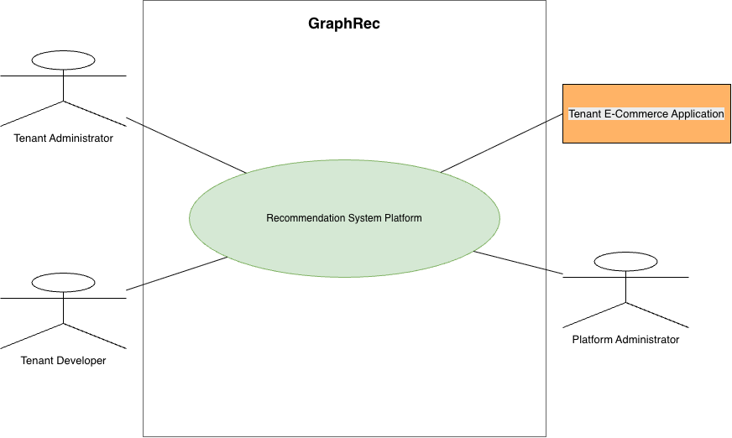
Figure 1: GraphRec Level-0 Use-Case Diagram

4.4 Level-1 Use-Case Diagram
Level: 1
Name: GraphRec Recommendation Platform Services
Actors: Tenant Administrator, Tenant Developer, Tenant E-Commerce Application, Platform Administrator
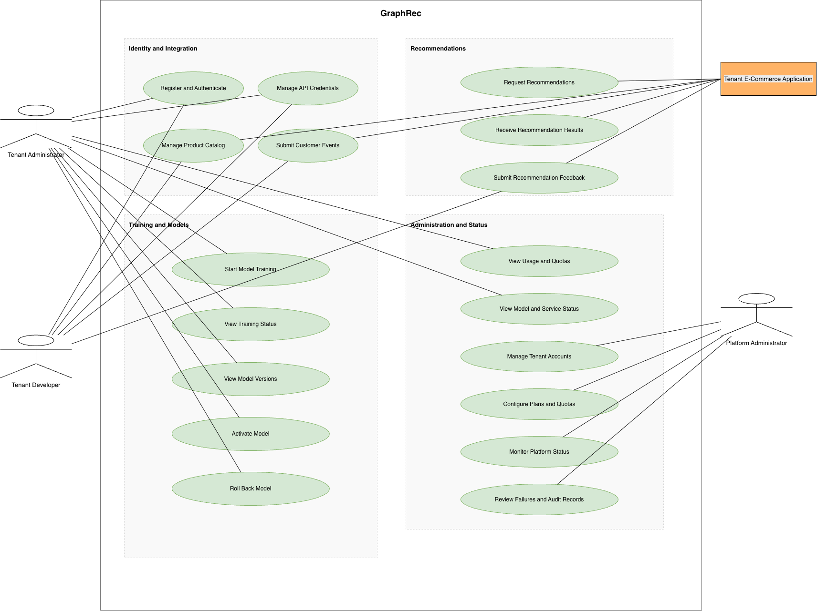
Figure 2: GraphRec Level-1 Use-Case Diagram

4.5 Module-Level Use-Case Diagrams and Scenarios

4.5.1 Level 1.1 - Tenant Registration and Authentication
Actors: Tenant Administrator, Tenant Developer
Use Cases: Register Tenant, Sign In, Recover Account, Manage API Credentials
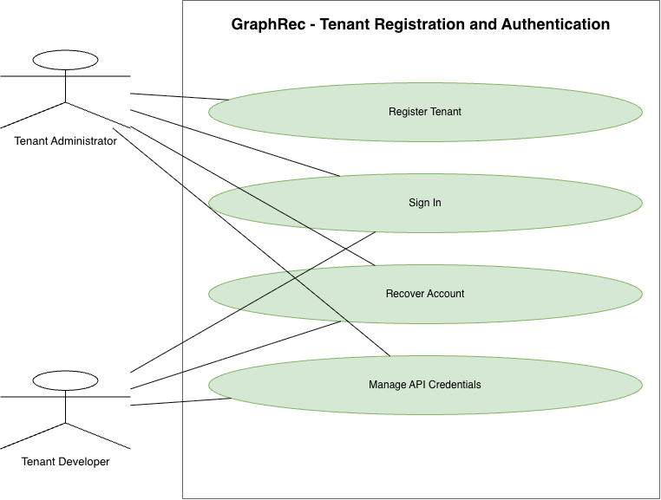
Figure 3: Tenant Registration and Authentication Use-Case Diagram
Table 11: Level 1.1 - Tenant Registration and Authentication Use-Case Summary
Use case | Actor | Preconditions | Input supplied | Output received | Alternative outcome
UC-01 Register Tenant | Tenant Administrator | Registration is available | Business name, administrator identity, contact information | Tenant registration and initial account status | Duplicate or invalid registration is rejected with correction guidance
UC-02 Sign In | Tenant Administrator; Tenant Developer | Active account exists | Authentication information | Authenticated session and authorized capabilities | Invalid, inactive, or rate-limited attempt is rejected
UC-03 Recover Account | Tenant Administrator; Tenant Developer | Recoverable account exists | Account identifier and recovery proof | Recovery confirmation and next action | Unknown, expired, or invalid request is rejected without disclosing private account details
UC-04 Manage API Credentials | Tenant Administrator; Tenant Developer | Actor is authenticated and authorized | Credential name, permissions, expiry, rotate or revoke request | One-time credential secret or updated credential status | Insufficient permission, duplicate name, or invalid state is reported

4.5.2 Level 1.2 - Product and Customer-Event Management
Actors: Tenant Developer, Tenant E-Commerce Application
Use Cases: Add Product, Update Product, Synchronize Product Data, Disable Product, Submit Customer Event, Submit Event Batch, View Submission Result
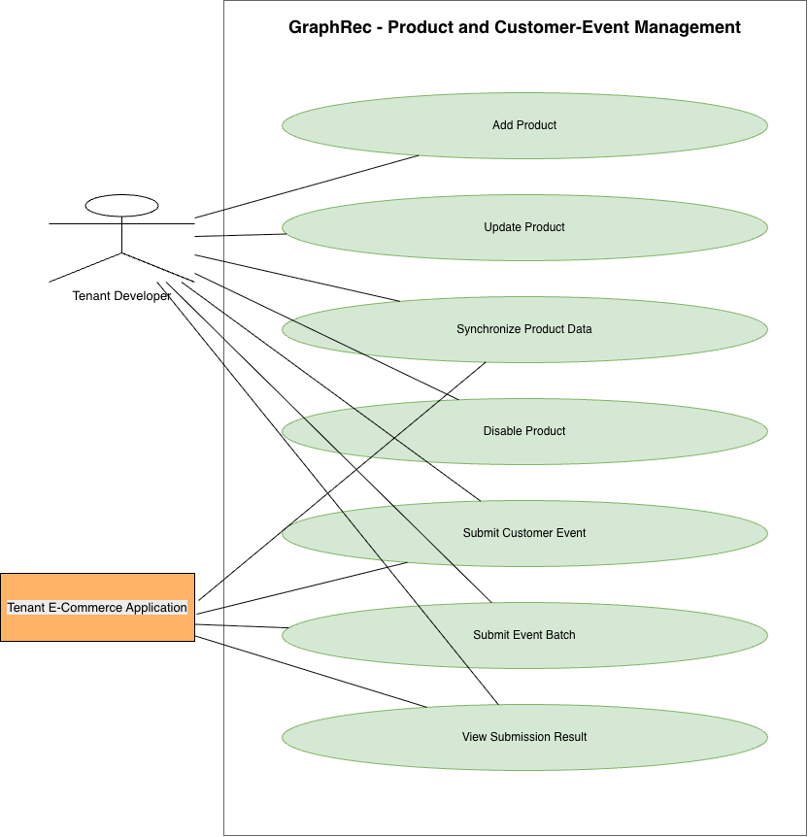
Figure 4: Product and Customer-Event Management Use-Case Diagram
Table 12: Level 1.2 - Product and Customer-Event Management Use-Case Summary
Use case | Actor | Preconditions | Input supplied | Output received | Alternative outcome
UC-05 Add Product | Tenant Developer | Valid catalog credential exists | Tenant-local product identifier and product information | Created product and validation status | Duplicate identifier, invalid data, or quota excess is reported
UC-06 Update Product | Tenant Developer | Product exists in the tenant | Changed product information | Updated product state | Missing product or conflicting update is reported
UC-07 Synchronize Product Data | Tenant Developer; Tenant E-Commerce Application | Integration credential is active | Bounded product collection and synchronization identifier | Accepted, updated, skipped, and failed counts | Oversized or invalid submission is rejected or partially reported
UC-08 Disable Product | Tenant Developer | Product exists and actor is authorized | Product identifier and reason | Disabled status | Missing, foreign, or already unavailable product produces a safe status
UC-09 Submit Customer Event | Tenant Developer; Tenant E-Commerce Application | Referenced product and credential are valid | Event identifier, customer identifier, product identifier, event type, time, optional context | Acceptance or duplicate confirmation | Invalid reference, unsupported type, or quota excess is reported
UC-10 Submit Event Batch | Tenant Developer; Tenant E-Commerce Application | Integration is active | Bounded event collection and batch identifier | Batch identifier and initial counts | Payload, schema, or limit failure is reported
UC-11 View Submission Result | Tenant Developer; Tenant E-Commerce Application | Submission belongs to the tenant | Submission or batch identifier | Processing status, counts, and safe errors | Missing or foreign identifier returns no resource details

4.5.3 Level 1.3 - Model Training Management
Actor: Tenant Administrator
Use Cases: Start Model Training, View Training Status, Cancel Training, View Training Result
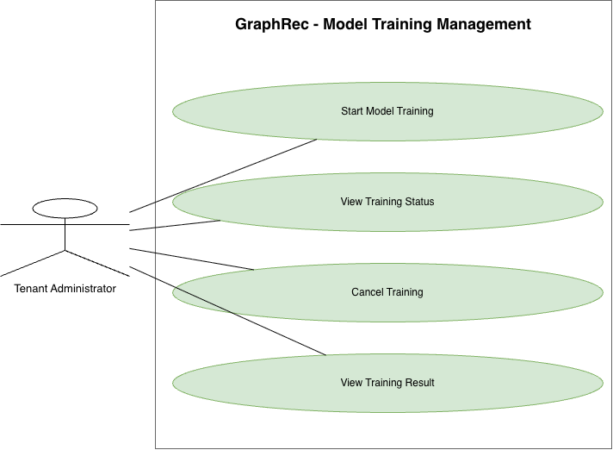
Figure 5: Model Training Management Use-Case Diagram
Table 13: Level 1.3 - Model Training Management Use-Case Summary
Use case | Actor | Preconditions | Input supplied | Output received | Alternative outcome
UC-12 Start Model Training | Tenant Administrator | Sufficient data, quota, permission, and no active tenant job | Model type, bounded configuration, request identifier | Accepted job identifier and initial state | Insufficient data, cooldown, duplicate active job, or quota excess is reported
UC-13 View Training Status | Tenant Administrator | Training job belongs to tenant | Job identifier or filter | Current stage, progress, timestamps, and safe failure information | Missing or foreign job is not disclosed
UC-14 Cancel Training | Tenant Administrator | Job is in a cancellable state | Job identifier and reason | Cancellation-requested or cancelled status | Terminal or non-cancellable job returns a state conflict
UC-15 View Training Result | Tenant Administrator | Job is terminal | Job identifier | Completion result, quality measures, and produced version when successful | Failure or cancellation result includes a safe reason and no version

4.5.4 Level 1.4 - Model-Version Management
Actor: Tenant Administrator
Use Cases: View Model Versions, View Model Quality, Activate Model, Roll Back Model, Archive Model Version
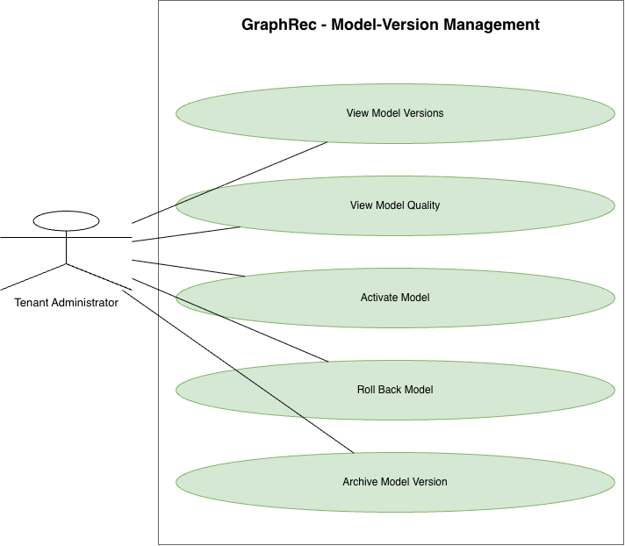
Figure 6: Model-Version Management Use-Case Diagram
Table 14: Level 1.4 - Model-Version Management Use-Case Summary
Use case | Actor | Preconditions | Input supplied | Output received | Alternative outcome
UC-16 View Model Versions | Tenant Administrator | Actor is authorized | Model filter or page request | Tenant-owned versions, lifecycle states, and active indicator | No versions returns an empty result
UC-17 View Model Quality | Tenant Administrator | Version belongs to tenant | Model-version identifier | Evaluation measures and comparison information | Missing metrics or foreign version is safely reported
UC-18 Activate Model | Tenant Administrator | Version is eligible and tenant-owned | Version identifier, reason, confirmation | Activation request and final active-version status | Ineligible or failed activation preserves the previous active version
UC-19 Roll Back Model | Tenant Administrator | Retained eligible target exists | Target version and reason | Rollback request and resulting active version | Invalid target or failed rollback preserves the current safe version
UC-20 Archive Model Version | Tenant Administrator | Version is inactive and not required for rollback | Version identifier and reason | Archived status | Active or protected version cannot be archived

4.5.5 Level 1.5 - Recommendation and Feedback Management
Actor: Tenant E-Commerce Application
Related Stakeholder: E-Commerce Customer
Use Cases: Request Recommendations, Receive Recommendation Results, Submit Recommendation Feedback
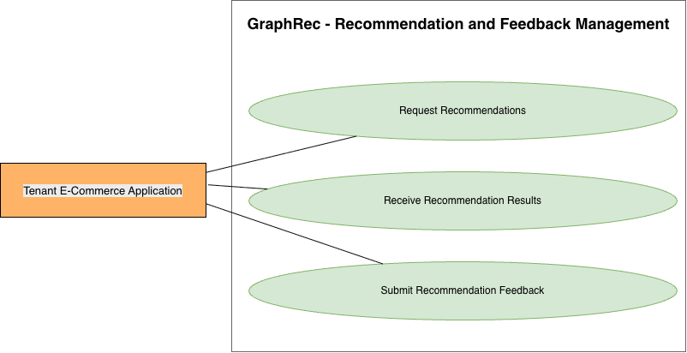
Figure 7: Recommendation and Feedback Management Use-Case Diagram
Table 15: Level 1.5 - Recommendation and Feedback Management Use-Case Summary
Use case | Actor | Preconditions | Input supplied | Output received | Alternative outcome
UC-21 Request Recommendations | Tenant E-Commerce Application | Valid credential and an available tenant recommendation service or fallback | Request identifier, customer or session context, recent events, result count, exclusions, optional eligibility hints | Accepted synchronous request | Invalid request, quota excess, or unavailable service returns a clear error
UC-22 Receive Recommendation Results | Tenant E-Commerce Application | Request passed validation | None beyond the active request | Ordered tenant products, model version, strategy, and fallback indicator | Safe fallback may be returned; otherwise unavailability is reported
UC-23 Submit Recommendation Feedback | Tenant E-Commerce Application | Referenced recommendation belongs to tenant | Feedback event identifier, request or result reference, product, position, type, time, optional value | Acceptance or duplicate confirmation | Invalid, foreign, or inconsistent reference is rejected

The E-Commerce Customer benefits from the recommendations but normally interacts with the tenant's own application rather than directly with GraphRec.

4.5.6 Level 1.6 - Usage, Quota, and Status Monitoring
Actors: Tenant Administrator, Platform Administrator
Use Cases: View Usage and Quotas, View Model Status, View Service Status, Manage Tenant Accounts, Configure Plans and Quotas, View Tenant Usage, Monitor Platform Status, Review Failures and Audit Records
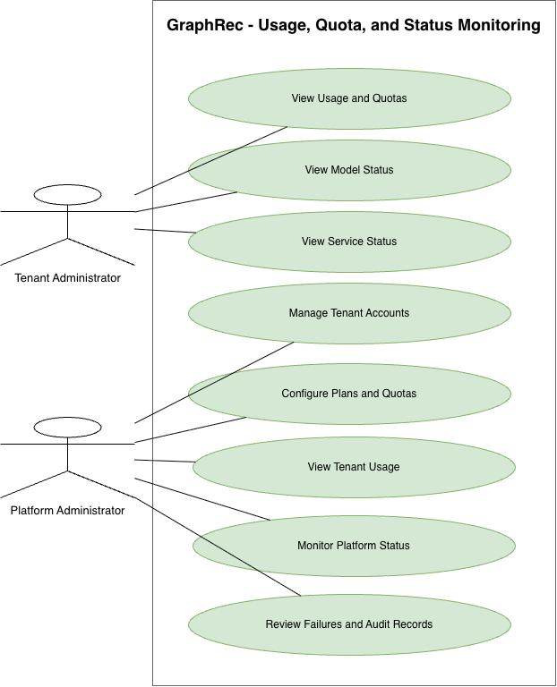
Figure 8: Usage, Quota, and Status Monitoring Use-Case Diagram
Table 16: Level 1.6 - Usage, Quota, and Status Monitoring Use-Case Summary
Use case | Actor | Preconditions | Input supplied | Output received | Alternative outcome
UC-24 View Usage and Quotas | Tenant Administrator | Authenticated tenant account | Period and usage filter | Current usage, limits, remaining allowance, and reset information | Temporarily unavailable measurements return a safe status
UC-25 View Model Status | Tenant Administrator | Tenant owns model records | Model or version filter | Active, desired, eligible, retired, or failed status | No model returns an explicit empty state
UC-26 View Service Status | Tenant Administrator | Tenant service exists or is being prepared | Optional time range | Availability, active version, ready capacity, recent errors, and fallback rate | Missing service or measurement delay is reported
UC-27 Manage Tenant Accounts | Platform Administrator | Platform permission exists | Tenant status action and reason | Updated tenant status and audit confirmation | Invalid transition or protected action is rejected
UC-28 Configure Plans and Quotas | Platform Administrator | Plan-management permission exists | Plan limits, tenant assignment, or approved override | Updated configuration and effective period | Invalid or conflicting limits are rejected
UC-29 View Tenant Usage | Platform Administrator | Authorized platform scope | Tenant, period, and usage filters | Tenant usage summary without private event payloads | Unauthorized scope or missing tenant is rejected
UC-30 Monitor Platform Status | Platform Administrator | Monitoring access exists | Time range and status filter | Shared service health, workload, capacity, and failure summary | Measurement gaps are identified rather than hidden
UC-31 Review Failures and Audit Records | Platform Administrator | Audit permission exists | Tenant, action, severity, or time filter | Redacted failures and immutable action history | Sensitive details remain hidden or access is denied

4.6 Activity Diagrams

4.6.1 Level 1 - Complete GraphRec Interaction
Level: 1
Name: Complete GraphRec Interaction
Reference: Use-Case Diagram Level 1
Actors: Tenant Administrator, Tenant Developer, Tenant E-Commerce Application, Platform Administrator
Source Use Cases: Register and Authenticate; Manage Integration and Data; Manage Training and Models; Request Recommendations and Submit Feedback; View or Manage Usage and Status
Table 17: Level 1 - Complete GraphRec Interaction Use-Case Summary
Use case group | Actor | Input to GraphRec | Output received from GraphRec
Register and Authenticate | Tenant Administrator; Tenant Developer | Registration or authentication information | Account, session, or corrective error
Manage Integration and Data | Tenant Developer; Tenant E-Commerce Application | Credentials, products, and events | Credential state and submission result
Manage Training and Models | Tenant Administrator | Training, activation, or rollback request | Status, model quality, and active version
Request Recommendations and Submit Feedback | Tenant E-Commerce Application | Customer or session context and feedback | Recommendations and submission confirmation
View or Manage Usage and Status | Tenant Administrator; Platform Administrator | Filters or authorized administrative action | Usage, status, failure, audit, or update result

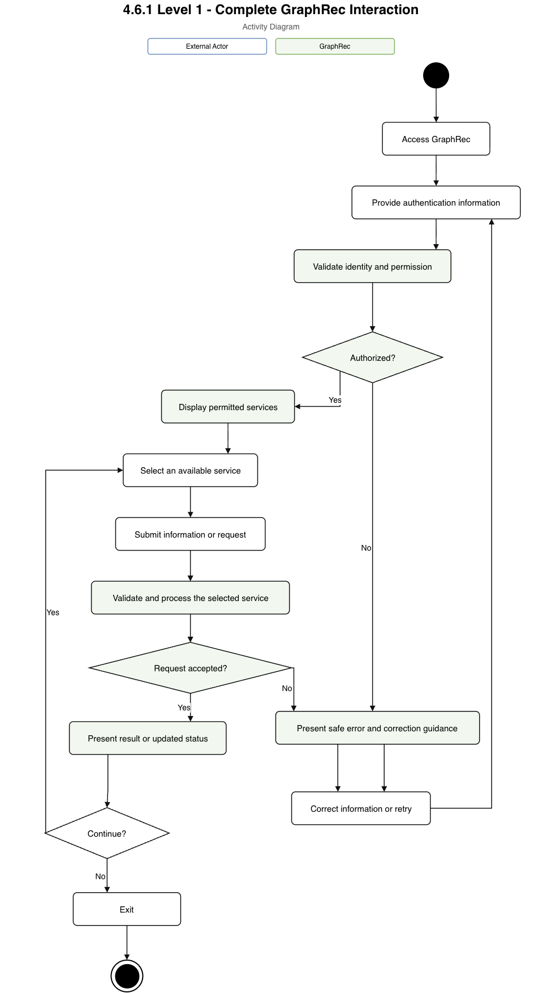
Figure 9: GraphRec Activity Diagram - Level 1

4.6.2 Level 1.1 - Tenant Registration and Authentication
Level: 1.1
Name: Tenant Registration and Authentication
Reference: Use-Case Diagram Level 1.1
Actors: Tenant Administrator, Tenant Developer
Source Use Cases: Register Tenant; Sign In; Recover Account; Manage API Credentials
Table 18: Level 1.1 - Tenant Registration and Authentication Use-Case Summary
Use case | Actor | Input to GraphRec | Output received from GraphRec
Register Tenant | Tenant Administrator | Business and initial administrator information | Tenant and account status
Sign In | Tenant Administrator; Tenant Developer | Authentication information | Authenticated session or error
Recover Account | Tenant Administrator; Tenant Developer | Account identity and recovery proof | Recovery status
Manage API Credentials | Tenant Administrator; Tenant Developer | Create, rotate, or revoke request | One-time secret or credential state

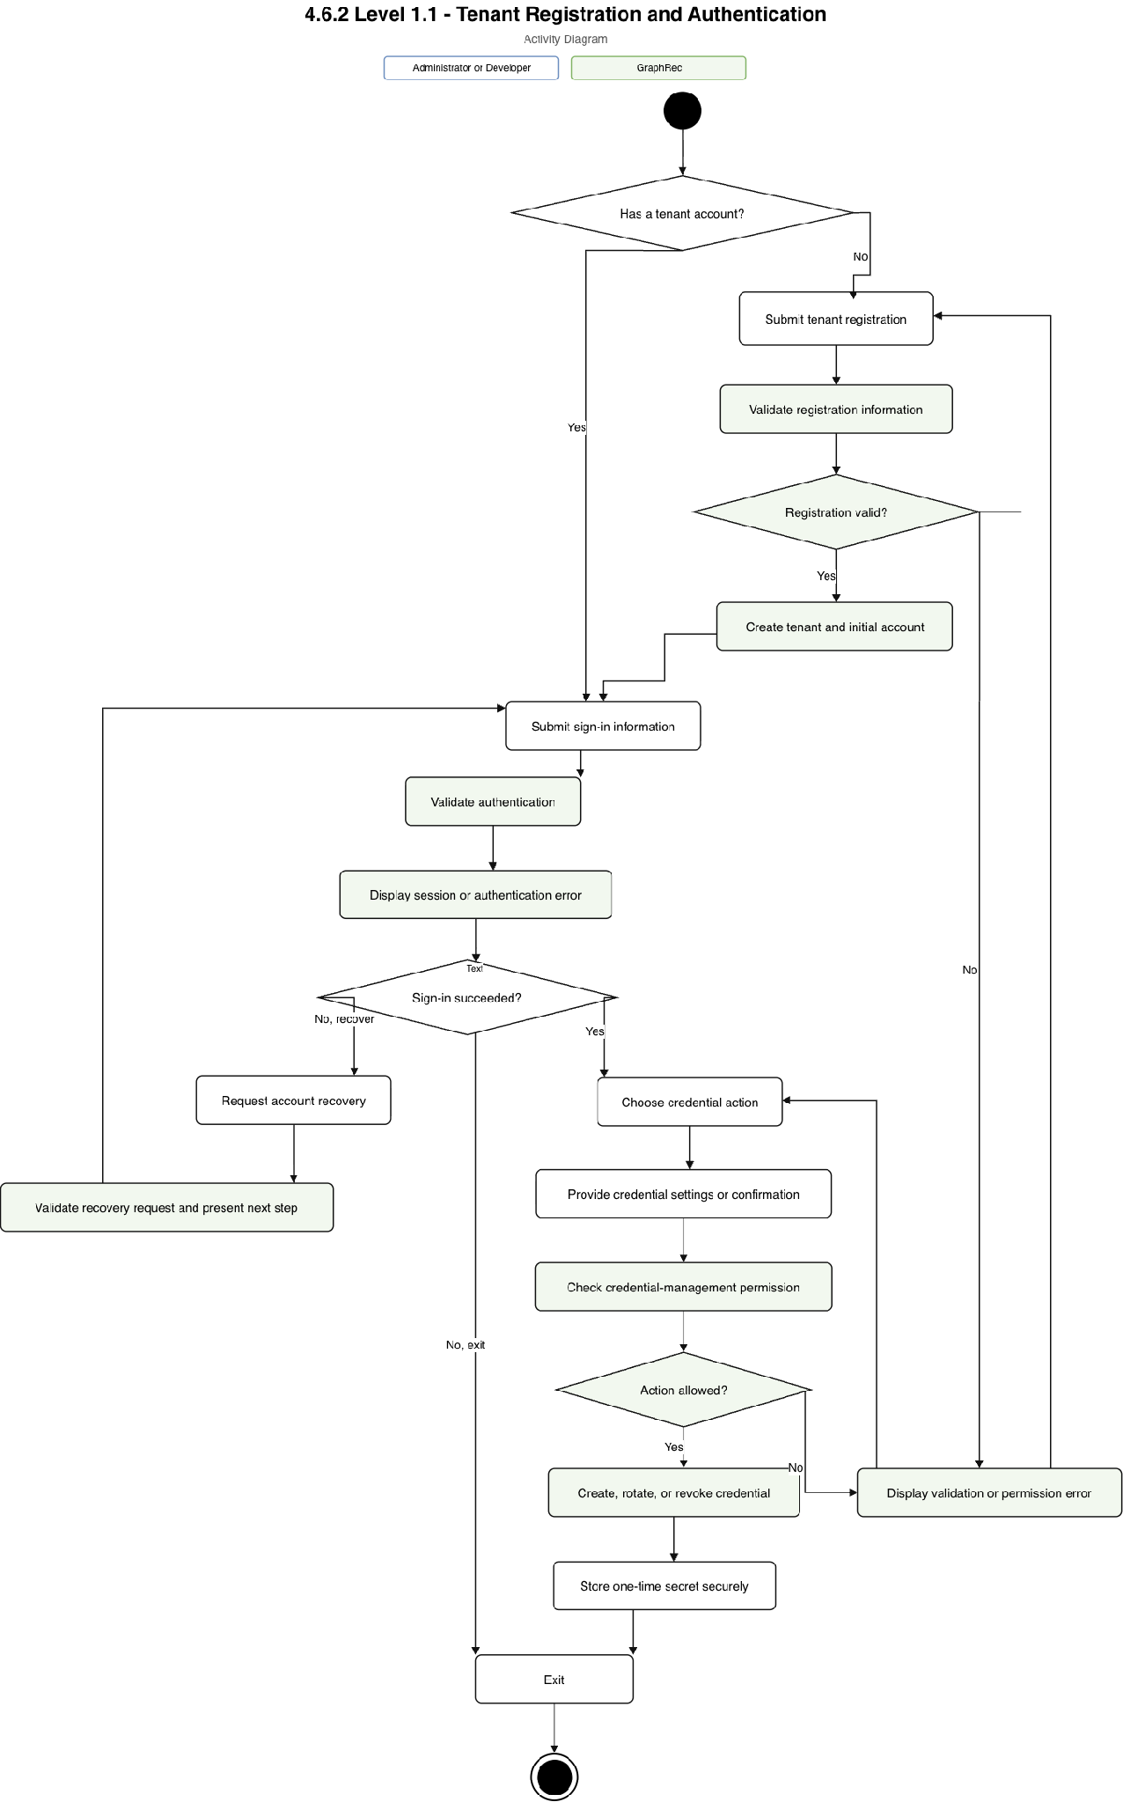
Figure 10: Tenant Registration and Authentication Activity Diagram

4.6.3 Level 1.2 - Product and Customer-Event Management
Level: 1.2
Name: Product and Customer-Event Management
Reference: Use-Case Diagram Level 1.2
Actors: Tenant Developer, Tenant E-Commerce Application
Source Use Cases: Add Product; Update Product; Synchronize Product Data; Disable Product; Submit Customer Event; Submit Event Batch; View Submission Result
Table 19: Level 1.2 - Product and Customer-Event Management Use-Case Summary
Use case | Actor | Input to GraphRec | Output received from GraphRec
Add, Update, Synchronize, or Disable Product | Tenant Developer; Tenant E-Commerce Application | Product identifier and catalog information | Product or synchronization status
Submit Customer Event or Event Batch | Tenant Developer; Tenant E-Commerce Application | Event identifiers, customer/product references, types, times, and context | Acceptance, duplicate, batch, or error status
View Submission Result | Tenant Developer; Tenant E-Commerce Application | Submission identifier | Counts, progress, and safe failures

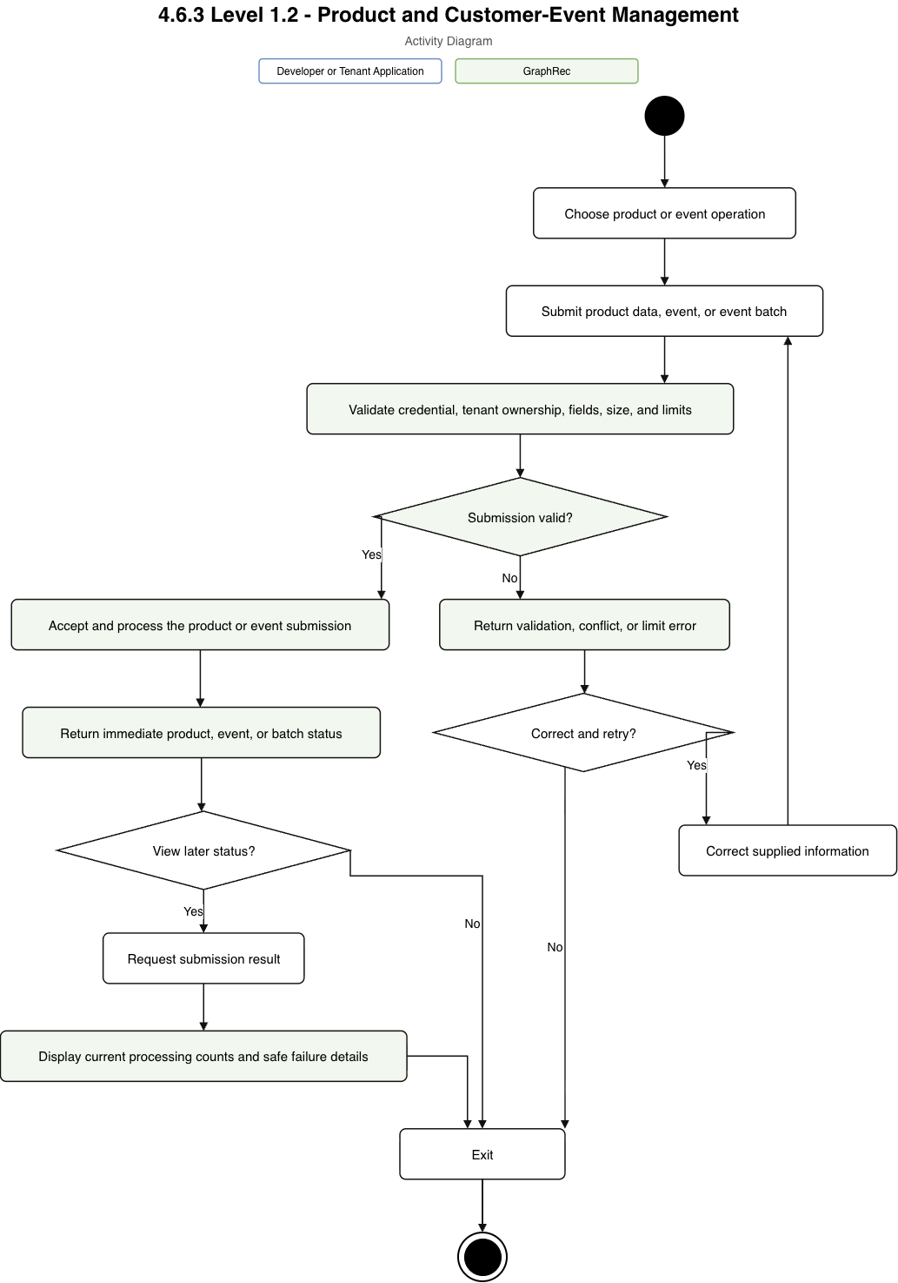
Figure 11: Product and Customer-Event Management Activity Diagram

4.6.4 Level 1.3 - Model Training Management
Level: 1.3
Name: Model Training Management
Reference: Use-Case Diagram Level 1.3
Actor: Tenant Administrator
Source Use Cases: Start Model Training; View Training Status; Cancel Training; View Training Result
Table 20: Level 1.3 - Model Training Management Use-Case Summary
Use case | Actor | Input to GraphRec | Output received from GraphRec
Start Model Training | Tenant Administrator | Model type and bounded configuration | Accepted job or rejection reason
View Training Status | Tenant Administrator | Job identifier | Current state and progress
Cancel Training | Tenant Administrator | Job identifier and reason | Cancellation status
View Training Result | Tenant Administrator | Terminal job identifier | Metrics and version, or failure/cancellation reason

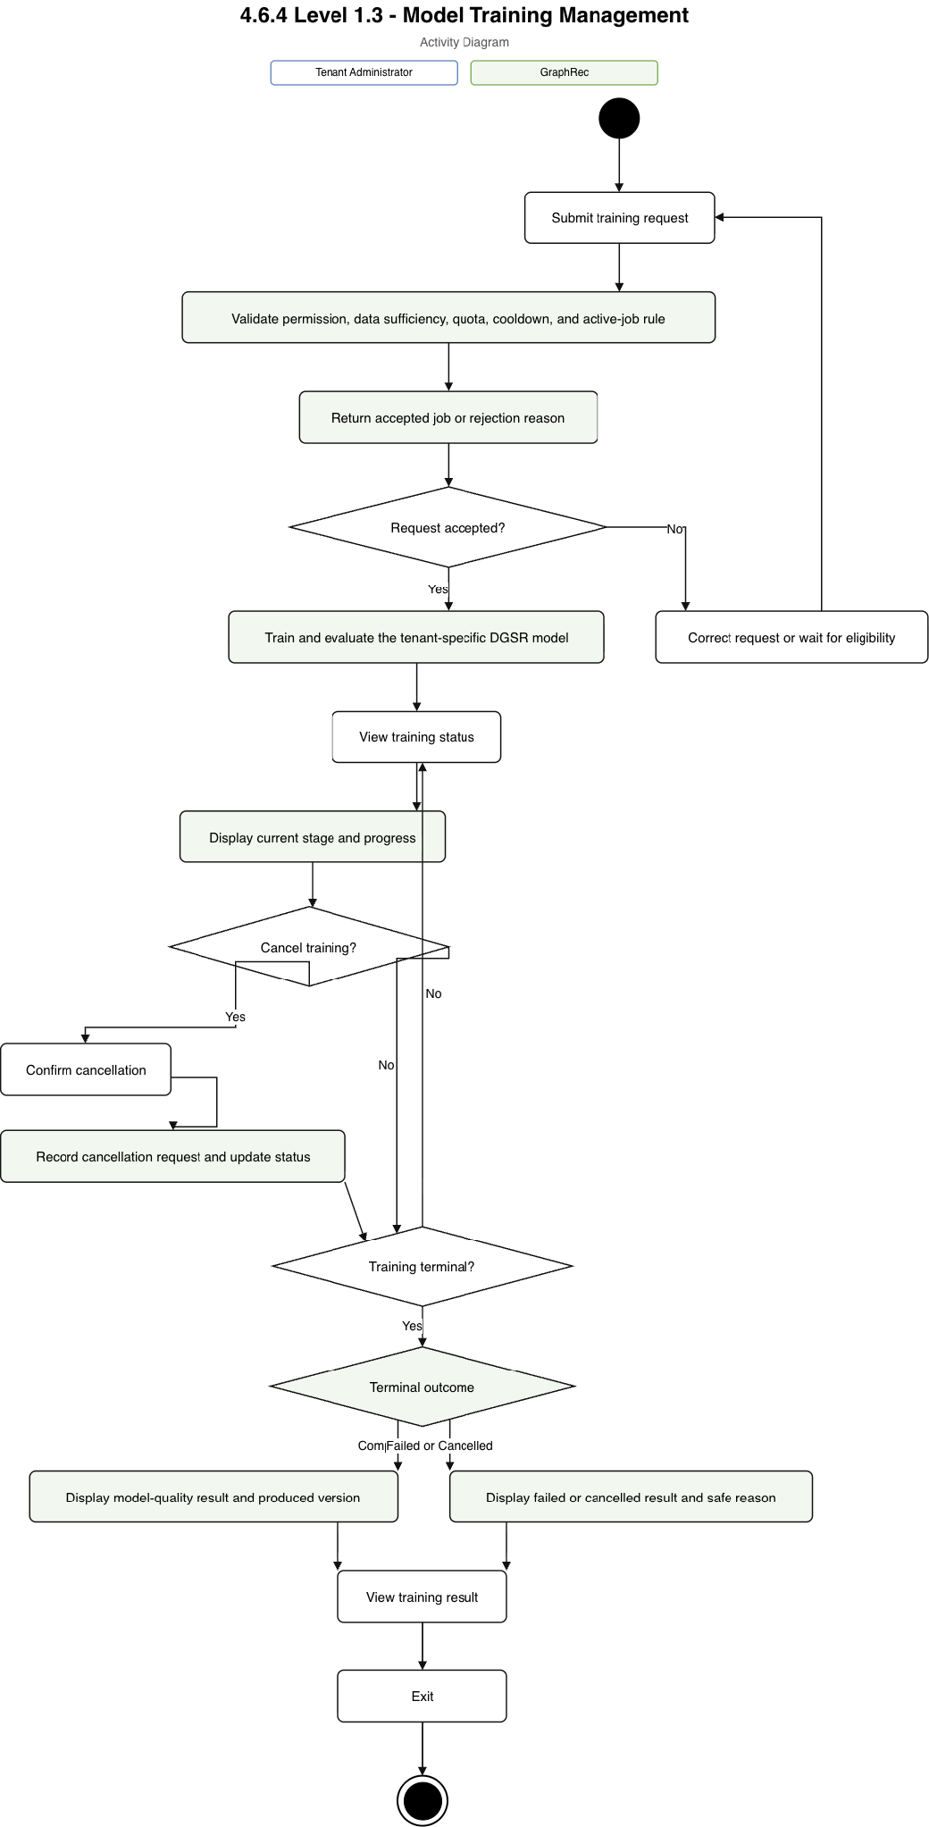
Figure 12: Model Training Management Activity Diagram

4.6.5 Level 1.4 - Model-Version Management
Level: 1.4
Name: Model-Version Management
Reference: Use-Case Diagram Level 1.4
Actor: Tenant Administrator
Source Use Cases: View Model Versions; View Model Quality; Activate Model; Roll Back Model; Archive Model Version
Table 21: Level 1.4 - Model-Version Management Use-Case Summary
Use case | Actor | Input to GraphRec | Output received from GraphRec
View Model Versions and Quality | Tenant Administrator | Model filters or version identifier | Lifecycle state, active indicator, and quality measures
Activate Model | Tenant Administrator | Eligible version, reason, and confirmation | Activation outcome and active-model status
Roll Back Model | Tenant Administrator | Retained target and reason | Rollback outcome and active-model status
Archive Model Version | Tenant Administrator | Inactive version and reason | Archived status or protected-version error

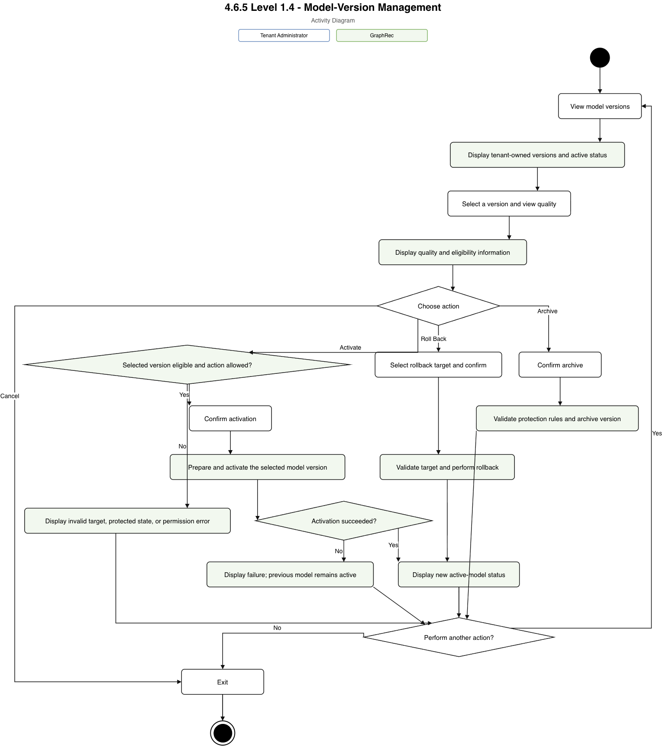
Figure 13: Model-Version Management Activity Diagram

4.6.6 Level 1.5 - Recommendation and Feedback Management
Level: 1.5
Name: Recommendation and Feedback Management
Reference: Use-Case Diagram Level 1.5
Actor: Tenant E-Commerce Application
Related Stakeholder: E-Commerce Customer
Source Use Cases: Request Recommendations; Receive Recommendation Results; Submit Recommendation Feedback
Table 22: Level 1.5 - Recommendation and Feedback Management Use-Case Summary
Use case | Actor | Input to GraphRec | Output received from GraphRec
Request Recommendations | Tenant E-Commerce Application | Customer or session context, recent events, count, exclusions, and fallback permission | Validation or recommendation response
Receive Recommendation Results | Tenant E-Commerce Application | Accepted request | Ranked products, model version, strategy, and fallback indicator
Submit Recommendation Feedback | Tenant E-Commerce Application | Recommendation reference, product, position, feedback type, and event identifier | Acceptance, duplicate confirmation, or error

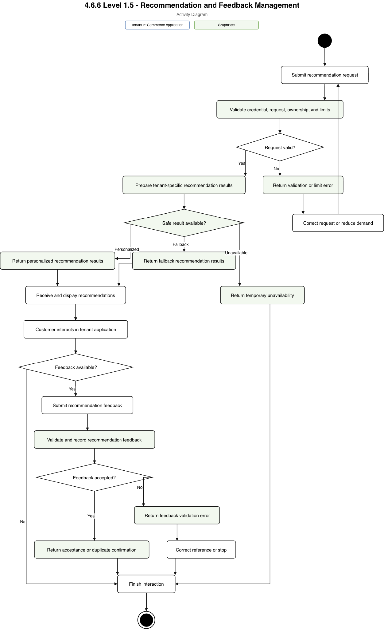
Figure 14: Recommendation and Feedback Management Activity Diagram

4.6.7 Level 1.6 - Usage, Quota, and Status Monitoring
Level: 1.6
Name: Usage, Quota, and Status Monitoring
Reference: Use-Case Diagram Level 1.6
Actors: Tenant Administrator, Platform Administrator
Source Use Cases: View Usage and Quotas; View Model Status; View Service Status; Manage Tenant Accounts; Configure Plans and Quotas; View Tenant Usage; Monitor Platform Status; Review Failures and Audit Records
Table 23: Level 1.6 - Usage, Quota, and Status Monitoring Use-Case Summary
Use case group | Actor | Input to GraphRec | Output received from GraphRec
View tenant usage, model, and service status | Tenant Administrator | Period, model, or status filter | Tenant-scoped usage, quota, model, and service information
Manage tenants and plans | Platform Administrator | Tenant action, plan configuration, quota override, and reason | Confirmation, effective configuration, or conflict
Monitor platform and review records | Platform Administrator | Time, tenant, severity, or action filter | Shared status, failures, and redacted audit history

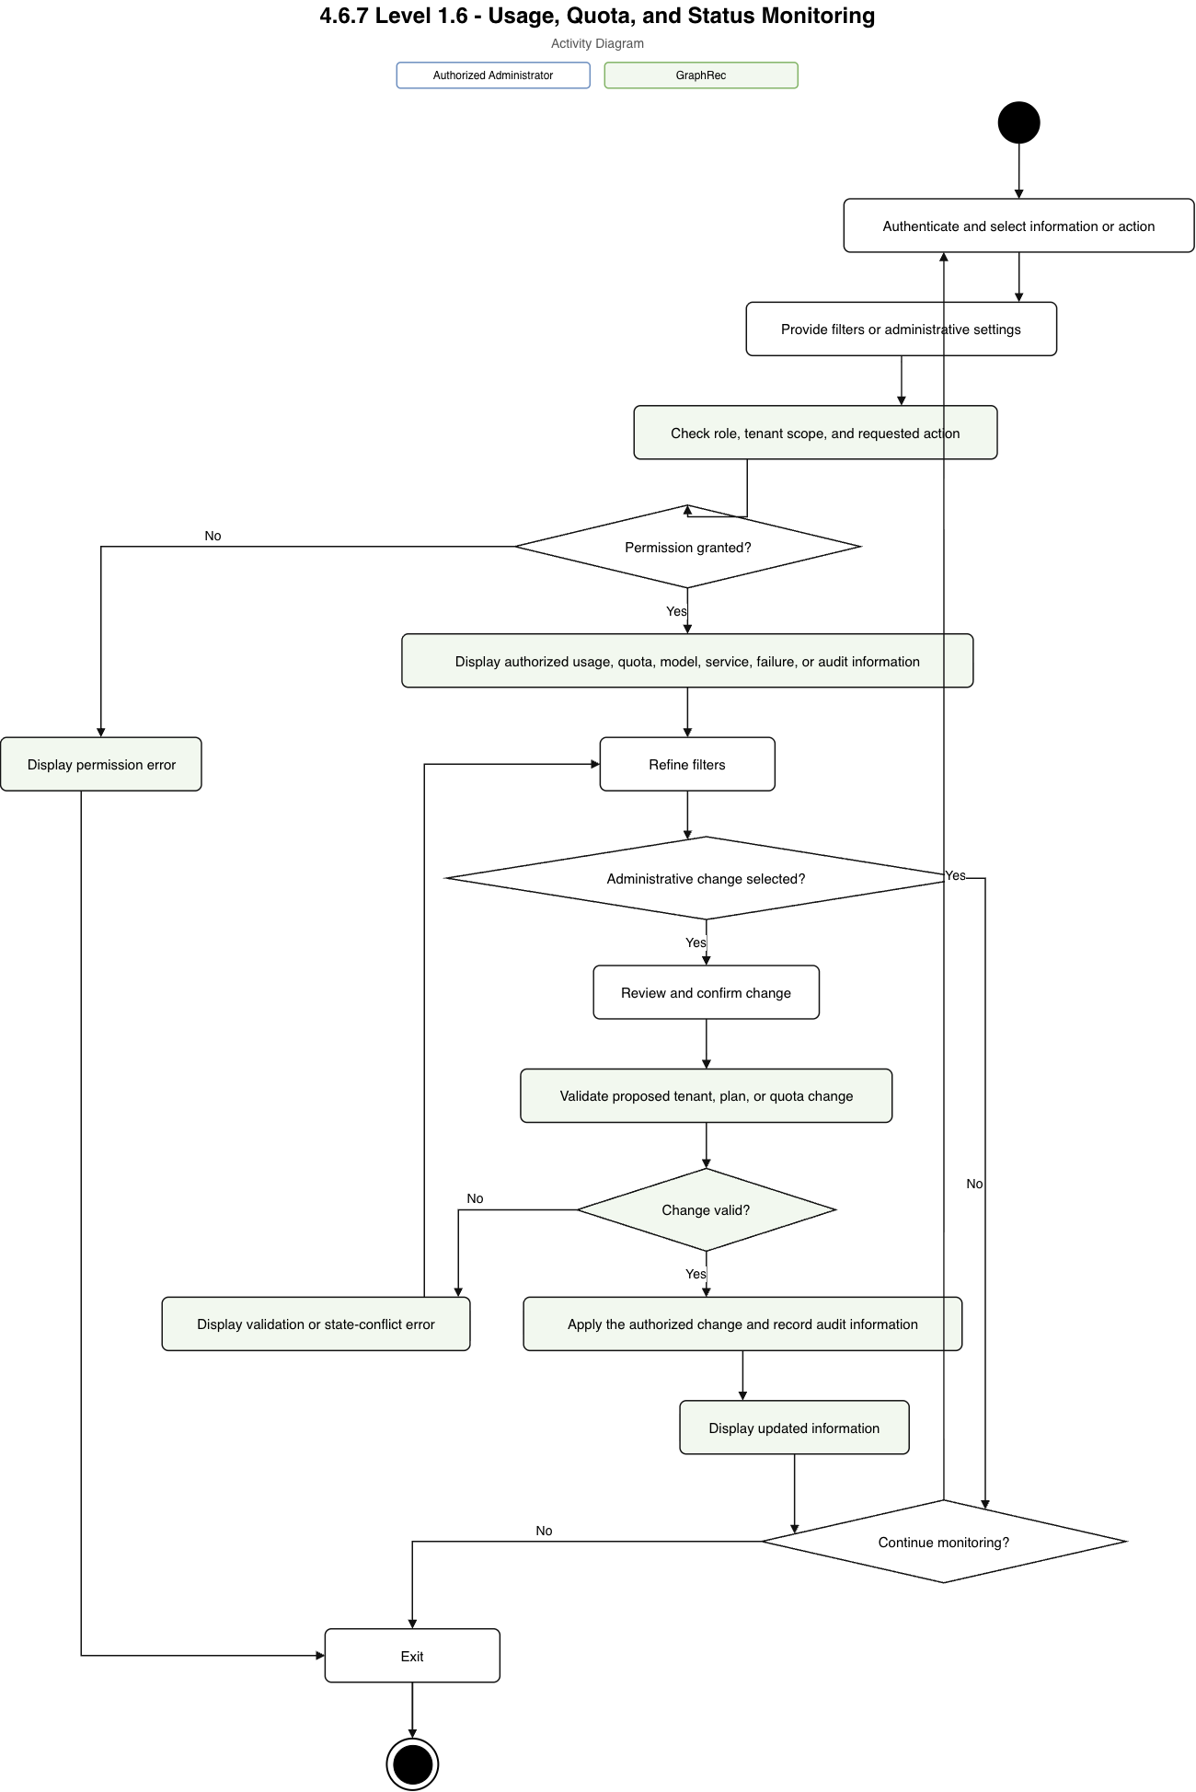
Figure 15: Usage, Quota, and Status Monitoring Activity Diagram

5. Data-Based Modeling

5.1 Entity-Relationship Modeling
The Entity-Relationship Model defines the information GraphRec must preserve independently of any implementation product. It identifies entities, attributes, primary and foreign keys, alternate keys, relationships, cardinality, optionality, and integrity constraints. The structure reduces avoidable duplication and preserves tenant ownership across identity, catalog, interaction, training, model, recommendation, usage, and audit information.

5.2 Logical Entities

5.2.1 Pricing Plan
Purpose: Defines reusable service limits assigned to tenants.
Table 24: Pricing Plan Logical Entity Attributes
Attribute | Logical type | Key | Required | Description
plan_id | Identifier | PK | Yes | Unique plan identifier
plan_code | Text | UK | Yes | Stable unique plan code
plan_name | Text |  | Yes | Display name
description | Long Text |  | No | Plan summary
event_limit | Integer |  | Yes | Accepted-event allowance per period
recommendation_limit | Integer |  | Yes | Recommendation allowance per period
training_limit | Integer |  | Yes | Training-job allowance per period
service_limits | Structured Data |  | Yes | Additional bounded quotas and service levels
is_active | Boolean |  | Yes | Whether new assignments are allowed

Keys, constraints, and relationships: plan_id is the primary key and plan_code is unique. Limits shall be non-negative. One Pricing Plan may be assigned to zero or many Tenants; each Tenant belongs to exactly one current Pricing Plan.

5.2.2 Tenant
Purpose: Represents one independent e-commerce business using GraphRec.
Table 25: Tenant Logical Entity Attributes
Attribute | Logical type | Key | Required | Description
tenant_id | Identifier | PK | Yes | Unique tenant identifier
plan_id | Identifier | FK | Yes | Assigned Pricing Plan
tenant_code | Text | UK | Yes | Stable unique platform code
tenant_name | Text |  | Yes | Business name
status | Enumeration |  | Yes | Pending, active, suspended, deleting, or deleted
created_at | DateTime |  | Yes | Registration time
updated_at | DateTime |  | Yes | Last tenant-state change
settings | Structured Data |  | No | Approved tenant-level configuration

Keys, constraints, and relationships: tenant_id is the primary key and tenant_code is unique across GraphRec. A Tenant must reference one active Pricing Plan when activated. A Tenant owns its users, credentials, customers, products, events, training jobs, snapshots, models, recommendations, usage, and audit records. Tenant deletion follows a controlled lifecycle rather than immediate removal.

5.2.3 Tenant User
Purpose: Represents an administrator or developer authorized to manage one tenant.
Table 26: Tenant User Logical Entity Attributes
Attribute | Logical type | Key | Required | Description
tenant_user_id | Identifier | PK | Yes | Unique tenant-user identifier
tenant_id | Identifier | FK | Yes | Owning Tenant
email | Text | UK | Yes | Tenant-local sign-in identity
display_name | Text |  | Yes | User-visible name
credential_digest | Text |  | Yes | Protected authentication verifier
role | Enumeration |  | Yes | Tenant administrator or tenant developer
status | Enumeration |  | Yes | Invited, active, locked, or disabled
created_at | DateTime |  | Yes | Account creation time
last_authenticated_at | DateTime |  | No | Most recent successful authentication time

Keys, constraints, and relationships: tenant_user_id is the primary key. The combination (tenant_id, email) is a unique alternate key. A Tenant User belongs to exactly one Tenant and may initiate many training, model-management, credential-management, and audit-recorded actions. A user cannot receive a role outside the permitted tenant role set.

5.2.4 API Credential
Purpose: Represents a revocable credential used by a tenant integration.
Table 27: API Credential Logical Entity Attributes
Attribute | Logical type | Key | Required | Description
api_credential_id | Identifier | PK | Yes | Unique credential identifier
tenant_id | Identifier | FK | Yes | Owning Tenant
credential_name | Text | UK | Yes | Tenant-local descriptive name
visible_prefix | Text | UK | Yes | Non-secret lookup and identification prefix
secret_digest | Text |  | Yes | Protected verifier; the full secret is not retained
permissions | Structured Data |  | Yes | Allowed integration operations
expires_at | DateTime |  | No | Optional expiry time
revoked_at | DateTime |  | No | Revocation time
created_at | DateTime |  | Yes | Creation time
last_used_at | DateTime |  | No | Most recent accepted use

Keys, constraints, and relationships: api_credential_id is the primary key. (tenant_id, credential_name) and visible_prefix are unique alternate keys. An API Credential belongs to one Tenant. Expired or revoked credentials cannot authorize requests. Secret material is displayed only at creation or rotation.

5.2.5 Customer
Purpose: Represents a tenant-local e-commerce customer or pseudonymous user whose behavior supports recommendations.
Table 28: Customer Logical Entity Attributes
Attribute | Logical type | Key | Required | Description
customer_id | Identifier | PK | Yes | Internal customer identifier
tenant_id | Identifier | FK | Yes | Owning Tenant
external_customer_id | Text | UK | Yes | Identifier supplied by the tenant application
attributes | Structured Data |  | No | Minimized approved customer features
status | Enumeration |  | Yes | Active, anonymized, or deleted
created_at | DateTime |  | Yes | First known time
updated_at | DateTime |  | Yes | Last profile change

Keys, constraints, and relationships: customer_id is the primary key and (tenant_id, external_customer_id) is unique. A Customer belongs to one Tenant, may generate zero or many Interaction Events, and may be associated with zero or many Recommendation Requests. Direct personal data is minimized; anonymization may preserve non-identifying aggregate behavior where permitted.

5.2.6 Product
Purpose: Represents one item in a tenant's recommendation catalog.
Table 29: Product Logical Entity Attributes
Attribute | Logical type | Key | Required | Description
product_id | Identifier | PK | Yes | Internal product identifier
tenant_id | Identifier | FK | Yes | Owning Tenant
external_product_id | Text | UK | Yes | Tenant-local catalog identifier
title | Text |  | Yes | Product display title
category | Text |  | No | Primary category or grouping
brand | Text |  | No | Product brand
price | Decimal |  | No | Current non-negative price
attributes | Structured Data |  | No | Approved metadata used for filtering or cold start
is_active | Boolean |  | Yes | Whether the product may be considered
availability_status | Enumeration |  | Yes | Available, unavailable, out of stock, or discontinued
updated_at | DateTime |  | Yes | Last catalog update

Keys, constraints, and relationships: product_id is the primary key and (tenant_id, external_product_id) is unique. A Product belongs to one Tenant and may appear in many events and recommendation results. Price, when present, shall be non-negative. Inactive, unavailable, deleted, or otherwise ineligible products shall not be returned.

5.2.7 Interaction Event
Purpose: Records a customer-product interaction used for usage, training, and evaluation.
Table 30: Interaction Event Logical Entity Attributes
Attribute | Logical type | Key | Required | Description
interaction_event_id | Identifier | PK | Yes | Internal event identifier
tenant_id | Identifier | FK | Yes | Owning Tenant
customer_id | Identifier | FK | Yes | Customer that produced the event
product_id | Identifier | FK | Yes | Product affected by the event
external_event_id | Text | UK | Yes | Tenant-supplied idempotency identifier
event_type | Enumeration |  | Yes | View, click, cart action, purchase, rating, or allowed type
event_value | Decimal |  | No | Optional rating, quantity, or business value
occurred_at | DateTime |  | Yes | Time the action occurred
received_at | DateTime |  | Yes | Time GraphRec accepted it
context | Structured Data |  | No | Bounded page, session, or approved contextual data

Keys, constraints, and relationships: interaction_event_id is the primary key and (tenant_id, external_event_id) is unique. The referenced Customer and Product must belong to the same Tenant as the event. Events are append-oriented; duplicate submission produces one durable effect. Event time cannot be omitted, and event type and optional value must satisfy type-specific rules.

5.2.8 Training Job
Purpose: Represents one tenant request to prepare, train, evaluate, and register a recommendation model.
Table 31: Training Job Logical Entity Attributes
Attribute | Logical type | Key | Required | Description
training_job_id | Identifier | PK | Yes | Unique job identifier
tenant_id | Identifier | FK | Yes | Owning Tenant
requested_by_user_id | Identifier | FK | Yes | Tenant User that requested training
requested_model_type | Enumeration |  | Yes | Approved model or baseline type
configuration | Structured Data |  | Yes | Bounded training configuration
status | Enumeration |  | Yes | Queued through terminal training state
requested_at | DateTime |  | Yes | Request time
started_at | DateTime |  | No | Processing start time
completed_at | DateTime |  | No | Terminal time
cancellation_requested_at | DateTime |  | No | Optional cancellation request time
failure_reason | Long Text |  | No | Sanitized terminal failure information

Keys, constraints, and relationships: training_job_id is the primary key. A Training Job belongs to one Tenant and one requesting Tenant User. At most one non-terminal training job may exist for a Tenant. A job creates exactly one Dataset Snapshot after preparation and may produce zero or one Model Version. Terminal timestamps and reasons shall be consistent with the final status.

5.2.9 Dataset Snapshot
Purpose: Defines the immutable, tenant-specific training data and cutoff used by one job.
Table 32: Dataset Snapshot Logical Entity Attributes
Attribute | Logical type | Key | Required | Description
dataset_snapshot_id | Identifier | PK | Yes | Unique snapshot identifier
tenant_id | Identifier | FK | Yes | Owning Tenant
training_job_id | Identifier | FK, UK | Yes | Training Job that created the snapshot
cutoff_at | DateTime |  | Yes | Latest event time eligible for the snapshot
query_definition | Structured Data |  | Yes | Reproducible selection and filtering rules
customer_count | Integer |  | Yes | Included customer count
product_count | Integer |  | Yes | Included product count
event_count | Integer |  | Yes | Included interaction count
content_reference | Text |  | Yes | Controlled reference to snapshot content
content_digest | Text | UK | Yes | Integrity and reproducibility digest
created_at | DateTime |  | Yes | Snapshot completion time

Keys, constraints, and relationships: dataset_snapshot_id is the primary key; training_job_id is unique because one job creates one snapshot. Counts shall be non-negative. The snapshot contains data from one Tenant only and must exclude events beyond cutoff_at. A snapshot may support zero or one registered Model Version in the semester scope.

5.2.10 Model Version
Purpose: Represents one immutable trained or baseline model release and its evaluation summary.
Table 33: Model Version Logical Entity Attributes
Attribute | Logical type | Key | Required | Description
model_version_id | Identifier | PK | Yes | Unique version identifier
tenant_id | Identifier | FK | Yes | Owning Tenant
training_job_id | Identifier | FK, UK | Yes | Producing Training Job
dataset_snapshot_id | Identifier | FK, UK | Yes | Source Dataset Snapshot
version_number | Integer | UK | Yes | Tenant-model sequence number
model_type | Enumeration |  | Yes | DGSR or approved baseline
lifecycle_status | Enumeration |  | Yes | Registered, eligible, active, retired, rejected, archived, or failed deployment
artifact_reference | Text |  | Yes | Controlled model-bundle reference
artifact_digest | Text | UK | Yes | Model-bundle integrity digest
feature_contract | Structured Data |  | Yes | Versioned input and preprocessing contract
evaluation_summary | Structured Data |  | Yes | Quality, coverage, diversity, and stability measures
created_at | DateTime |  | Yes | Registration time
activated_at | DateTime |  | No | First successful activation time

Keys, constraints, and relationships: model_version_id is the primary key. (tenant_id, version_number) is unique within the modeled recommendation family, and the producing job and snapshot are unique in the semester scope. The job, snapshot, artifact identity, and version must belong to the same Tenant. A version is immutable after registration except for lifecycle status and activation metadata. A rejected or archived version cannot be activated.

5.2.11 Model Deployment
Purpose: Represents the current desired and available recommendation-service state for one tenant.
Table 34: Model Deployment Logical Entity Attributes
Attribute | Logical type | Key | Required | Description
model_deployment_id | Identifier | PK | Yes | Unique deployment identifier
tenant_id | Identifier | FK, UK | Yes | Tenant with this current deployment
desired_model_version_id | Identifier | FK | No | Version requested for activation
active_model_version_id | Identifier | FK | No | Stable version currently reported as active
status | Enumeration |  | Yes | Pending, progressing, available, degraded, rolling back, or stopped
desired_capacity | Integer |  | Yes | Requested service instances within plan limits
ready_capacity | Integer |  | Yes | Instances ready to serve
last_transition_at | DateTime |  | Yes | Most recent lifecycle transition
failure_reason | Long Text |  | No | Sanitized rollout or capacity failure

Keys, constraints, and relationships: model_deployment_id is the primary key and tenant_id is unique, allowing zero or one current deployment per Tenant. Desired and active versions, when present, must belong to that Tenant. Capacity values shall be non-negative. Failed activation shall not replace the previously active version. One Model Version may serve many Recommendation Requests over time.

5.2.12 Recommendation Request
Purpose: Records one synchronous request for tenant-specific ranked products.
Table 35: Recommendation Request Logical Entity Attributes
Attribute | Logical type | Key | Required | Description
recommendation_request_id | Identifier | PK | Yes | Internal request identifier
tenant_id | Identifier | FK | Yes | Owning Tenant
external_request_id | Text | UK | Yes | Tenant-supplied idempotency identifier
customer_id | Identifier | FK | No | Known Customer, if identified
model_version_id | Identifier | FK | No | Version that served the request
session_reference | Text |  | No | Pseudonymous session reference
requested_count | Integer |  | Yes | Maximum requested result count
context | Structured Data |  | No | Recent events, page context, exclusions, and eligibility hints
strategy | Enumeration |  | No | Personalized, session, fallback, or unavailable strategy
status | Enumeration |  | Yes | Accepted, completed, rejected, or failed
requested_at | DateTime |  | Yes | Request time
completed_at | DateTime |  | No | Response completion time

Keys, constraints, and relationships: recommendation_request_id is the primary key and (tenant_id, external_request_id) is unique. At least one of Customer or session context shall be present. Customer and served Model Version, when present, must belong to the same Tenant. Requested count must be positive and within the configured maximum. One completed request produces one or more Recommendation Results unless it ends unavailable or rejected.

5.2.13 Recommendation Result
Purpose: Represents one product and position returned for a recommendation request.
Table 36: Recommendation Result Logical Entity Attributes
Attribute | Logical type | Key | Required | Description
recommendation_result_id | Identifier | PK | Yes | Unique result identifier
tenant_id | Identifier | FK | Yes | Owning Tenant
recommendation_request_id | Identifier | FK | Yes | Parent Recommendation Request
product_id | Identifier | FK | Yes | Recommended Product
rank_position | Integer | UK | Yes | One-based position within the request
model_score | Decimal |  | No | Raw model relevance where applicable
final_order_score | Decimal |  | No | Final bounded ordering score
candidate_source | Enumeration |  | Yes | Personalized, neighbor, popular, category, content, or tenant rule
strategy | Enumeration |  | Yes | Personalized or fallback lane
created_at | DateTime |  | Yes | Result creation time

Keys, constraints, and relationships: recommendation_result_id is the primary key and (recommendation_request_id, rank_position) is unique. Rank must be positive. The request and product must belong to the same Tenant, and a product may appear only once per request. A Recommendation Result may receive zero or many Recommendation Feedback records.

5.2.14 Recommendation Feedback
Purpose: Records an impression, click, conversion, or other approved response to a recommendation result.
Table 37: Recommendation Feedback Logical Entity Attributes
Attribute | Logical type | Key | Required | Description
recommendation_feedback_id | Identifier | PK | Yes | Unique feedback identifier
tenant_id | Identifier | FK | Yes | Owning Tenant
recommendation_result_id | Identifier | FK | Yes | Result receiving feedback
external_feedback_id | Text | UK | Yes | Tenant-supplied idempotency identifier
feedback_type | Enumeration |  | Yes | Impression, click, conversion, or allowed type
position_observed | Integer |  | No | Displayed position when supplied
feedback_value | Decimal |  | No | Optional quantity or conversion value
occurred_at | DateTime |  | Yes | Time of feedback action
received_at | DateTime |  | Yes | Time GraphRec accepted it
context | Structured Data |  | No | Bounded approved feedback context

Keys, constraints, and relationships: recommendation_feedback_id is the primary key and (tenant_id, external_feedback_id) is unique. The referenced result and its request and product must belong to the same Tenant. Position, when present, shall be positive and consistent with the displayed result. Duplicate feedback has one durable effect.

5.2.15 Usage Record
Purpose: Stores a tenant's measured usage for one period and usage type.
Table 38: Usage Record Logical Entity Attributes
Attribute | Logical type | Key | Required | Description
usage_record_id | Identifier | PK | Yes | Unique usage record identifier
tenant_id | Identifier | FK | Yes | Owning Tenant
usage_period_start | Date | UK | Yes | Beginning of the measured period
usage_period_end | Date |  | Yes | End of the measured period
usage_type | Enumeration | UK | Yes | Events, recommendations, training, products, storage, or service capacity
measured_quantity | Decimal |  | Yes | Non-negative reconciled quantity
limit_quantity | Decimal |  | No | Effective plan or override limit
last_reconciled_at | DateTime |  | Yes | Most recent reconciliation time
details | Structured Data |  | No | Bounded breakdown without private event content

Keys, constraints, and relationships: usage_record_id is the primary key and (tenant_id, usage_period_start, usage_type) is unique. Quantities shall be non-negative and period end shall not precede period start. One Tenant has many Usage Records, each derived from idempotently measured actions and reconciled observations.

5.2.16 Audit Record
Purpose: Preserves an append-only history of security-sensitive and administrative actions.
Table 39: Audit Record Logical Entity Attributes
Attribute | Logical type | Key | Required | Description
audit_record_id | Identifier | PK | Yes | Unique audit identifier
tenant_id | Identifier | FK | No | Related Tenant; absent only for platform-wide action
actor_type | Enumeration |  | Yes | Tenant user, tenant application, platform administrator, or system process
actor_reference | Identifier |  | No | Internal actor identifier where applicable
action_type | Enumeration |  | Yes | Credential, training, activation, rollback, quota, tenant, access, or security action
resource_type | Text |  | Yes | Type of affected resource
resource_reference | Identifier |  | No | Affected resource identifier
outcome | Enumeration |  | Yes | Succeeded, failed, denied, or cancelled
occurred_at | DateTime |  | Yes | Action time
correlation_reference | Identifier |  | No | Reference joining related actions without exposing secrets
redacted_details | Structured Data |  | No | Sanitized before and after information

Keys, constraints, and relationships: audit_record_id is the primary key. Audit Records are append-only and must not contain credential secrets, raw personal event payloads, or another tenant's information in tenant-facing views. A Tenant may have many Audit Records; platform-wide records may have no tenant reference and require platform authorization.

5.3 Relationship Summary
Table 40: Relationship Summary
Parent entity | Relationship | Child entity | Cardinality | Explanation
Pricing Plan | is assigned to | Tenant | One to zero or many | A plan may serve many tenants; each tenant has one current plan
Tenant | owns | Tenant User | One to zero or many | Tenant users administer or integrate one tenant
Tenant | owns | API Credential | One to zero or many | Each credential resolves to one tenant
Tenant | owns | Customer | One to zero or many | Customer identifiers are tenant-local
Tenant | owns | Product | One to zero or many | Product identifiers are tenant-local
Customer | generates | Interaction Event | One to zero or many | Each event references one customer
Product | receives | Interaction Event | One to zero or many | Each event references one product
Tenant | requests | Training Job | One to zero or many | Jobs are isolated and quota-controlled per tenant
Training Job | creates | Dataset Snapshot | One to exactly one | Accepted training uses one immutable tenant snapshot
Training Job | produces | Model Version | One to zero or one | Failed or cancelled jobs produce no version
Dataset Snapshot | supports | Model Version | One to zero or one | The semester model uses one snapshot per produced version
Tenant | owns | Model Version | One to zero or many | Versions and artifacts remain tenant-specific
Tenant | has current | Model Deployment | One to zero or one | A tenant may have no deployed model before activation
Model Version | is active in | Model Deployment | One to zero or many over time | A version may be activated, retired, or restored
Customer | initiates | Recommendation Request | One to zero or many | Anonymous session requests may omit the customer
Model Version | serves | Recommendation Request | One to zero or many | Completed personalized responses identify the serving version
Recommendation Request | produces | Recommendation Result | One to one or many | Successful result sets contain ranked products
Product | appears in | Recommendation Result | One to zero or many | A product may be recommended in many requests
Recommendation Result | receives | Recommendation Feedback | One to zero or many | A result may receive impression, click, and conversion feedback
Tenant | has | Usage Record | One to zero or many | Usage is unique by tenant, period, and type
Tenant | has | Audit Record | One to zero or many | Tenant-scoped actions are recorded and redacted

Tenant-Integrity Rules
- Every tenant-owned entity shall reference exactly one Tenant.
- Customer, Product, Event, request, and feedback external identifiers shall be unique within their Tenant.
- Every cross-entity reference shall preserve Tenant equality, even when internal identifiers are globally unique.
- An Interaction Event's Customer and Product shall belong to the event's Tenant.
- A Dataset Snapshot shall contain data from one Tenant and shall respect its cutoff.
- A Model Version shall belong to the same Tenant as its Training Job and Dataset Snapshot.
- A Model Deployment may activate only a Model Version owned by the same Tenant.
- A Recommendation Request's Customer and Model Version, when present, shall belong to the request's Tenant.
- A Recommendation Result's Product shall belong to the request's Tenant.
- Recommendation Feedback shall reference a result owned by the same Tenant.
- Usage Records shall be unique by Tenant, period, and usage type.
- Tenant-facing audit queries shall never reveal another Tenant's existence or data.

5.4 Logical ER Diagrams
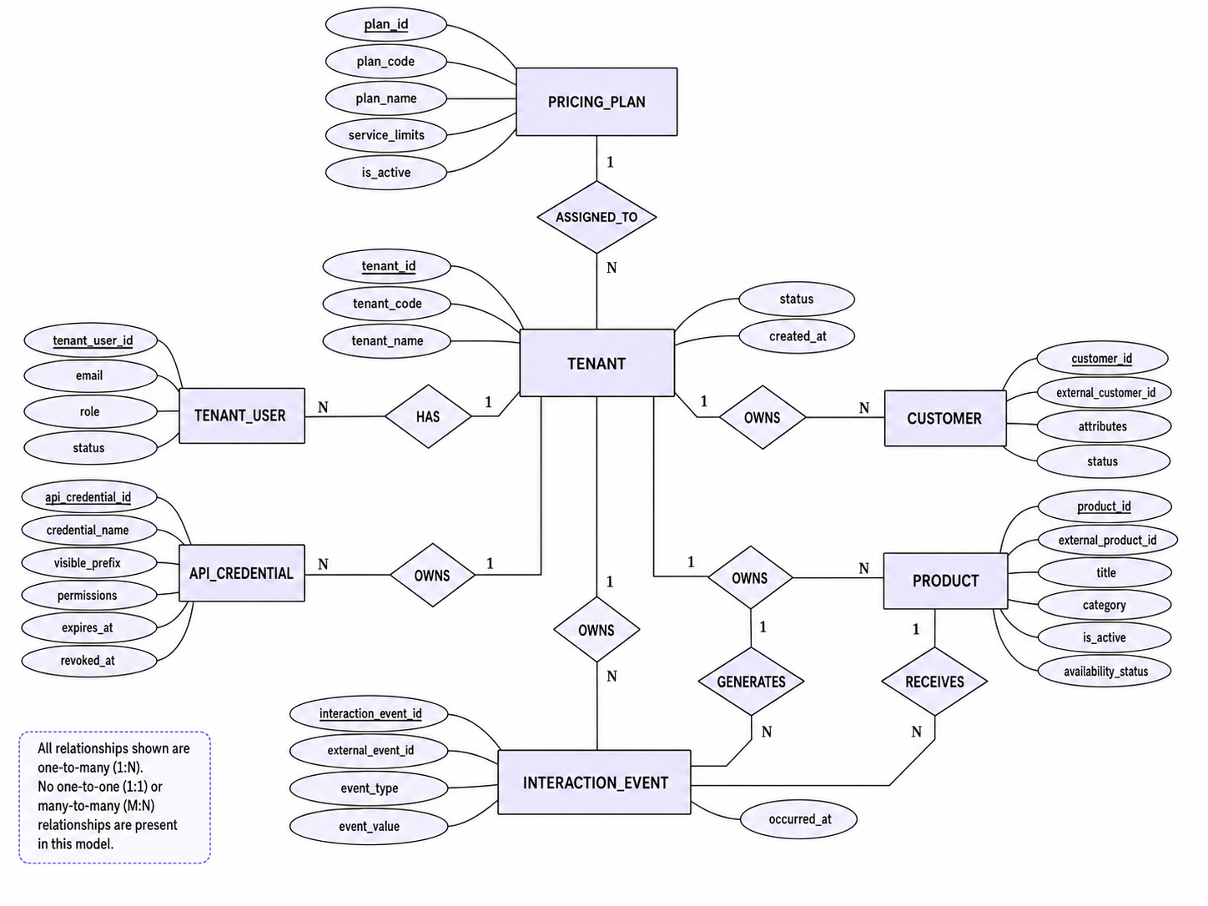
Figure 16: Tenant, Identity, Catalog, and Interaction Logical ERD
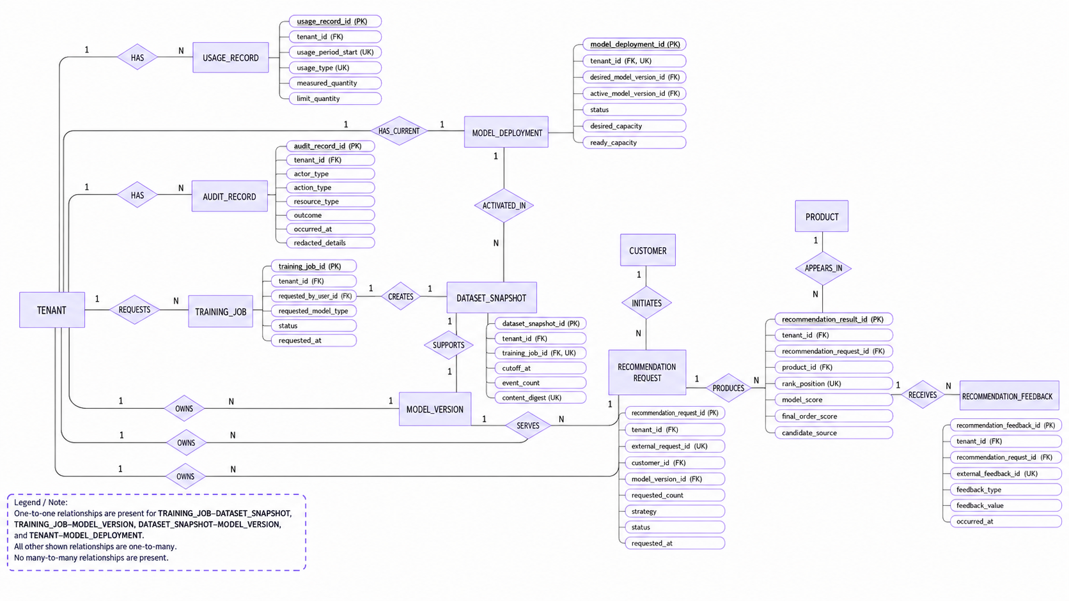
Figure 17: Training, Model, Recommendation, Usage, and Audit Logical ERD

6. AI Engineering Pipeline Architecture
GraphRec implements a strict architectural separation between asynchronous offline model training and real-time synchronous inference. Offline training generates tenant-specific GNN model weights and populates vector embeddings, while online serving retrieves candidate items, enforces eligibility rules, and delivers Top-N recommendations under low-latency constraints.
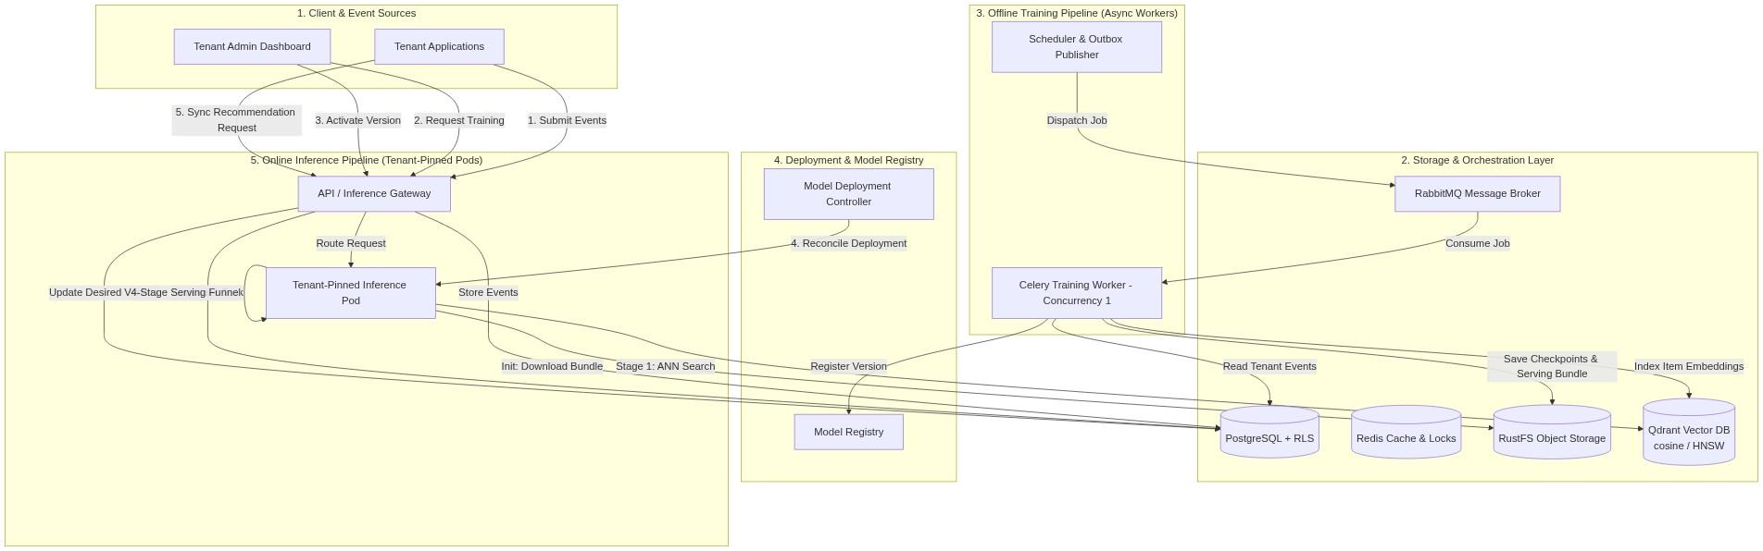
Figure 18: GraphRec System Architecture & Data Layer Overview

6.1 Offline Model Training Pipeline
The offline training pipeline runs asynchronously using Celery workers governed by Row-Level Security (RLS) and plan-fair weighted round-robin scheduling. To prevent resource starvation, global training concurrency is capped at one job across the cluster.
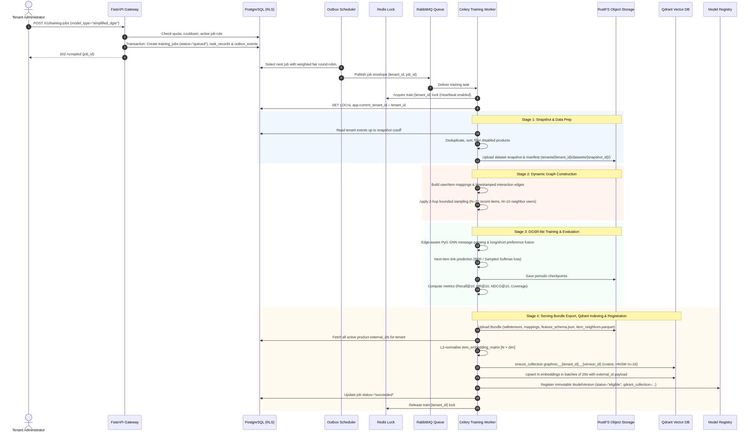
Figure 19: Offline Training Pipeline Detailed Sequence Diagram
Stage 1 (Snapshot & Data Prep): Reads customer interaction events up to a declared cutoff timestamp under RLS, deduplicates by event ID, and uploads an immutable dataset snapshot to RustFS storage.
Stage 2 (Dynamic Graph Construction): Builds user-item interaction graphs with 2-hop bounded neighborhood sampling (N=20 recent items, M=10 user neighbors) to constrain memory usage.
Stage 3 (DGSR-lite Training): Executes edge-aware PyTorch Geometric message passing, fuses long-term and short-term preferences, optimizes Bayesian Personalized Ranking (BPR) loss, and evaluates offline metrics (Recall@10, HR@10, NDCG@10, Coverage).
Stage 4 (Bundle Export & Qdrant Indexing): Exports an immutable serving bundle to RustFS (manifest.json, weights.safetensors, item_embeddings.safetensors, ordering_policy.json) and indexes L2-normalized item embeddings into a tenant-versioned Qdrant vector collection (graphrec__{tenant_id}__{version_id}) configured with HNSW (m=16, ef_construct=100, cosine distance).
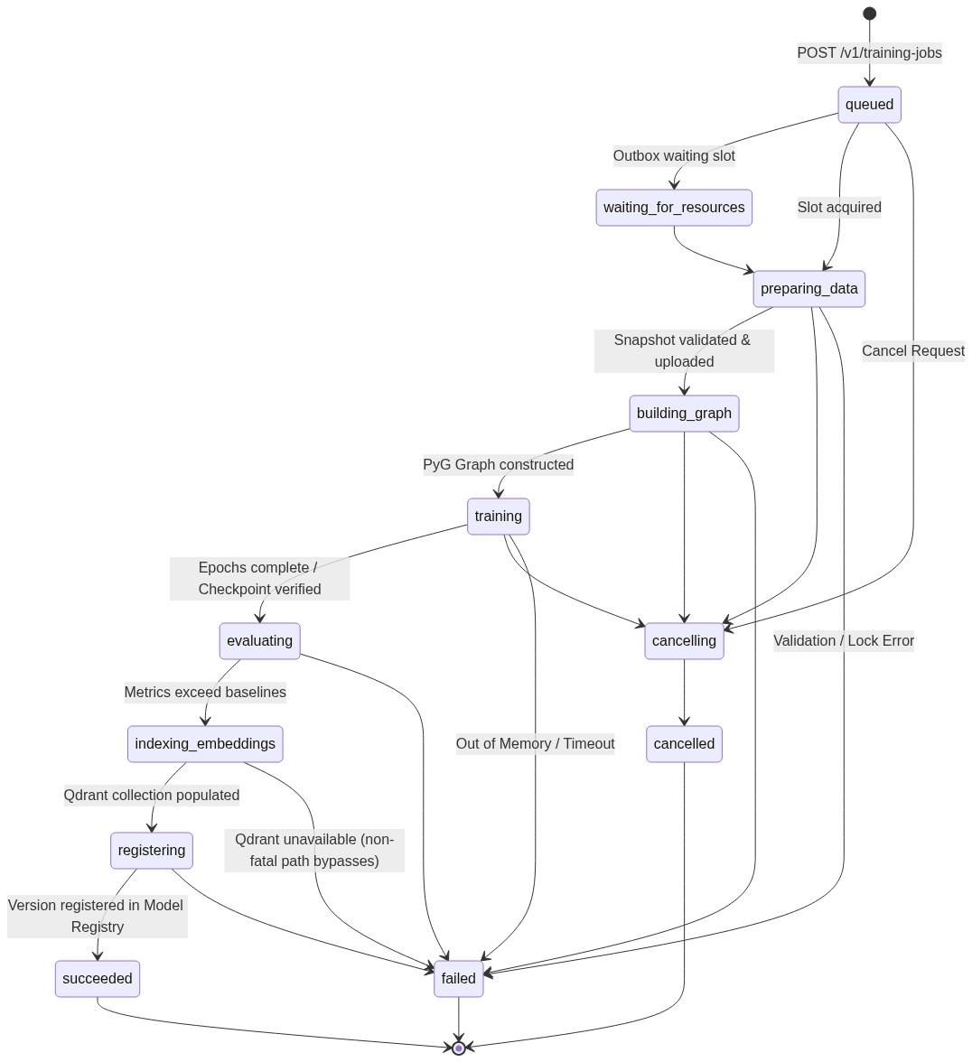
Figure 20: Offline Training Job State Lifecycle Diagram

6.2 Online Inference Pipeline
The online inference service delivers synchronous POST /v1/recommendations responses targeting P95 latency below 300 ms. Dedicated tenant-pinned pod processes initialize by downloading and verifying serving bundles from RustFS and confirming Qdrant vector index readiness before opening readiness probes.
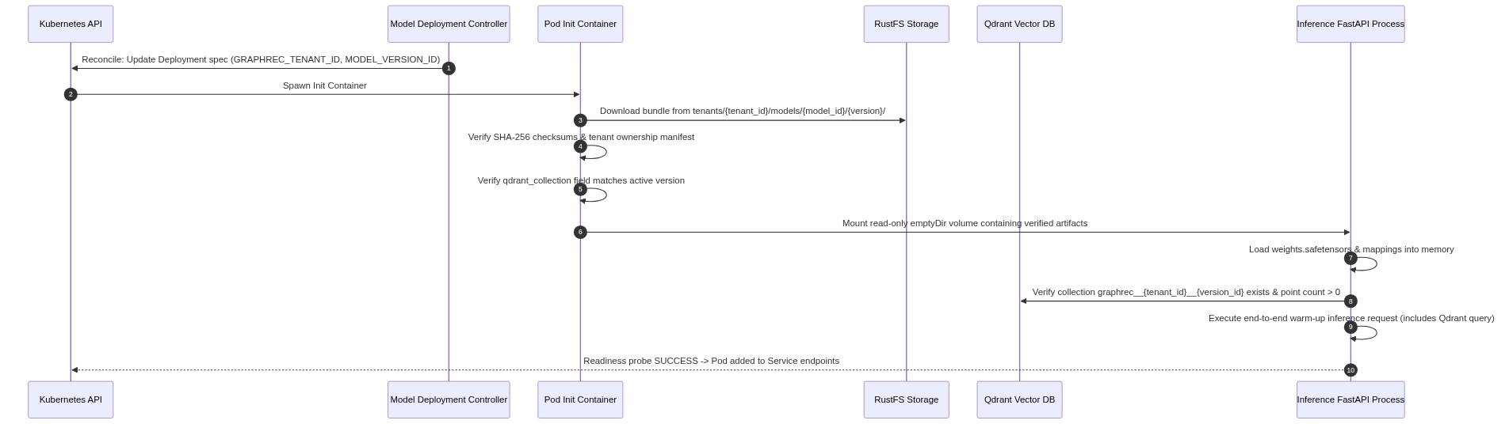
Figure 21: Pinned Inference Pod Initialization (Init Container Pattern)
Stage 1 (Candidate Retrieval): Assembles user/session query vectors and queries Qdrant ANN search for top-K candidates, applying tenant-isolation payload filters and item exclusion masks.
Stage 2 (Eligibility Filtering): Cross-references candidate product IDs against the PostgreSQL active catalog under RLS to filter out disabled, deleted, or out-of-stock items.
Stage 3 (Relevance Scoring): Batch-scores survivor items in a vectorized PyG GNN forward pass, routing cold-start items to a conservative baseline lane.
Stage 4 (Ordering & Re-Ranking): Ranks candidates with stable product ID tie-breaking, category/brand diversity caps, and Maximal Marginal Relevance (MMR) freshness boosting.
Fallback & Degradation Chain: If Qdrant is unreachable or empty, inference degrades gracefully through precomputed item neighbors → popularity baseline → Redis cache → empty 200 response.
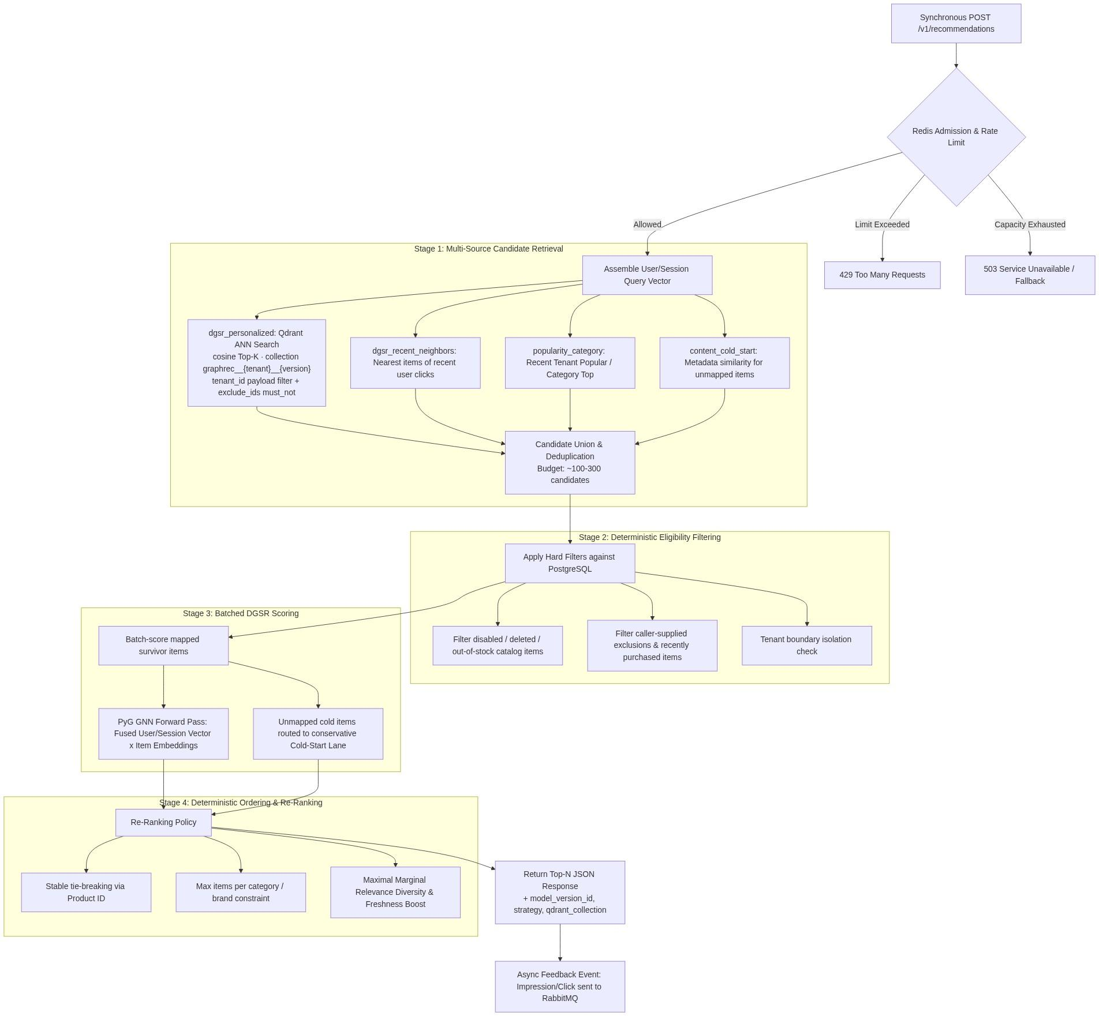
Figure 22: Four-Stage Online Recommendation Serving Funnel

6.3 Qdrant Vector Store Contract
Item vector embeddings are stored in Qdrant collections named graphrec__{tenant_id}__{version_id}. Strict tenant isolation is guaranteed by collection scoping combined with mandatory tenant_id payload filters on every query. Archiving a model version automatically deletes its Qdrant collection to reclaim storage.

6.4 Pipeline Comparison
Table 41 summarizes the key operational differences between the offline training and online inference pipelines.
Dimension | Offline Training Pipeline | Online Inference Pipeline
Execution Mode | Asynchronous batch job via Celery worker | Synchronous HTTP POST to /v1/recommendations
Latency Target | Minutes per job (Concurrency = 1) | Target P95 latency < 300 ms
Tenancy & Isolation | PostgreSQL RLS + lock train:{tenant_id} | Pinned pod (GRAPHREC_TENANT_ID) + Qdrant payload filter
Storage Access | Read/Write PostgreSQL, RustFS & Qdrant | Read Qdrant ANN; Read-only PostgreSQL eligibility filter
Fallback Behavior | Retries with backoff to Dead-Letter Queue | Qdrant → Item Neighbors → Popularity → Redis Cache
Table 41: Offline Training versus Online Inference Pipeline Comparison

8. Conclusion
This Software Requirement and Specification Analysis defines GraphRec's purpose, scope, stakeholders, actors, Normal requirements, Expected requirements, Exciting requirements, business rules, Quality Function Deployment, use-case scenarios, activity flows and logical data model. The report models the complete tenant journey from registration and integration through product and interaction collection, tenant-specific DGSR training, model evaluation, version activation, real-time recommendation delivery, feedback, usage control, and monitoring.
GraphRec demonstrates how multiple independent e-commerce businesses can share one recommendation platform while retaining tenant-specific customers, products, events, snapshots, models, deployments, results, quotas, and audit history. The specification emphasizes credential-derived tenant identity, one-tenant model artifacts, safe activation and rollback, synchronous Top-N serving, deterministic eligibility and ordering, fallback behavior, usage fairness, and visible failure states. The project remains intentionally bounded: it supports a small number of active tenants, offline training, controlled concurrency, and limited service capacity suitable for a semester demonstration. It does not claim production readiness, unlimited scale, enterprise disaster recovery, or enterprise-grade high availability.

