# Installation Guide

## Setup Process

### Backend Setup

1. Navigate to the backend folder:

* cd backend

1. Install required dependencies:

* pip install -r requirements.txt

1. Configure environment variables:
   * Create a .env file in the backend directory
     + Here setup alphavantage api
     + Example:

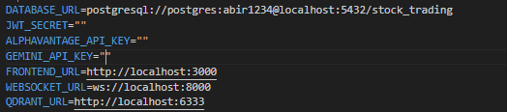

* + Create a config.py in backend/app directory
    - Here setup gemini api
    - Example

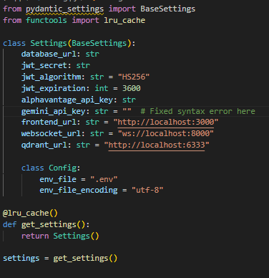

* + Add your database connection details

### Qdrant Database Setup

1. Run Qdrant database using Docker:

* docker run -p 6333:6333 -p 6334:6334 qdrant/qdrant

1. Update your .env file with the Qdrant port configuration

### Launch the Application

1. Start the backend server:

* - cd backend
* - python –m venv venv
* - .\vevn\Scripts\activate
* - uvicorn app.main:app --reload --host 0.0.0.0 --port 8000
* The backend will run on localhost:8080

1. Start the frontend:

* Simply run the frontend through vscode live server
* The frontend will be available at localhost:5050

## Verification

* Backend API: http://localhost:8080
* Frontend interface: http://localhost:5050