K8s Cluster Setup - Day 2

Docker Setup =======>>>>>>>>>>>>>>>>>>>>

Step 1 - Install Docker

- Install Docker:
sudo apt install -y docker.io
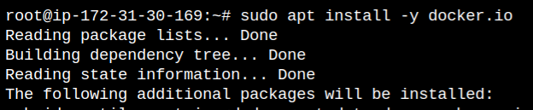
- sudo systemctl start docker
- sudo systemctl enable docker
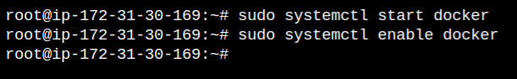
- sudo systemctl status docker
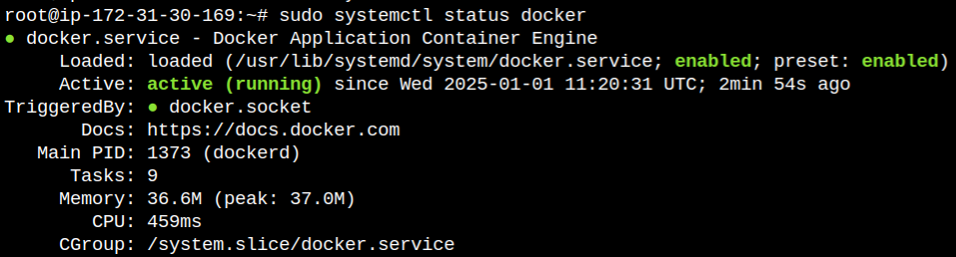
- su ubuntu
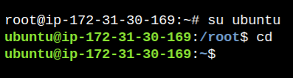
- sudo usermod -aG docker $USER : Add your user to the docker group
- newgrp docker : Start a new shell session for the group changes to take effect
- docker version : Test whether you can run Docker commands without sudo

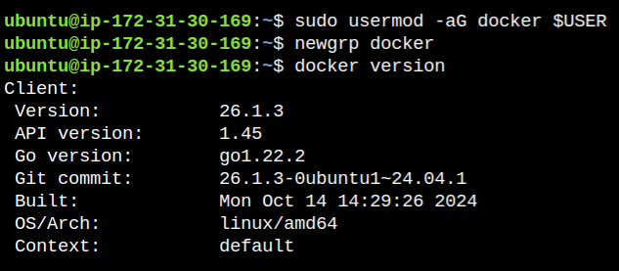

MiniKube Setup =======>>>>>>>>>>>>>>>>>>>>

Step 2 - Minikube on Ubuntu - At Least 2 CPUs & 2GB RAM required

- sudo apt update && sudo apt upgrade -y
- Ensure that curl installed:
sudo apt install -y curl wget apt-transport-https
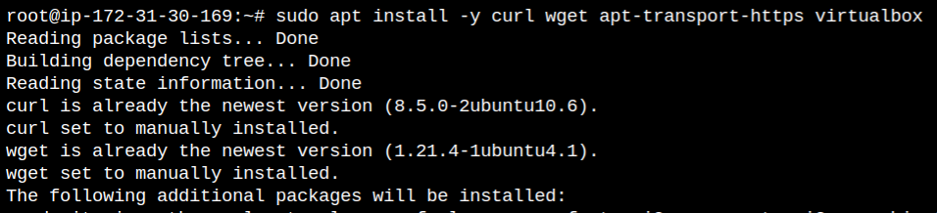
- Use the following command to download the Minikube binary:
curl -LO https://storage.googleapis.com/minikube/releases/latest/minikube-linux-amd64
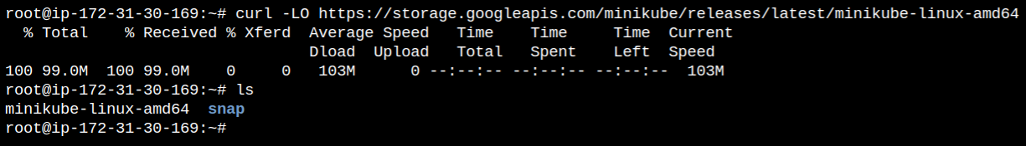
- Move the downloaded binary to your system's PATH:
sudo install minikube-linux-amd64 /usr/local/bin/minikube
- Check if Minikube is installed correctly:
minikube version
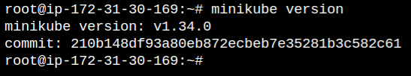
- Switch to Ubuntu user first:
su ubuntu
- Start Minikube with the following command:
minikube start
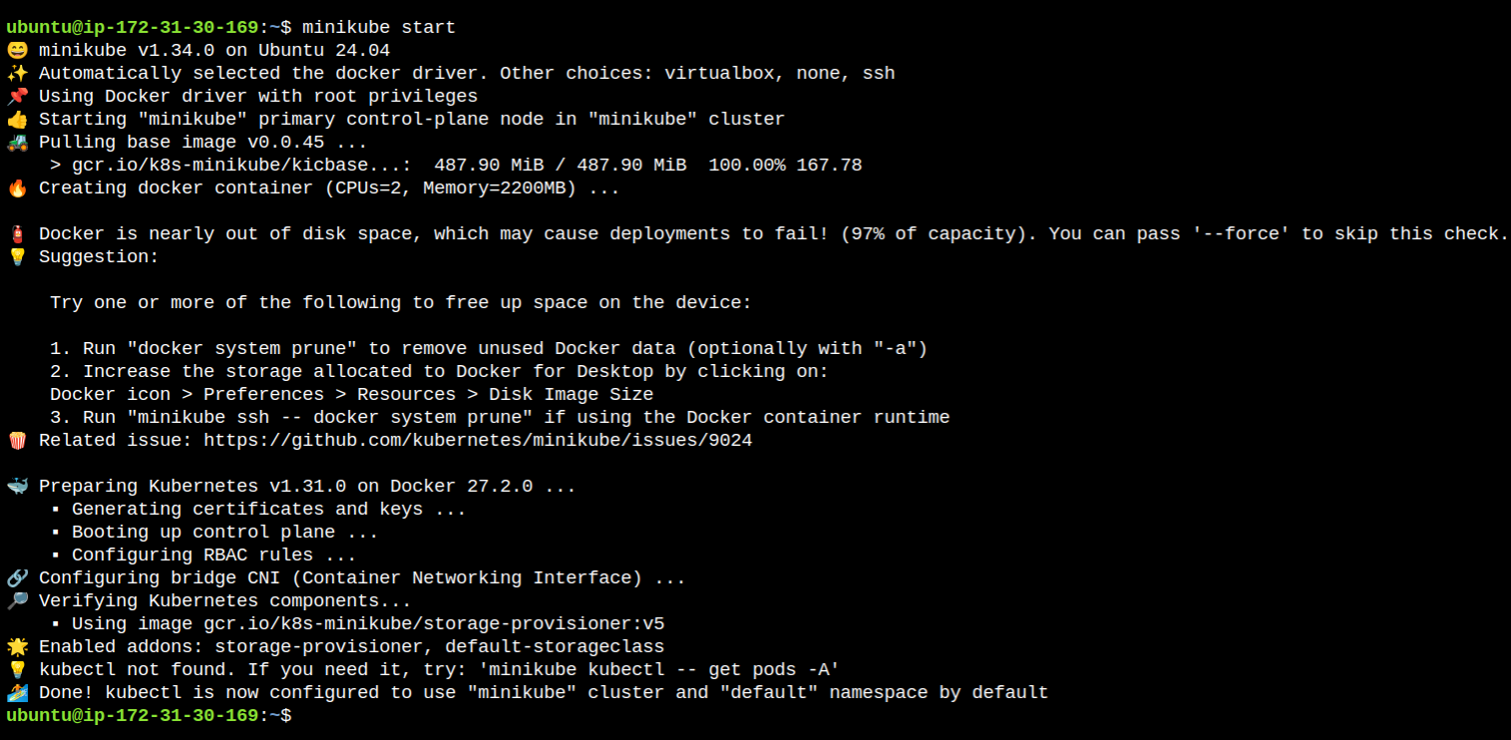

MiniKube Commands =======>>>>>>>>>>>>>>>>>>>>

Step 3 - Some sample minikube commands

- minikube stop : Stop Minikube Cluster
- minikube delete : Delete Minikube Cluster
- minikube start --driver=docker : Start Minikube Cluster with specific driver
- minikube kubectl -- get pods -A : Minikube kubectl commands to check pods
- minikube kubectl get ns : Minikube kubectl commands to check namespaces
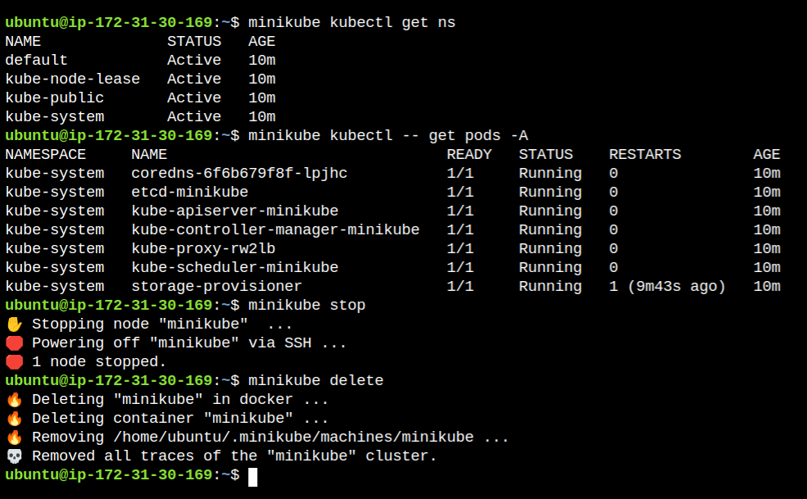

Install kubectl =======>>>>>>>>>>>>>>>>>>>>

Step 4 - Steps to install kubectl

- su ubuntu
- Download kubectl binary:
curl -O https://s3.us-west-2.amazonaws.com/amazon-eks/1.31.2/2024-11-15/bin/linux/amd64/kubectl
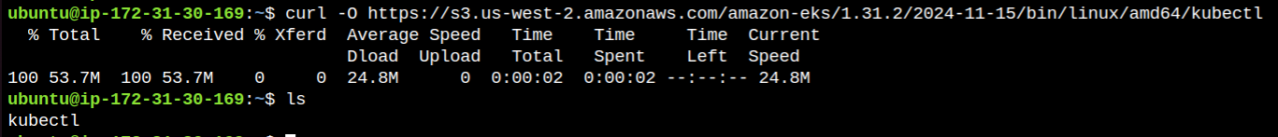
- Download kubectl binary checksum:
curl -O https://s3.us-west-2.amazonaws.com/amazon-eks/1.31.2/2024-11-15/bin/linux/amd64/kubectl.sha256
- Verify checksum
sha256sum -c kubectl.sha256
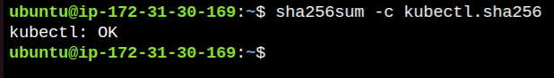
- chmod +x ./kubectl : Grant executable permission to kubectl dir
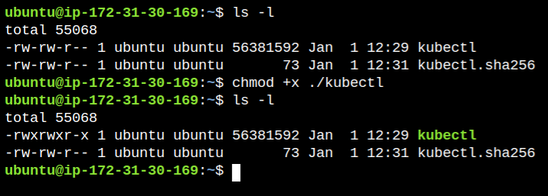
- mkdir -p $HOME/bin
- cp ./kubectl $HOME/bin/kubectl : Copy kubectl to bin folder
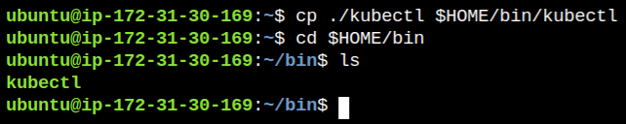
- echo 'export PATH=$HOME/bin/:$PATH' >> ~/.bashrc : Add PATH update to .bashrc to persist across sessions
- source ~/.bashrc : Reload bashrc file
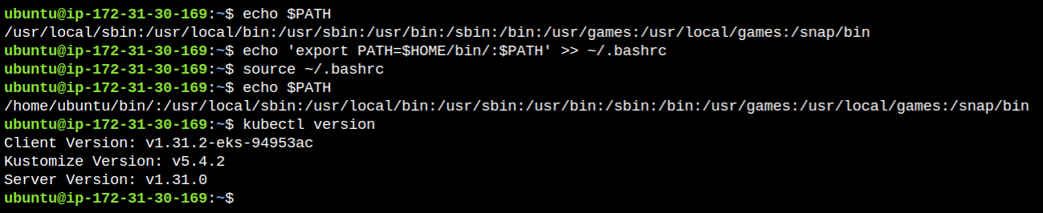

=======>>>>>>>>>>>>>>>>>>Enjoy kubectl<<<<<<<<<<<=============

Step 5 - kubectl commands

- Kubectl get pods
- Kubectl get nodes
- Kubectl get ns
- kubectl config current-context
