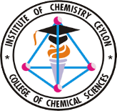
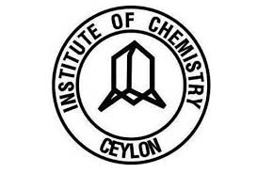
College of Chemical Sciences, Institute of Chemistry Ceylon, Sri Lanka
CHE/C 43016 Research Project

Project Proposal
Bachelor of Science Honours in Chemical Science & Graduateship Programme in Chemistry

Student Name | A.G.H.U.Adikari
Registration No. | 226197 | Research Project No. | R-25- 120
Proposed title of the Project:
Study of synergystic bioactivity of the leaves of Oroxylum Indicum with ZnO nanoparticles.

Principal Supervisor: (Name and Designation)
Dr.Kushan Weerasiri

Co-Supervisor 1: (Name and Designation)
None
Co-Supervisor 2: (Name and Designation)
None
Venues where the research will be conducted:
Institute of Chemistry Ceylon , College of Chemical Sciences
Abstract: (Maximum 200 words)

Introduction and Literature Review: (Maximum 200 words)

Research Gap/Problem: (Maximum 50 words)

Hypothesis/Hypotheses: (Please list your hypothesis/hypotheses. If you have more than one hypothesis, please separate them clearly. Your response should not exceed 200 words.)
Hypothesis 1:

Objective(s): (Maximum 100 words)

Significance of the Research: (If applicable, mention the scientific, social, and economic impacts of the research. Maximum 200 words)

Methodology and Experimental Design:

Expected Outcomes:

Action Plan: (Please include a Grant Chart)

References: (Peer reviewed references only, in ACS format)

Tentative Budget:

Student Signature  Date: |  | Signature of the Principal Supervisor  Date:
(Delete the box if not applicable)

Signature of the Co-Supervisor
Date:
For Official Use Only | Received on: | By: | Evaluator:

