
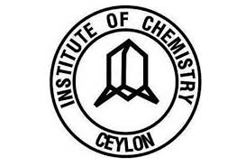
College of Chemical Sciences, Institute of Chemistry Ceylon, Sri Lanka
CHE/C 43016 Research Project

Monthly Report
Bachelor of Science Honours in Chemical Science & Graduateship Progarmme in Chemistry

Name: P. Sandali Hansika Dabare
Registration No.: 226104
Research Project No.: R – 25 – 121
Title of the Project: Study of synergistic bio-activities of leaves of Olax zeylanica with Zinc nanoparticles.
Principal Supervisor: Dr. Kushan Weerasiri (Senior Lecturer, College of Chemical Sciences, Institute of Chemistry Ceylon)
Reporting Month: November 2025
Reporting Period: 30th October 2025-30th November 2025
Report No: 01

- Research Objectives for the Month
- To initiate preliminary laboratory work related to the preparation of Olax zeylanica leaf extract for use as a reducing and stabilizing agent in the green synthesis of zinc oxide nanoparticles.
- To develop familiarity with plant extract preparation procedures, including drying, weighing, aqueous extraction, heating, and sequential filtration, to obtain a clear and stable plant extract.
- To perform a trial green synthesis of ZnO nanoparticles using Olax zeylanica extract and zinc acetate dihydrate to understand reaction behaviour, pH adjustment, and nanoparticles precipitation.
- To assess initial nanoparticle formation and yield, and to identify practical challenges during centrifugation, washing, and pellet recovery.
- To document observations and procedural outcomes, including colour changes, filtration behaviour, precipitate formation, and pellet loss, for future optimization.

- Experimental Procedures

  - Collection and Preparation of Plant Material
Fresh leaves of Olax zeylanica were collected from a home garden located in Gampaha on 10th November 2025 at 7.40 a.m. The leaves were washed several times thoroughly with tap water to remove dust and other impurities. Cleaned leaves were then spread out under shade at room temperature to undergo drying. Shade drying commenced on 10th November 2025 at 8.50 a.m. and continued for 14 days, until all visible moisture had evaporated and the leaves became crisp. After drying, the leaves were ground into a fine powder using a mechanical grinder. The resulting powder was stored in Ziplock bags at room temperature until required for extract preparation.

  - Preparation of Olax zeylanica Leaf Extract (Day 01 – 26/11/2025)
All glassware, including beakers, volumetric flasks, and watch glasses were washed and oven dried at 60 ⁰C. A Portion of 5.003 g of dried Olax zeylanica leaf powder was weighed accurately and placed in a 250 mL. Then volume of 100 mL of distilled water was measured using a 100 mL volumetric flask and added to the beaker. It was heated on a hot plate under low temperature with continuous medium-speed stirring for 30 minutes. After heating, the extract was allowed to cool to room temperature. Filtration was carried out first using a linen cloth. A second filtration using Whatman No.1 Filter paper took approximately two hours. The final filtrate was collected, transferred to an amber bottle, and stored at 4 ⁰C until further use.

  - Synthesis of Zinc Oxide Nanoparticles (Day 02– 27/11/2025)

Preparation of 0.01 M Zinc Acetate Dihydrate Solution

A 0.01 mol dm⁻³ zinc acetate dihydrate solution was prepared by dissolving 0.110 g of zinc acetate dihydrate in 5 mL of distilled water. The mixture was stirred for 10 minutes until completely dissolved.

Addition of Plant extract
A volume of 1 mL of Olax zeylanica extract was added slowly into the zinc acetate solution under gentle stirring for 10 minutes.

Addition of NaOH
A 2 mol dm⁻³ NaOH solution was freshly prepared by dissolving 8.250 g of NaOH pellets. NaOH was added dropwise to the reaction mixture while monitoring with a calibrated pH meter. At pH 12, a white precipitate formed, indicating ZnO nanoparticle nucleation. The mixture was stirred for an additional 45 minutes at medium speed.

Centrifugation and washing
The reaction mixture was centrifuged at 4500 rpm for 15 minutes, producing a small pellet. This pellet was washed with distilled water and centrifuged again for 10 minutes. A second washing was carried out using IMS (Industrial Methylated Spirit), followed by centrifugation at 4500 rpm for 5 minutes. The remaining quantity was too low to proceed with oven drying at 60 ⁰C for 12 hours. Drying was therefore not performed.
- Results

Olax zeylanica leaves Olax zeylanica leaves Leaf powder before drying after drying
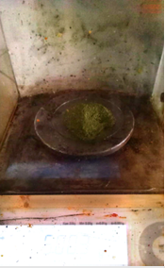
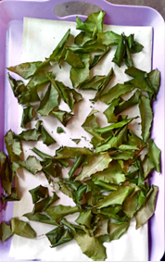
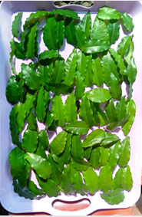

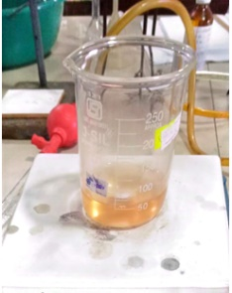
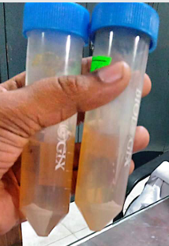
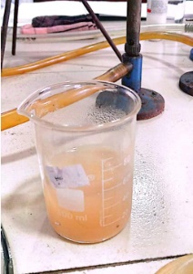
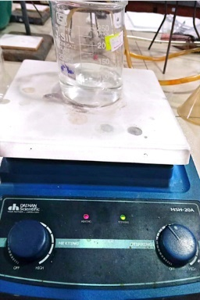
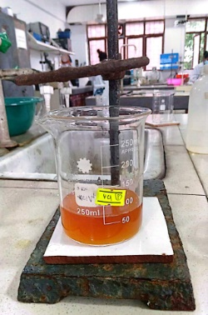
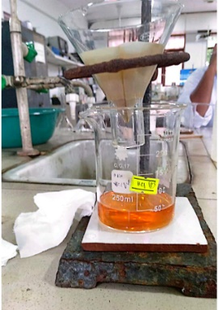
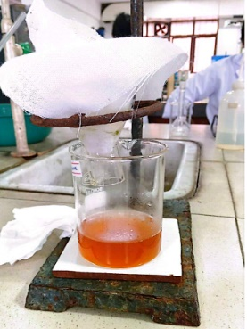
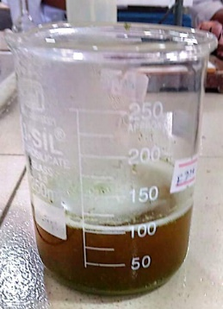
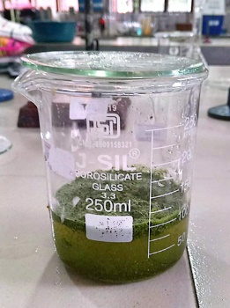
After adjusting the pH to 12
After centrifugation
After stirring 45 minutes
Filtration using Whatman No. 1 filter paper

After filtration
Zinc Acetate Dihydrate solution
Filtration using Linen Cloth
After stirring and heating
Leaf powder + distilled water

Mixing the plant powder with 100 mL of distilled water produced a dark brown suspension, which was heated and stirred for 30 minutes. After heating, the mixture changed to a dark brownish-green colour. Filtration through Linen cloth followed by Whatman No. 1 filter paper yielded a clear orange-brown extract, indicating successful extraction of water-soluble phytochemicals.
A clear aqueous solution of zinc acetate dihydrate was prepared by dissolving 0.110g of precursor in 50 mL of distilled water. The solution appeared transparent. Continuous heating and magnetic stirring resulted in complete dissolution, producing a uniform precursor solution.
During the dropwise addition of fresh prepared 2 M NaOH, the mixture gradually became turbid. A visible increase in cloudiness was observed once the pH approached 12, indicating the formation of zinc hydroxide intermediates. This transition confirmed the onset of nucleation.
With continued stirring, the mixture developed into a denser white suspension, suggesting the conversion of zinc hydroxide to ZnO nanoparticles under alkaline conditions. This white colouration is characteristic of ZnO nanoparticle formation, confirming that the reaction progressed along the expected green synthesis pathway.
The reaction mixture was centrifuged at 4500 rpm for 15 minutes. A small white pellet was visible at the bottom of the tubes, confirming successful precipitation of ZnO nanoparticles. However, significant pellet loss occurred during washing with distilled water and IMS. Much of the pellet adhered to the centrifuge tube walls or dispersed into the wash solutions. The remaining amount was insufficient for drying at 60 ⁰C, and therefore UV-Vis and FTIR characterization could not be performed during this month.

- Discussion
The preparation of Olax zeylanica extract and the preliminary synthesis of ZnO nanoparticles yielded several important observations regarding colour changes, filtration behaviour, and nanoparticle formation.
The initial mixture of plant powder and distilled water appeared greenish brown, which is typical for fresh leaf suspensions containing chlorophylls, carotenoids, tannins, and plant debris. Upon heating for 30 minutes, the mixture turned dark brownish-green. This darkening is attributed to:
- Release of polyphenols and flavonoids from plant tissues during heating
- Partial oxidation of phenolic compounds, which naturally darkens the extract
- Chlorophyll degradation at elevated temperatures produces brownish derivatives and increased solubilization of tannins, which contribute a brown colour.
The phytochemicals also serve as reducing and stabilizing agents in green nanoparticle synthesis, confirming that the extract was chemically active.
When NaOH was added to the zinc acetate precursor, the mixture gradually developed turbidity and later a white suspension. These visual changes correspond to:
- Formation of zinc hydroxide at alkaline pH (turbid),
- Conversion of zinc hydroxide to ZnO nanoparticles under heat and stirring (white suspension).
The white colour is typical of ZnO nanoparticles because they are wide-bandgap semiconductors that do not absorb visible light, causing them to appear bright white.
The differences between Linen cloth filtration and Whatman No.1 filtration were significant and scientifically expected. Filtration through Linen cloth was quick and easy because:
- Linen has large pore sizes, allowing water and small dissolved compounds to pass rapidly.
- Only large plant particles (Fibers, leaf fragments) are retained.
- Flow resistance is very low, so the filtrate drains quickly.
This step is ideal as a pre-filtration method to remove coarse debris.
Filtration through Whatman No.1 was much slower due to:
- Small pore size, which traps fine suspended particles,
- High amount of plant colloids and tannin complexes, which clog pores,
- The viscous nature of the extract after heating reduces the flow rate
Because the extract contains very fine plant particles and oxidized phytochemicals, the filter paper pore gradually becomes blocked, significantly slowing the filtration process. The long filtration time, therefore, indicates that the extract contained high amounts of small colloidal particles, which is normal for leaf extracts.
Although ZnO nanoparticle formation was visually confirmed (white precipitates and pellet), the final mass recovered after centrifugation was extremely low. The likely reasons include:
- Insufficient volume of plant extract (1 mL) to fully reduce and stabilize Zn²⁺ ions
- Loss of nanoparticles during washing steps
- Dispersion of fine nanoparticles in washing solutions
- Adhesion of the pellet to the walls of the centrifuge tube
- Possibly incomplete conversion of zinc acetate to ZnO due to short reaction time
Because of the low pellet mass, oven drying could not be performed, and therefore UV-Vis and FTIR characterization were not possible this month.

- Expected Work for the Following Month (December 2025)

- Optimize synthesis parameters by varying:
- Extract volume (1,3,5,6 mL)
- Zinc acetate concentrations (0.02-0.05 M)
- pH (10-12)
- Stirring time (45-120 min)
- Reaction temperature

- Improve centrifugation and washing steps:
        - Optimize rpm and time (4500-6000 rpm, 10-20 min)
        - Reduce pellet loss
        - Adjust wash volume for maximum yield

- Collect and dry nanoparticles:
        - Oven-dry ZnO nanoparticles at 60 ⁰C for 12 hours

- Conduct nanoparticle characterization:
        - UV-Visible spectroscopy to confirm the maximum wavelength
        - FTIR to identify functional groups responsible for reduction and stabilization

- References (ACS style)

- Wijesinghe, U.; Thiripuranathar, G.; Iqbal, H.; Menaa, F. Biomimetic synthesis, characterization, and evaluation of FRET, photoluminescence, and photocatalytic activity of zinc oxide nanoparticles. Sustainability 2021, 13, 2004.
- Matinise, N.; Fuku, X. G.; Kaviyarasu, K.; Mayedwa, N.; Maaza, M. ZnO nanoparticles via Moringa oleifera green synthesis: physical properties and mechanism of formation. Appl. Surf. Sci. 2017, 416, 1–9.
- Swain, M.; Mishra, D.; Sahoo, G. A review on green synthesis of ZnO nanoparticles. Discover Appl. Sci. 2025, 7, 997.
- Agarwal, H.; Kumar, S. V.; Rajeshkumar, S. A review on green synthesis of zinc oxide nanoparticles—an eco-friendly approach. Resour. Efficient Technol. 2017, 1, 2405–2537.
- Thanh, N. T. K.; Maclean, N.; Mahiddine, S. Mechanisms of nucleation and growth of nanoparticles in solution. Chem. Rev. 2014, 114, 7610–7630.

………………………….
Date of Submission

………………………….. ………………………
Student Signature Supervisor’s Signature

