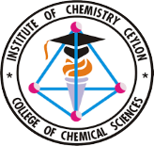
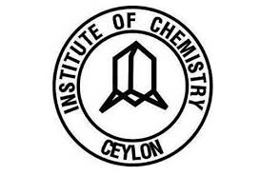
College of Chemical Sciences, Institute of Chemistry Ceylon, Sri Lanka
CHE/C 43016 Research Project

Monthly Report
Bachelor of Science Honours in Chemical Science & Graduateship Progarmme in Chemistry

Name: A.G.H.U.Adikari
Registration No.: 226197
Research Project No.: R – 25 - 120
Title of the Project: Study of synergistic bioactivities of the leaves of Oroxylum indicum with ZnO nanoparticles.
Principal Supervisor: Dr.Kushan Weerasiri (Senior lecturer, College of Chemical Sciences, Institute of Chemistry Ceylon)
Reporting Month: November 2025
Reporting Period: 30th October 2025 - 30th November 2025
Report No: 01

- Research Objectives for the Month

- Initiate lab work by preparing Oroxylum indicum leaf extract as a reducing and stabilizing agent for green synthesis of ZnO nanoparticles.

- Gain practical skills in extract preparation, covering drying, powdering, aqueous extraction, heating, and multi-step filtration for a stable filtrate.

- Conduct a trial synthesis using Oroxylum indicum extract with zinc acetate dihydrate, monitoring pH shifts, precipitation, and basic yield.

- Evaluate early nanoparticle recovery challenges during centrifugation and washing, noting any losses or adhesion issues.

- Record key observations like color shifts and procedural hurdles to guide optimizations next month.

- Experimental Procedures

- Collection and Preparation of Plant Material

Fresh leaves of Oroxylum indicum were collected from a home garden located in Kegalle on 10th November 2025 at 7.30 a.m. The leaves were washed well with tap water to remove dust and other impurities. Then the cleaned leaves were kept under the shade at room temperature to undergo drying. The drying process was commenced on 10th November 2025 at 11.00 a.m. and continued for 14 days until all the visible moisture had evaporated and the leaves became crisp. After drying, the leaves were ground into a fine powder using a mechanical grinder. The resulting powder was stored in ziplock bags at room temperature until required for the preparation of the extract.

- Preparation of Oroxylum indicum leaf extract ( Day 01 - 2025/11/26 )

All glassware, including beakers, volumetric flasks, and watch glasses, was washed and oven-dried at 60°C. A portion of 5.000 g of dried Oroxylum indicum leaf powder was weighed accurately and placed in a 250 mL beaker. Then, volume of 100 mL of distilled water was measured using a 100 mL volumetric flask and added to the beaker. Then it was heated on a hot plate under low temperature with medium-speed stirring, continuously for 30 minutes. After heating, the extract was allowed to cool to room temperature. The first filtration was carried out using a linen cloth. The second filtration using Whatman No.1 filter paper took approximately five and a half hours. The final filtrate was collected, transferred to a sterile airtight bottle, and stored at 4°C until further use.

- Synthesis of Zinc Oxide Nanoparticles (Day 02– 27/11/2025)

    - Preparation of 0.01 M Zinc Acetate Dihydrate Solution

A 0.01 mol dm⁻³ zinc acetate dihydrate solution was prepared by dissolving 0.110g of zinc acetate dihydrate in 5 mL of distilled water. The mixture was stirred for 10 minutes until completely dissolved.

    - Addition of Plant extract
A volume of 1 mL of Oroxylum indicum extract was added slowly into the zinc acetate solution under gentle stirring for 10 minutes.

    - Addition of NaOH
A 2 mol dm⁻³ NaOH solution was freshly prepared by dissolving 8.250 g of NaOH pellets. NaOH was added dropwise to the reaction mixture while monitoring with a calibrated pH meter. At pH 12, a white precipitate formed, indicating ZnO nanoparticle nucleation. The mixture was stirred for an additional 45 minutes at medium speed.

    - Centrifugation and washing
The reaction mixture was centrifuged at 4500 rpm for 15 minutes, producing a small pellet. This pellet was washed with distilled water and centrifuged again for 10 minutes. A second washing was carried out using IMS (Industrial Methylated Spirit), followed by centrifugation at 4500 rpm for 5 minutes. The remaining quantity was too low to proceed with oven drying at 60 ⁰C for 12 hours. Drying was therefore not performed.

- Results
Oroxylum indicum leaf powder
Oroxylum indicum leaves after drying

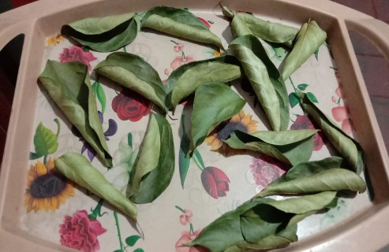
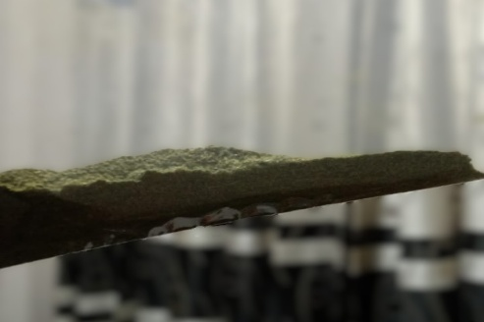

- Discussion
The preparation of Oroxylum indicum leaf extract was successfully completed by mixing 5 g of dried leaf powder with 100 mL of distilled water, followed by heating for 30 minutes under controlled stirring. The initial greenish-brown suspension transitioned to a darker brownish-green coloration upon heating, which is consistent with the extraction and partial oxidation of polyphenolic compounds and degradation of chlorophyll, typical phytochemicals known for their reducing and stabilizing properties in green synthesis. Filtration was conducted sequentially using linen cloth and Whatman No.1 filter paper; the latter exhibited a significantly slower filtration rate due to the presence of fine colloidal particles and tannin complexes that obstructed the filter pores.

The synthesis of zinc oxide nanoparticles was initiated by the addition of 1 mL of Oroxylum indicum extract into a 0.01 M zinc acetate dihydrate solution. Subsequent dropwise addition of NaOH until a pH of 12 resulted in the formation of turbidity, indicative of zinc hydroxide nucleation. Continued stirring caused the formation of a white suspension, characteristic of ZnO nanoparticle precipitation. Centrifugation at 4500 rpm yielded a small pellet; however, substantial material loss was observed during washing with distilled water and industrial methylated spirit, which limited further processing, such as drying and characterization. These outcomes are consistent with preliminary green synthesis trials reported in the literature, where low nanoparticle recovery is a common challenge due to adhesion and dispersion issues.

Overall, the initial synthesis process demonstrates that Oroxylum indicum leaf extract contains active phytochemicals capable of mediating ZnO nanoparticle formation. The visual observations and procedural challenges encountered provide a valuable basis for optimizing synthesis parameters in subsequent experiments to enhance nanoparticle yield and stability.

- Expected Work for the Following Month (December 2025)
- Fine-tuning synthesis conditions
- Experiment with different extract volumes (around 1–6 mL).
- Adjust zinc acetate precursor levels within the 0.02–0.05 M range.
- Maintain alkaline conditions by testing pH values between 10 and 12.
- Modify mixing duration (approximately 45–120 minutes).
- Evaluate how temperature variations influence the reaction.
- Enhancing separation and purification
- Optimize centrifugation by testing rpm settings between 4500–6000 and adjusting run times (10–20 minutes).
- Implement methods to minimize the loss of nanoparticle pellets.
- Refine the washing procedure by adjusting the washing volume to improve overall product recovery.
- Drying and collecting the final product
- Dry the synthesized ZnO nanoparticles in an oven at about 60 °C for roughly 12 hours.
- Performing material characterization
- Use UV–Vis spectroscopy to determine the absorption peak of the nanoparticles.
- Carry out FTIR analysis to identify the functional groups involved in nanoparticle formation and stabilization.

- References (ACS style)

- "Wijesinghe, U.; Thiripuranathar, G.; Iqbal, H.; Menaa, F. Biomimetic synthesis, characterization, and evaluation of FRET, photoluminescence, and photocatalytic activity of zinc oxide nanoparticles. Sustainability 2021, 13, 2004.​

- Agarwal, H.; Kumar, S. V.; Rajeshkumar, S. A review on green synthesis of zinc oxide nanoparticles—an eco-friendly approach. Resour. Effic. Technol. 2017, 3, 405–413.​​

- Xu, J.; Huang, Y.; Zhu, S.; Abbes, N.; Jing, X.; Zhang, L. A review of the green synthesis of ZnO nanoparticles using plant extracts and their prospects for application in antibacterial textiles. J. Eng. Fibers Fabr. 2021, 16, 1–12.​

- Mim, J. Green mediated synthesis of cerium oxide nanoparticles by Oroxylum indicum fruit extract: Antioxidant, antibacterial, and cytotoxic assessments. Results Surf. Interfaces 2024, 100214."

………………………….
Date of Submission

………………………….. ………………………
Student Signature Supervisor’s Signature

