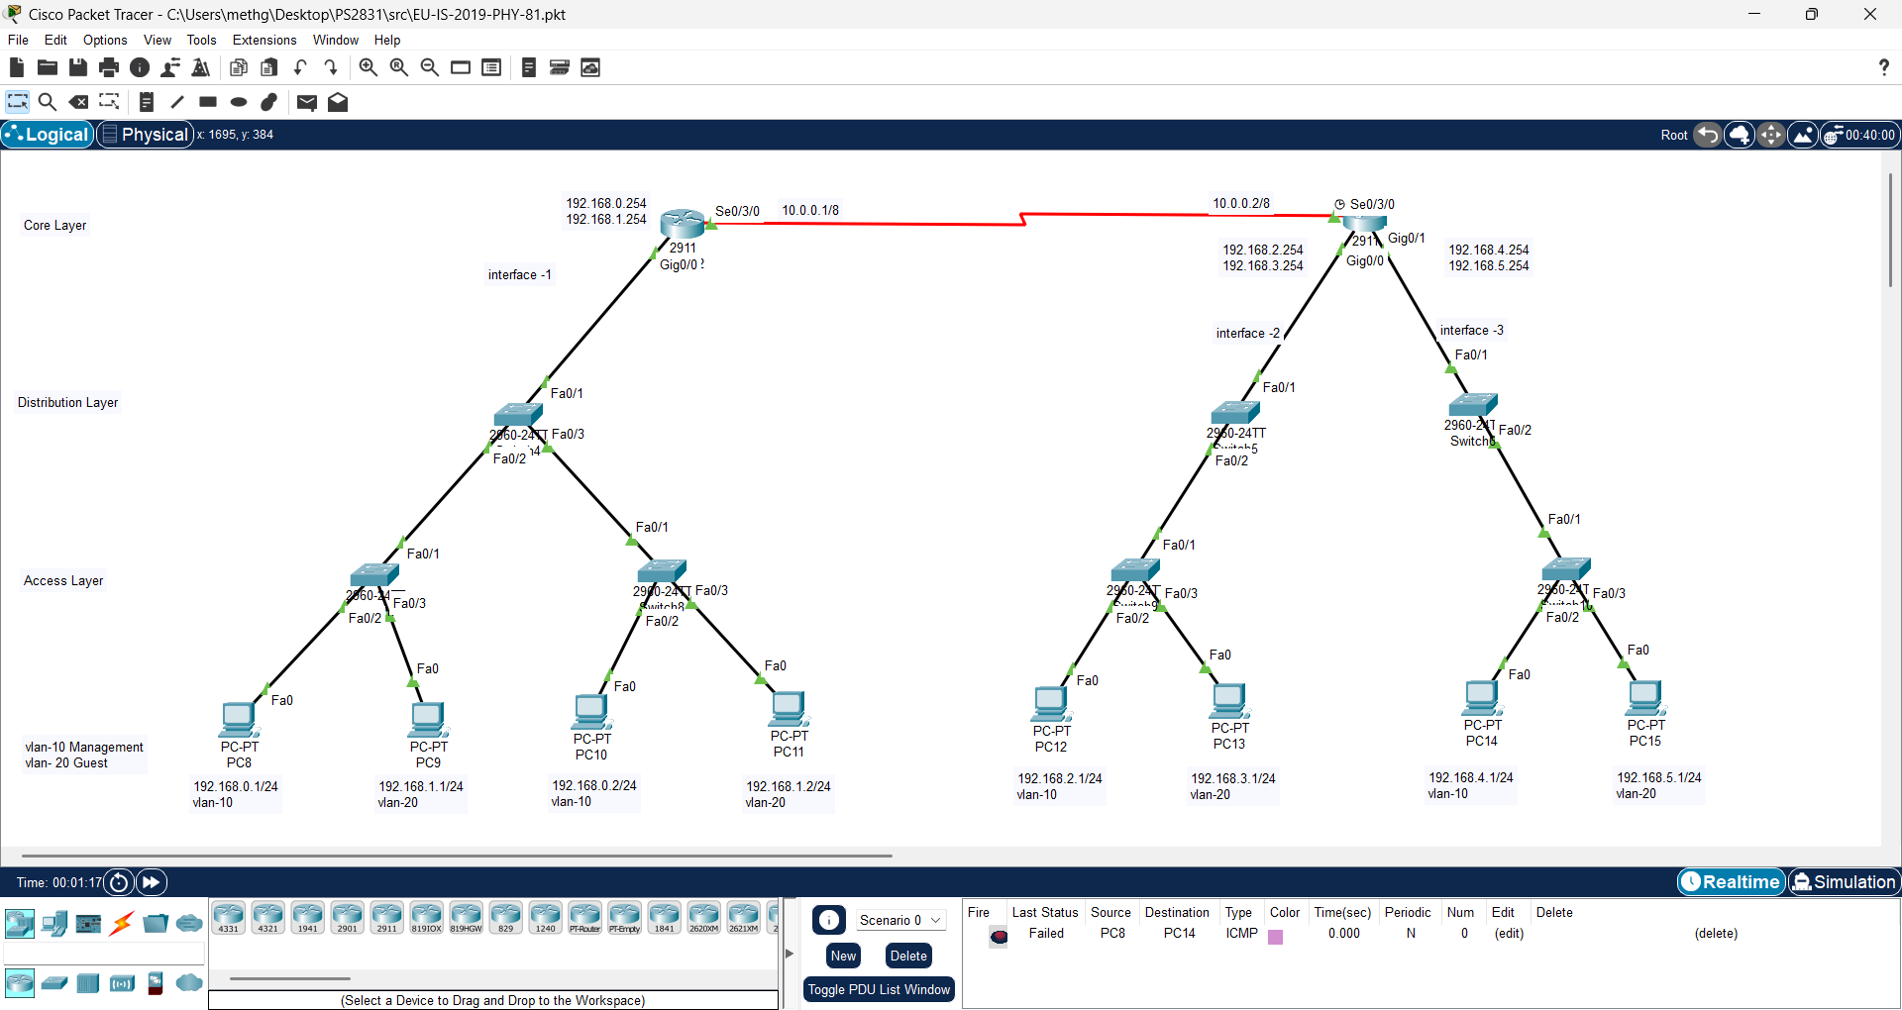

|  |  |  |  |
| --- | --- | --- | --- |
| interface | Vlan | Ip address | gateway |
| 1 | 10 | 192.168.0.1/24  192.168.0.2/24 | 192.168.0.254/24 |
| 20 | 192.168.1.1/24  192.168.1.2/24 | 192.168.0.254/24 |
| 2 | 10 | 192.168.2.1/24 | 192.168.2.254/24 |
| 20 | 192.168.3.1/24 | 192.168.3.254/24 |
| 3 | 10 | 192.168.4.1/24 | 192.168.4.254/24 |
| 20 | 192.168.5.1/24 | 192.168.5.254/24 |

Access layer

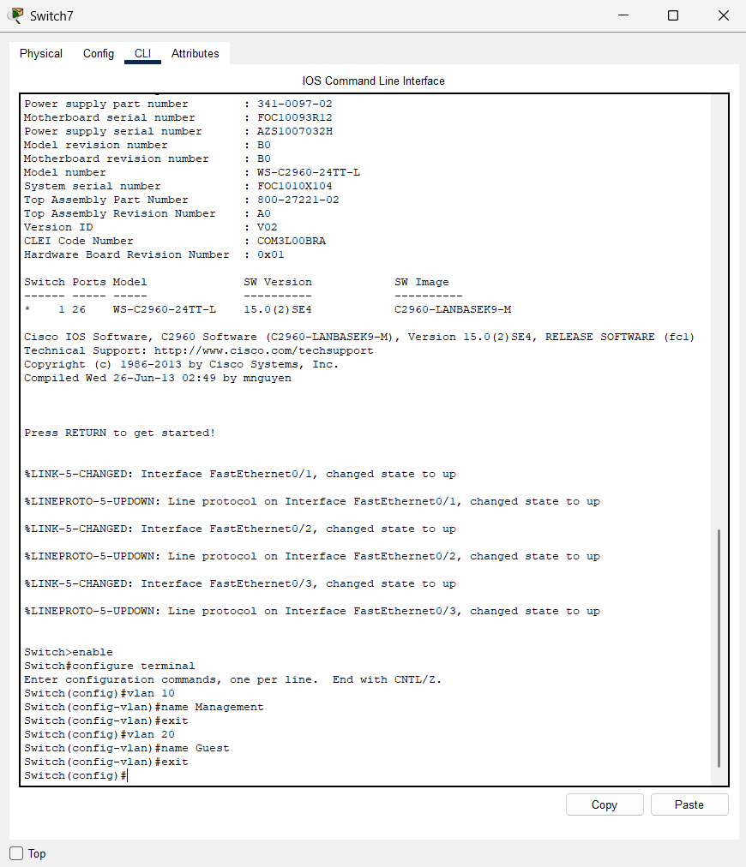

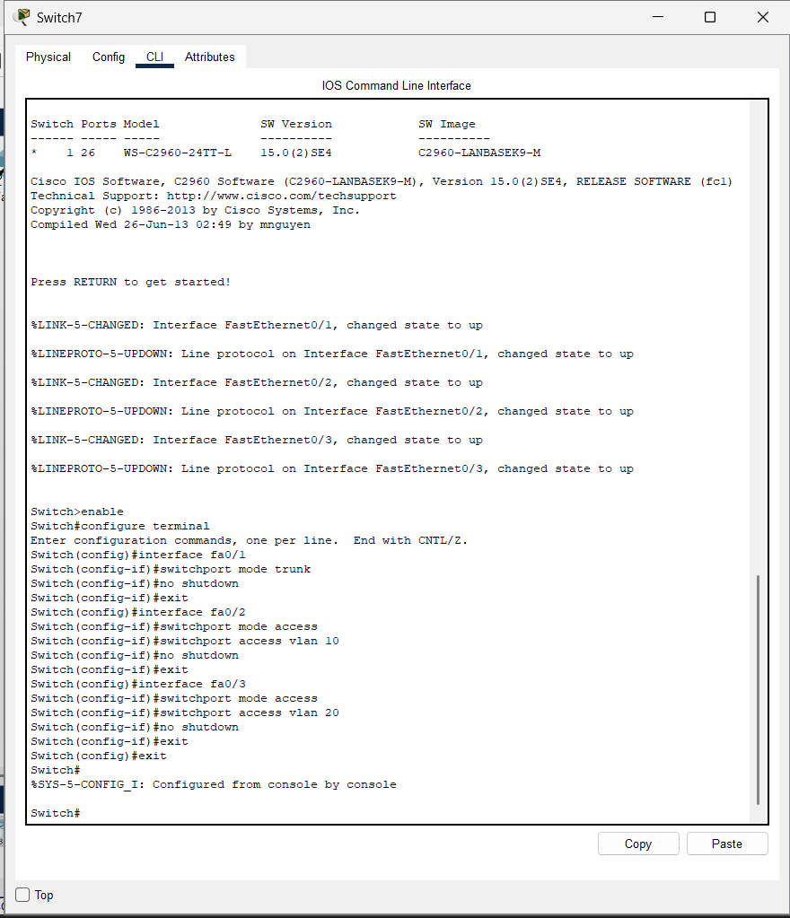

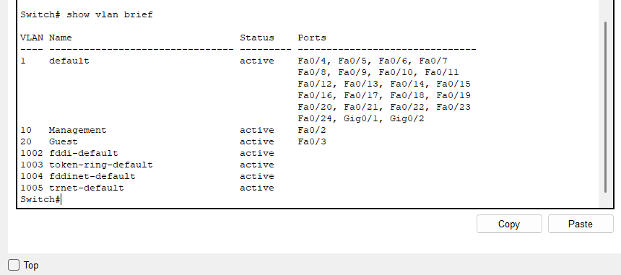

Distribute layer

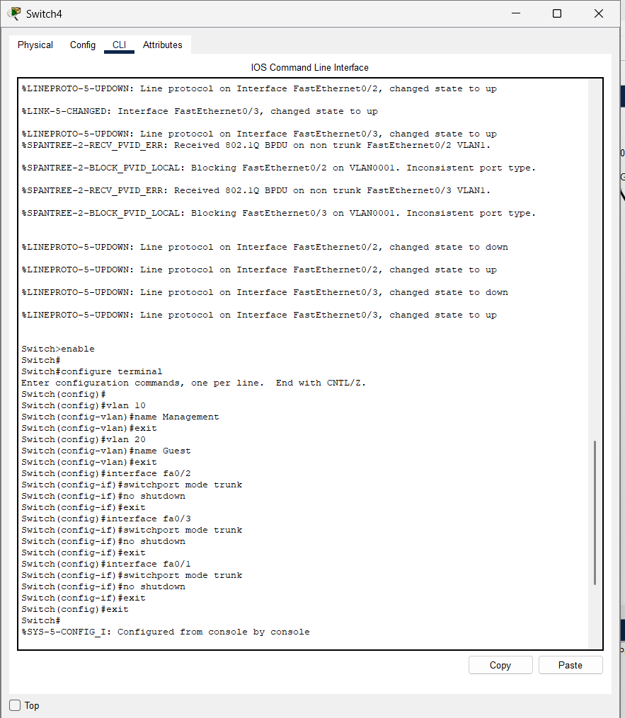

Core layer

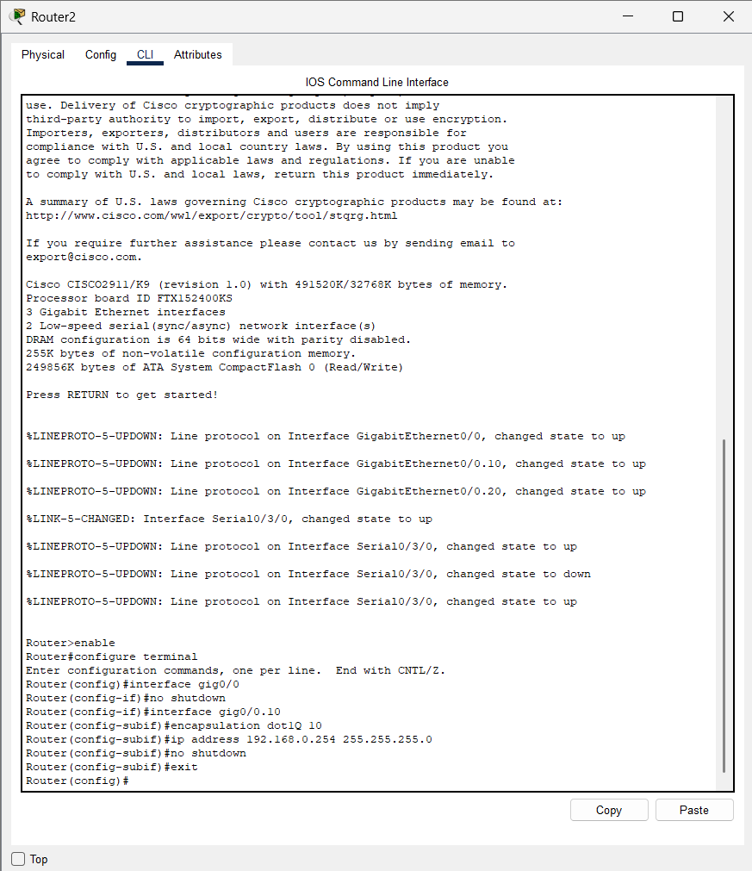

Likewise all components in all layers can be configured