### Why are there 1783 boxes?

The boxes.eval() shape of (1783, 4) indicates that the yolo_filter_boxes function returned 1783 bounding boxes after filtering. Each bounding box is represented by 4 values, corresponding to its coordinates.

The yolo_filter_boxes function typically filters and selects bounding boxes based on certain criteria, such as objectness scores and class probabilities. The number 1783 is the total number of boxes that met the criteria specified by the threshold parameter (in this case, 0.5) after filtering.

The maximum number of boxes after filtering is 19 * 19 * 5 = 1805. This occurs if none of the boxes are filtered out due to the threshold.

The minimum number is 0, which could occur if all boxes are filtered out due to very low confidence scores or class probabilities, or if the threshold is set such that no boxes meet the criteria.

### What is the advantage of using such anchor boxes?

1. Predefined Aspect Ratios and Scales: Anchor boxes allow the model to handle various object sizes and aspect ratios more effectively. By using predefined anchor boxes, the model can learn to predict the offsets from these anchors rather than learning from scratch for every object, which speeds up the learning process.
2. Improved Localization: Anchor boxes help in improving the localization of objects by giving the model a set of reference boxes that match typical object sizes and shapes. This improves the accuracy of bounding box predictions.
3. Handling Multiple Objects: Anchor boxes allow the model to predict multiple objects in a single grid cell by using different anchor boxes. This is especially useful in detecting objects of varying sizes and shapes within the same region.
4. Better Convergence: By providing a good initialization with anchor boxes, the model converges faster during training. The anchor boxes help in guiding the model towards plausible object locations and sizes, reducing the search space.

### What was the Method Used to Determine the Sizes of Anchor Boxes?

Collect Bounding Box Dimensions

### Uploaded Image

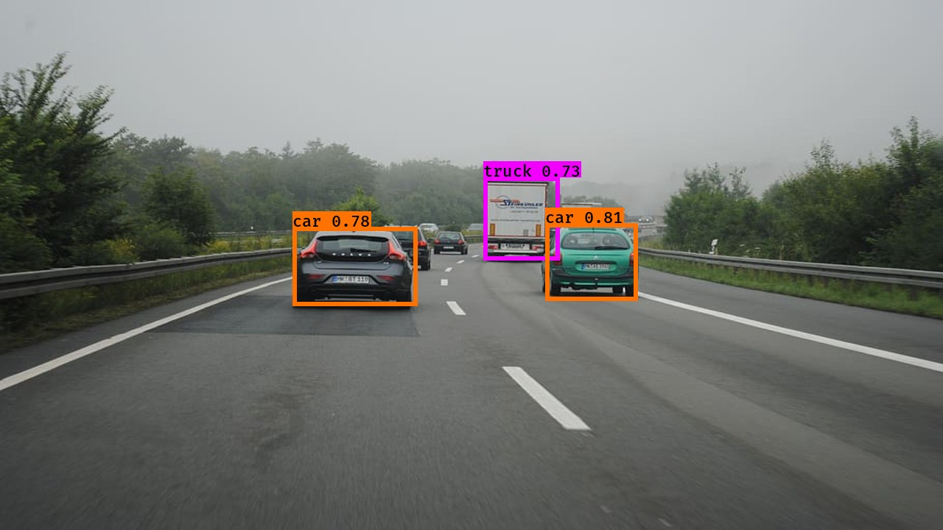

Figure 1 Uploaded Image

### max_boxes

* Value = 20

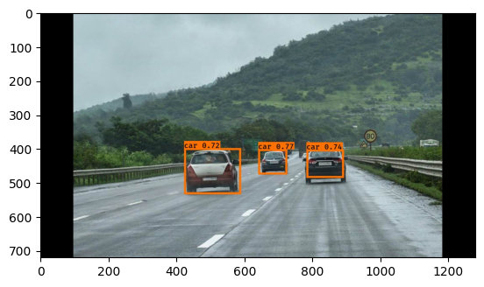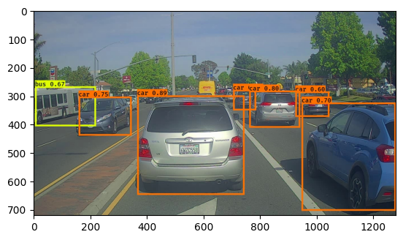

* Value = 2

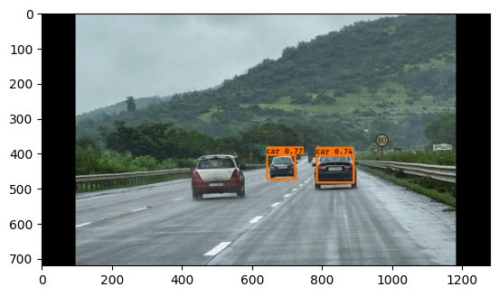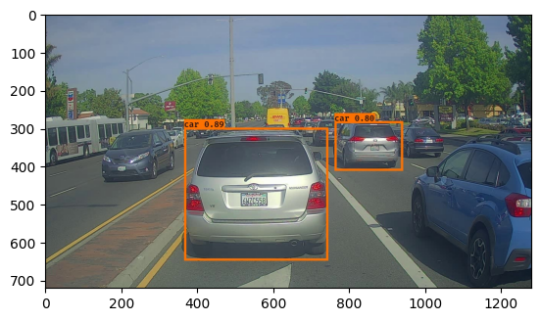

Increasing max_boxes: More boxes considered, potentially more detections, but also more clutter.

Decreasing max_boxes: Fewer boxes considered, cleaner output, but miss some detections.

### score_threshold

* Value = 0.8

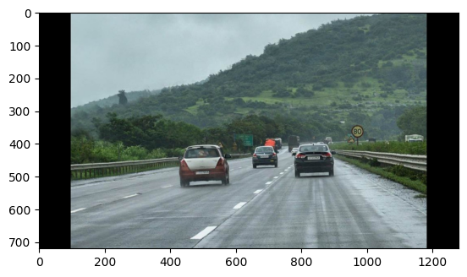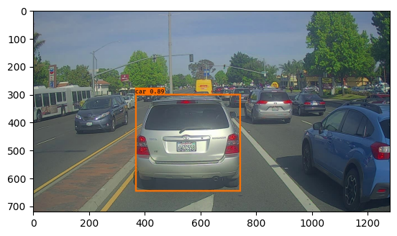

* Value = 0.4

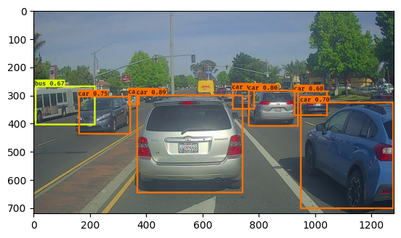

Increasing score_threshold: Fewer boxes with higher confidence, reduced false positives, but possible missed detections.

Decreasing score_threshold: More boxes with lower confidence, more detections, but potential increase in false positives.

### iou_threshold

* Value = 0.8

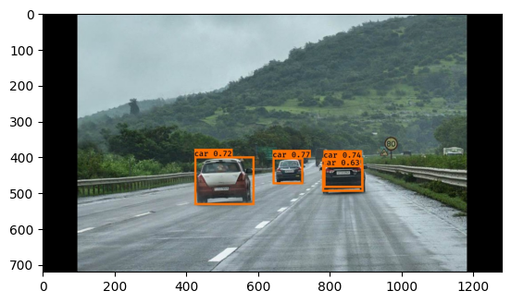

* Value = 0.3



Increasing iou_threshold: Fewer overlapping boxes, clearer results, but possible missed detections.

Decreasing iou_threshold: More boxes considered overlapping, more detailed detections, but can lead to cluttered results.