# DL Lab 07

## Exercise 01

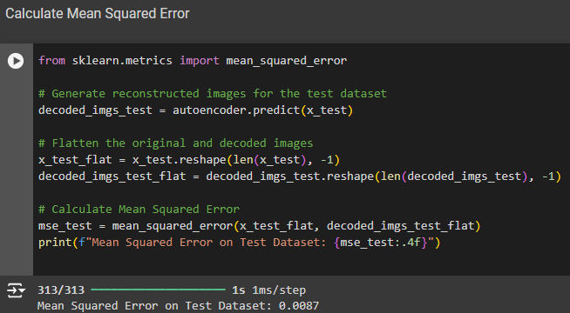

## Exercise 02

### Linear Autoencoder

1. **Architecture** - A Linear AE consists of an encoder and a decoder, both of which use linear transformations without any activation functions.
2. **Objective** - The goal of a Linear AE is to learn an efficient representation (encoding) of the input data by minimizing the reconstruction error, typically using Mean Squared Error (MSE).
3. **Weight Optimization** - During training, the weights of the linear layers are adjusted to find the optimal linear transformation that best compresses the input data into a lower-dimensional space and then reconstructs it back.

### Principal Component Analysis (PCA)

1. **Linear Transformation** - PCA is a statistical technique that transforms the data into a new coordinate system, where the axes (principal components) correspond to the directions of maximum variance in the data.
2. **Dimensionality Reduction** - It reduces dimensionality by projecting the data onto the first $k$ principal components, where $k<n$ (number of original features), capturing the most important features of the dataset.
3. **Eigenvalues and Eigenvectors** - PCA finds the eigenvectors and eigenvalues of the covariance matrix of the data. The eigenvectors (principal components) corresponding to the largest eigenvalues define the new feature space.

### Relationship

1. **Equivalent Outputs**: A Linear AE with no activation functions and a single hidden layer can be shown to produce the same principal components as PCA when the number of neurons in the hidden layer is equal to the number of principal components retained.
2. **Optimization Problem**: Both methods seek to minimize the same objective function. For a Linear AE, minimizing the reconstruction error leads to finding a linear transformation that captures the variance in the data, just like PCA.
3. **Linear Transformations**: Both methods rely on linear transformations. In the case of a Linear AE, the encoder applies a linear mapping, and PCA effectively achieves the same mapping through its projection onto the principal components.

## Exercise 03

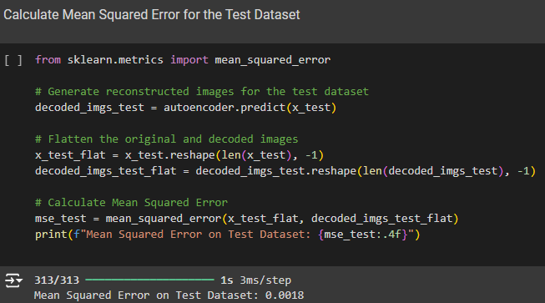

## Exercise 04

### Performance Comparison

1. **Mean Squared Error (MSE)** - The second model demonstrates a significantly lower MSE (0.0018), indicating that it reconstructs the input data much more accurately than the first model (0.0087).
2. Training and Validation Loss - The training loss of the second model exhibits a steeper decrease during the epochs, indicating faster convergence to an effective solution. In contrast, its lower validation loss suggests improved generalization to unseen data, as the model effectively captures the essential features of the dataset while minimizing the risk of overfitting.

### Possible Reasons for Improvement

1. **Model Architecture**

* The second model (Vanilla CNN) uses **convolutional layers**, which are better suited for image data. Convolutional layers effectively capture spatial hierarchies and local patterns, leading to improved feature extraction compared to the fully connected layers typically used in simpler models.

1. **Network Depth**

* The second model has a deeper architecture with multiple convolutional layers. This increased depth allows the model to learn more complex representations of the data, which can enhance reconstruction accuracy.

1. **Strides and Pooling**

* The second model uses strided convolutions to downsample the input images in the encoder. This allows the model to focus on the most salient features, reducing noise and irrelevant details that may affect reconstruction quality.

## Exercise 05



Lower values introduce less noise, while higher values introduce more noise, which make reconstruction harder.

## Exercise 06

The Image Denoising Autoencoder (Denoising AE) typically outperforms the Vanilla CNN Autoencoder in reconstructing clean images from noisy inputs due to its specialized training on noisy data, which enables it to learn robust feature extraction and noise suppression techniques. By effectively modeling the distribution of clean images and filtering out noise during reconstruction, the Denoising AE achieves lower Mean Squared Error (MSE) values. In contrast, the Vanilla CNN, trained only on clean images, struggles with noise, leading to higher reconstruction errors and reduced generalization to real-world scenarios.

## Exercise 07

|  |  |  |
| --- | --- | --- |
| **Feature** | **Autoencoder (AE)** | **Variational Autoencoder (VAE)** |
| Purpose | Learn compressed representations and reconstruct data | Learn data distribution and generate new samples |
| Encoding Mechanism | Maps input to a fixed latent representation | Maps input to a parameterized distribution (mean & variance) |
| Loss Function | Reconstruction loss (e.g., Mean Squared Error) | Composite loss (reconstruction loss + KL divergence) |
| Latent Space | Irregular and can be poorly structured | Structured and continuous, typically Gaussian |
| Applications | Dimensionality reduction, denoising, feature extraction | Generative modeling, new sample generation |

GitHub Link - https://github.com/HasinduRanasinghe/DL_Lab07.git