NurtureSense
A Secure, Adaptive Communication Framework for Low-Power Sensing
Project framework overview

1. Overview
NurtureSense is a research and prototyping project that combines lightweight environmental/channel sensing (RuView or Wi-Fi CSI) with an adaptive, authenticated-encryption pipeline for transmission over a long-range, low-power radio link (LoRa). The framework is designed so that every packet leaving the sensing node is formatted, keyed, and authenticated before it is encrypted with one of two interchangeable AEAD ciphers, then carried over the RF channel and independently re-validated at the receiver.
The goal of the framework is twofold: (1) to give resource-constrained sensor nodes a consistent, auditable security pipeline rather than an ad-hoc one, and (2) to allow the cipher used for authenticated encryption to be chosen adaptively — for example based on available compute, energy budget, or a configured security policy — without changing the surrounding protocol.

2. System architecture
The end-to-end pipeline is shown below. Data flows top to bottom through five stages: sensing, the security layer, authenticated encryption, the communication layer, and the receiver, which recovers the original data.
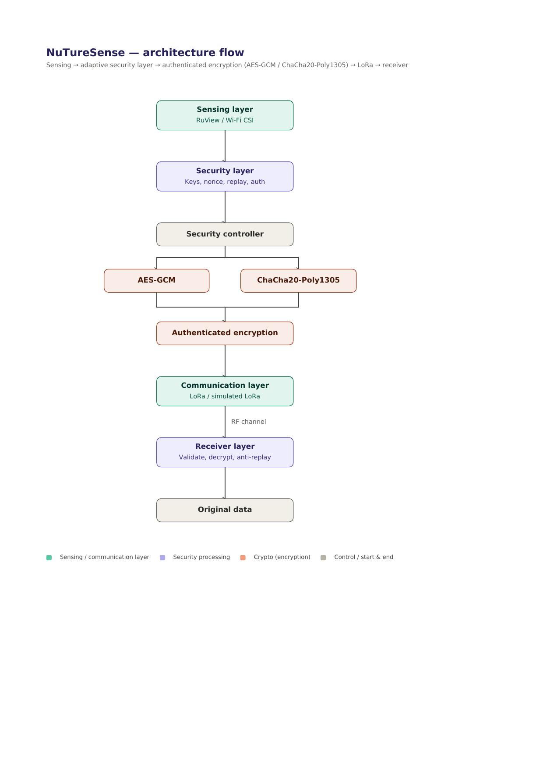
Figure 1. NuTureSense end-to-end architecture and adaptive cryptographic switch.
Layer | Component(s) | Function
Sensing | RuView / Wi-Fi CSI | Captures raw environmental / channel-state sensing data at the source node
Security | Data formatting, key management, nonce management, replay protection, authentication | Prepares and protects sensing data before transmission; establishes the cryptographic context for each packet
Authenticated encryption | AES-GCM or ChaCha20-Poly1305 (adaptively selected) | Encrypts and authenticates the formatted payload as a single AEAD operation
Communication | LoRa / simulated LoRa channel | Transmits the secured payload over a long-range, low-power RF link
Receiver | Packet validation, authentication check, replay detection, decryption | Verifies integrity and freshness of the received packet and recovers the original data

3. Adaptive cryptographic mechanism
At the center of the security layer sits a security controller responsible for the adaptive part of the framework. Rather than hard-coding a single cipher, the controller selects between two AEAD (authenticated-encryption-with-associated-data) constructions on a per-session or per-packet basis:
- AES-GCM — hardware-accelerated on platforms with AES-NI or dedicated crypto co-processors; preferred when such acceleration is available.
- ChaCha20-Poly1305 — a software-oriented AEAD cipher that performs well on constrained microcontrollers without hardware AES support.
Both branches converge on the same authenticated-encryption step, so the rest of the protocol (framing, key management, nonce handling, transmission over LoRa, and receiver-side validation) is identical regardless of which cipher was chosen. This keeps the adaptive switch isolated to a single, testable component and lets the framework trade off energy consumption, throughput, and platform support without redesigning the protocol.

4. Security layer responsibilities
Before encryption, the security layer performs the preparatory work that authenticated encryption depends on:
- Data formatting — normalizes sensing output into a fixed packet structure.
- Key management — derives or retrieves the session key used by the selected AEAD cipher.
- Nonce management — guarantees a unique nonce per packet, which is required for AEAD security.
- Replay protection — attaches sequence/timestamp information so stale packets can be rejected.
- Authentication — binds packet metadata to the ciphertext so tampering is detectable.
On the receiving side, these same properties are checked in reverse: packet validation, authentication verification, replay detection, and finally decryption to recover the original sensing data.

5. Threat model and adversarial testing
The repository dedicates a top-level attacks/ module to validating the design empirically rather than only on paper. Three adversarial capabilities are modeled directly against the prototype:
- Tampering — an attacker modifies packet contents in transit; the authentication tag should cause the receiver to reject the packet.
- Replay — an attacker re-sends a previously captured, valid packet; the nonce/sequence check in the security layer should detect and drop it.
- Forgery — an attacker attempts to construct a packet that passes authentication without knowledge of the session key.
These modules are paired with documentation/THREAT-MODEL.md, which is expected to define the assumed adversary capabilities, trust boundaries, and out-of-scope threats in more detail than is repeated here.

6. Repository structure
The project is organized so that research, formal documentation, implementation, adversarial testing, and evaluation are kept in separate, clearly scoped directories:
NuTureSense/
├── README.md
├── framework/
│ ├── NuTureSense_Framework.pdf
│ ├── NuTureSense_Framework.drawio
│ └── framework-images/
│ ├── architecture.png
│ ├── data-flow.png
│ ├── security-flow.png
│ └── adaptive-crypto.png
├── research/
│ ├── RESEARCH-PLAN.md
│ ├── RESEARCH-QUESTIONS.md
│ ├── OBJECTIVES.md
│ ├── RELATED-WORK.md
│ └── RESEARCH-PROGRESS.md
├── documentation/
│ ├── SYSTEM-ARCHITECTURE.md
│ ├── SECURITY-DESIGN.md
│ ├── PROTOCOL-DESIGN.md
│ ├── THREAT-MODEL.md
│ └── EXPERIMENT-PLAN.md
├── prototype/
│ ├── sender/
│ ├── receiver/
│ ├── crypto/
│ ├── protocol/
│ └── simulated-lora/
├── attacks/
│ ├── tampering/
│ ├── replay/
│ └── forgery/
├── experiments/
│ ├── benchmarks/
│ ├── results/
│ └── plots/
├── data/
│ ├── sample/
│ └── generated/
├── papers/
│ ├── papers-reviewed.md
│ └── references.bib
├── presentations/
│ └── ...
├── requirements.txt
├── LICENSE
└── .gitignore

Folder | Purpose
framework/ | Canonical framework diagram (PDF, editable .drawio) and exported figures used across the documentation
research/ | Research plan, questions, objectives, and a running log of related work and progress
documentation/ | Formal write-ups: system architecture, security design, protocol design, threat model, experiment plan
prototype/ | Implementation split into sender, receiver, crypto, protocol, and a simulated-LoRa channel for testing without hardware
attacks/ | Proof-of-concept adversarial modules used to validate the design against tampering, replay, and forgery
experiments/ | Benchmark scripts, raw results, and generated plots supporting the evaluation
data/ | Sample and generated datasets used for testing and benchmarking
papers/ | Literature review notes and a BibTeX reference list
presentations/ | Slide decks used for progress reviews and defenses

7. Evaluation approach
The experiments/ directory holds the benchmarking harness, raw results, and generated plots used to evaluate the framework — for example comparing AES-GCM and ChaCha20-Poly1305 on encryption/decryption latency, energy or CPU cost, and end-to-end throughput over the simulated LoRa channel, alongside the detection rate of the tampering, replay, and forgery attack modules.

8. Summary
NuTureSense packages a sensing front-end, an adaptive AEAD-based security layer, and a LoRa communication link into a single, testable pipeline, with the project repository organized to keep the research plan, formal design documentation, prototype, attack modules, and experimental evaluation traceable to one another. The adaptive cryptographic controller is the key novelty: it lets the system choose the more suitable AEAD cipher for the deployment context while leaving the surrounding protocol, key management, and anti-replay guarantees unchanged.

