AI ASSISTANT CODING
Assignment-6.3
NAME : Irumalla Hasini
HTNO: 2303A51286
BATCH : 05

TASK-1: Classes (Student Class)
Scenario
You are developing a simple student information management module.
Task
• Use an AI tool (GitHub Copilot / Cursor AI / Gemini) to complete a Student class.
• The class should include attributes such as name, roll number, and branch.
• Add a method display_details() to print student information.
• Execute the code and verify the output.
• Analyze the code generated by the AI tool for correctness and clarity.
PROMPT :
# a simple student information management module.
#The class should include attributes such as name, roll number, and branch.
#Add a method display_details() to print student information.
EXPLAINATION :
- An AI tool was used to generate a Python Student class.
- The class contains attributes: name, roll number, and branch.
- The __init__ constructor initializes student details.
- The display_details() method prints the student information.
- Object creation and method execution produced correct output.
- The AI-generated code was clear, readable, and correctly structured.

CODE:
class Student:
def __init__(self, name, roll_number, branch):
self.name = name
self.roll_number = roll_number
self.branch = branch

def display_details(self):
print(f"Name: {self.name}")
print(f"Roll Number: {self.roll_number}")
print(f"Branch: {self.branch}")
# Example usage
student1 = Student("Alice", "101", "Computer Science")
student1.display_details()
student2 = Student("Bob", "102", "Mechanical Engineering")
student2.display_details()
student3 = Student("Charlie", "103", "Electrical Engineering")
student3.display_details()

OUTPUT:

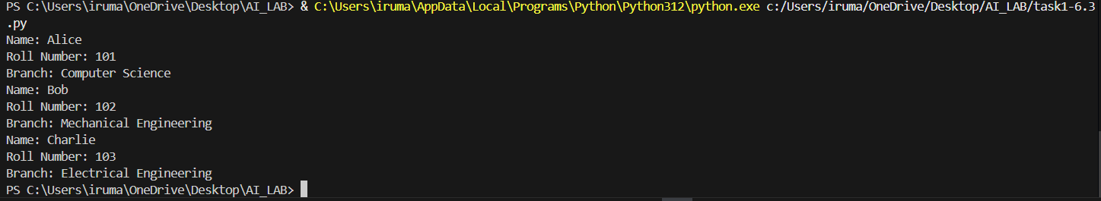

TASK-2 : Loops (Multiples of a Number)
Scenario
You are writing a utility function to display multiples of a given number.
Task
• Prompt the AI tool to generate a function that prints the first 10 multiples of a given number
using a loop.
• Analyze the generated loop logic.
• Ask the AI to generate the same functionality using another controlled looping structure (e.g. while instead of for).
PROMPT :
#utility function to display multiples of a given number.
#a function that prints the first 10 multiples of a given number using a loop.
EXPLAINATION :
- AI generated a function to print the first 10 multiples of a given number.
- A for loop was used to iterate from 1 to 10.
- Each iteration multiplies the number with the loop variable.
- A while loop version was also generated for comparison.
- Both approaches produced the same correct output.
- The for loop was more concise and readable.
CODE: USING FOR LOOP
def display_multiples(number):
print(f"First 10 multiples of {number}:")
for i in range(1, 11):
multiple = number * i
print(multiple)
# Example usage
display_multiples(5)
OUTPUT:
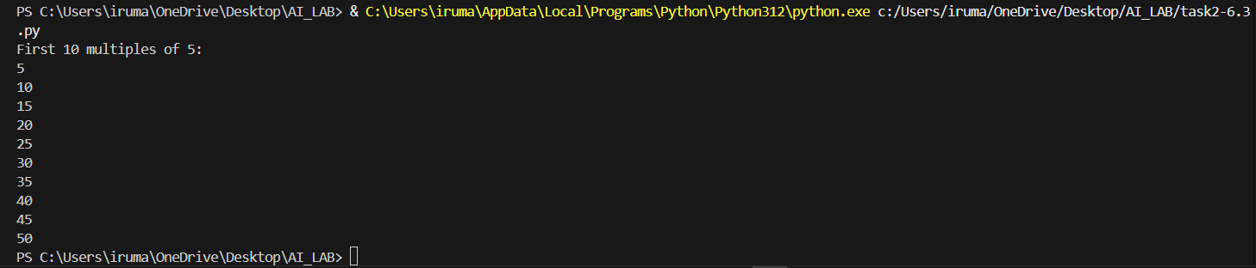

PROMPT :
#utility function to display multiples of a given number.
#a function that prints the first 10 multiples of a given number using while loop.
CODE : USING WHILE LOOP
def display_multiples(number):
count = 1
while count <= 10:
multiple = number * count
print(f"{number} x {count} = {multiple}")
count += 1
# Example usage
display_multiples(5)

OUTPUT :
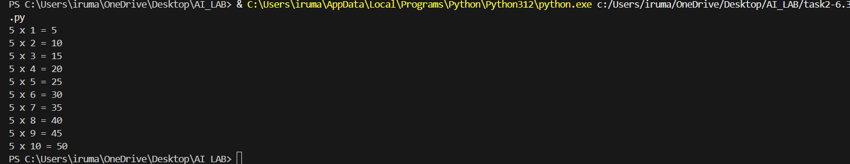

TASK-3 : Conditional Statements (Age Classification)
Scenario
You are building a basic classification system based on age.
Task
• Ask the AI tool to generate nested if-elif-else conditional statements to classify age groups
(e.g., child, teenager, adult, senior).
• Analyze the generated conditions and logic.
• Ask the AI to generate the same classification using alternative conditional structures (e.g.,
simplified conditions or dictionary-based logic).
PROMPT :
#a basic classification system based on age.
#nested if-elif-else conditional statements to classify age groups (e.g., child, teenager, adult, senior).
EXPLAINATION:
- AI generated if-elif-else conditions to classify age groups.
- Age categories included child, teenager, adult, and senior.
- Conditions were logically ordered to avoid incorrect classification.
- An alternative simplified conditional approach was suggested.
- The output correctly classified the age.
- The logic was clear and easy to understand.
CODE:
age = int(input("Enter your age: "))
if age < 0:
print("Invalid age.")
elif age <= 12:
print("You are a child.")
elif age <= 19:
print("You are a teenager.")

elif age <= 64:
print("You are an adult.")
else:
print("You are a senior.")
OUTPUT :

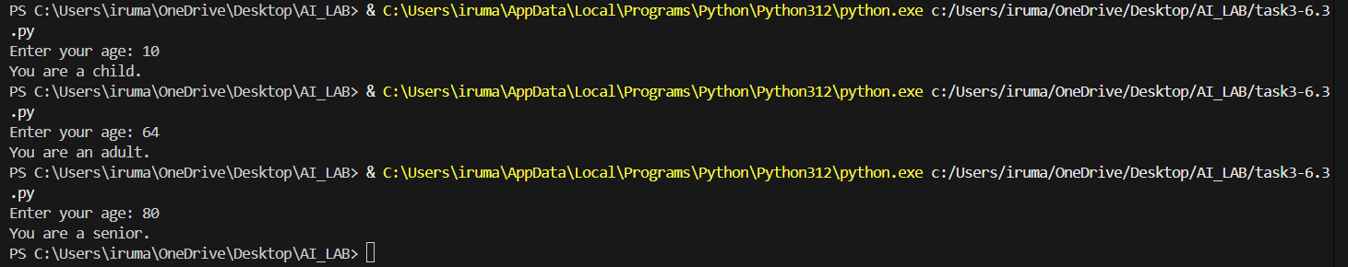

TASK-4 : For and While Loops (Sum of First n Numbers)
Scenario
You need to calculate the sum of the first n natural numbers.
Task
• Use AI assistance to generate a sum_to_n() function using a for loop.
• Analyze the generated code.
• Ask the AI to suggest an alternative implementation using a while loop or a mathematical
formula.
PROMPT:
# the sum of the first n natural numbers.
#a sum_to_n() function using a for loop.
EXPLAINATION :
- AI generated a function to calculate the sum of first n natural numbers.
- A for loop was used to add numbers from 1 to n.
- A while loop version was also implemented.
- AI suggested a mathematical formula as an optimized approach.
- All methods produced correct results.
- Loop-based methods were easier to understand.
CODE:
ef sum_to_n(n):
total = 0
for i in range(1, n + 1):
total += i
return total
# Example usage:
n = 10
print(f"The sum of the first {n} natural numbers is: {sum_to_n(n)}")
#a sum_to_n() function using a while loop.
def sum_to_n_while(n):
total = 0
i = 1
while i <= n:
total += i
i += 1
return total
# Example usage:
n = 10
print(f"The sum of the first {n} natural numbers is: {sum_to_n_while(n)}")

OUTPUT :

TASK-5: Classes (Bank Account Class)
Scenario
You are designing a basic banking application.
Task
• Use AI tools to generate a Bank Account class with methods such as deposit(), withdraw(),
and check_balance().
• Analyze the AI-generated class structure and logic.
• Add meaningful comments and explain the working of the code.
PROMPT :
#Classes (Bank Account Class)
#basic banking application.
#a Bank Account class with methods such as deposit(), withdraw(), and check_balance()
EXPLAINATION :
- AI generated a BankAccount class for basic banking operations.
- The constructor initializes account holder name and balance.
- deposit() method adds amount to the balance.
- withdraw() method checks balance before deduction.
- check_balance() displays the current balance.
- The code was well-structured and properly commented.

CODE:
class BankAccount:
def __init__(self, account_holder, initial_balance=0):
self.account_holder = account_holder
self.balance = initial_balance
def deposit(self, amount):
if amount > 0:
self.balance += amount
print(f"Deposited: ${amount:.2f}")
else:
print("Deposit amount must be positive.")

def withdraw(self, amount):
if amount > 0:
if amount <= self.balance:
self.balance -= amount
print(f"Withdrew: ${amount:.2f}")
else:
print("Insufficient funds.")
else:
print("Withdrawal amount must be positive.")

def check_balance(self):
print(f"Current balance: ${self.balance:.2f}")
# Example usage:
if __name__ == "__main__":
account = BankAccount("John Doe", 1000)
account.check_balance()
account.deposit(500)
account.check_balance()
account.withdraw(200)
account.check_balance()
account.withdraw(2000) # Attempt to withdraw more than the balance
account.deposit(-50) # Attempt to deposit a negative amount
account.check_balance()

OUTPUT :

