**Fake Currency Detection Using Image Processing**

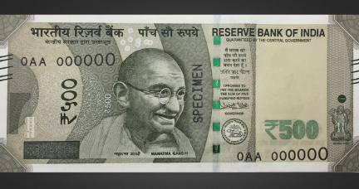

#### A currency detection system that classifies currency as real or counterfeit using image processing.

#### MOTIVATION:

#### Recognition of fake Indian currency is very important in major domains like banking. This system is used to detect whether the currency is fake or original through the automated system that is through convolution neural networks, in deep learning. The problem is that common person these days are facing issues in regard to circulating fake currencies and are not able to recognize which notes are real and which are counterfeit. The main objective of this project is to make it convenient for any common man to know whether or not a note is real by using our desktop or android application. To obtain a benchmark result, existing object detection pre-trained models were used, followed by ResNet50 architecture.

## **TECHSTACK/FRAMEWORK USED:**

* [Python](https://www.python.org/)
* [Tensorflow](https://www.tensorflow.org/)
* Keras

### **STEPS TO INSTALL AND RUN THE PROJECT:**

🡺Download python v3.6

🡺Download any source code editor (Example: VS code) 

🡺Required Libraries for the project:

🡺TensorFlow

🡺Keras

🡺Run the following command in the terminal: python Fake_Currency_Detection.py

**WORKING:**

The program will function in the following way:

* The model is trained on multiple images of fake and real Indian currency.
* An image of the note is passed as input to the system which returns the result with an accuracy of 90-92%.