Question 1:

How will you approach this problem, provide a flow chart that has complete coverage. Paste your flow chart in single page for better viewing.

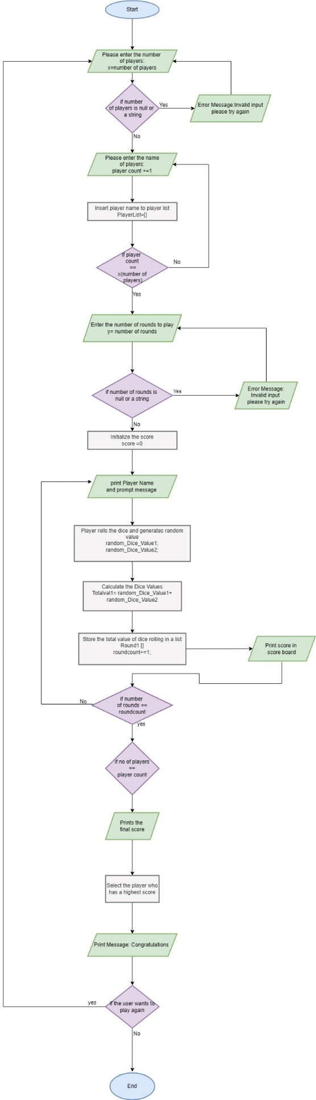

TestPrintGame(testing printgame() function failed) in check script. Attach terminal screenshot of test script along with sample output testing and any corner case you covered with descriptions for the screenshots.

