# System Specification

****Vitality**

*Fitness and Health App*

*A Project conducted under Learn IT Girl program February 2016 – April 2016*

Contents

System Specification 1

1. Introduction 2

1.1 Purpose 2

1.2 Product Scope 2

1.3 References 2

2. Overall Description 2

2.1 Product Perspective 2

2.2 Product Functions 3

3. Functional Requirements 4

3.1 Vitality Web Application 4

3.1.1 Vitality web app requires the following user data to be provided for full functionality. 4

3.2 PhoneGap Mobile app 4

3.2.1 Vitality Mobile app will collect data from the mobile phone’s different sensors and infer the following details 4

3.3 Backend Python processing 4

3.3.1 The application backend will utilize collected user data to infer the following data 4

3.4 Use Cases 5

3.1.1 Use Case 1 5

# Introduction

## Purpose

The document presents the requirements and design scope of a smart health and fitness tracking web application, hereby referred to as, “Vitality”. The application will track activity level, food consumption and calorie flow of the user daily, with capability to predict healthy level of calorie consumption patterns and produce trends of the user life style.

## Product Scope

The software application will have a web based backend developed in python, using Django framework, while utilizing mongo DB for data storage. The scope of this project will cover the backend wed application development and data analysis used to infer user consumption patterns. Depending on the time frame, a PhoneGap based client-side interface would be developed to obtain further biodata (i.e accelerometer , IR sensors to track motion and heartrate respectively).

## References

<to be added>

# Overall Description

## Product Perspective

**Vitality** is a web based fitness and health tracker with a database to track user fitness and health data over time across multiple users. The product is extendable to extract client data via a smart phone. The base product will enable user to input data via web browser. Diagram 2-1 illustrates the technology and components of the high level system.

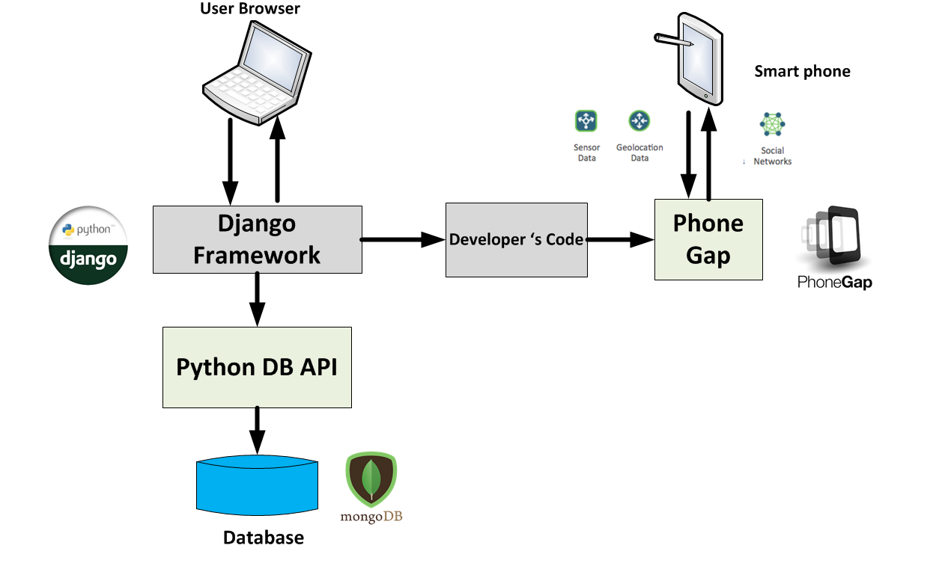

*Diagram 2-1*

## Product Functions

The Service enables each user to track daily health habits in the form of Activity Level, Food intake & Water intake by providing a daily diary to enter each user data. The data will then be utilized to identify calorie consumption over the day and check if the user is achieving the daily goals set by the user. The application has a portal to check Body-Mass-Index and Body-Fat-Percentage, thereby providing the ideal physical conditions user should be targeting. These ideal states will then be cascaded to the user in the form of predictions, providing user the ideal calorie intake and exercise calorie output required by the user.

**Vitality** will utilize an editable food dictionary and exercise dictionary with auto search functionality to input daily data.

User data collected over time will be viewed in graph format against the target level daily, weekly, monthly based on the collection of data. Predictions will be made based on the collection of data for the user to achieve optimum fitness level. ( E.g. If user is not achieving water intake goal, display a TIP to drink more water. If the user is not burning the required level of calories based on BMI, display a REMINDER for the user to workout and suggest a suited workout for the required burnout level.)

# Functional Requirements

## Vitality Web Application

## Vitality web app requires the following user data to be provided for full functionality.

#### Activity Level – Selected from a number of exercises in the exercise dictionary, or as a new entry added to the exercise dictionary

#### Food Intake – Selected from a number of food items in the food dictionary, or as a new entry added to food dictionary

#### Water Intake – Given as the number of glasses of water consumed. The volume of the glass can be specified and amended as a configuration detail

#### User measurements – User weight, age, height, neck/ waist/ hip perimeter is required to calculate BMI and Body Fat percentage

#### Vitality web app will provide the following outputs based on input data.

#### Daily Calorie balance – Given in equation format in the dashboard summary

#### Summary Graphs - Daily/ Weekly/ Monthly trend of user activity/ food intake/ water intake levels given in the format of graphs with goal levels given as reference

#### Daily Tips – Generated based on input data to enhance user health and fitness.

## PhoneGap Mobile app

## Vitality Mobile app will collect data from the mobile phone’s different sensors and infer the following details

#### User physical activity level (Running/ Walking/ Resting/ Sleeping) - Gyroscope/ Compass / Accelerometer / GPS

#### Transportation Mode – Gyroscope/ GPS / Wifi

#### Stress Level – Microphone (speaker dominance)

## Backend Python processing

## The application backend will utilize collected user data to infer the following data

#### Patterns in user activity through the week / month – Most active day/ Least active day

#### Patterns in water /food intake throughout the week – Unhealthy food intake probability for day

#### Changes in user anatomy – by weight & waist / neck/ hip measurements , identify user’s figure changes.

## Use Cases

The following provides use cases in a scenario a single user is utilizing Vitality as a web app with no smart phone support and a use case with a user utilizing both web app and smartphone app simultaneously.



### Use Case 1

1. User logs into the home page

User is shown the daily summary of his/ her fitness and health habits. The calories remaining and the amount of calorie burnt is shown as a subtraction of food consumed and exercised. The user can add exercise or add food fro the dashboard tab itself, which redirects the user to the input tabs.

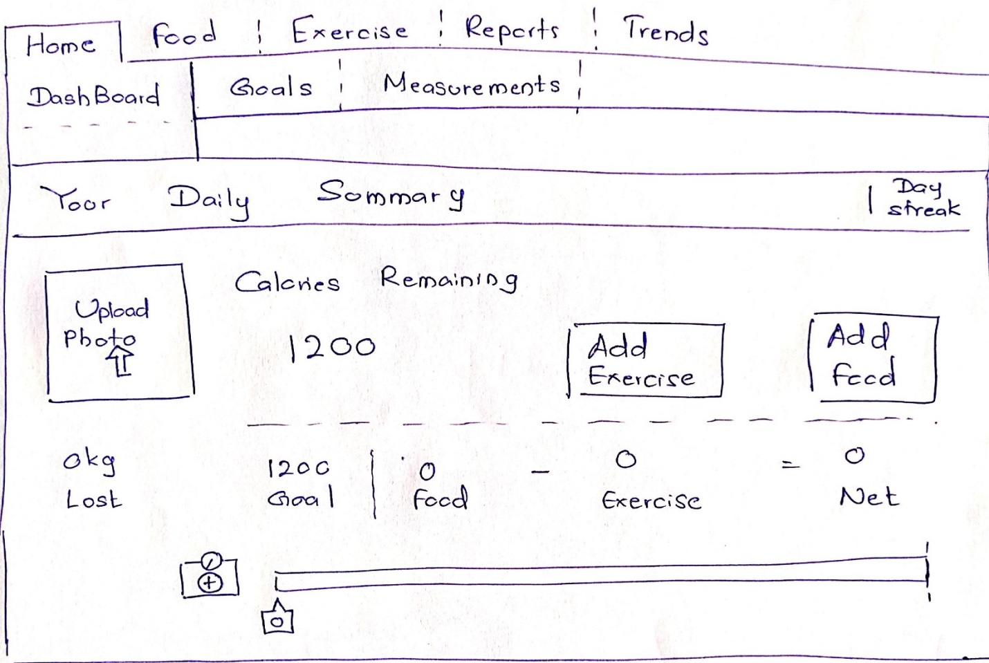

1. User updated daily goals

The user can navigate onto the goals tab from the home main category and update their desired outcome for the day/ week.

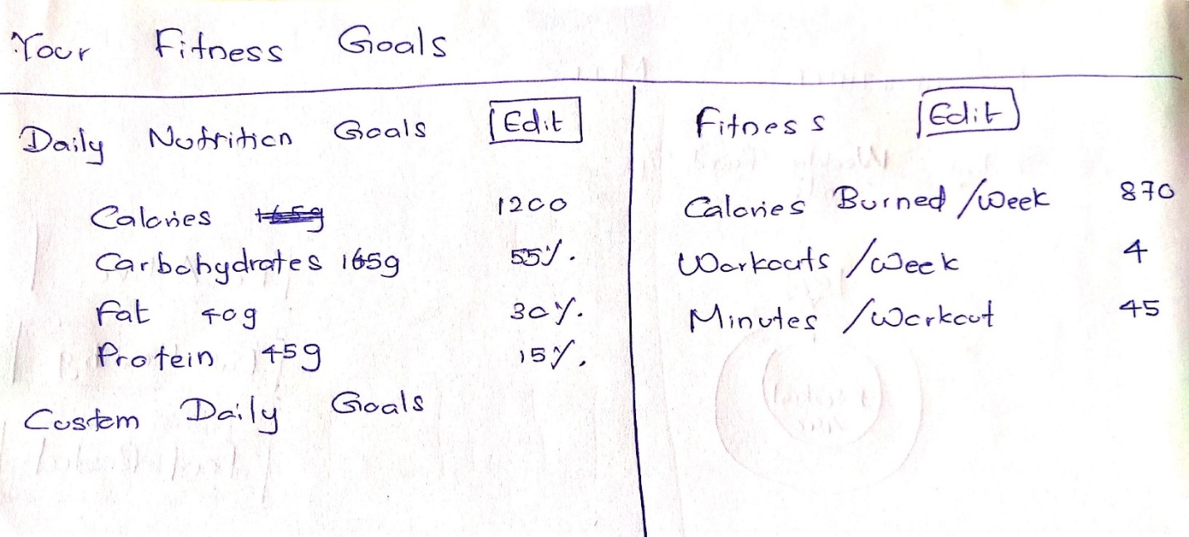

1. User updates base configurations – measurements indicating user anatomy features.

The user can input and update height/ weight (compulsory) and hip/wait/neck (perimeter) measurements (optional) in order for Vitality app to provide a more accurate fitness indicator. Thus BMI and Body Fat Percentage will be calculated.

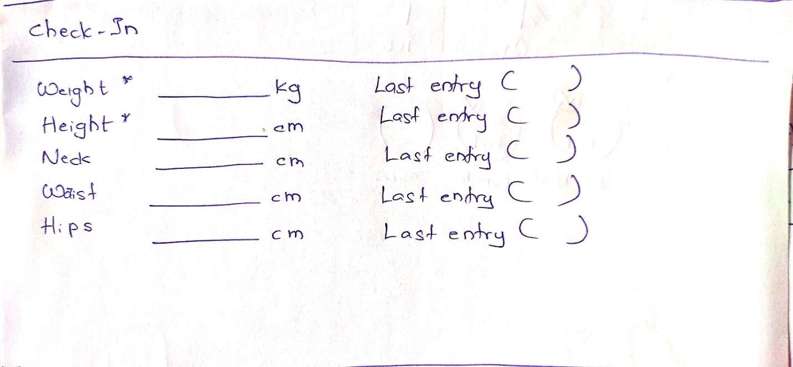

1. User inputs Food intake

User can update food intake information throughout the day as time permits to Vitality. The Food Diary tab will have input options and maintain a summary report of the daily calorie intake and each day’s data will be re-viewable by the use of the calendar button.

The entries can be saved and can be submitted at the end of the day.

Water consumption wll be tracked as the number of glasses consumed within the day.

Once the user adds a food item the user is directed to the database tab where a list of food items with nutrition data are suggested to the user based on search keyword provided by user.

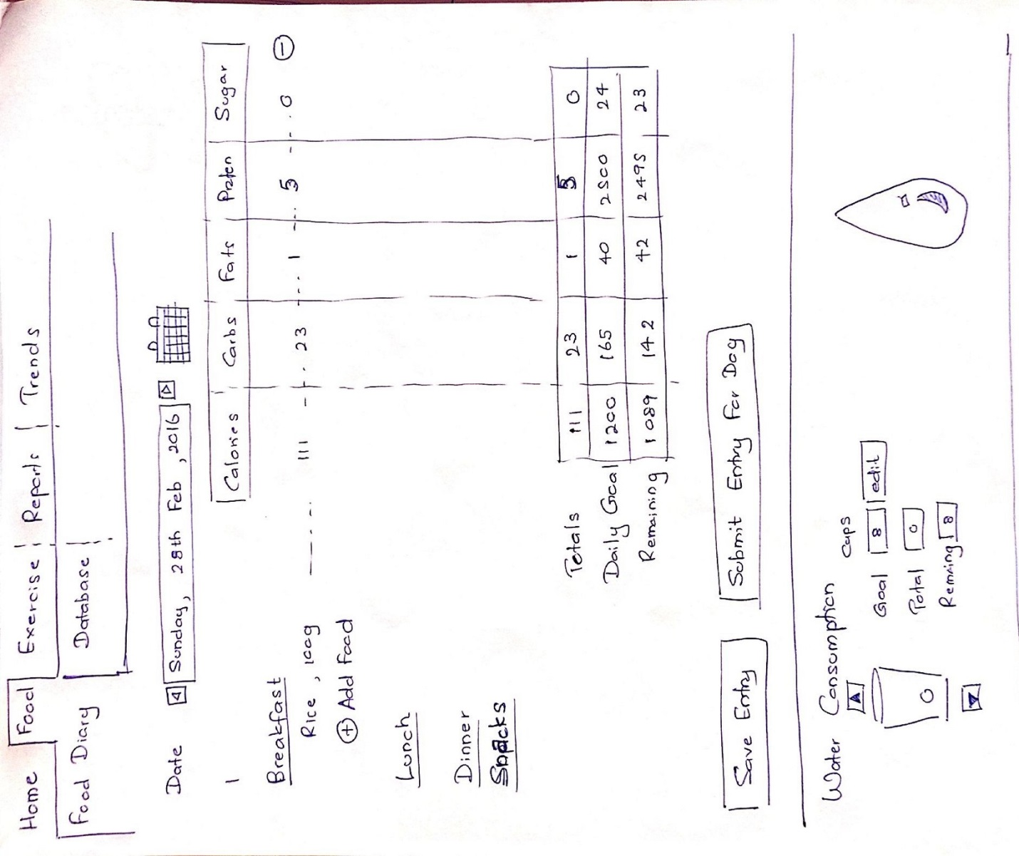

1. User searches for food items in the data base

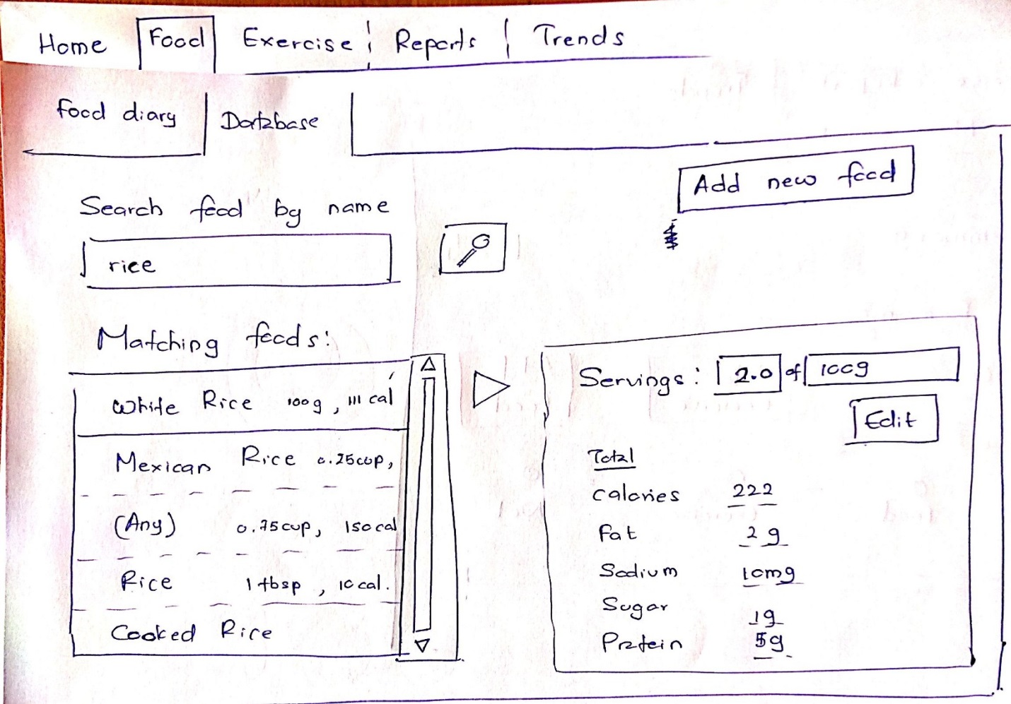User is given auto search functionality, and can skim through the search results and include a serving size and quantity for existing food items in dictionary or add a food item type themselves.

1. User enters Exercise details to the exercise diary.

The exercise diary functions in a similar manner to food diary. The data base provides similar functionality as the auto search food dictionary.

1. 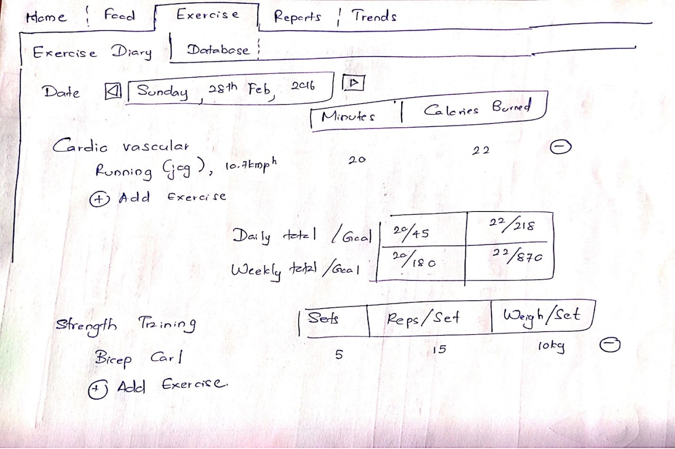User checks summary of day’s activities again in dashboard.

A tip appears in the bottom of the dashboard urging the user to drink more water. BMI and BFP are calculated and shown.

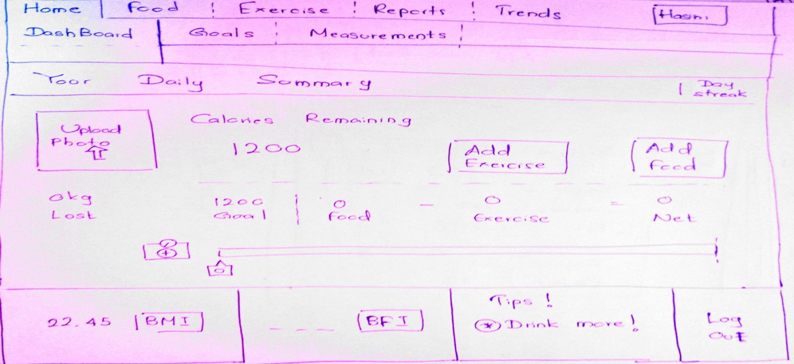

1. User can see reports in Reports tab which gives a sumamry of all activity.

User can define whether the summaries are iven daily/ weekly or monthly.

