Name: Akkireddy Hasini
Role: AI/ML Intern
Task -4
Overview
This report covers my research on AI technologies used in virtual try-on systems. I studied pose estimation models, body measurement systems and segmentation techniques and also implemented working code demos for each.
1. MediaPipe Pose
MediaPipe Pose is a lightweight AI framework made by Google that detects 33 body landmarks in real time from a camera or image. It works on normal CPU without needing a GPU making it perfect for mobile and web applications.
I implemented pose detection using MediaPipe in Module 1 of our project. The system successfully detected all 33 landmarks including shoulders, elbows, wrists, hips, knees and ankles and drew a skeleton on the person in real time.
Key features:
- Detects 33 body landmarks
- Works in real time on CPU
- Mobile and web compatible
- Easy to integrate with Python and OpenCV
2. OpenPose
OpenPose is a pose estimation framework developed by Carnegie Mellon University. It can detect multiple people in one frame simultaneously which makes it more powerful than MediaPipe for complex scenes.
Key features:
- Multi person detection
- Detects body, hands, face and feet
- Higher accuracy than MediaPipe
- Needs GPU for real time performance

3. SMPL Body Model
SMPL stands for Skinned Multi-Person Linear Model. It is a 3D human body model that generates a realistic digital avatar from just two parameters — body shape and body pose. It is used in advanced virtual try-on systems to create a 3D body that clothing can be draped onto.
Body = SMPL(β, θ)
β = body shape (thin, athletic, plus)
θ = body pose (joint angles)
Key features:
- Generates realistic 3D avatars
- Works for all body types
- Used in advanced cloth simulation
- Foundation of 3D virtual try-on

4. AI Body Measurement System
I implemented a body measurement system that calculates real body dimensions from a single photo using MediaPipe landmarks and a scale factor based on the person's height.
Measurements calculated in my implementation:
- Shoulder width
- Hip width
- Arm length
- Leg length
- Torso length
- Height estimation
Formula used:
Real Distance = Pixel Distance × (Known Height / Pixel Height)
Sample output from my code:
- Shoulder: 33.4 cm
- Hip: 16.9 cm
- Torso: 56.5 cm
- Arm: 42.8 cm
- Leg: 77.7 cm
This measurement system was connected to our Indian brands dataset to recommend the correct clothing size with a fit confidence score of 81.5%.

Comparison Table
Feature | MediaPipe | OpenPose | SMPL
Type | Pose Estimation | Multi-Person Pose | 3D Body Model
Speed | Fast | Moderate | Moderate
Accuracy | Good | Very High | Very High
GPU Needed | No | Yes | Yes
Mobile Support | Yes | No | No
3D Avatar | No | No | Yes
Best Use | Real time try-on | Multi person | 3D fitting

Integration Pipeline
User uploads photo
↓
MediaPipe detects body landmarks
↓
AI estimates body measurements
↓
rembg removes background
↓
Clothing aligned using landmarks
↓
Alpha blending for realistic overlay
↓
Size recommendation from dataset
↓
F inal virtual try-on output

1 . MediaPipe Pose Landmark Detection
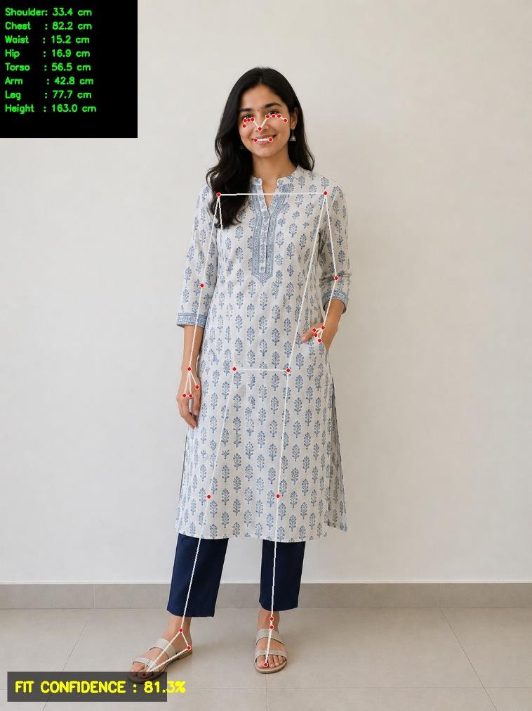
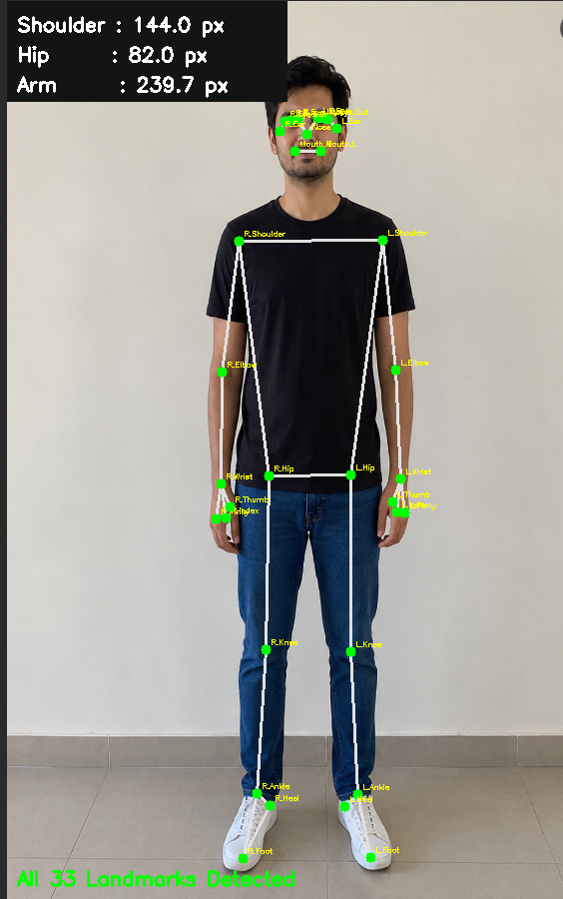
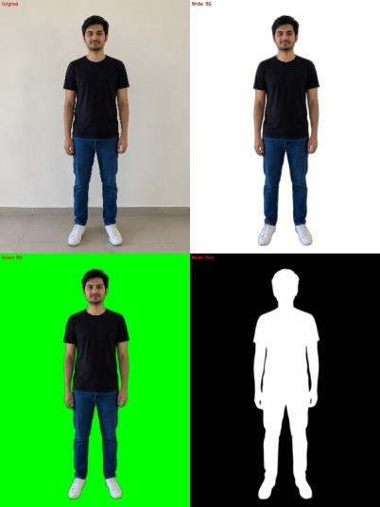
2. Simple clothing overlay aligned to body landmarks

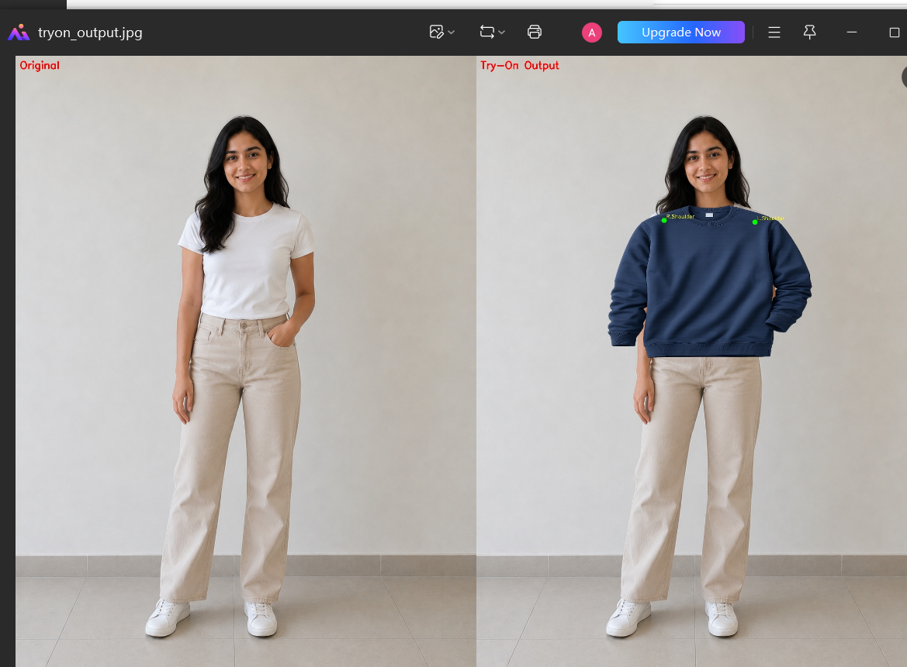
3.Background
Future Improvements
- Implement TPS garment warping for realistic cloth deformation
- Use HR-VITON for photorealistic try-on output
- Add SCHP for accurate cloth segmentation
- Support multiple poses and body types
- Build REST API for integration with Raritone platform

Conclusion
I researched and implemented AI based technologies for virtual try-on including pose estimation, body measurement, segmentation and clothing overlay. MediaPipe forms the foundation of our system providing accurate body landmarks for measurement and alignment. The combination of rembg for background removal and MediaPipe for body detection gives the best result for isolating the human body. Future work will focus on integrating HR-VITON for realistic garment warping to complete the full virtual try-on pipeline for Raritone.

5. Segmentation Research
Segmentation is the process of separating different parts of an image like the person, clothing and background from each other.
I tested three segmentation models:
MediaPipe Selfie Segmentation
- Real time background removal on webcam
- Good for standing poses
- Struggles with seated poses and furniture
GrabCut (OpenCV)
- Traditional algorithm, no AI
- Works based on color differences
- Not accurate for human segmentation
rembg (U2Net)
- Best background removal accuracy
- Clean hair and edge detection
- Includes chair in mask for seated poses
Combined rembg + MediaPipe
- rembg removes background
- MediaPipe detects human body bounding box
- Both masks combined for human only cutout

6. Virtual Try-On Implementation
I built a simple 2D virtual try-on system that:
- Takes person image and clothing image as input
- Removes background using rembg
- Detects body landmarks using MediaPipe
- Calculates dynamic measurements from landmarks
- Resizes and aligns clothing to shoulder and torso
- Applies alpha blending for smooth overlay
- Outputs final try-on result

Feature | MediaPipe |  | OpenPose |  |  | SMPL
Type |  |  |  |  |  |  | Pose Estimation |  |  | Multi-Person Pose | 3D Body Model
Speed |  | Fast |  | Moderate | Moderate
Accuracy |  | Good |  | Very High | Very High
GPU Needed |  | No |  | Yes | Yes
Mobile Support |  | Yes |  | No | No
3D Avatar |  | No |  | No | Yes
Best Use |  | Real time try-on |  | Multi person | 3D fitting
Comparison Table

Integration Pipeline for Raritone
User uploads photo
↓
MediaPipe detects body landmarks
↓
AI estimates body measurements
↓
rembg removes background
↓
Clothing aligned using landmarks
↓
Alpha blending for realistic overlay
↓
Size recommendation from dataset
↓
Final virtual try-on output

Challenges Faced
- Pixel to centimeter conversion accuracy depends on camera distance
- Dark clothing confused background removal models
- Seated poses caused chair to be included in human mask
- Clothing overlay without actual garment warping looks flat
- MediaPipe struggles with partially visible bodies

What I Built — Sample Outputs
- Module 1: Real time landmark detection with 8 body measurements
- Module 3: Background removal tested on 3 poses with 3 models
- Module 4: Simple clothing overlay aligned to body landmarks
- Size recommendation with 81.5% fit confidence

Future Improvements
- Implement TPS garment warping for realistic cloth deformation
- Use HR-VITON for photorealistic try-on output
- Add SCHP for accurate cloth segmentation
- Support multiple poses and body types
- Build REST API for integration with Raritone platform

Feature | Mediapipe | Openpose | SMPL
Type | Pose Estimation
Speed | Fast
Accuracy | Good
GPU Needed | No
Mobile Support | Yes
3D Avatar | No
Use | Real time Try-On

